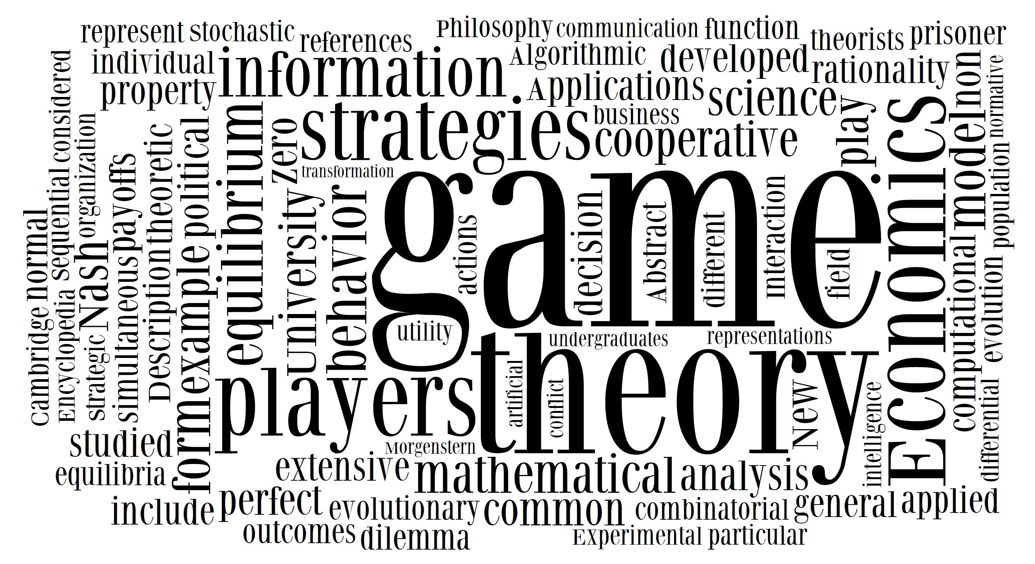
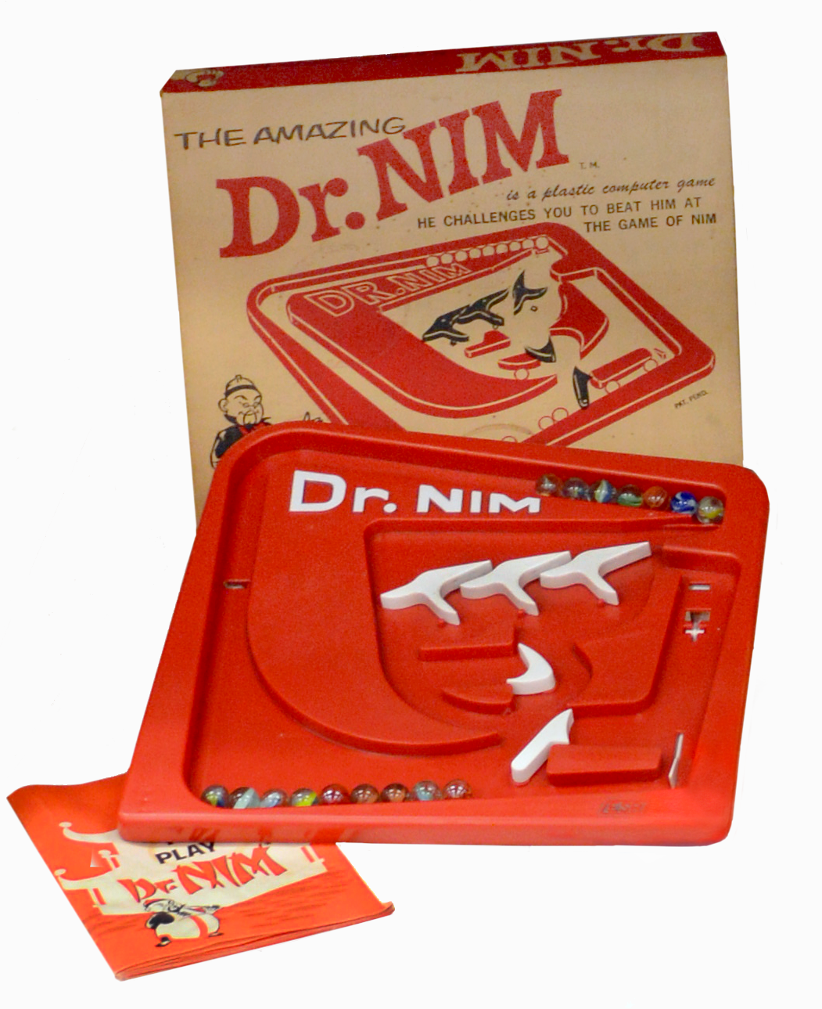
PROOF OF LEARNING
8 MATH PRACTICES

Date Assigned | ASSIGNMENT | POINTS EARNED | POINTS POSSIBLE
 | Quality Cipher
 | Poison Game of Nim (master strategy)
 | Patterns
 | Fraction patterns & booklet
 | Dominoes
 | Math Practices notes

8 MATHAMATICS PRACTICES FOR MASTERY
- Make sense of problems and persevere in solving them.
- Reason abstractly and quantitatively.
- Construct viable arguments and critique the reasoning of others.
- Model with mathematics
- Use appropriate tools strategically.
- Attend to precision.
- Look for and make use of structure.
- Look for and express regularity in repeated reasoning

PROOF OF LEARNING
8 MATH PRACTICES

RATIONAL NUMBERS AND EQUATIONS | 1. I am not sure of the problem | 2. I can do this with a an example | 3. I can do this on my own. | 4. I can teach others
I can make sense of problems and persevere in solving them

I can reason abstractly and quantitatively (Label numbers for understanding or take away labels to play with patterns)
I can construct viable arguments and critique the reasoning of others

I can model with mathematics
(Picture, table, chart, graph)

I can use appropriate tools strategically
(Book, calculator, chart, graph, etc.)
I can attend to precision
(Be accurate in calculations or drawings)
I can look for and make use of structure
(See patterns in shapes and pictures)
I can look for and express regularity in repeated reasoning (See patterns in calculations and numbers)

Attach the best or favorite assignment or example that proves your understanding of the concept.

