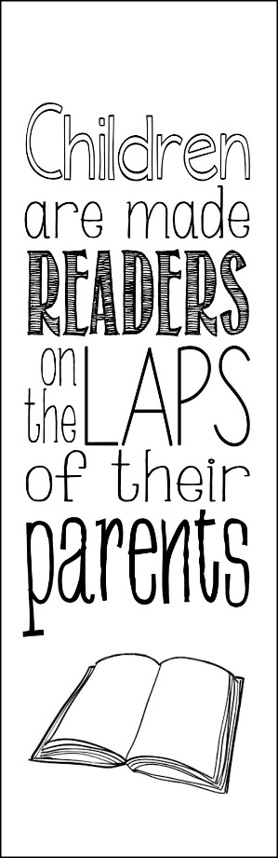
Purple Reading Folder
This reading folder will come home on Monday (unless we have a short week) and needs to be returned to the classroom by Friday that same week. It will include:
- Story – stays at home
- Vocabulary Words – stays at home
- Parent Comment Page – keep in the folder
- Spelling Words - stays at home
- Monthly Homework Assignment
I ask that you listen to your child read the story each week, or help them if they need. There are some questions and activities at the end of each story that I encourage you to try with your child. Discuss the story with your child and have them summarize what happened or what their favorite parts were. Talk about the vocabulary words as your child reads them in the story. Here are some other activities to try:
- Put your vocabulary words in alphabetical order.
- Use them in your daily life and in conversation.
- Read other books that may incorporate some of the words. Are they used the same way?
- Write a new story using the vocabulary words.
- Think of other words that mean something similar.
Enjoy this reading time together!

