17.1 Atmosphere Characteristics

Composition of the Atmosphere

- Major Components:

  - Nitrogen and Oxygen make up 99% of gas in the atmosphere
$$Argon {CO}_{2} \& Other Gases$$
1%
$$O_{2}$$
21%

- Variable Components Include:
$$N_{2}$$
78%
Water Vapor

Dust

Ozone

Ozone is a gas form of oxygen with three atoms. ($O_{3}$)

It is created by $O_{2}$ is split into a single Oxygen atom by Ultraviolet Radiation and recombined with another $O_{2}$molecule to form $O_{3}$

The Ozone Layer is only 3mm thick! It protects life on Earth by absorbing Ultraviolet Radiation.

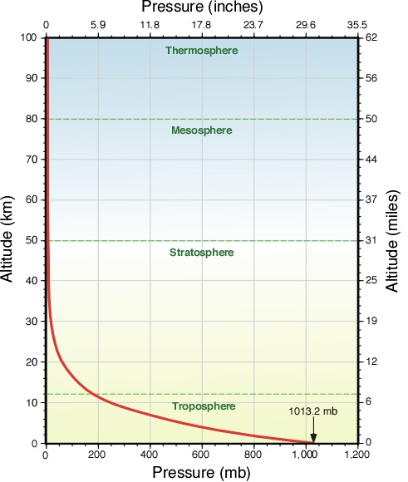
- Height and Structure of the Atmosphere

  - Pressure Change

Pressure decreases with an increase in altitude

- Troposphere
  - Sea level up to approx. 12 km
  - All weather occurs here.
  - Temp. drops because decrease in pressure

- Stratosphere
  - 12km up to 50 km
  - Temperature starts to warm up because of ozone layer

- Mesosphere
  - 50 km to 80 km
  - Temp. because air pressure drops

- Thermosphere
  - 80 km to 700 km (beyond this point is called Exosphere)
  - Temp. because $O_{2}$and $N_{2}$absorb short-wave high-energy solar radiation.

