Groundwater
Porosity – A measure of the amount of air space within a soil.
- A soil of high porosity means that there is a great deal of air space between soil particles.
Two Factors affecting porosity:
1. Shape of particles – The more well-rounded the particles within a soil or rock sample are, the more porosity the sample has.
2. Size distribution – If all particles are the same size, there is more porosity than if the particles are of mixed sizes
Permeability – Movement of water flowing through the rock and soil.
Factors affecting permeability
1. The larger the grain sizes, the more permeable the material
2. The more homogeneous the material sizes, the more permeable the soil is
3. Generally, the more well-rounded the material is, the more permeable it is.
Material can be porous without being permeable, but it cannot be permeable without being porous.
Regions of Groundwater
Unsaturated Zone “Zone of Aeration”
Composed of 3 regions….
1 - The uppermost regions where water forms a film around grains of topsoil (soil water)
2 - The middle zone which remains relatively dry.
3 - The Capillary Fringe which lies just above the water table and draw water up from the zone of saturation.
“Zone of Saturation” - Lower layer where all pore spaces are filled with water.
Porous and permeable
The water table is the upper layer of the zone of saturation.
  - The water table rises and falls with topography, season, and use.
Aquifer – an underground layer of water-bearing permeable rock, rock fractures or unconsolidated materials (gravel, sand, or silt) from which groundwater can be extracted using a water well.

Wells
Ordinary wells…
- Must penetrate deeply into highly permeable rock and sediment.
- If the well is not deep enough, the well may run dry during the summer months.
- As water is pumped out of such a well, a “cone of depression” forms in the water table. If this depression goes lower than the well, the well runs dry.
Artesian Wells and Springs
Require a sloping permeable layer of rock which often runs hundreds of miles underground. The layer is known as an “Aquifer”
Water collects in an area of high elevation in the exposed area of an aquifer and is then carried down underground by gravity.
The aquifer acts as a hose. When you tap into the hose, the water flows under its own pressure.

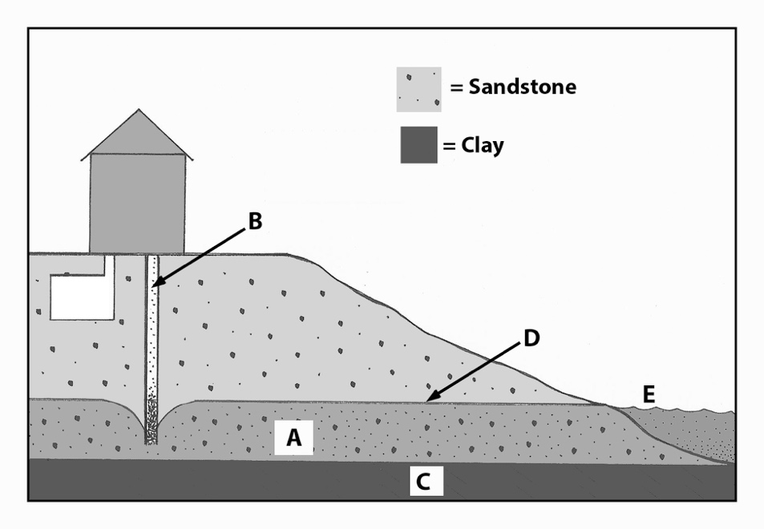
A. = Aquifer
B. = Bore well
C. = Impermeable rock or clay
D. = Water table
E. = Spring

Watersheds = area or ridge of land that separates waters flowing to different rivers, basins, and ultimately the ocean.

Characteristics of Watersheds
Divide – A high land area that separates one watershed from another.

Continental Divide – divide that separates the movement of water to different Oceans.

Ridgeline – continuous mountain ridge that divides two watersheds.

Headwaters – the source of a stream or river.

Tributaries – rivers and streams that flow into a larger stream or river system.

Floodplain – broad flat area extending from a stream’s bank covered by water during a flood.

Stream System – A river and all of it’s tributaries.

Estuary – the mouth of a large river, where it meets a larger body of water

Watershed and Stream Features

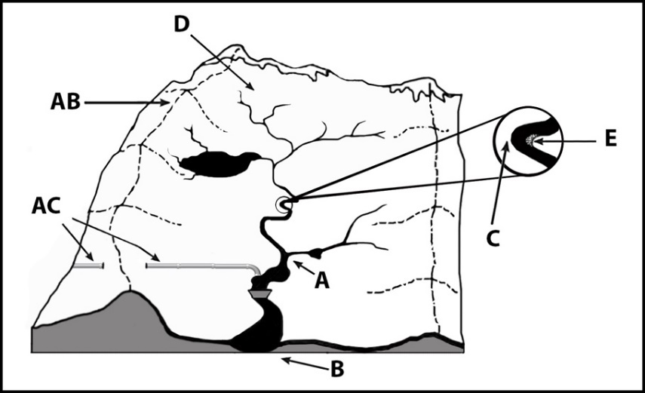
- Confluence (tributary meets main river)
- Mouth (where an estuary can form)
- Cut bank (water erodes riverbank)
- Headwaters
- Point bar (slower water deposits sand and gravel)
- Trans-mountain diversion
- Divide (Geographic area dividing two watersheds)
G
F

Stream Formation and Characteristics
Three Elements of Stream Formation
1. Headwaters - the region where water first accumulates to supply a stream.
2. Stream Channel - a narrow path carved by moving water.
3. Stream Bank - the ground on each side of a stream holding moving water in a stream channel.
Two types of Streams
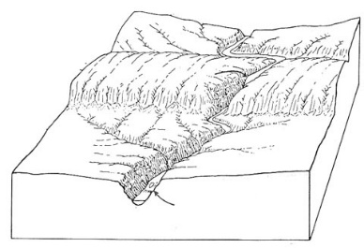
- Valley Streams = streams that have steep v-shaped channels that can form canyon or gorges.
  - Base Level = elevation at which a stream enters another body of water.
    - Gravity pulls water down eroding the land until it reaches the ocean

Base Level

- Meandering Stream = wide, winding or bending streams with a u-shaped stream bed.
  - Meander = A bend or curve in a stream channel caused by moving water.
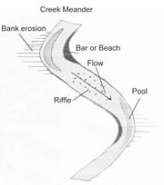
  - Water Velocity (speed) “flow of the stream”
    - Center of Channel – the fastest
    - Sides and Bottom – slower
  - Formation of a Meander
In a meander the water on the outside of a curve is the fastest and erosion occurs on the outside edge while deposition occurs on the inside edge resulting in a more defined meander.
- Oxbow Lake = a blocked off meander.
- Mouth = The area of a stream that leads into the ocean or another large body of water.

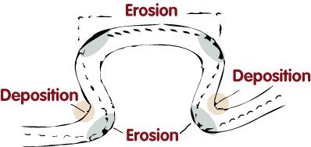
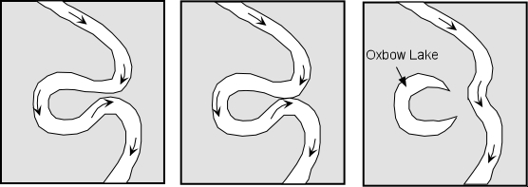

Running Water
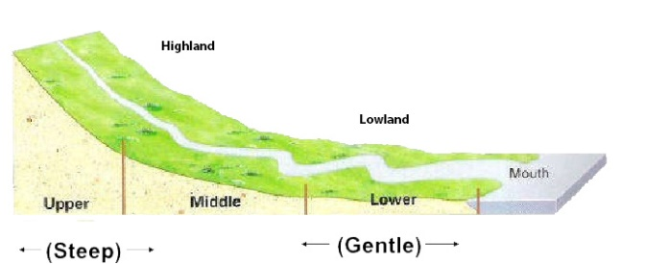
Stream Flow = the amount of water flowing in a river.

Stream Erosion depends on velocity of water
  - Faster water = more erosion

Factors that Effect Stream Velocity
- Gradient is the slope of a stream channel or the vertical drop over a certain distance.

Change in Elevation $÷$ Distance Traveled = Gradient

  - Streams start with a steep gradient and end with a gentle gradient at their mouth.
  - Under the influence of gravity water wants to find its way to the ocean.

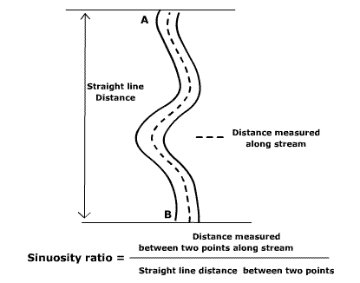
- Channel Characteristics
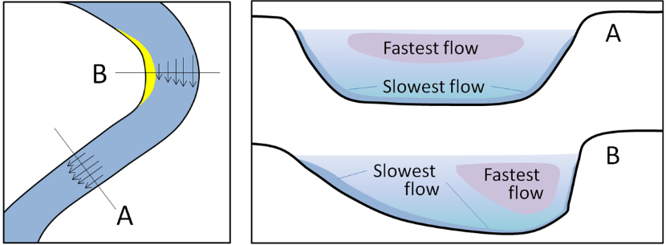

  - Stream vegetation – vegetation both in the water and on the stream bank.
  - Geology – physical characteristics of land the water is flowing through.
  - Friction – rocks and debris present in the stream.

Discharge = the volume of water flowing past a certain point in a given time.
  - Equation: Width(m) x Depth (m) x Velocity (m/s) = m³/s
Base Level – when water reaches its lowest point under the influence of gravity.
Channel erosion – when water erodes away the stream channel.

Practice Problems:

1. Calculate the gradient of a stream that drops 150 m over a distance of 2000 km.

2. What is the discharge of a stream that is flowing at 30 m/s, is 3 m wide, and 2 m deep?

Stream Transport Name __________________ period____ Date ______

Erosion – action of water that moves soil, rock, and dissolved substances.

Sediment Transport
- Conductivity – the capability of water to carry and electrical current.
  - Due to concentration of ions in water from salts and minerals.
  - Ion = an atom or molecule with a net electric charge due to the loss or gain of one or more electrons.
  - Measured in parts per million (ppm).
  - A higher conductivity indicates a higher sediment load which can be harmful to aquatic life such as insects and fish.

- Three sizes of sediment sand, silt, and clay.

- Suspended load – floating sediment that contributes to the cloudiness of streams.
- Transition sediment – sediment that gets transported in water by rolling, bouncing, or sliding.
- Base load – material that is too large to be suspended.
- Deposition – sediment deposited on land.
  - Largest sediment settles to the bottom.

