Cell Growth and Division Chapter 10 Name _________________

10.1 Cell Growth and Division
- Limits to Cell Size
  - 1) ________________________ – as size increases, DNA is not able to provide information for all the needs of the cell. (Library analogy)
  - 2) ______________________- If a cell gets too large, the surface area of the cell is not large enough to get oxygen and nutrients in and waste out
-surface area to volume ratio
-traffic analogy

- Cell Division = the process in which a ______________________________________________
- __________ Reproduction = the production of genetically identical offspring from a single parent
- __________ Reproduction = offspring inherit some of their genetic information from each parent

10.2 The process of Cell Division
- Chromosomes – threadlike structures of DNA and protein that contains genetic information
  - Prokaryotes – chromosomes are in _________________
  - Eukaryotes – chromosomes (chromatin) are in ___________________
    - Many eukaryotes have __________________________ which make it possible to _______________________________________________

Steps of the Cell Cycle
- Interphase (G1 Phase, S Phase, G2 Phase)
- Cell Division
  - Mitosis (Prophase, Metaphase, Anaphase, Telophase)
  - Cytokinesis
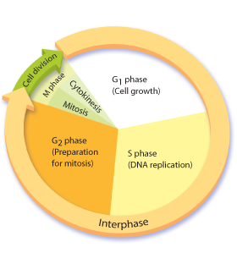
Important Cell Structures Involved in Mitosis
- Chromatid – each strand of a duplicated chromosome
- Centromere – the area where each pair of chromatids is joined
- Centrioles – tiny structures located in the cytoplasm of animal cells that help organize the spindle
- Spindle – a fanlike microtubule structure that helps separate the chromatids

Phases in the Cell Cycle
- Interphase _____________________________________________
  - __________G1 Phase = cell growth, make new proteins and organelles
  - ____ Phase = New DNA is made (doubles)
  - __________ Phase = Organelles needed for cell division are made

- Mitosis = ________________________________________________
  - Prophase
    - ________________________ (Chromosomes become visible)
    - Centrioles separate
    - _________________ starts to form
  - Metaphase
    - Chromosomes __________________ across the center of the cell.
    - Spindle fibers connect the _______________ of each chromosome
to the two poles of the spindle.
  - Anaphase
    - _________________________________
    - Individual chromosomes are __________________ on spindle fibers
  - Telophase
    - Chromosomes are at _________________ ends of the cell
    - Chromosomes spread out into ______________________
    - ___________________________ reforms
    - ___________________ breaks apart
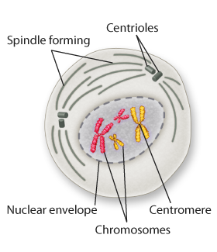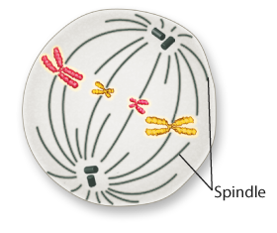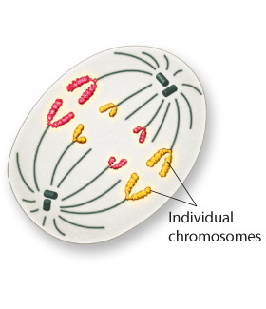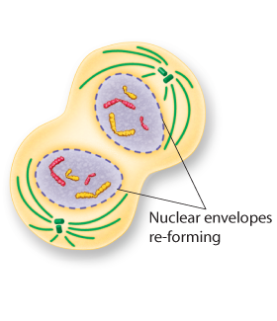
____________ _____________ _____________ _____________

- Cytokinesis = _________________________________________________________
  - The ______________________ pinches in half
  - Each of the two daughter cells has an ___________________ set of chromosomes

10.3 Regulating the cell cycle
- How do cells know when to divide?????
  - Some cells don’t divide once they are formed (muscle and nerve)
  - Cells in the bone marrow that make blood cells and digestive tract divide as fast as every few hours
- ___________________ = a family of proteins that regulates the cell cycle in eukaryotes
- Regulatory proteins instruct the cells when to divide
  - Internal regulatory proteins make sure that steps in the cell cycle are completed before the next step occurs
  - External regulatory proteins direct the cell to speed up or slow down the cycle
    - Ex. Growth factors – stimulate the division of the cell (embryonic development and wound healing)

- Apoptosis = __________________________________________
  - Cells either are damaged and die or they have programmed cell death
  - In apoptosis the cell and chromatin shrink, cell membrane breaks and other cells recycle it
  - Ex – mouse foot, human hand

Cancer
- Cancer = occurs when some of the body’s cells ___________________________________
  - Cancer cells do not respond to the signals that regulate growth and divide uncontrollably
  - Cancer cells absorb nutrients needed by other cells, block nerve connections, and prevent organs from functioning.

- Tumor = _______________________________
  - ______________ tumors = noncancerous tumors that do not spread to other tissue
  - ______________ tumor = cancerous tumor that invade and destroy surrounding tissue
  - Metastasis = the _____________________________
- Causes of cancer
  - Caused by defects in the genes that regulate cell growth and development
    - Sources of gene defects include
      - Tobacco, radiation exposure, defective genes, viral infection
    - Many cancers have a defective p53 gene which halts the cell cycle until chromosomes have been replicated
- Treatment of cancer
  - _________________________
  - _________________________
  - _________________________ – chemical compounds that kill cancer
    - Targets rapidly dividing cells and also interferes with cell division in normal cells (side effects)

10.4 Cell Differentiation
- During the development of an organism, cells differentiate into many types of cells.

Stem Cells
- Stem cells = __________________________________________________________________
- ________________________ cells= can develop into any type of cell in the body
- _______________________ = can develop into most (but not all) of the body’s cell types
  - Inner cells in the early embryo (a hollow ball called a blastocyst)

Embryonic Stem Cells
  - Found in the inner cells mass of the early embryo.
  - Embryonic stem cells are pluripotent. (cells have the capacity to produce most cell types in the human body)

Adult Stem Cells
  - Adult stem cells are multipotent. They can produce many types of differentiated cells
  - Adult stem cells of a given organ or tissue typically produce only the types of cells that are unique to that tissue.

Stem Cell Research
  - Repair or replace badly damaged cells and tissues.
    - heart attack
    - stroke
    - spinal cord injuries.

Stem Cells – the ethical concerns
  - Embryonic stem cells are harvested from early embryos
    - Most methods ____________________ the embryo
    - In the past, US limited funding for the embryonic cell lines used for research - NIH has 136 embryonic stem lines in the US that are currently being used for research
    - Research is being done to
      - harvest embryonic stem cells without destroying the embryo
      - turning adult stem cells into pluripotent cells
      - Embryonic stem cells out of umbilical cord blood
