Chapter 11 GENETICS Name ____________________________ Period_______

  - The work of Gregor Mendel
Genetics = _______________________________ (passing down of characteristics from parent to offspring)
-Gregor Mendel = “_____________________________”
- Born in 1822 – Austrian monk
- Worked with pea plants that were self-pollinating and true-breeding (the offspring always looked like the parent)
-Mendel cross pollinated his true-breeding plants
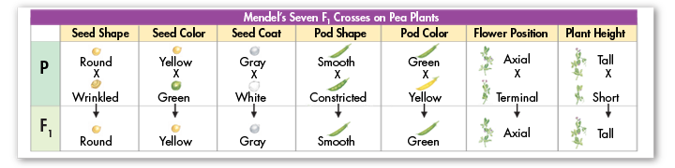
-The original pair of plants is called the __________(parental generation)
-The offspring are called the ______________ (first filial generation)
  - _______________ = offspring of crosses between parents with different characteristics
  - Trait = a _____________________________ (pea color, hair color)
  - _______________ = the factors that are passed from parent to offspring
  - Allele = __________________________________________

- Mendel’s Conclusions
-An individual’s characteristics are determined by factors (genes) that are passed from one parental generation to the next
-Principle of dominance = some alleles are dominant and some are recessive
  - ___________________ = need one allele (form of the gene) for the trait to be expressed
  - Recessive = need ________________________ for the trait to be expressed
  - Gametes = ________________________________________ (sperm, egg, pollen, ovule)
-During the formation of gametes, the alleles for the trait separate from each other
  - Each gamete gets 1 allele (copy of the gene)
-When fertilization occurs – the plant gets one allele from each parent (2 total)

11.2 Applying Mendel’s Principles
-Mendelian genetics is based on probability = the likelihood that an event would occur
-Dominant alleles are written in _______________________ T = tall
-Recessive alleles are written in _______________________ t = short
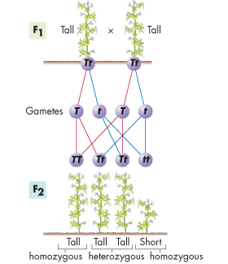

- In this example:
-There is a 50% chance that the plant the offspring will get a
“T” allele
-There is a 50% chance the plant will get a “t” allele
- Genotype = _______________________________of an organism
  - Homozygous=organisms that have two ___________alleles for a gene (BB or bb)
  - Heterozygous=organisms that have two ______________ alleles for a gene (Bb)
- Phenotype = the _________________________________________ of an organism

For each example, write the genotype and phenotype.
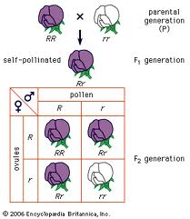
1) The Rr flower
Genotype - ___________________
Phenotype – __________________

2) The rr flower
Genotype - __________
Phenotype - ____________

- _____________________ = a diagram that uses probability to predict the possible genotype and phenotype combination in crosses
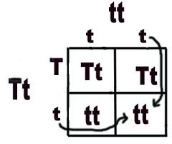
T = tall
t = small
(choose a letter from the dominant allele)

In peas, yellow seeds are dominant to green. Complete the following cross Yy x yy
- Make a key – yellow = _______
Green = _______
- Parental genotypes (if not given) yy x Yy
- Set up the punnett square
- Figure out the phenotypic and genotypic ratio
Phenotypic ratio: _________________________
Genotypic ratio: __________________________

DIHYBRID CROSS
- When there are 2 traits it is a _____________________________cross.
- Genes for different traits can segregate independently during the formation of gametes
EXAMPLE PROBLEM
Cross two plants that are heterozygous for height and pod color. Tall is dominant to short and green pods are dominant to yellow
Step 1 – Make a key and determine the parents
Tall = ________ Green = _______
Short = ________ Yellow = ________
Step 2 – Write the genotypes of the parents
_______________x _______________
Step 3 – Determine the possible allele combinations for the gametes
TtGg = ________ ________ ________ __________
Tt Gg = ________ ________ ________ __________
Step 4 – Set up the 16 square Punnett square
Step 5 – Complete the Punnett square
Step 6 – Determine the phenotypic ratio
____________________
11.3 Exceptions to Mendel’s rules
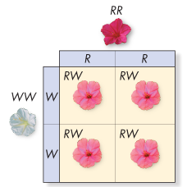
- __________dominance=one allele is not completely dominant over another
-Phenotype is a combination of the two alleles
EXAMPLE: Four o’clock flowers
R = Red
W = White
What are the genotypes of the following?
Red _____ White ______ Pink______
What are the phenotypes of the following?
RR _________ RW________ WW_______

- ________________________ = both alleles are seen in phenotype
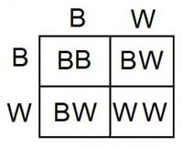
  - The phenotype shows each allele NOT a combination
Example – Some varieties of chickens
W = White
B = Black
WW = _________ BB = ___________ BW = ____________________
What is the phenotypic ratio when you cross two BW chickens?????
____________________________________________________________

- ___________alleles = there are more than ____ alleles for a trait
- Example – rabbit’s fur color, human blood types

4) _______________ = traits produced by more than one gene
- Examples – human skin color and height

-Genes provide a plan for development, but environment also plays a role in phenotype

  - Meiosis
________________________ = the process in which the number of chromosomes per cell is cut in half
  - Occurs through separation of __________________ chromosomes (matching chromosomes from a female and male parent)
  - Creates _____________________ (sex cells – sperm, eggs, pollen, etc.)
- __________________= a cell that contains both sets of homologous chromosomes (2N)
- ____________________ = a cell that contains a single set of chromosomes (N)

- Meiosis has two divisions (before meiosis 1 the cell is in interphase and replicates the chromosomes)
Meiosis 1
- __________________1
- Each chromosome matches with its holomogous chromosome (forms a tetrad)
- Crossing over occurs (chromatids cross over and exchange ends)
- __________________ 1
- Homologous chromosomes line up in the center of the cell
- __________________ 1
- Homologous chromosomes are pulled toward opposite ends of the cell by spindle fibers

- ___________________ 1
- Nuclear membrane forms around each nucleus
- Cytokinesis follows
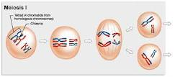
At the end of meiosis 1 there are two daughter cells
- Each has 1 set of chromosomes (is haploid)
- Chromosomes do not replicate before Meiosis II

Meiosis II
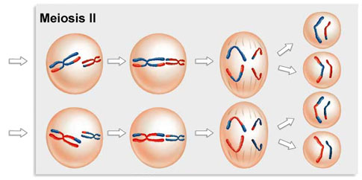
- __________________ II
- Chromosomes become visible
- __________________ II
- Chromosomes line up at the center of the cell
- __________________ II
- Chromatids separate
- __________________ II
- The nuclear membrane reforms

The result of Meiosis
- The result of meiosis is 4 haploid (N) daughter cells
- In our example each cells has 2 chromosomes (1/2 of the starting number)

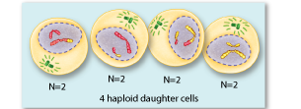
ORIGINAL CELL (______chromosomes) 4 DAUGHTER CELLS (______ chromosomes)

Gene linkage
-Alleles of different genes tend to be inherited together when those genes are located on the same chromosome (linked)
-Chromosomes assort independently
- _________________ = location of genes on a chromosome
  - Crossovers between genes that are close are rare
  - More crossing occurs with genes that are farther apart
  - Researchers looked at data to determine location of genes

