CHAPTER 12 DNA
  - The Role of DNA in Heredity
- _________________________ needed for traits and cell processes
- _______________ information needed for new cells
- ____________________ information from generation to generation

12.2 The structure of DNA
-The DNA molecule must give directions to make proteins which are needed to regulate the various functions of each cell
- What kind of structure could serve this purpose without varying from cell to cell?
- Understanding the structure of DNA has been the key to understanding how genes work.
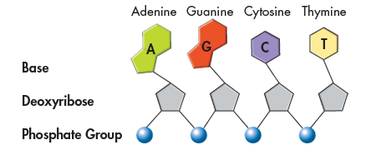
Components of DNA
- Made of ___________________ (___parts)
  - _____________ (deoxyribose)
  - __________________ group
  - __________ (nitrogenous base)
    - ____ (adenine)
    - ____ (thymine)
    - ____ (cytosine)
    - ____ (guanine)
- The nucleotides in a strand of DNA are joined by _____________ formed between the ___________ and __________________ groups.
- The bases stick out ___________________ from the nucleotide chain.
- The nucleotides can be joined together _____________________, any sequence of bases is possible

Solving the structure of DNA
- Chargaff discovered that the percent of _______________ and _______________ in DNA were the same.
- The percent of guanine and cytosine are also equal.
- The observation that [A] = [T] and [G] = [C] became known as one of “_________________________.”

- Rosalind Franklin (1950) – used____________________(aimed X-rays at DNA and looked at the scatter pattern) to find clues about the structure
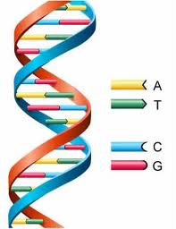
  - Showed DNA has ______ strands
  - The DNA strands are twisted around each other like a spring (helix shaped)
  - The bases are in the center

- ___________________________ – built models of DNA
  - Discovered the __________________ structure (2 strands twist around each other like staircases)
  - Explained Franklin’s and Chargaff’s earlier discoveries
  - Discovered that _____________________ bonds hold the DNA strands together
  - Weak forces that enable the DNA to __________________________

- Base pairing
  - _______________ pairs with thymine and _____________ pairs with cytosine

12.3 DNA replication
DNA replication
- Before a cell divides, it duplicates its DNA in a copying process called _____________________
- This process ensures that each resulting cell has the same complete set of DNA molecules

- How does the double helix structure of DNA make replication (copying) possible??????
- Each strand of the double helix has all the information needed to reconstruct the other half by the mechanism of base pairing.
- Because each strand can be used to make the other strand, the strands are said to be _____________

- The process of DNA Replication
- The DNA molecule ______________ into two strands and then produces two new ________________ strands following the rules of _________________________.
- Each strand of the double helix of DNA serves as a _____________, or model, for the new strand.
- The two strands of the double helix ___________________, or “unzip,” allowing two replication forks.
- New ______ are ______ following the rules of base pairing (A-T and C-G) to the newly forming strand.

- Results of DNA Replication
- Each DNA molecule has _________________ and __________________ (semi-conservative).
- The result of replication is two DNA molecules __________________ and to the _________ molecule.

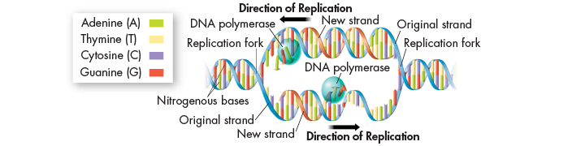
DNA Replication and enzymes
- DNA replication is carried out by enzymes. They first “unzip” a molecule of DNA by breaking the hydrogen bonds between base pairs and unwinding the two strands of the molecule
- ___________________ = enzyme that _______ individual ______________ to produce a new strand of DNA and __________________ the new strand

Telomeres
- The tips of chromosomes are known as _______________________
- Telomeres are ______________. DNA may be _________ from telomeres each time a chromosome is replicated.
- An enzyme (_________________) adds short, repeated DNA sequences to telomeres, _____________ the chromosomes and making it less likely important gene sequences will be lost during replication.

