Chapter 17 – Evolution Name ___________________________
Answer each of the following in complete sentences.
17.1-17.4
1) What 3 pieces of evidence gave early naturalists such as Alfred Wallace a clue that species could change over time. Explain each.
2) The following scientists contributed to Darwin’s thinking. List the ideas that each scientist presented. For each, tell if they are accurate or not accurate.
a. Cuvier
b. Lamarck
c. Lyell
d. Malthus
3) What is meant by the word “fitness” in biology?
4) Explain (in your own words) the theory of natural selection. Table 17.1 will be helpful.

READ 17.5-17.9 – This is a review of Earth Science from last year. You are responsible for this information on the test.

Chapter 18
18.1-18.5
1) What is the source of new alleles in a population?
2) Explain at least three ways new types of allele combinations are created.
3) Are natural populations in genetic equilibrium? Explain.
4) What is the Hardy-Weinberg equilibrium equation? What are p and q?
5) How is the Hardy-Weinberg equilibrium used in research?
6) Are each of the following directional selection, stabilizing selection, or disruptive selection?
a. Hummingbirds with long beaks are best suited to drink from long flowers
b. Black or white rabbits are better suited to live in the environment than in between gray rabbits.
c. Babies with a middle birth weight are best suited to survive
d. Label a, b, and c, below with the correct type of selection.
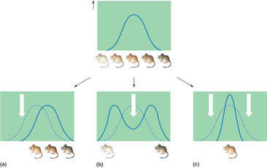

18.6-18.12

Chapter 19

