Properties of Water

Water and Life

  - Solvent: Water is a polar molecule which allows it to attract other polar water molecules allowing for its properties as a solvent.

  - Temperature: Water molecules held together through weak attractive forces allow it to absorb energy in the form of heat slowly and lose this same energy slowly. Helping maintain homeostasis.

    - Temperature = measurement of energy of molecules in motion.

  - Cohesion: molecules resist separation from one another.

- Water as a Solvent (Hydrogen Bonds):

  - Oxygen combines with hydrogen to form two covalent bonds.

  - The arrangement of the electrons as a result give hydrogen a partially positive charge and oxygen a partially negative charge.

  - Polar Molecule: water is a polar molecule because it has two partially positive hydrogen ends and one partially positive oxygen end.

  - Hydrogen bonds: a slight attraction between partially positive hydrogen and partially negative oxygen molecules.

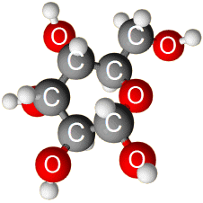
  - Hydrophilic “water loving”: molecules such as sugars form hydrogen bonds with water and thus can be dissolved and water acts as a solvent.

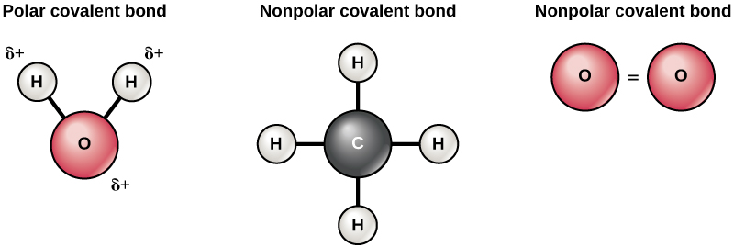
  - Hydrophobic “water dreading”: water does not form hydrogen bonds with non-polar molecules.

- Temperature:

  - Evaporation – as water molecules gain energy in the form of heat they break hydrogen bonds. This in-turn releases energy into the environment and decreases the temperature of surface water.

  - Water absorbs energy in the form of heat slowly and releases energy slowly helping to maintain homeostasis.

- Cohesion:

  - Plants use cohesion to draw columns of water up from roots to leaves.

  - Adhesion – when molecules adhere to different molecules.

  - Surface tension – hydrogen bonds between water molecules prevent the surface of water from stretching and breaking.

