Chapter 20 Notes - Viruses and Prokaryotes Name ______________________ Period _______
20-1 VIRUSES
__________= A nonliving (?) particle made of proteins, nucleic acids, and sometimes lipids (fats)
- Viruses only reproduce by ______________________
- Most viruses can only be seen with an electron microscope
- The first virus isolated was the tobacco mosaic virus in 1935

Structure of Viruses
- _____________ – protein coat surrounding the virus
- Genetic information – ___________________
- Viruses have specific proteins that bind to the host cell. Because of this they infect
_________________

_______________________ = Viruses that infect _________________

Viral Infections
- Inside living cells, viruses use their genetic information to make multiple copies of themselves. Some viruses replicate immediately (lytic infection), while others are inactive in the host (lysogenic infection).

______ Infection (ex. T4 bacteriophage) - the virus enters a cell, makes copies of itself and bursts the cell (lyse)
  - The virus injects its _______________________
  - The cell then begins to make __________________________________ (nucleic acid).
  - The viral nucleic acid and proteins are then assembled into ____________ virus particles
  - Viral proteins lyse (________________) the cell
  - New viruses can infect other cells
Lysogenic Infection - ________________________________________________________________________
_________________________________________________________________________________________
  - In each cell division the new cell is infected with the virus
  - When bacteriophage DNA is imbedded in the host’s DNA it is called a __________________
  - A trigger (heat, chemicals, radiation, etc) causes the prophage to remove itself from the host DNA and become a lytic infection.
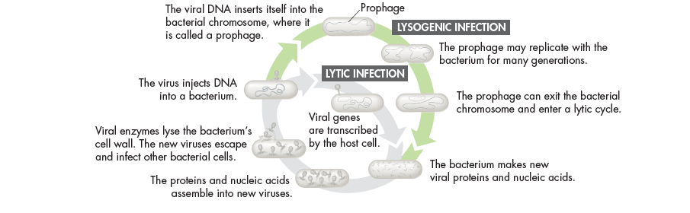
RNA Viruses
- 70% of viruses have ____________ instead of DNA
- RNA viruses cause colds, AIDS, cancer and others

The common cold
- The virus is brought in the host cell (nose, etc.)
- The host cell makes viral protein and RNA
- Within 8 hours the hose cell bursts and releases hundreds of new viruses

HIV
- HIV is a ___________________– the genetic information is copied from the RNA to DNA
- The viral DNA remains inactive for many cell divisions
- When activated, the viruses damage the host’s immune system.

VIRUSES vs. CELLS
- Viruses have many characteristics of cells
- Viruses depend on living things and therefore were not likely to be the first living organisms.
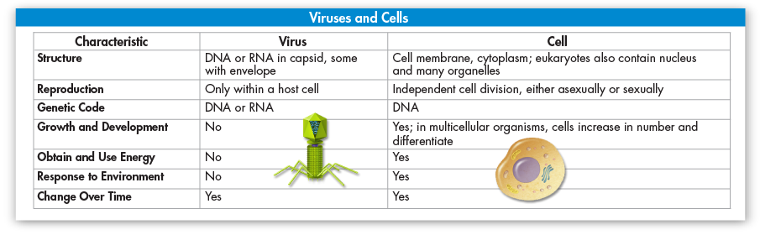

PROKAYROTES
Prokaryote –____________________________________________________ (DNA is found in the cytoplasm)
2 Domains of prokaryotes
1) ____________________
-Live almost everywhere (fresh and salt water, land, other organisms
-Have a cell wall made of peptidoglycan (sugar and amino acids)
-some have flagella and second cell membrane
2) _____________________
-DNA is more similar to eukaryotes
-many live in _______________environments (digestive tract, hot spring)

Structure and Function
- Prokaryotes vary in their size and shape, the way they move and the way the use energy
- Shapes –
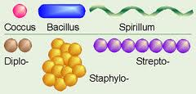
- Movement
  - Some don’t move
  - Flagella
  - Move in slime they make
- Obtaining Energy
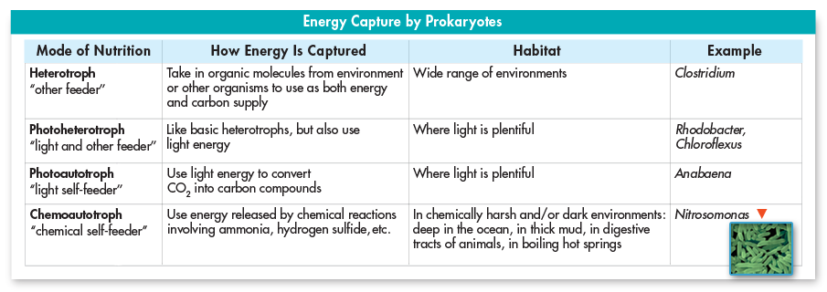
Growth and Reproduction
- Binary fission – a prokaryote replicates its DNA and divides in half, producing two identical cells
  - __________________ reproduction
  - Can occur every ________ minutes
- _________________ – a structure produced in unfavorable conditions
- A thick internal wall encloses the DNA and cytoplasm

How do prokaryotes evolve?
- Mutation – ________________________________
-passed on to _______________________
-one of the main way prokaryotes evolve
- Conjugation – ____________________________________________________________________
_________________________________________________________________________________
-increases genetic diversity
-many times a gene that enables the bacteria to live in a new environment is transferred in form of a __________________ (circular piece of DNA)

The Importance of Prokaryotes
- ______________________ – assist in breaking down dead organisms
- __________________ – food chains are dependent on bacteria for producing food
  - 1 cyanobacterium (Prochlorococcus) is the most abundant photosynthetic organism – makes over ½ of food in the open ocean
- _______________ Fixers – converts nitrogen into a form plants use (N2 to NH3)
  - 90% of the nitrogen organisms use comes from fixation
- Human Uses of Prokaryotes
  - Production of Food – yogurt, cheese, vinegar
  - Clean oil spills
  - Remove human waste and poison from water
  - Medicine – synthesize drugs – insulin, human growth hormone
  - Digestion

  - Disease
Bacterial Diseases
- __________________________ = a virus or bacteria that causes disease
- Bacteria cause disease by
- _________________________ directly of cause tissue damage when they provoke an immune response from the host
    - Tuberculosis (TB) is inhaled into the lungs and the immune response destroys tissue
- ______________________ that upset the normal activities of the host
    - Botulism – food poisoning
    - tetanus – causes lockjaw, muscle spasms

Bacterial Diseases
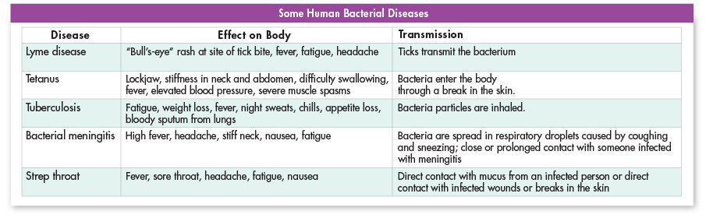
Controlling Bacteria
- ___________________ – hand washing removes bacteria
- ____________________ - chemicals that kill bacteria
- _____________________ – refrigeration/freezing slows the growth
- ____________________ – boiling, frying, steaming kills bacteria
- Sterilization _______________ – kills bacteria
- ________________ – a preparation of weakened or killed pathogen or inactivated toxin
-The vaccine stimulates the body to produce immunity to a specific disease
- __________________– block the growth and reproduction of bacteria
  - Disrupt proteins or cell processes specific to bacterial cells
  - Do not harm host’s cells

Viral Diseases
Viruses also cause disease by
- _____________________ cells directly
2) interrupting cellular processes
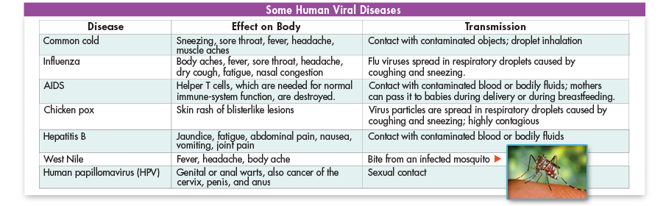
Prevention and Treatment for viral diseases
  - _____________________
- ________________________
-wash hands
-avoid sick people
-cough into a tissue or sleeve
  - ______________________DO NOT WORK for viral infections
- There are a handful of antiviral drugs - they speed recovery from flu/may reduce spread of HIV

Emerging Diseases
  - ________________________ = an unknown disease that appears in a population for the first time or a well-known disease that has become harder to control
  - Pathogens that cause emerging diseases are threatening because humans have little or no resistance for them and control methods have not been developed
  - Human populations once isolated are now connected –quick spread of disease

Superbugs
  - Use of antibiotics has lead to bacteria that are resistant to antibiotics
  - Penicillin killed many infections in the 1940s when it was introduced. Now is has lost effectiveness
  - Bacteria that are resistant to penicillin reproduce and pass resistance on through conjugation
  - MRSA – skin infection spread by close contact

New Viruses
  - Genetic makeup of viruses changes quickly and allows a virus to jump form one species to another.
    - AIDS may have jumped from nonhuman primates
    - “Bird flu” is a concern because it may jump to humans and is similar to some of the most deadly human versions of the flu

Prions
  - ___________________ – protein particle that causes disease
    - misfolded proteins in the brain that cause a chain reaction of misfolding in other normal proteins they contact, clogging the brain tissue and causing disease.
Sheep – scrapies
Cow – mad cow

