Name: _____________________________________________ Date: ____________________________

AP Biology Exam Review: Biochemistry

Helpful Videos and Animations:

- Bozeman Biology: Biological Molecules

- Bozeman Biology: Nucleic Acids
- Bozeman Biology: Lipids
- Bozeman Biology: Carbohydrates
- Bozeman Biology: Proteins
- Bozeman Biology: Polymers
- Bozeman Biology: Gibbs Free Energy

- Bozeman Biology: Life Requires Free Energy

- Bozeman Biology: Coupled Reactions
- Bozeman Biology: Enzymes

Topic Outline

Relevant Objectives:
  - Be able to state the difference between a monomer and a polymer

  - Be able to name the four main classes of macromolecules and the monomers that compose them

  - Describe dehydration synthesis and hydrolysis reactions
  - Explain the properties of water and why they are essential to life
  - Describe the steps of protein folding
  - Explain the difference between polar and non polar molecules
  - Know and explain the steps of the scientific method
- Know the components of a valid experiment

- Explain the function of an enzyme and describe how an enzyme works

- Explain factors influencing enzyme activity ([Substrate], [Enzyme], pH, temperature, [Ion], and describe how these factors influence activity

- Be able to determine the rate of an enzyme catalyzed reaction from a graph or data table and compare and contrast rates
- Explain how activators and inhibitors effect enzyme activity

- Differentiate between different types of inhibitors - competitive, non-competitive, irreversible

- Bonds: Ionic, Covalent (Polar vs. Nonpolar), Hydrogen; know the relative strengths of each bond and where they are used in nature

- Molecules and atoms from the environment are necessary to build new molecules
  - C,H,N,O,P, and S are the most common elements in living organisms

  - Carbon (know where it is found in the four macromolecules and how it cycles between the environment and living organisms via the Carbon Cycle)

  - Nitrogen (know where it is found in proteins and nucleic acids and how it cycles between the environment and living organisms via the Nitrogen Cycle)

  - Phosphorus (know where it is found in lipids and nucleic acids and how it cycles between he environment and living organisms via the Phosphorus Cycle)

  - Know where/how carbon, hydrogen, nitrogen, oxygen, phosphorus, and sulfur are used in the macromolecules

- The Properties of Water (all come from water’s polarity and its ability to form hydrogen bonds ; understand how the structure of the water molecule is related to its function)

  - Excellent solvent (know how water dissolves polar and ionic compounds → we have water-based cellular fluids)

  - Cohesion and adhesion → transpiration in plants

  - Less dense as a solid → prevents ponds and lakes from freezing solid

  - High Heat Capacity / Specific Heat → evaporative cooling (sweating) in animals ; moderates air temperatures near large bodies of water

- pH: acid-base/ 0-14, # of H+ ions determines scale; logarithmic- pH 3 = 10⁻³ = 1/1000 (concentrationof H+ ions)…blood- 7.4, stomach- 2, small intestine- 8; enzymes are specific to pH

- Reactions of Life

  - Dehydration Synthesis (releases water; used to create polymers connected by covalent bonds; anabolic; endergonic)

  - Hydrolysis (uses water; used to break polymers into monomers by breaking covalent bonds; catabolic; exergonic)

- Macromolecules
  - Carbohydrates
- CHO 1:2:1 ratio
- Monomers = monosaccharides (know the basic structure and examples)
- Dimers = disaccharides (know the basic structure, how they form, and examples)

  - Polymers = polysaccharides (know the basic structure, how they form, and the following examples – cellulose, starch, chitin, and glycogen)

- Lipids
  - C, H, O (not a 1:2:1 ratio) *P only in phospholipids
- Basic structure (fatty acid chains and a polar region)

- Degree of saturation of fatty acid chains (# of H’s linked to carbons, which is inversely related to the number of hydrogen bonds) → unsaturated fatty acid chains with kinks (liquid at room
temperature) vs. saturated straight fatty acid chains (solid at room temperature)
- Phospholipids make up cell membranes (double layer) and are amphipathic- hydrophilic and

hydrophobic

  - Functions = cell membrane (phospholipids), energy storage (fats, oils), steroid hormones like testosterone and estrogen (variations on a cholesterol 5-ring lipid), insulation, myelin sheath of neurons
- Proteins
  - C, H, O, N (may have other elements like S in R group)

- Monomers = amino acids (know the basic structure ; the 20 different amino acids only differ in their R groups)

- Parts of amino acid= carboxyl group (COOH) on one end, amino group on the other end (NH2), central carbon and variable R group (can be hydrophobic or hydrophilic) which determines

chemical properties.

- Protein Folding- shape determines function; primary structure = amino acid chain; secondary = beta pleated sheet or alpha helix (hydrogen bonds between non-adjacent carboxyl and amino groups); tertiary = globular; folds in on itself (disulfide bridges, hydrogen bonds, hydrophobic interactions; ionic bonding between R groups); quartenary = more than one polypeptide.
  - Many functions: enzymes (ex: amylase), structure (ex: keratin), transport (ex: hemoglobin),
signaling (ex: oxytocin hormone), protein carriers in cell membrane, antibodies

- Nucleic Acids
  - C,H,O,N, and P
- Monomers = nucleotides (know the basic structure; made of nitrogenous bases, phosphate groups,

and deoxyribose sugars)
- Polymers = DNA and RNA
- Nucleotide made up of sugar, phosphate and base

- DNA is double stranded, has deoxyribose, A, G, C, T o RNA is single stranded, has ribose, A, G, C, U

o mRNA- copies genetic message; rRNA- attaches mRNA and makes up ribosomes (most common);tRNA- carries amino acids; DNA- carries genetic code
o Function: storage and transmission of genetic information

- Enzymes

  - Biological catalysts (made of protein) that speed up rate of chemical reactions by lowering activation energy required for reaction to occur

  - Enzyme has active site (exposed R groups) where reaction occurs
  - Enzymes can break down substance (catabolic reaction) or build up substances (anabolic)
  - Enzyme/substrate complex is formed
  - Substrate is what enzyme acts on
  - Rate is determined by collisions between substrate and enzyme
  - Ends in –ase, named after substrate often

  - Enzyme is specific to substrate; the substrate must be complementary to the surface properties (shape and charge) of the active site (which is made up of R groups with specific chemistry, i.e. hydrophobic).

  - Enzyme rate is affected by:

- pH (optimal for each enzyme),
- temperature (optimal for each enzyme but in general increased temp means increased collisions

so rate goes up initially; too much heat can denature enzyme), enzyme concentration (more enzyme faster rate or vice versa)
  - substrate concentration (more substrate = faster rate, until the point of enzyme saturation)

- Know the difference between an endergonic and exergonic reaction and be able to analyze their reaction curves ; be able to explain energy coupling and provide examples

- Inhibition-competitive inhibition (something competes for active site; can be overcome with more substrate)

- Non-competitive inhibition- attaches at allosteric site and changes shape of enzyme so it is not functional; can not be overcome with more substrate

- Coenzymes (organic; NAD and vitamin B etc.) and cofactors (inorganic; zinc, magnesium etc.) interact with enzymes to put them into the right structure to do work.

Practice Multiple Choice Questions:

- Which of the following is not a property of carbon?

  - Carbon-to-carbon bonds are limited to single bonds.
  - Carbon has four valence electrons.
  - Carbon can form bonds to various other atoms.
  - Carbon-to-carbon bonds are strong.

2. Carbohydrate molecules:
- serve as structural components of human cell walls.
- form the regulatory compounds known as enzymes.
- are a source of energy.
- help protect vital organs from damage.
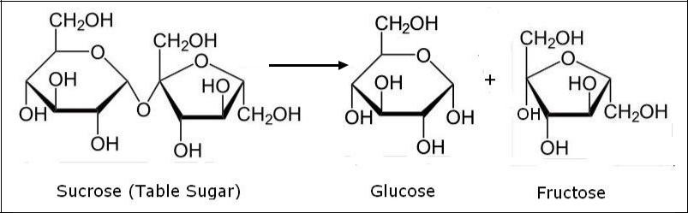

Enzyme

3. The process illustrated in the figure above is called:

- condensation.
- protein synthesis.
- hydrolysis.

- denaturation.

4. The products of the process in the figure above are:
- monosaccharides.
- molecules of glycerol.
- representative of a glycoside linkage.
- enzymes.

5. In which of the following reactions must the equivalent of a water molecule be added in order to break a bond?
- fatty acids + glycerol → fat

- glucose + fructose → sucrose
- glycogen → glucose
- alanine + glycine → dipeptide

6. Which of the following illustrates hydrolysis?

- the reaction of two monosaccharides to form a disaccharide
- the reaction of two amino acids to form a dipeptide
- the reaction of a hydrogen atom and a hydroxide ion to form water
- the reaction of a fat to form glycerol and fatty acids

7. A molecule of a saturated triacylglycerol (aka triglyceride) contains:
- the maximum number of double bonds between carbons in the fatty acid chains.
- the maximum number of triple bonds between carbons in the fatty acid chains.
- the maximum number of hydrogen atoms in the fatty acid chains.
- alternating single and double bonds between carbons in the fatty acid chains.

8. In the figure below, ionic attractions would form between the R groups of which amino acids?
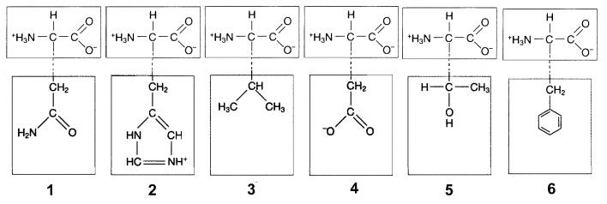
- 1 and 3
- 2 and 4

- 3 and 5
- None of the above.

9. Which of the following is responsible for the alpha-helical structure of proteins?
- hydrophobic interactions
- nonpolar covalent bonds
- ionic interactions
- hydrogen bonds

10. At which level of protein structure are peptide bonds most important?
- primary
- secondary
- quaternary
- globular
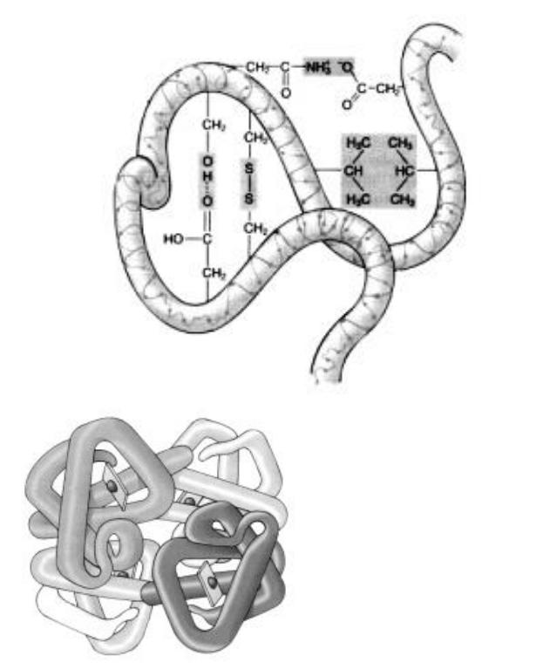

- All of the following types of chemical bonds are responsible for maintaining the tertiary structure of this polypeptide except:

  - ionic bonds.
  - peptide bonds.

  - hydrophobic interactions.
  - disulfide bonds.

- If the differently shaded portions of this molecule represent different polypeptide chains, then this figure is representative of:

  - an amino acid.
  - The primary structure of a protein
  - The secondary structure of a protein
  - The quaternary structure of a protein

- Analysis of a certain complex compound shows that it contains phosphate groups, ribose groups, and pyrimidines. Based on this information, which of the following is the best description of this compound?

- It is most likely ribonucleic acid.
- It is DNA.
- It is an inorganic compound.
- It contains thymine.

14. Which monomer is incorrectly matched with the corresponding polymer?
  - Amino acids are used to build proteins.
  - Monosaccharides are used to build polysaccharides.
  - Fatty acids are used to build nucleic acids.
  - Glucose molecules are used to build starches.

- Which characteristic of water molecules directly contributes to the remarkable "water walking" success of the aquatic insects pictured in the accompanying figure?
  - hydrogen bonds

  - capillary action
  - nonpolar covalent bonds
  - ionic bonds
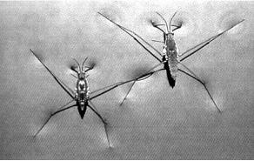

- A stalk of celery is placed in a solution of blue colored dye. After one hour, the leaves have blue fluid in their veins. Which property of water is being demonstrated?
  - adhesion and cohesion
  - evaporation and cooling
  - lower density as a solid than as a liquid
  - high specific heat

- Which of the following pairs of functional groups characterizes the structure of an amino acid?
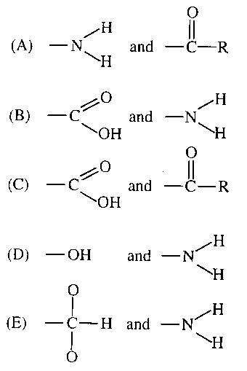

- A feature of organic compounds NOT found in inorganic compounds is the presence of a. ionizing chemical groups
b. electrons

c. carbon atoms covalently bonded to each other d. oxygen

- The carbon that makes up organic molecules in plants is derived directly from a. combustion of fuels

b. carbon fixed in photosynthesis

c. carbon dioxide produced in respiration d. carbon in the lithosphere

- Which of the following is responsible for the cohesive property of water?

a. Hydrogen bonds between the oxygen atoms of two adjacent water molecules b. Covalent bonds between the hydrogen atoms of two adjacent water molecules

c. Hydrogen bonds between the oxygen atom of one water molecule and a hydrogen atom of another water molecule d. Covalent bonds between the oxygen atom of one water molecule and a hydrogen atom of another water molecule

Write the letter or letters that correspond to the picture that matches with each description
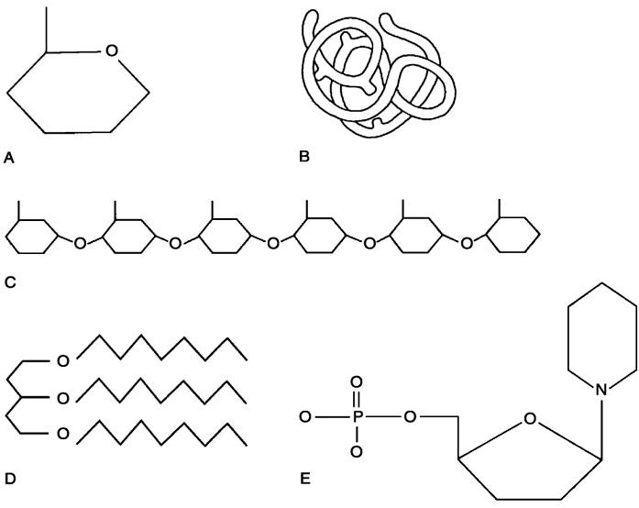
- Lipid.
- Functional protein.

- Nucleotide.
- Polysaccharide.
- Monosaccharide.
- Polymer
- Tertiary (protein) structure

- The figure below shows the calories of heat energy required to convert a gram of water from solid to liquid state, and then again from liquid to a gaseous state. Especially distinctive is the large increase in energy required to move water from liquid to gas form.
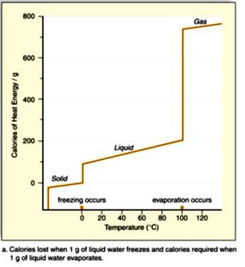

This graph predicts which of the following properties of water that would affect plant survival?

a. Plant leaves doing transpiration are cooled down on hot days.

b. Inside a plant stem, cohesion attracts one water molecule to the water molecule above it, allowing a “chain” of water molecules to move up the stem.

c. At a plant’s roots, adhesion attracts water molecules to “stick” to root hairs, aiding absorption.

d. Sugar will dissolve in water, leading to a plant fluid called phloem, which typically flows from the leaves, down towards the roots.

- Air that is dry changes temperature quickly, while air that is moist retains its temperature. What property allows for this regulation of temperature?

a. The heat of fusion in of the nitrogen in the air, due to the free electrons.

b. The high electric potential of the air, which results from the static charges of the molecules in dry conditions.

c. The green house effect, due to the increase in carbon dioxide in the atomosphere.

d. The high specific heat of water, which results from the polarity and hydrogen bonding.

- Which of the following is an example of a hydrogen bond? a. The peptide bond between amino acids in a protein

b. The bond between an oxygen atom and a hydrogen in the carboxyl group of a fatty acid.

c. The attraction between a hydrogen of one water molecule and the oxygen of another water molecule. d. The bond between carbon and hydrogen in methane

Questions 31-34 Choose an item from the list below that is best associated with the following statements.

  - Cholesterol
  - Triglyceride
  - Phospholipid
  - Protein

- The major component of the fluid bilayer of a plasma membrane
- Carrier molecule in the plasma membrane
- Steroid affecting the fluidity of the plasma membrane
- ATP synthase (synthetase) in the inner mitochondrial and chloroplast membrane

- Which of the following best characterizes the reaction represented below
A + B + energy → AB

- hydrolysis
- catabolism
- oxidation-reduction
- exergonic reaction
- endergonic reaction

- Which of the following can be used to determine the rate of enzyme-catalyzed reactions a. rate of disappearance of the enzyme

b. rate of disappearance of the substrate c. rate of disappearance of the product d. change in volume of the solution
e. increase in activation energy

Practice Long Response Questions: Make an outline of the information you would include in each of these essays.

- Water is important for all living organisms. The functions of water are directly related to its physical properties.

a. Describe how the properties of water contribute to TWO of the following
  - transpiration
  - thermoregulation in endotherms
  - plasma membrane structure

b. Water serves as a reactant and a product in the carbon cycle. Discuss the role of water in the carbon cycle.

c. Discuss the impact of one human activity on the water cycle.

- The physical form of cells and organisms is often influenced by special structural polymers. For the polymers below, describe the structure and role of each in a cell or organism.

Polymers: messenger RNA & transfer RNA

- Proteins — large complex molecules — are building blocks of all living organisms. Discuss the following in relation to proteins.

a. the chemical composition and levels of structure of proteins b. the roles of DNA and RNA in protein synthesis
c. the roles of proteins in membrane structure and transport of molecules across the membrane

4. The effects of pH and temperature were studied for an enzyme-catalyzed reaction. The following results were obtained.
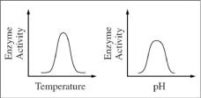

a. How do (1) temperature and (2) pH affect the activity of this enzyme? In your answer, include a discussion of the relationship between the structure and the function of this enzyme, as well as a discussion of how structure and function of enzymes are affected by temperature and pH.

b. Describe a controlled experiment that could have produced the data shown for either temperature or pH. Be sure to state the hypothesis that was tested here.

- The physical structure of a protein often reflects and affects its function. a. Discuss how the structure of a protein affects:
  - regulation of enzyme activity
  - cell signaling

b. Abnormal hemoglobin is the identifying characteristic of sickle cell anemia. Explain the genetic basis of abnormal hemoglobin. Explain why the sickle cell allele is selected for in certain areas of the world.

Thinking Practice Questions:

- If the following molecules were to undergo a dehydration synthesis reaction, what molecules would result? Circle the parts of each amino acid that will interact and draw the resulting molecule.
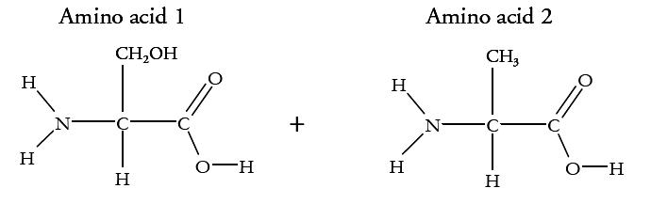

- Identify which of the six main elements (CHNOPS) are found in each of the four macromolecules (carbohydrates, lipids, proteins, and nucleic acids).

- Describe the relationship between substrate concentration and reaction rate shown in the graph and propose an explanation for it.

- DNA polymerase from T. aquaticus (Taq) is used in PCR (polymerase chain reaction). PCR is a technique where millions of copies of DNA can be made from one original copy. In this method, the target DNA molecule is subjected to temperatures over 95 °C to make the double-stranded DNA separate. The temperature is then lowered slightly to allow primers to anneal before the Taq polymerase catalyzes the reactions to incorporate new nucleotides into the complementary strands. The cycle is then repeated over and over until there are millions of copies of the target DNA.

  - Predict why this bacterial polymerase is used instead of a human polymerase.
  - What would happen if you used a human polymerase in a series of PCR reactions?
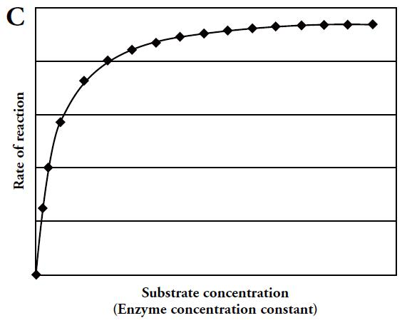

Name: _____________________________________________ |  |  |  |  |  |  | Date: ____________________________
 |  |  | AP Biology Exam Review: Cell Structure, Communication, and Division
 | Helpful Videos and Animations: |  |  |  | Relevant Objectives:
 |  |  |  |  | 9. Explain why cells are so small
 | 1. | Bozeman Biology: Cell Membranes |  | 10. |  | Relate surface area to volume ratio to cell size
 | 2. | Bozeman Biology: Transport Across |  | 11. |  | Know the organelles of a cell and their functions
 |  | Cell Membranes |  | 12. |  | Explain the fluid-mosaic model of a cell membrane
 | 3. | Bozeman Biology: |  | 13. |  | Explain the difference between passive and active transport
 |  | Compartmentalization |  | 14. |  | Define hypertonic, hypotonic, and isotonic
 | 4. | Bozeman Biology: Cellular |  | 15. |  | Make predictions about what will happen to cells in certain
 |  | Organelles |  |  | solutions due to diffusion
 | 5. | Bozeman Biology: Cell |  | 16. |  | Explain how cells communicate over long and short distances
 |  | Communication |  | 17. |  | Explain how cells receive signals (2 ways)
 | 6. | Bozeman Biology: Signal |  | 18. |  | Explain the advantages of signal transduction pathways (2)
 |  | Transduction Pathways |  | 19. |  | Know the phases of the cell cycle
 | 7. | Bozeman Biology: Signal |  | 20. |  | Know the phases of mitosis in depth
 |  | Transmission and Gene Expression |  | 21. |  | Explain how cells influence each-other in the cell cycle
 | 8. | Bozeman Biology: Effects of |  | 22. |  | Explain what happens when there is an error in the cell cycle
 |  | Changes in Pathways |  | 23. |  | Know approximately how long a cell spends in each phase of the
 | 9. | Bozeman Biology: Evolutionary |  |  | cell cycle, and why
 |  | Significance of Cell Communication |  | 24. |  | Know the steps of meiosis and what happens in each
 | 10. | Bozeman Biology: The Cell Cycle, |  | 25. |  | Explain how meiosis reduces the chromosome number by half, and
 |  | Mitosis, and Meiosis |  |  | why this is essential to sexual reproduction
 |  |  |  | 26. |  | Explain how meiosis produces genetic variability (3 ways)
 |  |  |  | 99. |  | Explain how water potential effects the movement of water

Topic Outline:

- Structure of the Cell Membrane (understand the fluid mosaic model and identify the structure and function of molecules found within it – phospholipids, integral proteins, peripheral proteins, glycolipids, and glycoproteins)

- Semi/Selective Permeability – which molecules can move through the phospholipid bilayer and which molecules must move with the help of a transport protein?

- Passive Transport vs. Active Transport – up vs. down concentration gradient, use of energy?

- Types of Passive Transport
  - Simple Diffusion

  - Facilitated Diffusion using channel or carrier proteins (what is the difference between these two types transport proteins?)

  - Osmosis (hypertonic, hypotonic, isotonic) – be able to predict the movement of water across a semi-permeable membrane based on solute OR water concentration (Hint: you must know how to analyze a

“U-tube” problem) and water potential

  - Associated Vocabulary: lysis (animal cells), flaccid (plant cell), plasmolyzed (plant cell), turgid / turgo pressure (plant cell)

- Types of Active Transport
  - Protein pumps (know how the sodium (Na+) / potassium (K+) pump works!)
  - Co-transport
  - Bulk Transport: Exocytosis vs. Endocytosis

- Importance of having a large membrane surface area → efficient transport of materials into and out of the cell (Note: this is why cells of the small intestine—an organ used for absorption—have many membrane folds called microvilli or why the mitochondria has many folds)

- Be able to perform cell surface area to volume ratio calculations to compare the efficiency of membrane transport in cells of various shapes and sizes

- The Difference between Prokaryotic and Eukaryotic Cells (organelles present, size, organization of DNA, etc.)

- Structures and Functions of Eukaryotic Organelles (make sure you understand how the structure and molecular composition of each cell part gives it its unique functions)
  - Nucleus (with nuclear membrane, nuclear pores, nucleolus, and chromatin)
  - Ribosomes (free vs. bound… what kinds of proteins does each type create?)
  - Endoplasmic Reticulum (smooth vs. rough)
  - Golgi Apparatus
  - Vacuoles (compare plant vs. animal vacuoles)
  - Mitochondria
  - Chloroplasts
  - Cytoskeleton
  - Centrosomes + Centrioles
  - Cilia and Flagella
  - Extracellular Matrix

  - Intercellular Junctions: three types in animal cells (tight junctions, desmosomes, and gap junctions); one type in plant cells (plasmodesmata)

- Identify which organelles are found in plant vs. animal cells and identify each in an image

- Describe the function of the endomembrane system in protein synthesis and secretion (be able to list / sequence all structures and processes involved)

- The Cell Cycle

  - Reason for division- as cells increase in volume, the surface area decreases and demand for material resources increases which limits cell size

  - Smaller cells have a more favorable surface area-to-volume ratio for exchange of materials with the environment (diffusion, etc.). High SA:V ratio is favorable. Ex. 6:1 is better than 6:5

  - Mitosis = creation of new body cells (somatic cells) with 46 chromosomes each (diploid cells/2n = two sets of chromosomes

  - Organization of DNA in eukaryotic cells = multiple linear chromosomes vs. organization of DNA in prokaryotic cells = single circular chromosome

  - Interphase (normal life of the cell, 90% of cell’s life)… : growth (G1), synthesis of DNA (S) and preparation for mitosis (G2); G0 is when a cell exits the cell cycle for a period of time – can still perform life processes

  - Be able to describe the events that take place in the following steps of mitosis: prophase, prometaphase, metaphase, anaphase and telophase (+ cytokinesis, division of the cytoplasm by a cleavage furrow in animals or cell plate in plants)

  - Be able to explain how/why eukaryotic cell division is different from binary fission

  - Vocabulary: chromosome, sister chromatids, centromere, nuclear envelope, mitotic spindle, microtubules, kinetochore, centrioles / centrosome, metaphase plate, cleavage furrow, cell plate

- Meiosis

  - Cell division to create gametes (sex cells) with half the number of chromosomes (23) of a somatic cell (haploid cell/n = one set of chromosomes)

  - Understand the difference between sexual vs. asexual reproduction

  - There are 23 pairs of homologous chromosomes in a body cell (what are homologous chromosomes?) that divide during meiosis

  - 22 pairs are autosomes and 1 pair consists of sex chromosomes (XX for females and XY for males)
  - Fertilization = the fusion of haploid gametes (egg + sperm) to create a diploid zygote
  - Meiosis includes two rounds of division to produce four daughter cells

  - Be able to explain how Meiosis I is different from Meiosis II and describe what occurs in each of the stages of meiosis: Prophase I, Metaphase I, Anaphase I, Telophase I / Cytokinesis, Prophase II, Metaphase II, Anaphase II, Telophase II / Cytokinesis

  - During meiosis, homologous chromosomes are paired (one from mom and one from dad) and line up in the center of the cell randomly. The homologues are pulled apart and separated in meiosis I. A second division occurs in which the duplicated chromosomes are pulled apart.

  - Variation occurs in gametes during crossing over; during random fertilization, because of separation of alleles (leading to new combinations during fertilization (law of segregation); because of all the possible combinations of homologous chromosomes aligning during metaphase I (law of independent assortment)

- Control of the Cell Cycle
  - There are internal checkpoints that tell the cell to continue dividing or stop dividing

  - Major checkpoints = G1 phase checkpoint (after G1 phase), G2 phase checkpoint, and M phase checkpoint

  - If the cell does not receive the “go ahead” signal at the G1 checkpoint, it enters the “G0 phase,” a state of semi-dormancy where no cell division is occurring (ex: mature nerve cells)

  - Example: if cyclin molecules bind to Cdk molecules (cyclin dependent kinases), they produce MPF (mitosis/maturation promoting factor,) enough MPF can allow the cell to pass the G2 checkpoint and enter mitosis. To bring mitosis to a close, MPF switches itself off by starting a process that degrades cyclin

  - If checkpoints are normal, cells will show density-dependent inhibition (stop dividing when they are crowded) and anchorage dependency (must be attached to a substrate to divide)

  - If cells divide too frequently, they will not show density-dependent inhibition or anchorage dependency
    - tumors (know the difference between benign and malignant tumors and be able to define metastasis)

- There are three main steps in cell signaling
  - Reception (target cell’s detection of a signal molecule)
  - Transduction (conversion of the signal to a form that can bring about a particular cell response)
  - Response (the specific cellular response to the signal molecule)

- Reception
  - Ligand (signal molecule) binds to receptor

      - Intracellular receptors (for hydrophobic molecules like steroids that can pass through the cell membrane)

      - Plasma membrane receptors (for hydrophilic molecules that cannot pass through the cell membrane)
Ex: G protein coupled receptor or receptor tyrosine kinase (see notes to recall how these work)

- Transduction

  - Transduction involves amplifying the signal (making it stronger) and converting it to a form the cell can respond to

      - Second messengers (ex: calcium ions – Ca2+ -- or cyclic AMP) carry the signal from the receptor and may be used to activate protein kinases or other key molecules in the transduction process. Second messengers amplify the signal because multiple second messengers are created from one ligand received and these second messengers can activate multiple kinases

      - Phosphorylation cascade (protein kinases activate molecules by adding a phosphate group, these molecules then activate other molecules, and ultimately you activate a molecule that causes the specific cell response)

- Response

  - Regulating Synthesis of Proteins: Transduction may activate transcription factors that initiate transcription of particular genes in the nucleus (by enabling the binding of RNA polymerase to start creating mRNA from DNA)

  - Regulating Activity of Proteins: ex: In the epiphrine pathway in liver cells that initiates breakdown of glycogen to produce blood glucose to fuel the fight or flight response, protein kinases activate the enzyme phosphorylase, which chops apart glycogen

Practice Multiple Choice Questions:

- Celery stalks that are immersed in fresh water for several hours become stiff and hard. Similar stalks left in a 0.15 M salt solution become limp and soft. From this we can deduce that the cells of the celery stalks are

- hypotonic to both fresh water and the salt solution.
- hypertonic to both fresh water and the salt solution.
- hypertonic to fresh water but hypotonic to the salt solution.
- hypotonic to fresh water but hypertonic to the salt solution.
- isotonic with fresh water but hypotonic to the salt solution.

- Mammalian blood contains the equivalent of 0.15 M NaCl. Seawater contains the equivalent of 0.45 M NaCl. What will happen if red blood cells are transferred to seawater?
- Water will leave the cells, causing them to shrivel and collapse.
- NaCl will be exported from the red blood cells by facilitated diffusion.
- The blood cells will take up water, swell, and eventually burst.
- NaCl will passively diffuse into the red blood cells.
- The blood cells will expend ATP for active transport of NaCl into the cytoplasm.

The solutions in the arms of a U-tube are separated at the bottom of the tube by a selectively permeable membrane. The membrane is permeable to sodium chloride and water but not to glucose. Side A is filled with a solution of 0.4 M glucose and 0.5 M sodium chloride (NaCl), and side B is filled with a solution containing 0.8 M glucose and 0.4 M sodium chloride. Initially, the volume in both arms is the same. Refer to the figure to answer the following questions.
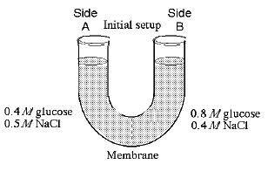

3. At the beginning of the experiment,

- side A is hypertonic to side B.
- side A is hypotonic to side B.
- side A is isotonic to side B.
- side A is hypertonic to side B with respect to glucose.
- side A is hypotonic to side B with respect to sodium chloride.

4. If you examine side A after three days, you should find

- a decrease in the concentration of NaCl and glucose and an increase in the water level.

- a decrease in the concentration of NaCl, an increase in water level, and no change in the concentration of glucose.

- no net change in the system.

- a decrease in the concentration of NaCl and a decrease in the water level.

- no change in the concentration of NaCl and glucose and an increase in the water level.

- A patient has had a serious accident and lost a lot of blood. In an attempt to replenish body fluids, distilled water–equal to the volume of blood lost–is transferred directly into one of his veins. What will be the most probable result of this transfusion?

- It will have no unfavorable effect as long as the water is free of viruses and bacteria.

- The patient's red blood cells will shrivel up because the blood fluid has become hypotonic compared to the cells.

- The patient's red blood cells will swell because the blood fluid has become hypotonic compared to the cells.

- The patient's red blood cells will shrivel up because the blood fluid has become hypertonic compared to the cells.

- The patient's red blood cells will burst because the blood fluid has become hypertonic compared to the cells.

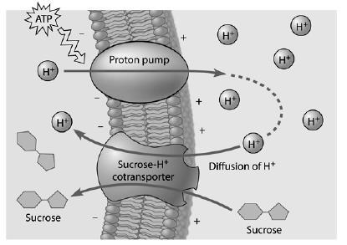
- Based on the figure to the right, which of these experimental treatments would increase the rate of sucrose transport into the cell?

- decreasing extracellular sucrose concentration
- decreasing extracellular pH
- decreasing cytoplasmic pH
- adding an inhibitor that blocks the regeneration of ATP

- adding a substance that makes the membrane more permeable to hydrogen ions

Read the following information and refer to the graph below to answer the following question.

Five dialysis bags, constructed from a semi-permeable membrane that is impermeable to sucrose, were filled with various concentrations of sucrose and then placed in separate beakers containing an initial concentration of 0.6 M sucrose solution. At 10-minute intervals, the bags were massed (weighed) and the percent change in mass of each bag was graphed.
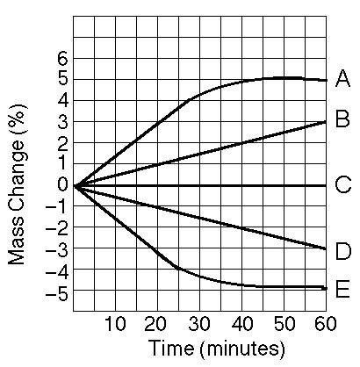

- Which line represents the bag that contained a solution isotonic to the 0.6 molar solution at the beginning of the experiment?

- Cells of the pancreas will incorporate radioactively labeled amino acids into proteins. This "tagging" of newly synthesized proteins enables a researcher to track their location. In this case, we are tracking an enzyme secreted by pancreatic cells. What is its most likely pathway?
- ER → Golgi → nucleus

- Golgi → ER → lysosome

- nucleus → ER → Golgi
- ER → Golgi → vesicles that fuse with plasma membrane
- ER → lysosomes → vesicles that fuse with plasma membrane

- Which of the following is one of the ways that the membranes of winter wheat are able to remain fluid when it is extremely cold?
- by increasing the percentage of unsaturated phospholipids in the membrane
- by increasing the percentage of cholesterol molecules in the membrane
- by decreasing the number of hydrophobic proteins in the membrane
- by co-transport of glucose and hydrogen

- by using active transport

- Tay–Sachs disease is a human genetic abnormality that results in cells accumulating and becoming clogged with very large, complex, and undigested lipids. Which cellular organelle must be involved in this condition?

- the endoplasmic reticulum
- the Golgi apparatus
- the lysosome
- mitochondrion
- membrane–bound ribosomes

- A cell has the following molecules and structures: enzymes, DNA, ribosomes, plasma membrane, and mitochondria. It could be from:
a. A bacterium.

b. An animal, but not a plant. c. A plant, but not an animal. d. A plant or an animal.

e. Any kind of organism.

- In a plant cell, DNA may be found
a. only in the nucleus.
b. only in the nucleus and mitochondria.

c. only in the nucleus and chloroplasts.
d. in the nucleus, mitochondria, and chloroplasts.

- All of the following are part of a prokaryotic cell except a. DNA.

b. a cell wall.

c. a plasma membrane. d. ribosomes.
e. an endoplasmic reticulum.

- A gland cell capable of producing large quantities of a protein hormone would have well-developed: a. Cilia.

b. Centrioles.

c. Rough Endoplasmic Reticulum. d. Smooth Endoplasmic Reticulum

- A toxin that destroys adenylyl cyclase, the enzyme responsible for creating cyclic AMP—a second messenger molecule in the cell – is injected into a cell. What will be the final effect on the signaling pathway?
a. The initial messenger molecule (ex: epinephrine) will be unable to bind to its plasma membrane receptor.

b. The initial messenger molecule (ex: epinephrine) will bind more easily to the plasma membrane receptor. c. The transduction step will be inhibited, resulting in a smaller response.
d. The transduction step will be more efficient, resulting in a larger response.

- If ATP is not present in the cell pictured to the right, what would
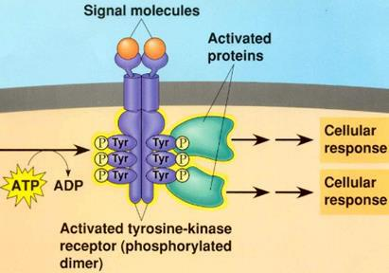
be the most immediate effect on the receptor tyrosine kinase pathway?
a. The signal molecules will not be able to bind to the receptor.

b. The tyrosine molecules will be unable to detach from the receptor.

- The tyrosine molecules will not be able to “steal” phosphate groups from ATP and use these phosphate groups to activate other proteins.

- The two parts to the receptor will not be able to come together as a dimer.

- The pathway below shows the effect of insulin, a hormone released in response to high blood glucose, on liver cells. In Type 1 diabetes, cells in the pancreas cannot create and secrete insulin. How will this affect blood glucose levels?
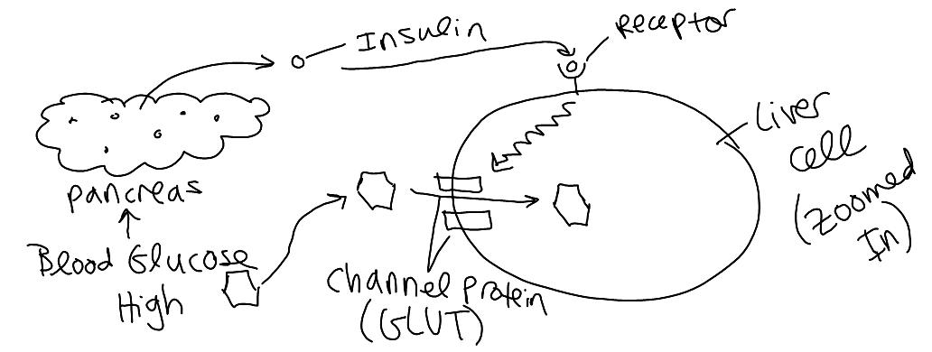

a. Blood glucose levels will remain high because glucose will not be removed from the blood by the GLUT channels in liver cells.

b. Blood glucose levels will decrease because glucose will be successfully removed from the blood by the GLUT channels in liver cells.
c. Blood glucose levels will remain high because the pancreas will never receive the signal to create insulin.

d. Blood glucose levels will decrease because the receptor will be activated by another hormone.

- Of the following, a receptor protein in a membrane that recognizes a chemical signal is most similar to a. the active site of an enzyme in the cytoplasm that binds to a specific substrate.
b. RNA specifying the amino acids in a polypeptide.

c. a particular metabolic pathway operating within a specific organelle. d. an enzyme with an optimum pH and temperature for activity.
e. genes making up a chromosome.

- At puberty, an adolescent female body changes in both structure and function of several organ systems, primarily under the influence of changing concentrations of estrogens and other steroid hormones. How can one hormone, such as estrogen, mediate so many effects?

a. Estrogen is produced in very large concentration and therefore diffuses widely.

b. Estrogen has specific receptors inside several cell types, but each cell responds in the same way to its binding. c. Estrogen is kept away from the surface of any cells not able to bind it at the surface.

d. Estrogen binds to specific receptors inside many kinds of cells, each of which have different responses to its binding. e. Estrogen has different shaped receptors for each of several cell types.

- How would you expect the length of interphase to differ in a skin cell (which has to be continuously replaced) vs. a mature nerve cell (which is never replaced)?

- Interphase is longer in the skin cell because a long interphase corresponds to a faster rate of cell division.
- Interphase is shorter in the skin cell because a short interphase corresponds to a faster rate of cell division.
- Interphase is longer in the skin cell because a long interphase corresponds to a slower rate of cell division.
- Interphase is shorter in the skin cell because a short interphase corresponds to a slower rate of cell division.

- In some organisms such as certain fungi and algae, cells undergo mitosis repeatedly without subsequently undergoing cytokinesis. What would result from this?

a. A rapid rate of sexual reproduction b. A decrease in chromosome number

c. Division of the organism into many cells, most lacking nuclei d. Large cells containing many nuclei

- A cell containing 92 chromatids at metaphase of mitosis would, at its completion, produce two nuclei each containing how many chromosomes?

a. 12 b. 16 c. 23 d. 46 e. 92

- The karyotype of one species of primate has 48 chromosomes. In a particular female, cell division goes awry and she produces one of her eggs with an extra chromosome. The most probable source of this error would be a mistake in which of the following?

a. Mitosis in her ovary

b. Metaphase I of one meiotic event c. Telophase II of one meiotic event d. Telophase I of one meiotic event e. Either anaphase I or II

- Which of the steps below take place in both mitosis and meiosis?

  - Formation of four new nuclei, each with half the chromosomes present in the parental nucleus
  - Alignment of tetrads at the metaphase plate
  - Separation of sister chromatids
  - Separation of the homologues; no uncoupling of the centromere

  - Synapsis; chromosomes moving to the middle of the cell in pairs

- 2

- 3
- 5
- 2 and 3 only
- 2, 3, and 5

- How do cells at the completion of meiosis compare with cells that have replicated their DNA and are just about to begin meiosis?

a. They have twice the amount of cytoplasm and half the amount of DNA. b. They have half the number of chromosomes and half the amount of DNA. c. They have the same number of chromosomes and half the amount of DNA.

d. They have half the number of chromosomes and one-fourth the amount of DNA. e. They have half the amount of cytoplasm and twice the amount of DNA.
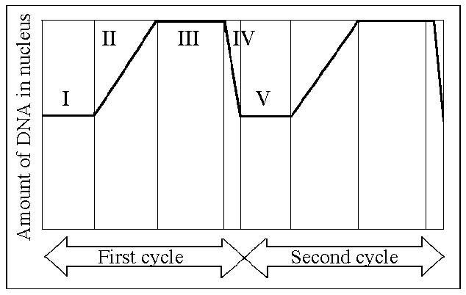

- Which number above represents the point in the cell cycle during which the chromosomes are replicated?

a. I b. II c. III d. IV e. V

27. In multicellular organisms, mitosis is
- the means of tissue growth and repair.
- a way of generating increasing genetic variation in members of the next generation
- the means of sexual reproduction.
- able to occur in only a few cells of specialized tissues.
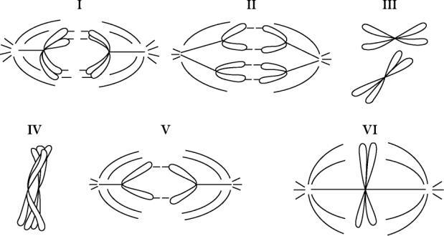

- Which diagram represents prophase I of meiosis?

a. I b. II c. IV d. V e. VI

- Natural selection and recombination due to crossing over during meiosis I are related in which of the following ways? a. Recombinants are usually selected against.

b. Non-recombinant organisms are usually favored by natural selection if there is environmental change. c. Most recombinants reproduce less frequently than do non-recombinants.

d. Recombinants may have combinations of traits that are favored by natural selection. e. Recombination does not affect natural selection.

- For a chemotherapeutic drug to be useful for treating cancer cells, which of the following is most desirable?

a. It only attacks cells that are large in size.
b. It only attacks cells that are highly specialized.

c. It interferes with cells entering G0.
d. It interferes with rapidly dividing cells.

- The organelle that is the major producer of ATP and is found in both heterotrophs and autotrophs is the a. chloroplast

b. nucleus c. ribosome

d. Golgi apparatus e. mitochondrion

- If plant cells are immersed in distilled water, the resulting movement of water into the cells is called
- conduction
- active transport
- transpiration
- osmosis
- facilitated diffusion

Questions 33-35. The following questions refer to an experiment in which a dialysis-tubing bag is filled with a mixture of 3% starch and 3% glucose and placed in a beaker of distilled water, as shown at right. After 3 hours, glucose can be detected in the water outside the dialysis-tubing bag, but starch cannot.
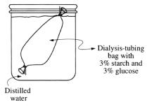

- From the initial conditions and results described which of the following is a logical conclusion?

a. The initial concentration of glucose in the bag is higher than the initial concentration of starch in the bag.

b. The pores of the bag are larger than the glucose molecules but smaller than the starch molecules.

c. The bag is not selectively permeable.
d. A net movement of water into the beaker has occurred.
e. The molarity of the solution in the bag and the molarity of the solution in the surrounding beaker are the same.

- Which of the following best describes the conditions expected after 24 hours?
a. The bag will contain more water than it did in the original condition.
b. The contents of the bag will have the same osmotic concentration as the surrounding solution.

c. Water potential in the bag will be greater than water potential in the surrounding solution.
d. Starch molecules will continue to pass through the bag.
e. A glucose test on the solution in the bag will be negative.

- If, instead of the bag, a potato slice were placed in the beaker of distilled water, which of the following would be true of the potato slice?
a. It would gain mass.
b. It would neither gain nor lose mass.
c. It would absorb solutes from the surrounding liquid.

d. It would lose water until water potential inside the cells is equal to zero. e. The cells of the potato would increase their metabolic activity.

Practice Long Response Questions: Make an outline of the information you would include in each of these essays.

- A laboratory assistant prepared solution of 0.8 M, 0.6 M, 0.4 M, and 0.2 M sucrose, but forgot to label them. After realizing the error, the assistant randomly labeled the flasks containing these four unknown solutions as flask A, flask B, flask C, and flask D.

Design an experiment, based on the principles of diffusion and osmosis, that the assistant could use to determine which of the flasks contains each of the four unknown solutions. Include in your answer

- a description of how you would set up and perform the experiment
- the results you would expect from your experiments
- an explanation of those results

2. Membranes are essential components of all cells.

a. Identify TWO macromolecules that are components of the plasma membrane in a eukaryotic cell and discuss the structure and function of each.
b. Explain how membranes participate in TWO of the following biological processes.
- muscle contraction
- fertilization of an egg
- chemiosmotic production of ATP
- intercellular signaling

- A major distinction between prokaryotes and eukaryotes is the presence of membrane-bound organelles in eukaryotes. a. Describe the structure and function of TWO eukaryotic membrane-bound organelles other than the nucleus.

b. Prokaryotic and eukaryotic cells have some non-membrane-bound components in common. Describe the function of TWO of the following and discuss how each differs in prokaryotes and eukaryotes.
  - DNA
  - cell wall
  - ribosomes

c. Explain the endosymbiotic theory of the origin of eukaryotic cell and discuss an example of evidence supporting this theory.

- The following experiment was designed to test whether different concentration gradients affect the rate of diffusion. In this experiment, four solutions (0% NaCl, 1% NaCl, 5% NaCl, and 10% NaCl) were tested under identical conditions. Fifteen milliliters (mL) of 0% NaCl were put into a bag formed of dialysis tubing that is permeable to Na⁺, Cl⁻, and water. The same was done for each NaCl solution. Each bag was submerged in a separate beaker containing 300 mL of distilled water. The concentration of NaCl in mg/L in the water outside the bag was measured at 40-second intervals. The results from the 5% bag are shown in the table below.
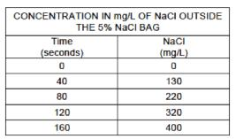

a. On the axes provided, graph the data for the 5% NaCl solution

b. Using the same set of axes, draw and label three additional lines representing the results that you would predict for the 0% NaCl, 1% NaCl, and 10% NaCl solutions. Explain your predictions.

c. Farmlands located near coastal regions are being threatened by encroaching seawater seeping into the soil. In terms of water movement into or out of plant cells, explain why seawater could decrease crop production. Include a discussion of water potential in your answer.

- The value for Ψ in root tissue was found to be -3.3 bars.

a. If you place the root tissue in a 0.1 M solution of sucrose at 20°C in an open beaker, what is the Ψ of the solution, and in which direction would the net flow of water be?

b. If the solution in question 4 contained 0.1 M NaCl instead of 0.1 M sucrose, what is the Ψ of the solution, and in which direction would the net flow of water be?

- Paclitaxel is a chemotherapy drug used to treat a variety of cancers. Paclitaxel inhibits both assembly and disassembly of microtubules.
a. Which phases in the cell cycle are affected by Paclitaxel? How does this drug inhibit the growth of cancer?

b. Paclitaxel affects not only cancer cells, but normal cells as well. Would the effects of Paclitaxel be seen first in organs that have quickly dividing cells (like the intestine and hair follicles) or in organs that have slow or nondividing cells (like muscles and the nervous system). Justify your reasoning.

Thinking Practice Questions:
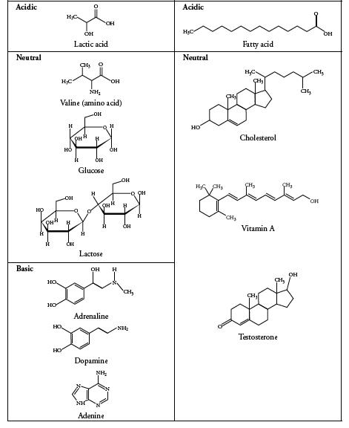

- For each molecule shown to the right, answer the following, providing justifications for each:

a. Is it polar or nonpolar?
b. Is it hydrophobic or hydrophilic?

c. In order to be transferred into a cell, would the molecule require a protein channel?

- Biological systems rely heavily on the properties of water movement. Excretion, digestion, and blood pressure are just a few examples of situations where water balance is important. Suppose you have a semi-permeable membrane that ONLY water can pass. On one side of the membrane you have 0.1 M CaCl2. On the other side of the membrane, you have 0.1 M Glucose. CaCl2 ionizes in water to produce 3 ions. Glucose does not ionize in water.

a. Calculate the water potential for each side of the membrane, assume room temperature (25 ^{O}C or 298 K). b. Describe which direction the water will flow and explain your answer.

- Embedded proteins, as shown below, are often found spanning the membrane of a cell or organelle. These proteins serve as channels for specific molecules to travel through the membrane, either into or out of the cell.
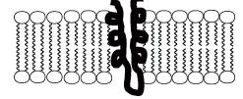

a. What sections of the embedded protein chain are most likely to contain amino acids with hydrophobic R-groups? Explain your reasoning.

b. What sections of the embedded protein chain are most likely to contain amino acids with hydrophilic R-groups? Explain your reasoning.
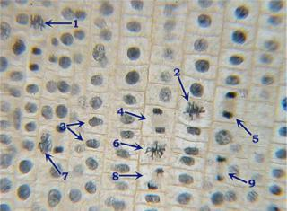

4. Refer to the figure to the right.

a. What process is being shown in this picture?

b. What type of organism are these cells from? How do you know?

c. Identify a numbered cell for each of the four major stages of mitosis?

d. In what stage are most of the cells in this image? What does this indicate about the amount of time spent in each phase of the cell cycle?

- Two students debate about proteins that regulate the cell cycle. One argues that MPF triggers the production of cyclin, while the other argues that cyclin triggers the production of MPF.

a. Based on the figure shown below, which statement is correct and why?
b. Propose a possible function of MPF, based on when it is produced in the cell cycle.
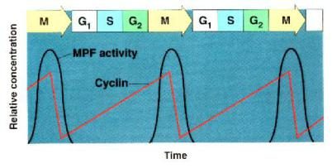

Name: _____________________________________________ Date: ____________________________

AP Biology Exam Review: DNA, Protein Synthesis & Biotechnology

Helpful Videos and Animations:

- Bozeman Biology: DNA Replication
- Bozeman Biology: DNA and RNA - Part 1
- Bozeman Biology: DNA and RNA - Part 2
- Cold Spring Harbor Lab Animation: Griffith / Avery, McCarty, and Macleod Experiments

- McGraw-Hill Animation: Hershey Chase Experiment
- Bozeman Biology: Transcription and Translation

- McGraw-Hill Animation: Transcription
- McGraw-Hill Animation: Translation
- McGraw-Hill Animation: Intron Removal by Spliceosomes containing snRNP's (small nuclear riboproteins)

- McGraw-Hill Animation: Lytic vs. Lysogenic Cycle of Viral Infection
- Sumanas Animation: Life Cycle of HIV, a Retrovirus
- McGraw-Hill Animation: Bacterial Transduction Using a Temperate Phage

- Bozeman Biology: Mechanisms of Genetic Variation in Prokaryotic vs. Eukaryotic Cells
- Sumanas Animation: Trp Operon (Repressible Operon)

- Sumanas Animation: Lac Operon (Inducible Operon)
- Bozeman Biology: Operon
- Bozeman Biology: Gene Regulation in Prokaryotic vs. Eukaryotic Cells

- Sumanas Animation: Gel Electrophoresis
- McGraw-Hill Animation: Restriction Enzymes (AKA Restriction Endonucleases)

- McGraw-Hill Animation: Restriction Fragment Length Polymorphisms
- Sumanas Animation: Polymerase Chain Reaction (PCR)
- Cold Spring Harbor Lab Animation: Bacterial Transformation

- Bozeman Biology: Response to External Environments

Relevant Objectives:

- Describe the structure of DNA
- Describe the experiments leading to the discovery of DNA as the genetic material

- Describe the process of DNA replication, including: leading and lagging strand, enzymes involved in replication, the semi-conservative model, primers, and telomeres

- Describe how mutations in the DNA can arise and the process of DNA repair enzymes
- Explain how DNA is converted into a protein.

- Describe the process of transcription and how this produces a modified mRNA product based off of DNA.
- Describe the process of translation and how this leads to the production of a polypeptide from an mRNA sequence
- Describe how proteins are modified and sent to the correct location

- Explain the different types of mutations and how they can affect protein formation
- Describe the makeup of a virus
- Explain how viruses use host cells to replicate

- Be able to differentiate between the lytic and lysogenic phases of bacteriophage replication
- Explain how retroviruses differ from other viruses, and describe their mode of replication

- Describe how vaccines prevent viral infection
- Explain how viroids and prions can be infectious agents
- Explain how bacteria can transfer DNA (3 ways) and how this influences evolution

- Explain how bacteria can evolve quickly
- Explain how recombinant DNA is made and inserted into an organism

- Describe the potential uses for recombinant DNA technology
- Explain how to screen for and select bacteria that has undergone transformation for intended gene
- Explain what cDNA is and describe the uses of cDNA and DNA libraries

- Describe the process of gel electrophoresis and its uses
- Describe the process of PCR and its uses
- Explain why genetic engineering is a highly debated issue, and describe both sides’ views on the topic

- Describe the organization of an operon
- Explain how prokaryotes regulate gene expression using operons

- Describe the difference between a repressible operon and an inducible operon, and give an example of each

- Explain how genes are regulated in eukaryotes by the following methods: DNA packaging, transcriptional regulation, post-transcriptional regulation, translational regulation, post-translational regulation

Topic Outline:
- DNA History

  - Be able to describe the experiments leading to the discovery of DNA as the cell’s genetic material. Key scientists and experiments include

o Franklin, Watson, Crick, Wilkins – structure of DNA o Griffith – bacterial transformation, genetic material

o Hershey / Chase – sulfur and phosphorus tagged viruses, showed DNA passed not proteins o Avery, MacLeod, McCarty – tried transformation after knocking out macromolecules (RNA,

DNA, proteins, lipids, carbohydrates) transformation NOT successful if DNA knocked out

- Structure of DNA
  - Deoxyribose nucleic acid
  - Double helix (two twisted stsrands) made of nucleotides (monomers)
  - Nucleotide = phosphate + 5C deoxyribose sugar + nitrogen base
  - Antiparallel strands- one runs 3’ to 5’ the other runs 5’ to 3’, sides of phosphates and sugars
  - (backbone), rungs of paired bases with hydrogen bonds in between
  - Purines (adenine, guanine; double rings) pair with Pyrimidines (cytosine, uracil, thymine; single ring)
  - A & T – double H bond
  - C & G – triple H bond
•

- Location of DNA

  - In eukaryotes DNA is found in nucleus on multiple linear chromosomes (a chromosome IS a strand of DNA with proteins etc. associated).

  - In prokaryotes DNA is not in a nucleus and is usually a single circular chromosome

  - Prokaryotes, viruses, and eukaryotes (yeast) can contain plasmids (small extra-chromosomal DNA that is double stranded DNA)

- DNA replication
  - Process of making exact copies of DNA (i.e. for mitosis or meiosis)
  - Process is semi conservative (original strand is copied)
  - Steps
    - Enzyme (helicase) unzip strands by breaking hydrogen bonds

    - “Spare” nucleotides are added bidirectionally to bond complementarily with use of DNA polymerases (DNA pol)
    - DNA pol only can add to the 3’ end of DNA and new DNA is made in the 5’ to 3’direction

    - Replication bubbles open up and a replication fork is created because bubble is in half and it has one side 3/5 and one 5/3
    - RNA primers must be laid down to start process (RNA primase makes primers)
    - Leading strand makes DNA continuously (Read 3→5, laid down 5→3)

    - Lagging strand makes DNA discontinuously (Read 5→3, must flip strand to orient correctly), Okazaki fragments
    - Lagging strand requires enzyme (ligase) to fuse fragments

- RNA
  - Ribonucleic acid
  - Single stranded, different sugar called ribose, different base called uracil INSTEAD of thymine
  - Base pair rules in RNA, A-U and C-G
  - messenger RNA or mRNA carries information from DNA to the ribosome
  - transfer RNA or tRNA bind amino acids and are used in translation at ribosome

  - ribosomal RNA or rRNA acts as an enzyme in the ribosome aiding in forming peptide bonds – likely one of the first enzymes (ribozyme)

- Transcription
  - making mRNA in nucleus

  - enzyme RNA pol reads the DNA in 3’ to 5’ direction and synthesizes complementary mRNA in 5’ → 3’ direction

o Ex. 3’ to 5’ DNA is ATG CAT then the 5’ to 3’ mRNA made will be UAC GUA

  - Steps

    - Initiation – Promoter is where RNA pol binds and begins

    - Elongation – adding of RNA nucleotides, does not stay attached to DNA
    - Termination – ends when RNA pol reaches a termination sequence

- mRNA editing
  - introns spliced out (cut out) using spliceosomes (snRNP’s)
    - alternative splicing leads to many proteins from one mRNA
  - add polyA tail to 3’
  - add GTP cap to 5’
  - each 3 nucleotides are called a codon
  - go to ribosome (free or in rough ER)

- Translation

  - mRNA code is read and matched with tRNA (brings amino acids) to construct a polypeptide using the ribosome

    - Ex. mRNA codon is AAA then tRNA anticodon will be UUU and will have a corresponding amino acid for that codon of mRNA

  - 3 steps: Initiation, Elongation, Termination (see notes)

  - If in ER then: polypeptide is released into ER, then to Golgi complex, vesicle to cell membrane, then exocytosis (may be given signals for exit/destination)

  - Free ribosomes typically make products for the cell and are not exported – go to other organelles, used in cytoplasmic reactions

- Mutations and Increasing Genetic Diversity

  - Changes to the DNA sequence are not all harmful, some can increase genetic variability → more possible forms of traits so that not all organisms can be killed off by any one factor (ex: a disease that kills all tall people)

  - They can be spontaneous errors in replication or they can be caused by mutagens (environmental factors like radiation, chemicals, cigarette smoke, etc.)

  - If a mutagen causes changes in genes that regulate the cell cycle/cell division it is considered a carcinogen (a cancer-causing factor)

  - Some mutations are neutral (happen in introns that do not code for proteins)
  - Some mutations are harmful (change protein function in a negative way)
  - Types of Mutations:

  - Point mutation – change in one base pair of a gene (substitution: replace one base with another)
  - Silent – changes one base, but codes for the same amino acid (due to redundancy)

  - Missense – codes for another amino acid (changes protein sequence and usually function) Example: sickle cell disease, one T substituted for A in the gene coding for hemoglobin protein
- Nonsense – code changes to a stop codon (makes a nonfunctional protein that is terminated early)

- Frameshift mutation – the mutation effects all nucleotides/codon groupings farther along the DNA/RNA code, typically caused by insertion or deletion

    - Insertion – adding extra nucleotides (causes a frameshift if you are not adding exactly three extra bases)

    - Deletion – removing nucleotides (causes a frameshift if you are not removing exactly three bases)

Example: O blood type allele involves a deletion in the A blood type code

- Viruses – protein coating with nucleic acids (ssDNA, ssRNA, dsDNA or dsRNA) inside. Needs host to replicate.
  - Viral Replication
o Viruses inject DNA or RNA into host cell

o Viruses have highly efficient replicative capabilities that allow for rapid evolution

o Viruses replicate via the lytic cycle, allowing one virus to produce many progeny simultaneously o Virus replication allows for mutations to occur through usual host pathways.

o RNA viruses lack replication error-checking mechanisms, and thus have higher rates of mutation o Related viruses can combine/recombine information if they infect the same host cell
o Some viruses are able to integrate into the host DNA and establish a latent (lysogenic) infection

o HIV is a well-studied system where the rapid evolution of a virus within the host contributes to the pathogenicity of viral infection.

o Genetic information in retroviruses is a special case and has an alternate flow of information: from RNA to DNA, made possible by reverse transcriptase, an enzyme that copies the viral RNA genome into DNA. This DNA integrates into the host genome and becomes transcribed and translated for the assembly of new viral progeny.

- Bacterial Reproduction and Genetic Recombination
  - Transformation – bacteria uptakes DNA from another bacteria
  - Transduction – virus transfers DNA between two bacteria
  - Conjugation – bacterial “sex”
  - Transposition – “jumping genes”

- Prokaryotic Gene Regulation
  - Bacteria are prokaryotic with a single circular chromosome
  - Bacteria express all the genes needed for a product (more than one gene at a time)
  - Organization includes the promoter region of DNA, operator, and structural genes

  - Trp operon = repressible; anabolic pathway; used to make enzymes that help make tryptophan if none is present

o Repressor is naturally INACTIVE so it will make tryptophan

o Repressor only becomes ACTIVE when trp (called corepressor) is in excess and binds to repressor changing its shape

  - Lac operon = inducible; catabolic pathway; used to make enzyme to break down lactose when it is available

o Repressor is naturally ACTIVE so it will block gene transcription unless lactose (called inducer) binds and makes repressor INACTIVE

- Eukaryotic Gene Regulation

  - Enhancers- Areas on genome that are non-coding that are located at a distance from a promoter Transcription factors / activators can bind to these areas and cause transcription of certain genes (turns on)

  - mRNA Degradation by RNAi - mRNA has a life span in the cytoplasm (can last a few hours to a week) (turns off)

  - RNA processing (intron splicing, 3’ poly a tail, 5’ cap) (turn on and alter expression)
  - Histone Acetylation (turn on)
  - DNA methylation (turn off)
  - Translation Repressors (turn off)
  - Posttranslational modifications- folding, cleaving, etc. (alter expression)

- Creation of Recombinant DNA and Bacterial Transformation

  - Toolkit includes plasmid (piece of round DNA from bacteria/yeast) or other vector such as viruses; restriction enzymes; host cell (usually bacteria like E. coli)

  - Restriction enzymes cut genes at restriction sites to make blunt or sticky ends
  - Cut gene of interest with same enzyme to get same ends
  - Use ligase to seal gene of interest into the plasmid
  - Insert vector into host
  - Used to clone and make copies or to produce a foreign protein such as HGH or insulin

- Polymerase Chain Reaction (PCR)

  - Used to make large amounts of clones of DNA without using a host; heat which opens; use a primer to mark the place in the sequence where Taq polymerase begins replication; cool; repeat

- Gel Electrophoresis

Used to look at unique pattern created by fragments of DNA; cut DNA using enzyme; load into a gel; turn on electricity; DNA runs from negative to positive; larger chunks move less; unique for each person if testing variable areas of DNA (ex: RFLP’s); can be used for protein or mRNA too
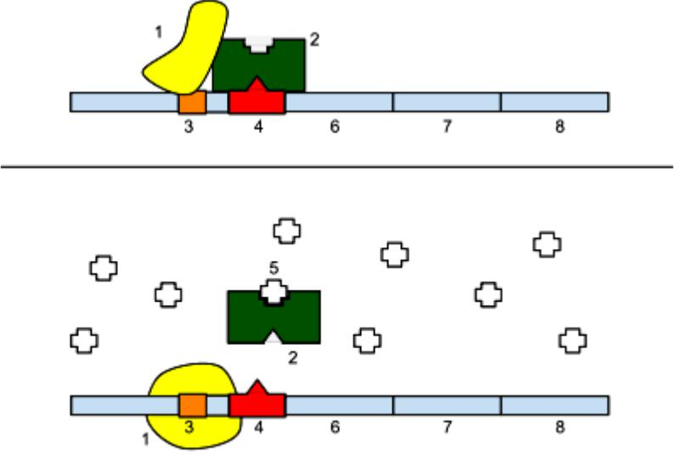

Practice Multiple Choice Questions:

Questions 1 and 2. With regard to the operon pictured to the right, the image on top shows the operon in its normal state, and the image on the bottom shows the operon in the presence of molecule #5 (looks like a + sign). The identities of some of the molecules shown in the picture are given below.

- RNA polymerase

- Promoter
- Operator
6, 7, and 8. Genes of the operon

***Note: In the picture on top, RNA polymerase is UNABLE to bind correctly to the promoter region and initiate transcription of the genes of the operon***

- What type of operon is shown in the image, and how do you know? a. An inducible operon; it is usually off but can be turned on.

b. An inducible operon; it is usually on but can be turned off. c. A repressible operon; it is usually off but can be turned on. d. A represible operon; it is usually on but can be turned off.

- What is the role of molecule #5 in regulating the operon?

a. It is an inducer, which is used to inactivate the repressor protein (#2) and prevent it from binding to the operator.
b. It is an inducer, which is used to activate the repressor protein (#2) and allow it to bind to the operator.
c. It is a repressor, which is used to inactivate the repressor protein (#2) and prevent it from binding to the operator.

d. It is a repressor, which is used to activate the repressor protein (#2) and allow it to bind to the operator.

3. Why is an anabolic operon usually repressible?
a. It is used to break down a molecule in the environment (ex: maltose sugar) so it should usually be on.
b. It is used to break down a molecule in the environment (ex: maltose sugar) so it should usually be off.

c. It is used to build an essential molecule in the cell so it should usually be on.
d. It is used to build an essential moelcule in the cell so it should usually be off.

- Adding acetyl groups to the histone proteins interacting with the DNA of the insulin gene causes the DNA to coil less tightly. What will be the effect on gene expression?

a. This will prevent expression of the insulin gene and result in decreased amounts of insulin protein produced. b. This will prevent expression of the insulin gene and result in increased amounts of insulin protein produced. c. This will facilitate expression of the insulin gene and result in decreased amounts of insulin protein produced. d. This will facilitate expression of the insulin gene and result in increased amounts of insulin protein produced.

- How can multiple types of antibodies be synthesized from the same “antibody gene”?
a. Changing the tightness of coiling of the DNA can result in the creation of different antibody proteins.
b. Changing the speed of transport of mRNA out of the nucleus can result in the creation of different antibody proteins.
c. Changing which introns are spliced out of the pre-mRNA can result in the creation of different antibody proteins.

d. Changing the regulatory proteins that bind to the 5’ end of the mRNA and prevent ribosome attachment can result in the creation of different antibody proteins

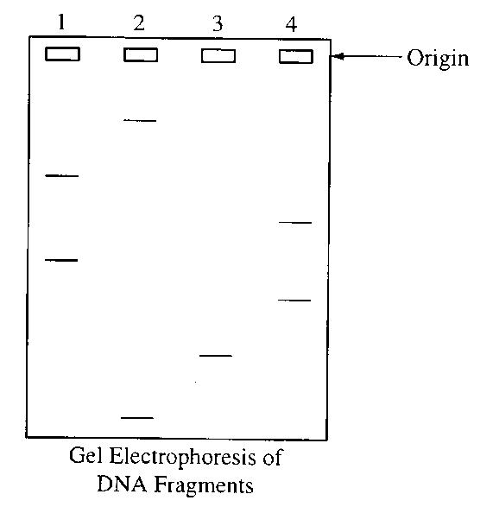
- The electrophoretic separation of the pieces of DNA in each of the four samples shown to the right was achieved because of differential migration of the DNA fragments in an electric field. This differential migration was caused by the

a. relative amounts of radioactivity in the DNA b. number of cleavage points per fragment
c. size of each fragment
d. overall positive charge of each fragment

- The DNA in this sample was labeled with ³²P in order to
a. stimulate DNA replication
b. inhibit the uptake of unlabeled ATP

c. show which fragments included the 5' end and which fragments included the 3' end

d. visualize the fragments

A scientist is using an ampicillin-sensitive strain of bacteria that cannot use lactose because it has a nonfunctional gene in the lac operon. She has two plasmids. One contains a functional copy of the affected gene of the lac operon, and the other contains the gene for ampicillin resistance. Using restriction enzymes and DNA ligase, she forms a recombinant plasmid containing both genes. She then adds a high concentration of the plasmid to a tube of the bacteria in a medium for bacterial growth that contains glucose as the only energy source. This tube (+) and a control tube (-) with similar bacteria but no plasmid are both incubated under the appropriate conditions for growth and plasmid uptake. The scientist then spreads a sample of each bacterial culture (+ and -) on each of the three types of plates indicated below.

- If no new mutations occur, it would be most reasonable to expect bacterial growth on which of the following plates?

a. 1 and 2 only b. 3 and 4 only c. 5 and 6 only d. 4, 5, and 6 only

e. 1, 2, 3, and 4 only

- The scientist used restriction enzymes for what purpose in the experiment?

a. To make the plasmid small enough to transform cells b. To make cuts in the plasmid DNA
c. To make the plasmid enter the cells

d. To enable the fragments of DNA to form covalent bonds
e. To enable the plasmid to recognize the bacterial cells

- If the scientist had forgotten to use DNA ligase during the preparation of the recombinant plasmid, bacterial growth would most likely have occurred on which of the following?

a. 1 and 2 only b. 1 and 4 only c. 4 and 5 only d. 1, 2, and 3 only e. 4, 5, and 6 only

- If the scientist used the cultures to perform another experiment as shown above, using medium that contained lactose as the only
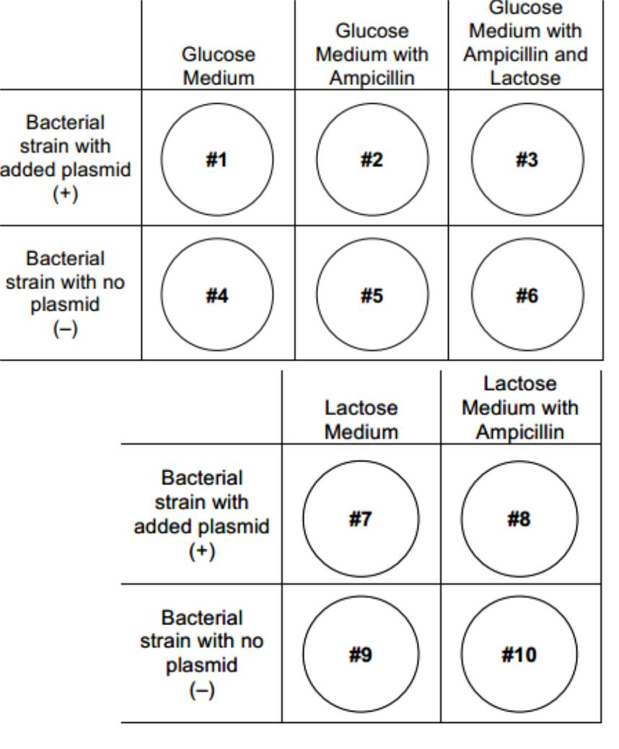
energy source, growth would most likely occur on which of the following plates?

a. 10 only b. 7 and 8 only c. 7 and 9 only d. 8 and 10 only e. 9 and 10 only

- Actinomycin D is an antibiotic drug that inhibits protein synthesis by blocking transcription. In some cells, the application of the drug does not affect the synthesis of certain proteins. Which of the following best explains such an occurrence?

a. Not all proteins need tRNA molecules for their synthesis.

b. The proteins that are made are using mRNA synthesized before application of the drug. c. Nuclear proteins do not require the cytoplasmic machinery of ribosomes.
d. Protein synthesis is blocked in the cytoplasm at the ribosome level.

. . . glycine-serine-glycine . . .

- Which of the following DNA strands will code for the amino acid sequence shown above? a. . . . ACTCCTTCT . . .

b. . . . TCTCCGTCG . . .
c. . . . CCGTCGACT . . .
d. . . . CCTTCGCCT . . .

- A single substitution in the third position would
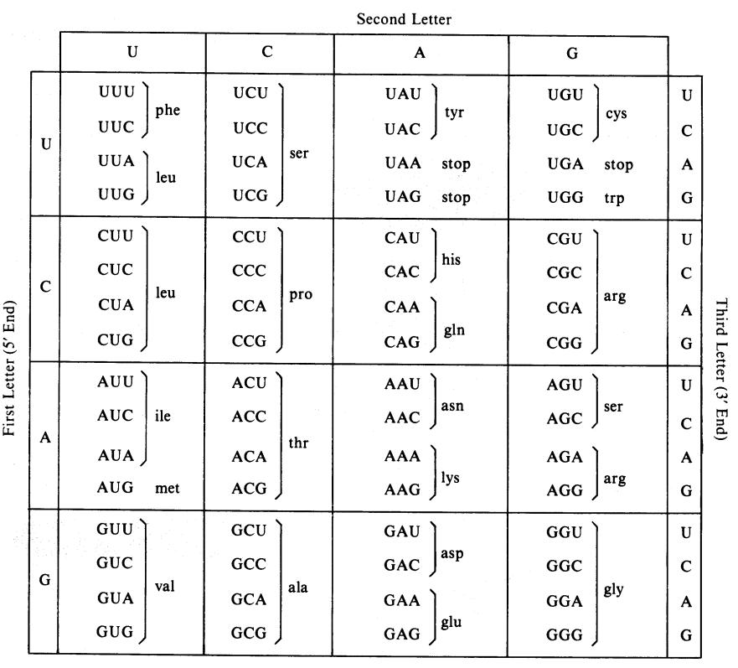
have the greatest probability of mutational effect on the codon

- GUU
- AUU
- CGU
- AUG
- CCC

- What would be the sequence of bases of an mRNA molecule that was transcribed from the sequence of DNA bases shown below?

GTAGTAGGT

- GTAGTAGGT
- CAUCAUCCA
- UCGUCGUUC
- AUGAUGAAU
- CATCATCCA

Questions 16-20. Refer to the following list to answer the following questions. The answers may be used once, more than once, or not at all.

- transcription

- translation
- transformation
- replication
- reverse transcription

- Process in which a protein is assembled at a ribosome.

- Process in which naked DNA is taken up by a bacterial or yeast cell.

- Process in which RNA is produced by using a DNA template.

- Process that results in the production of cDNA from an RNA molecule.

- Process in which DNA is produced by using a DNA template.

- DNA replication can be described as a. semiconservative

b. conservative c. degenerative d. dispersive e. radical

- In DNA replication, DNA polymerase catalyzes the reaction in which a. The double helix unwinds

b. The sugar-phosphate bonds of each strand are broken
c. A phosphate group is added to the 3’-carbon or 5’-carbon of ribose

d. A nucleotide with a base complementary to the base on the template strand is added to the new DNA strand e. Two nucleotide strands come together and intertwine to form a double helix

- The replacement of glutamine by valine at a specific position in the beta chains of hemoglobin leads to sickle cell anemia. This change represents which of the following mutational events?

a. DNA base-pair substitution b. DNA base-pair deletion

c. DNA base-pair addition d. Chromosomal deletion e. Frame-shift mutation

Questions 24-27. Refer to these scientists famous for their work with DNA.
a. Hershey and Chase
- Griffith
- Rosalind Franklin
- Avery, McCarty, MacLeod

- Discovered transformation in bacteria.

- Showed that DNA was the genetic material by doing transformation experiments while knocking out different macromolecules.

- Proved that the nuclear material in a bacteriophage, not the protein coat, infects a bacterium.

- The first to analyze DNA by x-ray crystallography, proposed DNA was helical.

- Once transcribed, eukaryotic RNA normally undergoes substantial alteration that results primarily from
a. removal of exons
b. removal of introns
c. addition of introns
d. combining of RNA strands by ligase

- When DNA replicates, each strand of the original DNA molecule is used as a template for the synthesis of a second, complementary strand. Which of the following figures most accurately illustrates enzyme-mediated synthesis of new DNA at a replication fork?
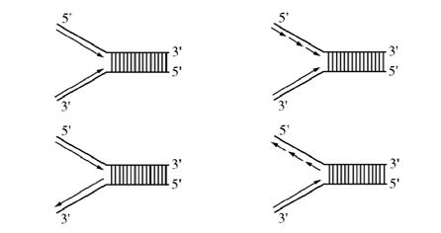

a. b.

c. d.

- If guanine makes up 28% of the nucleotides in a sample of DNA from an organism, then thymine would make up

__________ % of the nucleotides. a. 28

b. 56 c. 22 d. 44

- Prions are
a. bacteriophages that cause disease
b. infectious proteins
c. a bacterium that infects viruses
d. the cause of sickle cell anemia

Practice Long Response Questions: Make an outline of the information you would include in each of these essays.

- Describe how recombinant DNA technology can be used to accomplish the following: a. The creation of human insulin protein to treat diabetes.

b. The creation of golden rice, which is a transgenic plant (meaning it contains DNA from two different organisms) that has been given the gene for beta carotene (vitamin A) production using a bacterial vector.

- Meiosis reduces chromosome number and rearranges genetic information.

a. Explain how the reduction and rearrangement are accomplished in meiosis.

b. Several human disorders occur as a result of defects in the meiotic process. Identify ONE such chromosomal abnormality; what effects does it have on the phenotype of people with that disorder? Describe how this abnormality could result from a defect in meiosis.

c. Production of offspring by parthenogenesis or cloning bypasses the typical meiotic process. Describe either parthenogenesis or cloning and compare the genomes of the offspring with those of the parents.

- A difference between prokaryotes and eukaryotes is seen in the organization of their genetic material a. Discuss the organization of the genetic material in prokaryotes and eukaryotes.
b. Contrast the following activities in prokaryotes and eukaryotes:
  - replication of DNA
  - transcription
  - gene regulation
  - cell division

- All humans are almost genetically identical. However, every person has a unique DNA fingerprint. Explain this contradiction.

Thinking Practice Questions:

Compare the two DNA sequences shown below. Transcribe them into mRNA and translate them into an amino acid sequence.

GTG CAC CTC ACA CCA GAG GAG (Normal Hemoglobin)

GTG CAC CAC ACA CCA GTG GAG (Sickle Cell Hemoglobin)

a. Circle any differences there are in the DNA, RNA and amino acid sequences that might exist between these two sequences.

b. Identify the type of mutation that is represented AND EXPLAIN, IN DETAIL, what effect this would have on the protein/pigment.

- In prokaryotic cells, translation begins before transcription is finished. Give two reasons why this would not be possible in eukaryotic cells.

- Describe the processes occurring at each of the numbered positions (I, II, III, and IV) in the diagram below.
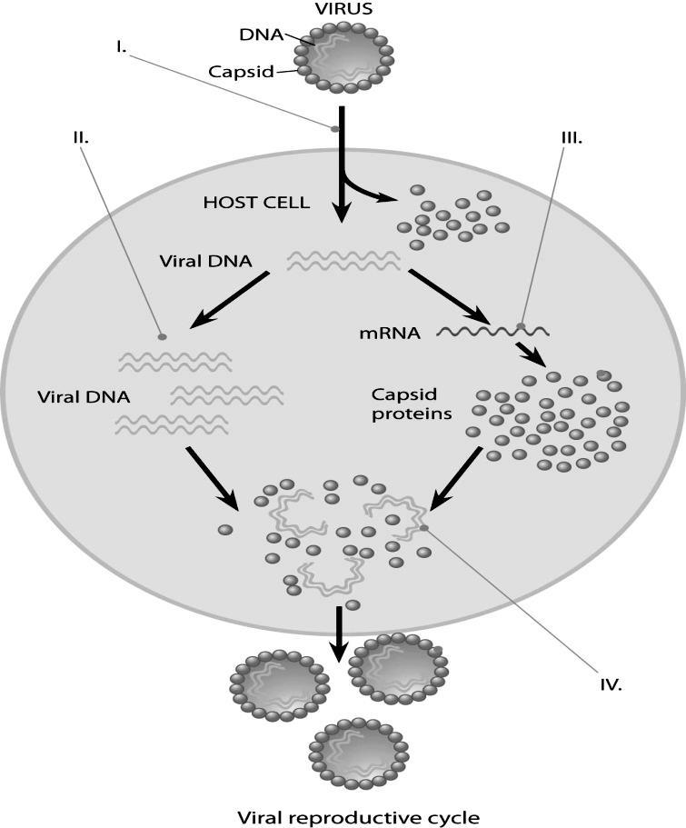

- In a molecular biology laboratory, a student obtained competent E. coli cells and used a common transformation procedure to induce the uptake of plasmid DNA with a gene for resistance to the antibiotic kanamycin. The results below were obtained.
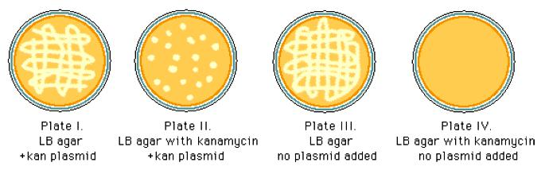

a. What is the purpose of Plate IV?

b. Explain the growth you see and the type of bacteria (transformed vs. non-transformed or both) that would be on Plate 1.

- Explain the growth you see and the type of bacteria (transformed vs. non-transformed or both) that would be on Plate II.

- If the student repeated the experiment, but the heat shock was unsuccessful and the plasmid was unable to be transformed, for which plates would growth be expected? Explain your answer.

Name: _____________________________________________ Date: ____________________________

AP Biology Exam Review: Genetics, Evolution, and Classification

Helpful Videos and Animations:

- Bozeman Biology: Natural Selection (an overview of natural selection and Hardy-Weinberg Equilibrium)
- Bozeman Biology: Examples of Natural Selection
- Bozeman Biology: Genetic Drift
- Bozeman Biology: Evidence of Evolution

- Bozeman Biology: Essential Characteristics of Life (preserved by natural selection)
- Bozeman Biology: Natural Selection Unit Review (a review from the previous five videos)

- Bozeman Biology: Solving Hardy Weinberg Problems
- Bozeman Biology: Speciation and Extinction
- Bozeman Biology: Speciation

- Bozeman Biology: Evolution Continues
- Bozeman Biology: Classification of Life

- Bozeman Biology: The Three Domains of Life

- Bozeman Biology: Mendelian Genetics
- Bozeman Biology: A Beginner's Guide To Punnett Squares

- Bozeman Biology: Probability in Genetics - Multiplication and Addition Rules
- Bozeman Biology: Linked Genes
- Bozeman Biology: The Genetics of Blood Types

- Andrew Douch: Pedigree Analysis 1
- Andrew Douch: Pedigree Analysis 2

Relevant Objectives:

- Describe Mendel’s experiments with peas and how they revealed modern laws of genetics
- Explain the difference between phenotype and genotype
- Define homozygous and heterozygous

- Explain the law of segregation

- Explain the law of independent assortment
- Be able to construct a punnett square and use it to predict characteristics of offspring for monohybrid and dihybrid crosses

- Explain how genetics can be more complicated than simple dominance and recessiveness - can be co-dominance and incomplete dominance
- Describe what a sex-linked trait is, and be able to complete punnett squares using sex-linked traits

- Be able to use a chi-squared test to show whether predicted results match actual results
- Be able to read a pedigree and determine to mode of inheritance from a pedigree

- Give examples of human genetic diseases and their mode of inheritance

- Explain the difference between the Lamarckian theory of evolution and the Darwinian theory of evolution
- Explain how evolution by natural selection occurs

- Describe the necessary conditions for evolution by natural selection to occur

- Explain the forces driving evolution, including selection (sexual, predation, etc), genetic drift (founder effect, bottleneck), gene flow, and co-evolution

- Give examples of how force driving evolution can impact a population
- Describe the types of selection that can occur (stabilizing, directional and disruptive)
- Explain what the values represent in the Hardy-Weinberg equilibrium
- Be able to use the Hardy-Weinberg equilibrium to determine if a population is evolving
- Define a species

- Describe the different ways speciation can occur (allopatric vs. sympatric & pre- and post reproductive barriers)
- Describe the evidence supporting evolution (fossil record, anatomical record, molecular record, artificial selection)

- Explain the modern evidence supporting evolution (peppered moths, chromosomes, resistance)
- Explain the leading theory for the origin of life
- Be able to interpret phylogenetic trees and infer evolutionary relationships from them

- Be able to create a phylogenetic tree given evolutionary information
- Be able to interpret cladograms and infer evolutionary relationships from them

- Be able to create a cladogram given evolutionary information
- Name the levels of classification
- Describe the basis of the Linnaean classification system vs. modern classification systems
- Describe the defining characteristics of each domain

Topic Outline:
- Mendel’s experiments
  - Pea plants with distinct dominant vs. recessive traits
  - Came up with laws
  - Mendel’s Laws

o Law of Dominance – one trait will always be expressed over another; recessive traits are only seen in the absence of dominant traits
o Law of Segregation – alleles separate from each other, gametes only carry one form of an allele

o Law of Independent Assortment – genes for different traits can segregate independently from one another; i.e. mom’s traits can separate from other mom traits, same with dad

- Basic Genetics Vocabulary

  - Gene vs. allele – gene is a section of DNA that codes for a protein, allele is a form of a gene (ex: blonde vs. blue eyes are two different alleles of the same gene)

  - Homozygous vs. heterozygous – homozygous = two of the same alleles (AA or aa); heterozygous = two different alleles (Aa), also known as hybrid

  - Genotype vs. Phenotype – genotype = genetics of individual (Aa or aa); phenotype = appearance of individual (do they express the dominant or recessive trait)

  - Monohybrid Cross vs. Dihybrid Cross – monohybrid = one trait hybrid mating (Aa x Aa); dihybrid = two traits hybrid mating (AaBb x AaBb)

  - Testcross or backcross – breeding unknown genotype that expresses the dominant allele with a recessive phenotype

- Setting up & analyzing genetic crosses with Punnett squares

  - Know how to set up monohybrid and dihybrid crosses given information regarding parent genotypes and phenotypes and analyze offspring genotype/phenotype ratios

o Ratios to know:

    - 3:1 = Monohybrid cross; 75% express dominant trait, 25% express recessive

    - 9:3:3:1 = Dihybrid cross; 9/16 express both dominant traits, 3/9 express one recessive trait, 3/9 express the other recessive trait, 1/3 express both recessive traits
  - Understand the rules of probability in Punnett Square analysis

o Rule of Multiplication: when calculating the probability that two or more independent events will occur together in a specific combination, multiply the probabilities of each of the two events
    - For example, the probability of a coin landing face up two times in two flips is ½ x ½ = ¼

    - In genetics, if you cross two organisms with the genotypes AABbCc and AaBbCc, the probability of an offspring having the genotype AaBbcc is ½ X ½ X ¼ = 1/16

    - Rule of Addition: when calculating the probability that any of two or more mutually exclusive events will occur, you need to add together their individual probabilities.

      - For example, if you are tossing a die, what is the probability that it will land on either the side with four spots or the side with five spots? (1/6 + 1/6 = 1/3)

- Non-Mendelian Patterns of Inheritance
  - Sex-linkage is different from autosomal patterns of inheritance – only on sex chromosomes (X or Y – typically X)

    - Do not see normal ratios, typically seen more often in males because males only have one X (if recessive trait)

o Punnett squares set up the same way, but with trait linked to sex chromosome. ▪ Ex: If X linked – X^{R}X^{r} x X^{r} Y

- Codominance and Incomplete Dominance – codominance = both genes expressed at once (blood type); incomplete dominance = blended phenotype (red & white flowers make pink)
- Multiple Alleles (blood type Punnett squares! Use the alleles i, I^{A}, and I^{B})
- Pleiotropy
- Polygenic Inheritance
- Nonnuclear inheritance (traits determined by DNA in mitochondria or chloroplasts, not DNA in the nucleus)
- Traits influenced by the environment (ex: human height)
- Epigenetics

5. Analyzing a pedigree of a human inherited condition

- Be able to determine the type of inheritance shown in a pedigree (autosomal dominant, autosomal recessive, sex-linked dominant, and sex-linked recessive)
    - Hints:
      - If there are significantly more males with a condition than females, the trait is sex-linked recessive

      - With an autosomal trait, if a child has a trait but the parents don’t, the trait is recessive (both parents are carriers)

- Linked Genes (found on the same chromosome and inherited together during cell division)

  - Crossing over between homologous chromosomes during Prophase I of meiosis may separate linked genes onto different chromosomes. The frequency of recombination of linked genes due to crossing over increases if two genes are farther apart on the chromosome

  - We can create a linkage map shown the location of genes on a chromosome. The distance between genes is measured in map units. 1 map unit = 1% recombination frequency → those genes are close
  - Recombination frequency can be calculated mathematically – # of recombinants/total number of offspring

- Natural Selection
  - Major mechanism of change over time – Darwin’s theory of evolution
  - How natural selection occurs:
- There is variation among phenotypes – genetic mutations play a role in increasing variation, as does

independent assortment, crossing over, and random fertilization
- Too many offspring are produced than can possibly survive
- Competition for resources results in differential survival, with individuals with the most favorable traits

surviving to reproduce offspring
  - Favorable traits become more common over time, population evolves due to changes in allele frequency

- An adaptation is a genetic variation that is favored by selection and is manifested as a trait that provides an advantage to an organism in a particular environment.

- Fitness is the ability to survive and reproduce
- Different types of selection:

    - Stabilizing selection – selects for average, ex: birth weight o Disruptive selection – selects for extremes ex: beak type

o Directional selection – towards one extreme ex: peppered moth o Sexual selection – competition for mates drives evolution

  - Artificial selection – humans breed organisms with desired traits

- Evidence for Evolution

  - Fossils can be dated by a variety of methods that provide evidence for evolution. These include the age of the rocks where a fossil is found, the rate of decay of isotopes including carbon-14, the relationships within phylogenetic trees, and the mathematical calculations that take into account information from chemical properties and/or geographical data.

  - Morphological homologies represent features shared by common ancestry. Vestigial structures are remnants of functional structures, which can be compared to fossils and provide evidence for evolution.

  - Biochemical and genetic similarities, in particular DNA nucleotide and protein sequences, provide evidence for evolution and ancestry.

- Genetic Variation
  - Be able to describe the basic structure of DNA and its organization in chromosomes in eukaryotic cells

  - Be able to describe how chromosomes are divided into gametes (sex cells) during meiosis and how these gametes come together during fertilization to create a zygote

  - Be able to describe the mechanisms of creating new genes and combining genes in different ways to increase genetic variation – mutation, crossing over, independent assortment, and random fertilization.

  - Be able to explain why genetic variation is important for the survival of a population

- Hardy-Weinberg Equilibrium - A mathematical model used to calculate changes in allele frequency, providing evidence for the occurrence of evolution in a population.
  - 5 conditions must be met for a population to be in HW equilibrium – conditions are seldom met

    - Large population/no genetic drift (understand why genetic drift has a more significant effect on the gene pool of small populations; be able to describe both the bottleneck and founder effects)

    - No migration
    - No mutations
    - Random mating
    - No natural selection
- Equations
o p + q = 1 and p² + 2pq + q² = 1
- p = the frequency of dominant alleles in a population

- q = the frequency of recessive alleles in a population

- p² = the frequency of homozygous dominant individuals in a population
- q² = the frequency of homozygous recessive individuals in a population
- 2pq=the frequency of heterozygous individuals in a population

- Speciation

  - An evolutionary process by which 2 or more species arise from 1 species and 2 new species can no longer breed and reproduce successfully

  - Many mechanisms by which it can occur

- Geographic isolation; allopatric – different place ▪ Species separated by physical barrier
  - Reproductive isolation; sympatric – same place
    - Different behaviors limit mating

    - Different habitats limit mating

    - Different mating seasons limit mating

    - Different anatomical structures limit mating

- Can take place over millions of years or rapidly (after extinction events, for example)

- Divergent evolution/adaptive radiation – species adapt to different environments, end up different; convergent evolution – species adapt similar structures to deal with same problem; co-evolution – two species influence each other’s evolution (ex: predator/prey, flower/pollinator)

- Analogous vs. homologous structures
  - Analogous – different structure, evolved separately, deals with same problem (ex: flight, leaves/spines)

  - Homologous structures – similar structure, evolved from common ancestor, can have same function but could be different (ex: bones in forelimb of vertebrates)

- Pacing: gradualism vs. punctuated equilibrium
  - Gradualism – slower and smaller changes
      - Punctuated equilibrium – quicker and more abrupt changes

    - Prezygotic and postzygotic barriers to population interbreeding; prezygotic is before fertilization, postzygotic is after

      - Prezygotic (pre-reproductive)
        - Ecological isolation, behavioral isolation, gametic isolation, temporal isolation, mechanical isolation

      - Postzygotic (post-reproductive)
        - Reduced hybrid viability, reduced hybrid fertility, hybrid breakdown

- Phylogenetic Trees

  - Phylogenetic trees and cladograms illustrate the relatedness between two species, in that relatedness of any two groups on the tree is shown by how recently two groups had a common ancestor.

  - Phylogenetic trees and cladograms can be constructed from morphological similarities of living or fossil species, and from DNA and protein sequence similarities.

  - Phylogenetic trees and cladograms are dynamic, constantly changing due to current and emerging knowledge.

  - Be able to analyze an existing cladogram, and create a cladogram from a chart comparing organisms and their traits.

  - Be able to explain the development of the six kingdom and three domain classification systems and discuss major characteristics of organisms in each group.

- Origin of Life

  - Primitive Earth provided inorganic precursors from which organic molecules could have been synthesized due to the presence of available free energy and the absence of a significant quantity of oxygen.

  - Chemical experiments have shown that it is possible to form complex organic molecules from inorganic molecules in the absence of life.

  - These complex reactions could have occurred in solution (organic soup model) or as reactions on solid reactive surfaces.

  - The RNA World hypothesis proposes that RNA could have been the earliest genetic material.

Practice Multiple Choice Questions:

- In garden peas, a single gene controls stem length. The recessive allele (t) produces short stems when homozygous. The dominant allele (T) produces long stems. A short-stemmed plant is crossed with a heterozygous long-stemmed plant. Which of the following represents the expected phenotypes of the offspring and the ratio in which they will occur?

a. 3 long-stemmed plants: 1 short-stemmed plant
b. 1 long-stemmed plant: 1 short-stemmed plant

c. 1 long-stemmed plant: 3 short-stemmed plants d. Long-stemmed plants only

- In the pedigree below, squares represent males and circles represent females. Individuals who express a particular trait are represented by shaded figures. Which of the following patterns of inheritance best explains the transmission of the trait?

a. Sex-linked dominant b. Sex-linked recessive c. Autosomal recessive d. Autosomal dominant

- In humans, red-green color blindness is a sex-linked recessive trait. If a man and a woman produce a color-blind son, which of the following must be true?
a. The father is color-blind.
b. Both parents carry the allele for color blindness.

c. Neither parent carries the allele for color blindness. d. The mother carries the allele for color blindness.

- Assume that genes A and B are not linked. If the probability of allele A in a gamete is ½ and the probability of allele B in a gamete is ½, then the probability that both A and B are in the same gamete is
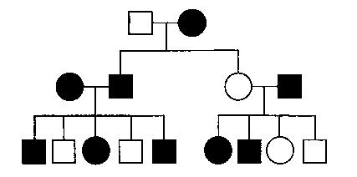
a. ½ x ½ b. ½ + ½
c. ½ ÷ ½ d. ½

- In corn, the trait for tall plants (T) is dominant to the trait for dwarf plants (t) and the trait for colored kernels (C) is dominant to the trait for white kernels (c). In a particular cross of corn plants, the probability of an offspring being tall is 1/2 and the probability of a kernel being colored is 3/4. Which of the following most probably represents the parental genotypes?

a. TtCc x ttCc b. TtCc x TtCc c. TtCc x ttcc d. TTCc x ttCc

- A form of vitamin D-resistant rickets, known as hypophosphatemia, is inherited as an X-linked dominant trait. If a male with hypophosphatemia marries a normal female, which of the following predictions concerning their potential progeny would be true?

a. All of their sons would inherit the disease.

b. All of their daughters would inherit the disease.
c. About 50% of their sons would inherit the disease.
d. About 50% of their daughters would inherit the disease.

- In fruit flies, vermilion eyes are a sex-linked recessive characteristic. If a vermilion-eyed female is crossed with a wild-type male, what proportion of the male offspring should have vermilion eyes?

a. 0% b. 25% c. 50% d. 100%

- If red hair, blue eyes, and freckles were consistently inherited together, the best explanation would be that
a. these traits are recessive characteristics
b. crossing over has occurred

c. the genes for these traits are linked on the same chromosome d. gene duplications have occurred

Questions 9-11 refer to the pedigree below.

- The genotype of the P1 male must be a. OO

b. AO c. BO d. AB

- The only other possible genotype for children of the F1 AB male would be

a. OO b. BO c. AO d. AB

- The most likely genotype of the mate of the F1 AO female is a. AB

b. BB c. OO d. AA

- Trout in stream A and trout in stream B look similar, but not quite identical. Scientists were unsure if they were two populations of one fish species, or two separate species. To figure this out, they studied the life cycle, habitat, and reproduction of the trout. In a year with a typical amount of rainfall, the trout stay within their own stream and mate with individuals that live nearby. However, in years that include excessive rainfall and flooding, the fish are washed downstream to a larger river, and must swim back up into either stream A or stream B. They choose which stream to swim up randomly, often ending up in a different location than where they themselves were born. When a trout that originated from stream A does breed with a trout from stream B, their offspring are healthy and show no decrease in fertility. Scientists think that flooding in this watershed is happening more and more frequently, due to global climate change. Given this information, predict what is the most likely result for trout A and trout B.

a. they will become reproductive isolated from each other b. they will become more similar in their gene pools
c. they will go through random changes due to genetic drift
d. they will adapt to different conditions and look more and more different

- The Hardy-Weinberg formula is used to estimate the frequency of carriers of alleles that cause genetic disorders and traits. In considering the Hardy-Weinberg equilibrium equation

a. p represents the number of dominant individuals. b. q represents the number of recessive individuals.

c. p² + 2pq represents the percent of individuals expressing the dominant phenotype. d. q² represents the number of recessive alleles.
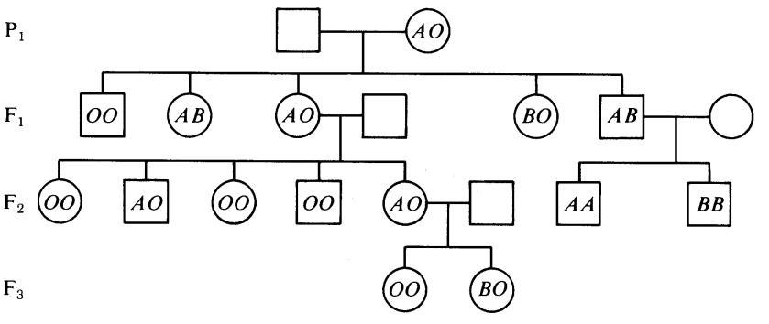

Questions 14-15. The graph to the right shows the growth rates of populations of bacteria that have evolved for many generations at different culture temperatures (25°C, 30°C, and 35°C). Each population grows over only a limited range of temperatures (its thermal niche), which are bounded by its critical thermal limits. Within this range, growth rate increases with temperature up to a maximal value and then declines rapidly with increasing temperature. Growth rates are known to be the major determinant of fitness for these bacteria.
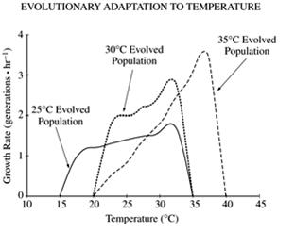

- Which of the following is true concerning the thermal dependence of growth rate between 25°C and 30°C in these populations?

a. Thermal dependence is greatest in the population evolved at 25°C.

b. Thermal dependence is greatest in the population evolved at 30°C. c. Thermal dependence is greatest in the population evolved at 35°C.

d. Growth rates of all populations are equally thermally dependent over this temperature range.

- If all three populations were mixed together and placed at 37°C, which of the following would be most likely to happen?

a. Only the population evolved at 25°C would die and become extinct. b. Only the population evolved at 35°C would survive and reproduce. c. All the bacteria would die and the populations would become extinct.
d. All populations would grow, and transfer of genes would create one common population.

Questions 16-18. One of the classical examples of evolution occurs on the Galápagos Islands with Darwin’s finches. The islands have always been separate from the South American mainland and vary in size and elevation. The lowlands are covered with thorn scrub, while higher elevations (found only on the larger islands) are covered with moist, dense forests. All the organisms living on these islands are descendants of species that have emigrated there, primarily from South America. In studying the finch populations, researchers have identified fourteen species, none of which are found on the mainland.

- The initial colonizing population of finches most likely exhibited which of the following? a. Hybridization with bird species already existing on the islands

b. High rates of interbreeding with mainland populations c. Increased rates of mutation to fill habitats
d. A smaller gene pool than that of the mainland populations

- Initially, one species of finch may have settled on two different islands, maintained this separation over hundreds of years, and eventually followed divergent adaptive pathways. If these now two separate species should migrate onto a new island, they could maintain their individual species identities on this island in all the following ways EXCEPT if one species

a. hybridizes successfully with the other species
b. lives in the forests and the other in the scrubland

c. carries out different stages of its life cycle at different times than the other species d. fails to produce viable young after mating with the other species

- Although the initial finch species on the islands may have all been seed eaters, which of the following processes minimized competition as the population expanded?
a. Selection for niche diversification
b. Development of more efficient attack behavior

c. Further emigration when carrying capacity was reached d. Genetic drift

- As many as 60% of people in malaria-infected regions of Africa have the sickle-cell allele, but only about 10% of the U.S. population of African ancestry carries the allele. Malaria remains a major disease in central Africa but has not been a serious problem in the U.S. for many generations. What are the reasons for the difference in the percentages and what is a reasonable statement about future percentages?

a. The presence of malaria in Africa maintains the advantage of the heterozygous sickle-cell trait, and the prevalence of malaria will likely continue to preserve the 60% rate in Africa. However, we would predict that the prevalence of the sickle-cell trait will continue to decline in the African-American population.

b. The difference is due to lack of interbreeding between the African and African-American populations. We would expect travel and gene flow to increase in human populations, until native Africans and African-Americans both level off at about a 35% rate.

c. African-Americans have a lower rate of sickle cell because not all of their ancestors migrated from the regions of Africa infected by malaria. However, now that new therapies are treating sickle-cell anemia among African-Americans, we expect the prevalence of sickle-cell anemia to rise in the African-American population until it reaches the 60% mark.

d. Natural selection is affecting the African-American population, reducing the prevalence of a harmful allele, but natural selection is not affecting the African population. We expect the African-American population to continue decreasing the prevalence of the sickle-cell trait, but the African population to remain unchanged until affected by genetic drift.

- Guppies are small fish found in streams in Venezuela. Male guppies are brightly colored, with black, red, blue and iridescent (reflective) spots. Males cannot be too brightly colored or they will be seen and consumed by predators, but if they are too plain, females will choose other males. Natural selection and sexual selection push in opposite directions. When a guppy population lives in a stream in the absence of predators, the proportion of males that are bright and flashy increases in the population. If a few aggressive predators are added to the same stream, the proportion of brightly-colored males decreases with about 5 months (3-4 generations). The effects of predators on guppy coloration have been studied in artificial ponds with mild, aggressive, and no predators, and by similar manipulations of predators in natural stream environments.

Fitness is a term often used by biologists to explain the evolutionary success of certain organisms. Which feature would a biologist consider to be most important in determining which guppies are “most fit?”

a. Large body size and ability to swim quickly away from predators. b. Excellent ability to compete for food.

c. High number of offspring that survive to reproductive age. d. High number of matings with many different females.

- Populations of a plant species have been found growing in the mountains at altitudes above 2,500 meters. Populations of a plant that appears similar, with slight differences, have been found in the same mountains at altitudes below 2,300 meters.

Which of the following describe TWO kinds of data that could be collected to provide a direct answer to the question, do the populations growing above 2,500 meters and the populations growing below 2,300 meters represent a single species? a. Rate of hybrid death, rate of hybrid success.

b. Number of differences between the species and the rate of reproductive success.
c. Rate of successful interbreeding between the populations, occurrence of hybrid fertility.
d. Ability of upper plant species to grow in the altitudes below 2,300 meters, and length of life of hybrids

- In a certain prairie community, a dominant prairie grass species has an allele frequency of P = .7 and q = .3. Ten years ago there was a wild fire on the prairie, which resulted in the death of 80% of the prairie grass. Over the past ten years the population has rebounded and currently the allele frequencies are P = .1, q = .9 Which of the following justifies this data?

a. The new allele frequencies are due to selective pressure placed on the dominant allele.

b. The reduction in the dominant allele frequencies is due to a less favorable trait, which resulted in selection against the allele

c. The increase in the recessive allele frequency is due to the combined effects of a bottleneck and genetic drift. d. The change in the allele frequencies is due to the migration of new species in the area once the competition was reduced.

- The introduction of antibiotics such as penicillin several years ago was immediately effective in combating infections caused by Staphylococcus. In 1958, however, there were several outbreaks of staphylococcal infections. People with the infections did not respond to treatment with any of the antibiotics and there were a large number of deaths. The best explanation for this situation is that

a. the bacteria from other hosts such as birds, cats, and dogs migrated into human hosts b. the bacteria exposed to non-lethal doses of antibiotics quickly learned to avoid them c. each generation of bacteria acquired the ability to use antibiotics as nutrients

d. antibiotic-resistant bacteria survived and multiplied, and these were the forms causing the infections

Species | 1 | 2 | 3 | 4 | 5
1 | - | 3 | 19 | 18 | 27
2 |  | - | 19 | 18 | 26
3 |  |  | - | 1 | 27
4 |  |  |  | - | 27

24. Which of the following phylogenetic trees is the most consistent with the data above?
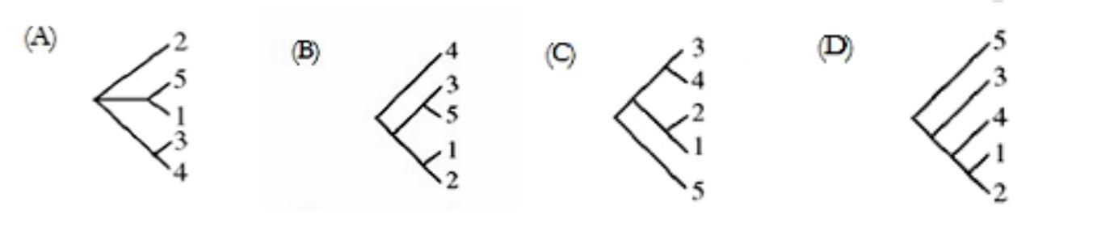

a. |  | b. |  | c. |  | d.

Questions 25-26 Refer to the phylogenetic tree below.
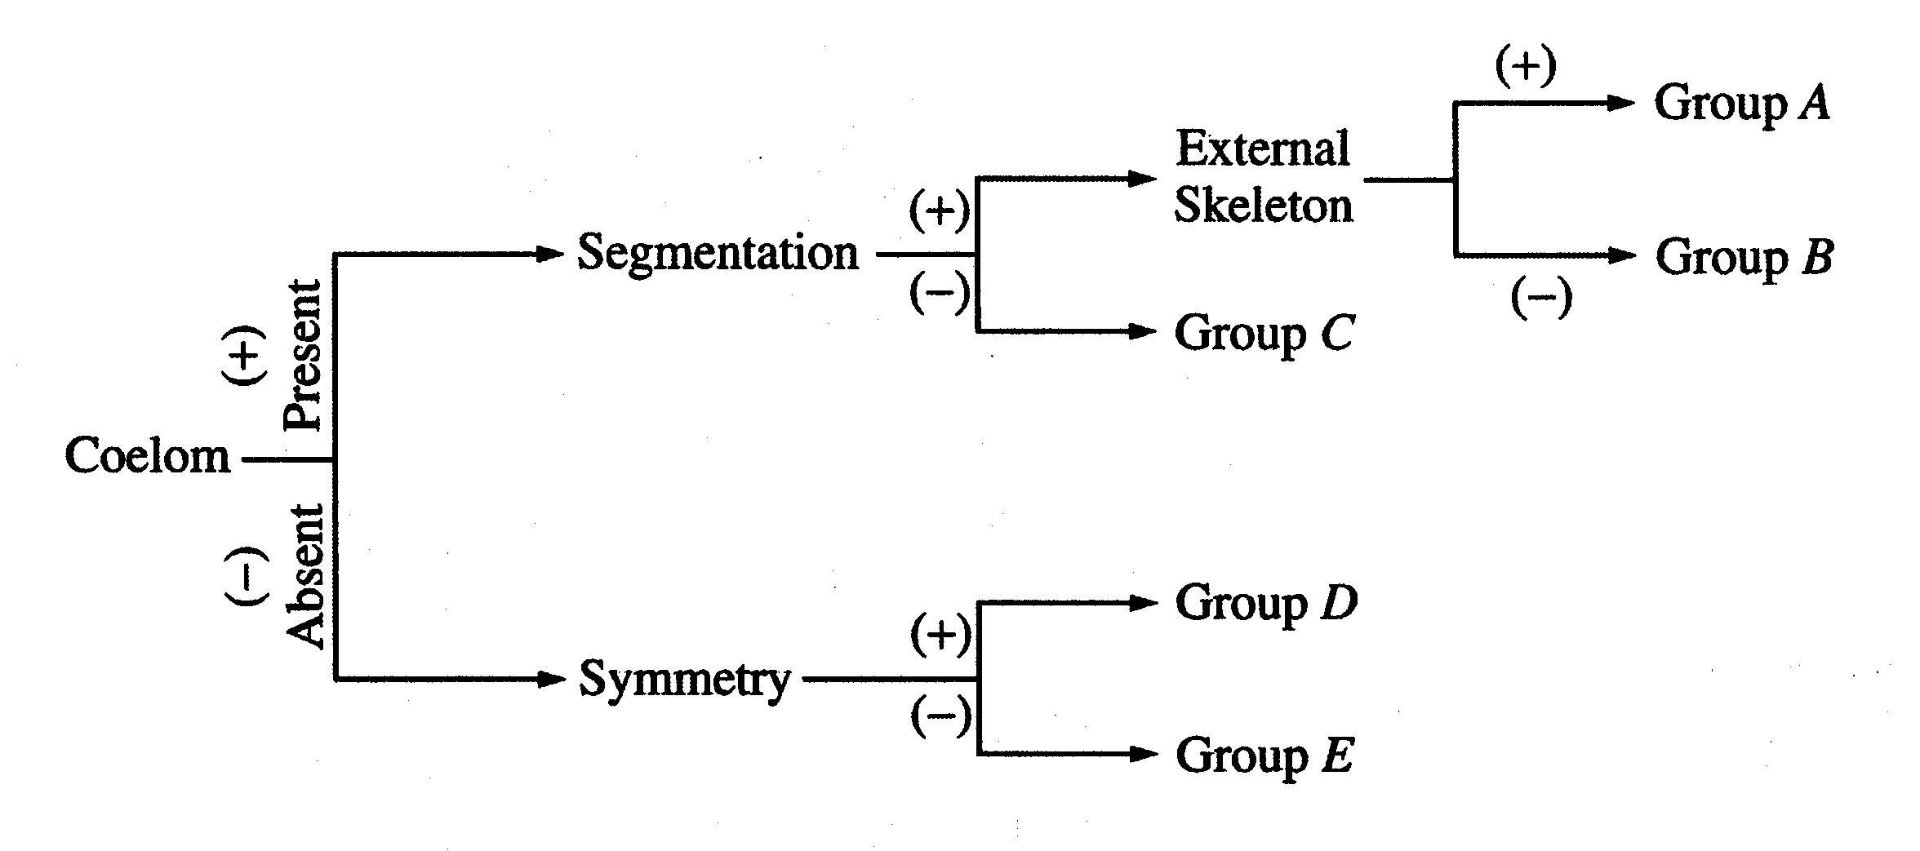

- Centipedes and millipedes should NOT be placed in group B because they a. have an exoskeleton

b. display segmentation c. have a coelom
d. are heterotrophic

- All organisms in this tree have which of the following present, and why? a. Prokaryotic cells – because they are the most primitive type of cells

b. Cilia – because they all move

c. Glycolysis – because it is conserved across all recognized domains d. Mitochondria – because that is where cellular respiration occurs

- Which of the following is most often associated with the elaborate courtship rituals conducted by many birds? a. species recognition
b. migration

c. feeding response d. altruism
e. kin selection

- The differences in cricket calls among sympatric species of crickets are examples of a. habitat isolation

b. temporal isolation

c. physiological isolation d. behavioral isolation e. geographical isolation

- Which of the following statements best expresses the concept of punctuated equilibrium? a. Small variations gradually accumulate in evolving lineages over periods of millions of years.

b. Random mating ensures that the proportions of genotypes in a population remain unchanged from generation to generation.

c. Stability is achieved when selection favors the heterozygote, while both types of homozygotes are at a relative disadvantage.

d. Evolutionary changes consist of rapid bursts of speciation alternating with long periods in which species remain essentially unmodified.
e. Under competition for identical resources, one of the two competing species will be eliminated or excluded.

- Which of the following principles is NOT part of Darwin’s theory of evolution by natural selection?
a. Evolution is a gradual process that occurs over long periods of time.
b. Variation occurs among individuals in a population.
c. Mutations are the ultimate source of genetic variation
d. More individuals are born than will survive
e. Individuals that possess the most favorable variations have the best chance of reproducing.

Questions 31-32. In a certain flock of sheep, 4 percent of the population has black wool and 96 percent has white wool.
Assume Hardy-Weinberg equilibrium.

- If black wool is a recessive trait, what percentage of the population is heterozygous for this trait? a. 4%

b. 20% c. 32% d. 64% e. 80%

- What percentage of the population is homozygous for white wool?
- 20%
- 40%
- 64%
- 80%
- 96%

- A represents the dominant allele and a represents the recessive allele of a pair. If, in 1000 offspring, 500 are aa and

- are of some other genotype, which of the following are most probably the genotypes of the parents? a. Aa and Aa

b. Aa and aa c. AA and Aa d. AA and aa e. aa and aa

- Which of the following is the most likely explanation for a high rate of crossing-over between two genes?
a. The two genes are far apart on the same chromosome.
b. The two genes are both located near the centromere.
- The two genes are sex-linked.

- The two genes code for the same protein.
- The two genes are on different chromosomes.

Practice Long Response Questions: Make an outline of the information you would include in each of these essays.

*For number one, please do all calculations for part a & b.

- In fruit flies, the phenotype for eye color is determined by a certain locus. E indicates the dominant allele and e indicates the recessive allele. The cross between a male wild-type fruit fly and a female white-eyed fruit fly produced the following offspring:

 | Wild-type | Wild-type | White-eyed | White-eyed | Brown-eyed
 | Male | Female | Male | Female | Female
F1 | 0 | 45 | 55 | 0 | 1

The wild-type and white-eyed individuals from the F1 generation were then crossed to produce the following offspring

F2 23 31 22 24 0

- Determine the genotypes of the original parents (P generation) and explain your reasoning. You may use punnett squares to enhance your description, but the results from the punnett squares must be discussed in your answer.

- Use a Chi-squared test on the F2 generation data to analyze your prediction of the parental genotypes. Show all your work and explain the importance of your final answer.

- The brown-eyed female in the F1 generation resulted from a mutational change. Explain what a mutation is, and discuss two types of mutations that might have produced the brown-eyed female in the F1 generation.

- A new species of fly was discovered on an island in the South Pacific. Several different crosses were performed, each using 100 females and 100 males. The phenotypes of the parents and the resulting offspring were recorded.

Cross I: True-breeding bronze-eyed males were crossed with true-breeding red-eyed females. All the F1 offspring had bronze eyes. F1 flies were crossed, and the data for the resulting F2 flies are given in the table below.

F2 Phenotype | Male | Female
Bronze Eyes | 3,720 | 3,800
Red Eyes | 1,260 | 1,320

Cross II: True-breeding normal-winged males were crossed with true-breeding stunted-winged females. All the
F1 offspring had stunted wings. F1 flies were crossed, and the data for the resulting F2 flies are given in the table below.

F2 Phenotype | Male | Female
Normal Wings | 1,160 | 1,320
Stunted Wings | 3,600 | 3,820

Cross III: True-breeding bronze-eyed, stunted-winged males were crossed with true-breeding red-eyed, normal-winged females. All the F1 offspring had bronze eyes and stunted wings. The F1 flies were crossed with true-breeding red-eyed, normal-winged flies, and the results are shown in the table below.

F2 Phenotype | Male | Female
Bronze Eyes, Stunted Wings | 2,360 | 2,220
Bronze Eyes, Normal Wings | 220 | 300
Red Eyes, Stunted Wings | 260 | 220
Red Eyes, Normal Wings | 2,240 | 2,180

- What conclusions can be drawn from cross I and cross II? Explain how the data support your conclusions for each cross.

- What conclusions can be drawn from the data from cross III? Explain how the data support your conclusions.

- Identify and discuss TWO different factors that would affect whether the island’s fly population is in Hardy-Weinberg equilibrium for the traits above.

- Charles Darwin proposed that evolution by natural selection was the basis for the differences that he saw in similar organisms as he traveled and collected specimens in South America and on the Galapagos Islands.

a. Explain the theory of evolution by natural selection as presented by Darwin.
b. Each of the following relates to an aspect of evolution by natural selection. Explain THREE of the following.

  - Convergent evolution and the similarities among species (ecological equivalents) in a particular biome (e.g., tundra, taiga, etc.)

  - Natural selection and the formation of insecticide-resistant insects or antibiotic resistant
  - bacteria
  - Speciation and isolation
  - Natural selection and behavior such as kinesis, fixed-action-pattern, dominance hierarchy, etc.
  - Natural selection and heterozygote advantage

- Phylogeny is the evolutionary history of a species.

- The evolution of a species is dependent on changes in the genome of the species. Identify TWO mechanisms of genetic change, and explain how each affects genetic variation.

- Based on the data in the table below, draw a phylogenetic tree that reflects the evolutionary relationships of the organisms based on the differences in their cytochrome c amino-acid sequences and explain the relationships of the organisms. Based on the data, identify which organism is most closely related to the chicken and explain your choice.

- Describe TWO types of evidence—other than the comparison of proteins—that can be used to determine the phylogeny of organisms. Discuss one strength of each type of evidence you described.

THE NUMBER OF AMINO ACID DIFFERENCES IN CYTOCHROME c AMONG VARIOUS ORGANISMS

 | Horse | Donkey | Chicken | Pengiun | Snake
Horse | 0 | 1 | 11 | 13 | 21
Donkey |  | 0 | 10 | 12 | 20
Chicken |  |  | 0 | 3 | 18
Penguin |  |  |  | 0 | 17
Snake |  |  |  |  | 0

Name: _____________________________________________ Date: ____________________________

AP Biology Exam Review 5: Enzymes & Metabolism (Photosynthesis & Respiration)

Helpful Videos and Animations:
- Bozeman Biology: Photosynthesis and Respiration
- Bozeman Biology: Photosynthesis
- Bozeman Biology: Cellular Respiration

Relevant Objectives:

- Explain the function of an enzyme and describe how an enzyme works

- Explain factors influencing enzyme activity ([Substrate], [Enzyme], pH, temperature, [Ion], and describe how these factors influence activity

- Be able to determine the rate of an enzyme catalyzed reaction from a graph or data table and compare and contrast rates
- Explain how activators and inhibitors effect enzyme activity

- Differentiate between different types of inhibitors - competitive, non-competitive, irreversible
- Describe the function of plant pigments and explain the adaptive purpose of plants having multiple pigments
- Explain how ATP stores and releases energy
- Know the equation for photosynthesis
- Describe the light reaction of photosynthesis and explain the purpose of it
- Be able to name the reactants and products of the light reactions
- Name the electron carrier in photosynthesis
- Describe the Calvin Cycle (Light-Independent Reactions) of photosynthesis and explain the purpose of it
- Be able to name the reactants and products of the Calvin Cycle
- Explain how water potential effects the movement of water
- Describe how plants transport water and nutrients throughout

- Describe transpiration and explain how guard cells regulate water loss and CO2 levels
- Name the electron carriers in cellular respiration
- Describe the process of glycolysis, naming the reactants, products, and where it occurs in the cell
- Explain how NAD⁺ is recycled after glycolysis

- Describe the difference between aerobic and anaerobic respiration
- Describe the Krebs cycle, naming the reactants, products, and where it occurs in the cell
- Describe the ETC, naming the reactants, products, and where it occurs in the cell
- Explain how the ETC is used to produce ATP
- Be able to do energy accounting for each step in respiration
- Explain how exercise effects the rate of cellular respiration

Topic Outline:
1. Photosynthesis (Endergonic reaction – captures energy and stores in glucose)

- Autotophs (producers) – organism that uses energy from the sun (photosynthesis) or chemicals (chemosynthesis) to producer their own food; different from heterotrophs, which must eat food
• Equation: in the presence of sunlight
  - 6CO2 + 6 H2O C6H12O6 + 6O2

- Structure of a chloroplast – double membrane bound organelle; outer membrane and inner membrane of sacs

- Cells with high concentrations of chloroplasts in mesophyll tissue of leaf
- Structures within a chloroplast:

  - Stroma – open space within the chloroplast; light-independent reactions (Calvin Cycle) take place here

- Thylakoid – membrane bound sacs within the chloroplast, in stacks of grana; ; light-dependent reactions take place here
- Granum – stacks of thylakoid
- Thylakoid space – space within the membranes of thylakoids

- Stomata – on bottom of leaves
    - Open to allow CO2 in to leaves and O2 out of leaves, allows H2O out of leaves.
      - H2O leaving stomata (transpiration) aids in water transport throughout plant

      - Low water content = stoma close (no CO2 coming in for photosynthesis); high water content = stoma open; controlled by turgor pressure in guard cells
- Two steps in Photosynthesis: Light Reactions and Calvin Cycle (Light-Independent Reactions)
I. Light Reactions (in thylakoid membrane)

- In Photosystem II, light is absorbed by chlorophyll. Light excites electrons in photosystem II and the electrons travel down an electron transport chain to photosysthem I, generating ATP using chemiosmosis to power the addition of a phosphate group to ADP (ADP → ATP); this process is called photophosphorylation

  - Water is split when electrons are removed from photosystem II, and O2 is released from the
stomata; replenishes e⁻ in photosystem II, and provides H⁺ ions to drive production of ATP
- Light re-excites the electrons at photosystem I, and again the electrons fall down an electron

transport chain. This time, they do not fall all the way down the transport chain, instead they are transferred to NADP⁺ in a high energy state, along with an H⁺ (NADP⁺ → NADPH)
- NADP⁺ and ATP go to the stroma to be used in the Calvin cycle
  - Other accessory pigments are able to absorb light as well (carotenoids, xanthophylls); these pigments transfer light energy to the reaction centers of photosystem I or II

    - Reading absorption spectra – light reflected (not absorbed) = color of pigment II. Calvin Cycle (in stroma)

  - Electrons and H⁺ from NADPH and energy from ATP are used to reduce CO2 into organic molecules (Glyceraldehyde-3 Phosphate/G3P, the precursor molecule to glucose) in a process

called carbon fixation

    - Ribulose bisphosphate (RuBP) is the molecule that combines with CO2 to start the Calvin cycle; RuBisCO enzyme catalyzes this reaction, thus fixing carbon

- Cellular Respiration (Exergonic reaction – releases energy from glucose)
  - Aerobic cellular respiration and anaerobic cellular respiration (aka fermentation)
  - Aerobic = with oxygen, in the mitochondria; anaerobic = without oxygen, in the cytoplasm
- Equation:
o C6H12O6 + 6O2 ^{enzymes} 6H2O + 6CO2

- Structure of mitochondria – double membrane bound organelle; outer membrane and highly folded inner membrane (cristae) to increase surface area for maximum number of reactions

- Structures within a mitochondria:
- Outer membrane – outermost membrane of mitochondria
- Intermembrane space – space between outer and inner membrane
  - Inner membrane – inner most membrane of mitochondria, highly folded
  - Cristae – folds of inner membrane
  - Matrix – space inside the inner membrane of the mitochondria

- A Series of Redox Reactions: Oxidation (loss of electrons/energy); reduction (gain of electrons/energy)
- Step 1: Gycolysis
  - In cytosol
  - Glucose broken apart → 2 Pyruvate

    - electrons and H⁺ taken from glucose to reduce 2NAD+ → 2NADH; 2 net ATP gained
- Intermediate Step: Oxidation of Pyruvate
  - Transport protein moves pyruvate from cytosol to matrix of mitochondrion
  - 2 Pyruvate → 2 Acetyl CoA
    - an enzyme removes CO2 from pyruvate, takes away electrons to reduce NAD+ → NADH, and adds coenzyme A

    - Happens twice (once per pyruvate) = 2 NADH, 2 CO2, 2 Acetyl CoA

- Step 2: Citric Acid Cycle (Krebs Cycle)
  - In mitochondria
- 2 turns of the cycle (1 per acetyl CoA) → one molecule of glucose is fully oxidized to CO2
  - A series of redox reactions produces 2 CO2, 3 NADH, 1 FADH2 and 1 ATP per turn of the cycle

  - Total (1 turn x 2 acetyl CoA) = 4 CO2, 6 NADH, 2 FADH2, 2 ATP

- Step 3: Electron Transport Chain and Chemiosmosis o Both happen inside the mitochondira

o ETC

  - NADH and FADH2 “dump” high-energy electrons off to the inner mitochondrial membrane’s electron transport chain

  - Electrons lose energy as they are transferred from one protein to the next

  - Proteins use energy from electrons passed between them to pump H⁺ across the inner mitochondrial membrane into the intermembrane space

  - Final electron acceptor is O2 (O2 combines with H⁺ after chemiosmosis → H2O released) o Chemiosmosis

  - H⁺ flow back down their gradient (proton motive force) through a channel in ATP synthase into the matrix

  - ATP synthase turns and creates ATP from ADP and Pi; 26-28 ATP produced

  - Chemiosmosis is an energy-coupling mechanism that uses energy stored in the form of an H⁺ gradient across a membrane to drive cellular work (creation of ATP by ATP synthase)
  - This method of making ATP is known as oxidative phosphorylation (ADP is phosphorylated and oxygen is necessary to keep the electrons flowing)

  - Oxidative phosphorylation accounts most of the ATP created during cellular respiration

- Fermentation/Anaerobic Respiration (creating ATP without oxygen)

- Occurs after glycolysis (the Kreb’s/Citric Acid Cycle and Electron Transport Chain are not used) o Glycolysis = 2 ATP

o Reactions regenerate NAD⁺ to act as an electron acceptor for electrons released during the breakdown of glucose to pyruvate
o 2 Types of Fermentation – alcoholic fermentation and lactic acid fermentation

  - Alcohol Fermentation – pyruvate is converted to ethanol, releasing CO2 and regenerating NAD+ from NADH

  - Lactic Acid Fermentation – pyruvate is reduced by NADH (NAD⁺ is formed in the process), and lactate is formed as a waste product

  - Facultative anaerobes can use aerobic respiration if oxygen is present but can switch to fermentation under anaerobic conditions; obligate anaerobes cannot survive in the presence of oxygen

- Enzymes – see review packet 1 (Biochemistry)

Practice Multiple Choice Questions:

- An airtight, temperature-controlled glass box containing actively growing tomato plants was placed under a light source. Plastic wrapping that only transmits green light was placed over the box, and two days later air samples from inside the box were collected and analyzed. The most likely change in air quality is

a. an increase in nitrogen (N2)

b. an increase in carbon dioxide (CO2) c. an increase in oxygen (O2)

d. a decrease in carbon dioxide (CO2)

- In photosynthesis, if the input water is labeled with a radioactive isotope of oxygen, ¹⁸O, then the oxygen gas released as the reaction proceeds is also labeled with ¹⁸O. Which of the following is the most likely explanation?
a. During the light reactions of photosynthesis, water is split, the hydrogen atoms combine with the CO2, and oxygen gas is released.

b. During the light reactions of photosynthesis, water is split, removing electrons and protons, and oxygen gas is released. c. During the Calvin cycle, water is split, regenerating NADPH from NADP+, and oxygen gas is released.

d. During the Calvin cycle, water is split, the hydrogen atoms are added to intermediates of sugar synthesis, and oxygen gas is released.

- The end products of the light-dependent reactions of photosynthesis are

a. ADP, H2O, NADPH b. ADP, G3P, RuBP c. ATP, CO2, H2O d. ATP, NADPH, O2 e. CO2, H+, G3P

Questions 4 & 5. Frogs of three different species are weighed and the amount of oxygen consumed by each species is determined by placing them in a respirometer for 1 hour. The results of this experiment are listed below.

 |  | Average | Total Cubic Centimeters of Oxygen
Species |  | Weight in Grams |  | Consumed in 1 Hour
1 |  | 15 |  | 0.75
2 |  | 11 | 0.55
3 |  | 21 | 1.05

4. From the information in the table, it is most reasonable to conclude that

a. since all frogs respire through their skin, smaller frogs with smaller surface areas will consume less oxygen per gram of body weight than larger frogs with larger surface areas
b. frogs placed in a warm environment will respire more rapidly than frogs placed in a colder environment

- each species of frog has its own unique rate of respiration
- the amount of oxygen consumed per gram of body weight for each species is the same

- During aerobic cellular respiration, oxygen gas is consumed at the same rate as carbon dioxide gas is produced. In order to provide accurate volumetric measurements of oxygen gas consumption, the experimental setup should include which of the following?

a. A substance that removes carbon dioxide gas b. A plant to produce oxygen
c. A glucose reserve
d. A valve to release excess water

Questions 6-8. The graph below shows the relationship of photosynthetic rate and irradiance (light intensity) influenced by both temperature and carbon dioxide level.
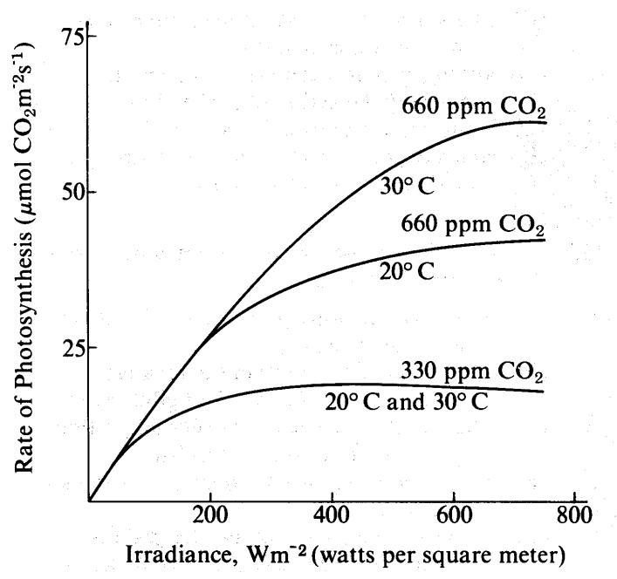

- According to the graph, the greatest rate of photosynthesis occurs when CO2 is present at

a. high concentrations and low temperatures b. low concentrations and high temperatures

c. high concentrations and low irradiance levels d. high concentrations and high irradiance levels

- From the data in the graph, which of the following conclusions is most reasonable?

a. The rate of photosynthesis is inversely proportional to light intensity.

b. The rate of photosynthesis at 660 ppm CO2 is more dependent on temperature than the rate at 330 ppm CO2.

c. There is no theoretical maximum for the rate of photosynthesis. d. Attempts to increase the photosynthetic yield in field crops

should involve the lowering of CO2 levels.

- Which of the following seems most likely from the data?

a. Light produces heat, which causes increases in the rates of photosynthesis.

b. Light causes the saturation of cytochrome oxidase, which then limits the use of CO2.

- The photosynthetic rate could be increased further by decreasing the CO2 concentration.

- Increasing irradiance levels above 800 Wm^{–2} would have less effect on the rate of photosynthesis than would increasing the CO2 concentration.

9. Which of the following enzymes is responsible for CO2 fixation in C3 plants?

a. succinate dehydrogenase b. RuBP carboxylase c. hexokinase d. amylase e. DNA polymerase

Questions 10-13. A tissue culture of vertebrate muscle was provided with a constant excess supply of glucose under anaerobic conditions starting at time zero and the amounts of pyruvic acid and ATP produced were measured. The solid line in the graph below represents the pyruvic acid produced in moles per liter per minute. ATP levels were also found to be highest at points A and C, lowest at B and D. A second culture was set up under the same conditions, except that substance X was added, and the results are indicated by the dotted line.
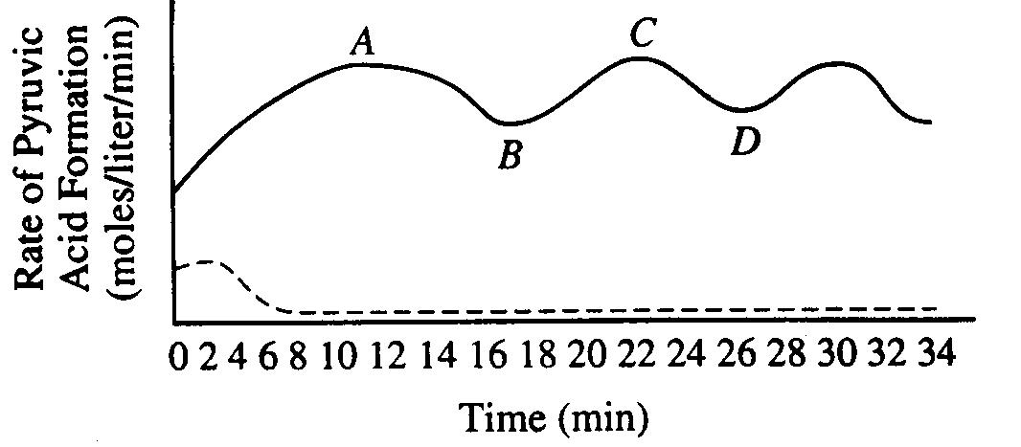

- The rate of pyruvic acid formation fluctuates because a. all glucose has reacted
b. all enzymes have been used up

c. the reaction is accelerated by positive feedback d. the reaction is affected by negative feedback

- Which of the following best accounts for the shape of the solid line between points A and D?

a. After ten minutes the cellular enzymes became ineffective b. Respiration became uncontrolled

c. ATP acted as an allosteric inhibitor on one or more of the enzymes d. The measurements of pyruvic acid were unreliable

12. It is most reasonable to hypothesize that, in the breakdown of glucose, substance X is
a. an activator b. an inhibitor
c. a substrate d. a coenzyme

- Which of the following is most likely to result if oxygen is added to the tissue culture? a. Lactic acid formation will increase

b. For each glucose molecule consumed, more ATP will be formed c. The levels of ATP produced will decrease
d. Ethyl alcohol will be produced

- If plants are grown for several days in an atmosphere containing ¹⁴CO2 in place of ¹²CO2, one would expect to find a. very little radioactivity in the growing leaves

b. large amounts of radioactive water released from the stomates c. a large increase in ¹⁴C in the starch stored in the roots
d. a large decrease in the rate of carbon fixation in the guard cells

e. an increase in the activity of RuBP carboxylase in the photosynthetic cells

- During respiration, most ATP is formed as a direct result of the net movement of
a. potassium against a concentration gradient
b. protons down a concentration gradient

c. electrons against a concentration gradient
d. electrons through a channel
e. sodium into the cell

- On a sunny day, the closing of stomata in plant leaves results in a. a decrease in CO2 intake

b. a loss of water from the plant c. an increase in transpiration

d. an increase in the concentration of CO2 in mesophyll cells e. an increase in the rate of production of starch

- Oxygen consumption can be used as a measure of metabolic rate because oxygen is a. necessary for ATP synthesis by oxidative phosphorylation

b. necessary to replenish glycogen levels c. necessary for fermentation to take place d. required by all living organisms

e. required to break down the ethanol that is produced in muscles

- All of the following statements are correct about enzymes EXCEPT a. they enable reactions to occur at a relatively low temperature

b. they remain unchanged during a reaction
c. they raise the energy of activation of all reactions
d. they are often located within the plasma membrane of a cell

- The role of oxygen in aerobic respiration is

- to transport CO2
- most important in the Krebs Cycle

- to provide electrons for the electron transport chain

- as the final H2 acceptor in the electron transport chain

C6H12O6 + 6O2 6H2O + 6CO2 + 38ATP

- The process shown above is a. reduction and is endergonic b. reduction and is exergonic c. oxidation and is endergonic d. oxidation and is exergonic

- Most energy during cellular respiration is harvested during a. the Krebs cycle

b. oxidative phosphorylation c. glycolysis
d. anaerobic respiration

- After strenuous exercise, a muscle cell would contain decreased amounts of ______ and increased amounts of _____. a. glucose; ATP

b. ATP; glucose c. ATP; lactic acid d. lactic acid; ATP

- The ATP produced during glycolysis is generated by which of the following?
a. the electron transport chain
b. substrate level phosphorylation
c. oxidative phosphorylation
d. chemiosmosis

- Glycolysis is a complex, enzyme-controlled set of reactions. One of the enzymes at the beginning of glucose is PFK, phosphofructokinase, an enzyme which is allosterically inhibited by ATP. Which of the following statements best explains the importance of the enzyme PFK in glycolysis?

a. PFK inhibits glycolysis when oxygen levels are high

b. PFK enables glycolysis to continue when no oxygen is present c. PFK inhibits the production of ATP when ATP levels are high d. PFD enhances the production of ATP when ATP levels are high

- The graph below shows an absorption spectrum for an
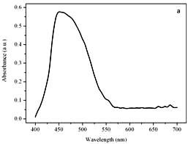
unknown pigment molecule. What color would this pigment appear?
- red
- orange
- green

- blue

Violet Blue Green Yellow Orange Red

Questions 26-32. Indicate which of the following events occurs during
- light-dependent reactions
- light-independent reactions

26. | Oxygen is released | 27. | Carbon gets reduced | 28. Oxidative phosphorylation
29. | ATP is produced | 30. | Electrons flow through an electron transport chain
31. | Oxidation of NADPH | 32. | Reduction of NADP⁺

- Which of the following probably evolved first? a. the Krebs cycle

b. oxidative phosphorylation c. glycolysis
d. the electron transport chain

- Which process of cell respiration is most closely associated with intracellular membranes? a. oxidative phosphorylation

b. the Krebs Cycle c. glycolysis
d. substrate level phosphorylation

- The reaction shown to the right is
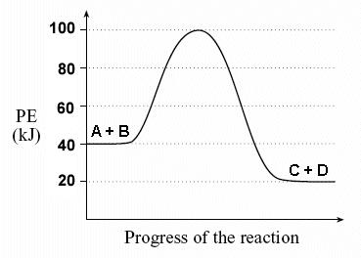
a. endergonic because energy is released b. exergonic because energy is released c. endergonic because energy is captured d. exergonic because energy is captured

Practice Long Response Questions:

- An agricultural biologist was evaluating two newly developed varieties of wheat as potential crops. In an experiment, seedlings were germinated on moist paper towels at 20ºC for 48 hours. Oxygen consumption of the two-day-old seedlings was measured at different temperatures. The data are shown in the graph below.
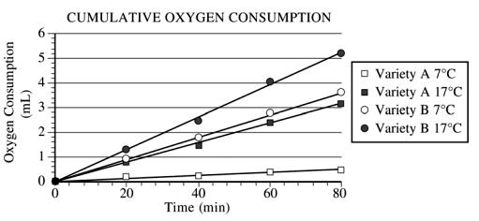

- Calculate the rates of oxygen consumption in mL/min for each variety of wheat at 7°C and at 17°C. Show your work (including your setup and calculation).

- Explain the relationship between metabolism and oxygen consumption. Discuss the effect of temperature on metabolism for each variety of seedlings.

- In a second experiment, variety A seedlings at both temperatures were treated with a chemical that prevents NADH from being oxidized to NAD⁺. Predict the most likely effect of the chemical on metabolism and oxygen consumption of the treated seedlings. Explain your prediction.

- ATP and GTP are primary sources of energy for biochemical reactions. a. Describe the structure of the ATP or the GTP molecule.
b. Explain how chemiosmosis produces ATP.
c. Describe TWO specific cell processes that require ATP and explain how ATP is used in each process.

- A controlled experiment was conducted to analyze the effects of darkness and boiling on photosynthetic rate of incubated chloroplast suspension. The dye reduction technique was used. Each chloroplast suspension was mixed with DPIP, an electron acceptor that changes from blue to clear when it is reduced. Each sample was placed in individually in a spectrophotometer and the percent transmittance was recorded. (Hint: The percent transmittance is higher through clear liquid than blue liquid!) The three samples used were prepared as follows:
  - Sample 1 – chloroplast suspension + DPIP
  - Sample 2 – chloroplast suspension surrounded by foil wrap to provide a dark environment + DPIP
  - Sample 3 – chloroplast suspension that has been boiled + DPIP

 | Light, unboiled | Dark, Unboiled | Light, Boiled
Time (min) | % Transmittance | % Transmittance | % Transmittance
 | Sample 1 | Sample 2 | Sample 3
0 | 28.8 | 29.2 | 28.8
5 | 48.7 | 30.1 | 29.2
10 | 57.8 | 31.2 | 29.4
15 | 62.5 | 32.4 | 28.7
20 | 66.7 | 31.8 | 28.5

a. Construct and label a graph showing the results of the three samples b. Identify and explain the control or controls for this experiment

c. The differences in the curves of the graphed data indicate that there were differences in the number of electrons produced in the three samples during the experiment. Discuss how electrons are generated in photosynthesis and why the three samples gave different transmittance results.
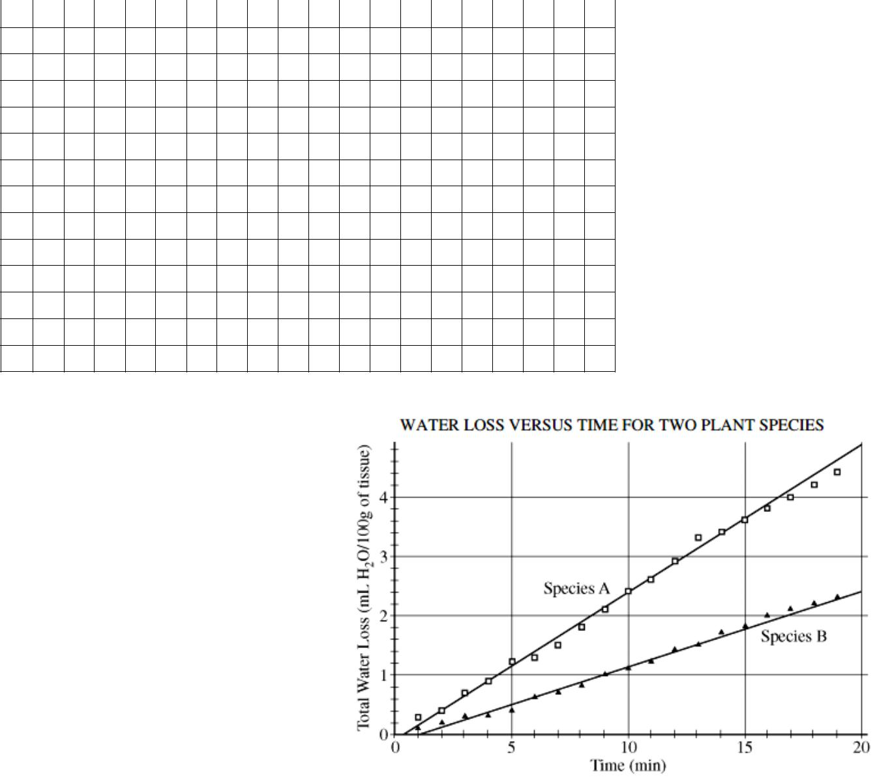

- The regulation of transpiration is an important homeostatic mechanism in plants.

(a) Under controlled conditions, a transpiration experiment was conducted using two plant species. The data collected are shown in the figure to the right. Using the data from the experiment, calculate the rate of transpiration for species A and species B between the times of 5 and 15 minutes (show your work). Summarize the difference between the two transpiration rates.

  - Identify and explain THREE different structural or physiological adaptations that could account for the different transpiration rates of species A and B.

(c) Water potential (Ψ) is described by the following formulas.

Ψ = Ψp + Ψs & Ψs = -iCRT

Discuss the variables in both formulas and how they affect water potential.

Thinking Practice Questions:

- The figure below outlines the process of cellular respiration. Glucose and oxygen are both reactants in this process.
  - Describe the journey of a single carbon atom from glucose in cellular respiration
  - Describe the journey of a single hydrogen atom from glucose in cellular respiration
  - Describe the function of the oxygen molecules in cellular respiration
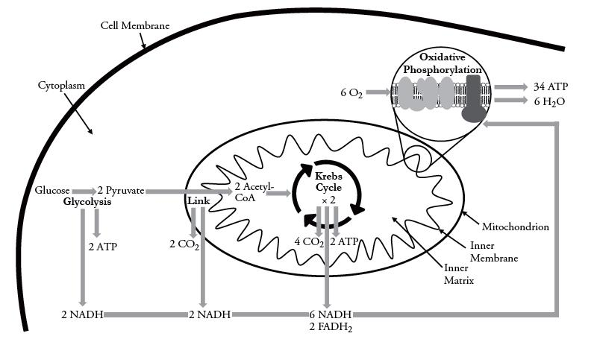

- The figures below display the absorption range for several different pigments found in plants (top) and the rate of photosynthesis at varying conditions of wavelength in one plant species (bottom)

  - What color and wavelength of light is reflected by the plant species tested? How do you know?

  - What wavelength(s) increase the rate of photosynthesis in the plant species tested? What pigment does this correspond to? How do you know?
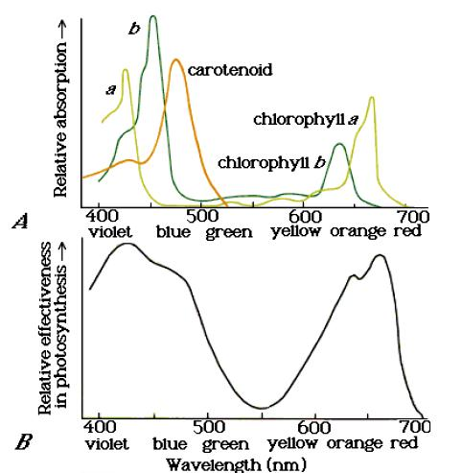

- The figure below outlines the process of photosynthesis. Carbon dioxide and water are both reactants in this process.
  - Describe the journey of a single hydrogen atom from water in photosynthesis.
  - Describe the journey of a single oxygen atom from water in photosynthesis.
  - Describe the journey of a carbon dioxide molecule in photosynthesis.
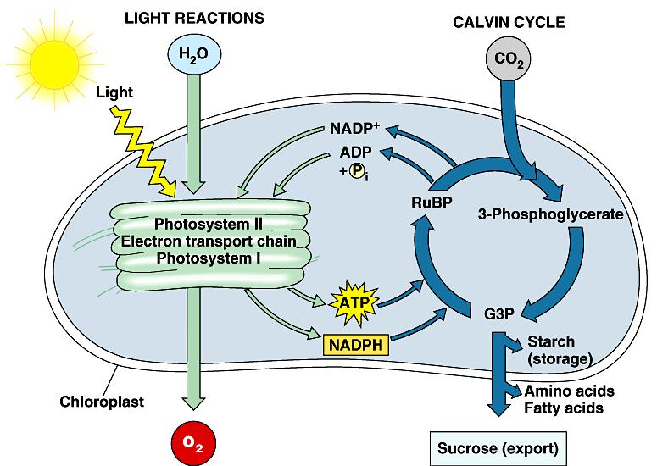

Name: _____________________________________________ Date: ____________________________

AP Biology Exam Review 6: Organism Form and Function

Helpful Videos and Animations:

  - Bozeman Biology: Response to External Environments

  - Bozeman Biology: Plant and Animal Defense
  - Bozeman Biology: Development - Timing and Coordination
  - Bozeman Biology: Gene Regulation in Embryonic Development
  - Bozeman Biology: Cellular Specialization
  - Bozeman Biology: Mechanisms of Timing and Control
  - Bozeman Biology: The Nervous System

- Describe the difference between reflexes and reactions

- Describe how a nerve propagates a signal
- Explain what a threshold potential is, and how the action potential is propagated (voltage-gated channels)

- Explain how myelin sheath increases the speed of nerve signals
- Describe how the nerve is "re-set" (Na/K pump)
- Describe what happens in the synapse of a nerve
- Explain the purpose of neurotransmitters
- Describe the different types of neurons and explain their purpose
- Describe the different types of sensory receptors
- Explain the difference between CNS and PNS, and Sympathetic and Parasympathetic nervous system
- Describe the evolution of nervous systems into brains
- Describe the functions of the major parts of the brain
- Describe the two different types of hormones, and explain how each acts on a cell

- Describe how the body maintains homeostasis, and be able to explain how negative feedback loops and positive feedback loops work
- Give examples of plant hormones and their functions
- Explain how the body maintains proper water and solute levels
- Describe how hormones help to maintain proper osmolarity
- Describe different adaptations to excreting body wastes in differing environments
- Explain how the body transports gases and nutrients through blood
- Describe how homeostasis can be affected by changes in the blood, and how these changes affect proteins

- Explain the evolution of plant reproduction from simple to complex forms, describing how alernation of generations decreases as plants become more complex

- Describe the difference between sexual and asexual reproduction
- Describe different sexual strategies besides strictly having two sexes (parthenogenesis and hermaphrodism)
- Describe the role reproductive hormones have in humans
- Describe the menstrual cycle and explain how it is controlled in females
- Explain the difference between spermatogenesis and oogenesis, and describe the evolutionary advantages of each

- Describe the process of development in humans, explaining how the body plan is determined, and how this is influenced by gene expression

- Explain the role of stem cells in development and be able to describe why stem cell research is controversial (but becoming less so!)
- Explain the importance of the placenta
- Explain the laws of thermodynamics and how they apply to living organisms

- Describe the two different metabolic strategies of temperature regulation – endothermic and exothermic, and explain how each relates to energy use
- Describe how body size influences metabolic rate, and explain the reasons why
- Explain how metabolic rate changes as external conditions vary
- Describe the stages of defences the immune system has in the human body

- Explain how acquired immunity helps protect against disease that the body has been previously exposed to, and the evolutionary advantages of this immunity
- Describe how acquired immunity works to recognize invaders
- Explain the difference between humoral and cell-mediated immunity
- Describe how autoimmune disease and allergies are a malfunction of the immune system
- Describe how other organisms maintain homeostasis and compare these mechanisms with those of the human body

Topic Outline:
- The Nervous System
  - Functions
o Sensory input – take in and integrate information (either internal or external)
    - Sensory receptors

      - chemoreceptors – sense chemicals (pheremones, solute concentration, etc)
      - mechanoreceptors – sense physical change (pressure, touch, etc)
      - thermoreceptors – sense temperature
      - pain receptors
      - electromagnetic receptors – allow some animals to navigate
  - motor function – allow movement to respond to changes (either internal or external)
  - regulation – keep body within homeostatic limits
- Structure
  - Neuron (nerve cell) – Composed of:

    - Dendrites – branched portion of nerve that receive signal

    - Axon – long, slender portion of nerve cell that transmits signals

    - Myelin sheath – made of schwann cells, insulate signal; allows signal to propagate faster

    - Synapse – space between two neurons

- Polarized neuron – Na⁺ outside, K⁺ and Cl⁻ inside (overall + charge on outside, overall - charge on inside)
- Depolarization moves Na⁺ into neuron, generating an action potential
  - All or nothing
- Repolarization exchanges Na⁺ and K⁺ through the sodium-potassium pump
- At synapse, calcium channels open to allow calcium to rush in, stimulating release of neurotransmitters
- Neurotransmitters released into synapse to generate action potential for motor neuron or muscle cell

- The structure of the neuron allows for the detection, generation, transmission and integration of signal information

- Schwann cells separated by gaps of unsheathed axon over which the impulse travels as the signal propagates along the neuron

- Different types of nerve cells
  - Sensory – receives signals from receptors
- Interneuron – between sensory and motor
  - Motor – transmits signals to muscle cells (effector)
- Parts of Nervous system
  - Sympathetic – fight or flight

- Parasympathetic – rest and relax o Central – brain & spinal cord

  - Brain evolved from nerve nets to large, cephilized brains (cephilization); humans have large forebrain, where most complex functions occur
    - Peripheral – nerves branching off of spine

- The Endocrine System

  - Negative feedback mechanisms maintain dynamic homeostasis for a particular condition (variable) by regulating physiological processes, returning the changing condition back to its target set point’
o End result reduced beginning, lowering end result (ex: insulin and glucose levels)

  - Positive feedback mechanisms amplify responses and processes in biological organisms. The condition initiating the response is moved farther away from the initial set-point. Amplification occurs when the stimulus is further activated which, in turn, initiates an additional response that produces system change o End result amplifies beginning, which amplifies end result, etc. (ex: oxytocin and contractions)

  - Endocrine system secretes hormones into the bloodstream and travel to different target cells (close or far)

- One signal molecule can have multiple target cells/tissues/organs but it is a slow method of signaling o Hormones can be

  - Lipid based – diffuse easily through cell membrane, bind with receptor in cytoplasm of cell, which then acts as a transcription factor

  - Protein based – cannot diffuse easily through cell membrane, binds with receptor on the cell membrane, signal transduction occurs, eventually acting as a transcription factor

- Hormones to know:

- Insulin/glucagon – regulate blood glucose levels by negative feedback (insulin lowers blood glucose when it is high, glucagon increases blood glucose when it is low)

- ADH (anti-diuretic hormone) – regulates blood osmolarity by negative feedback (too much water being secreted in urine, ADH re-absorbs water)
- Testosterone – male characteristics, causes sperm production
    - Estrogen – female characteristics, egg production, high levels = ovulation, low levels = menstruation
    - Progesterone – maintains uterine lining, low levels = menstruation
    - Auxin – plant hormone, causes phototropism

    - Ethyline – plant hormone, causes fruit ripening

- Circulatory system

  - Oxygen comes in to lungs, enters blood stream through capillaries wrapped around alveoli, goes to heart, is transported to cells where oxygen is exchanged for CO2, brought back to lungs where CO2 is released

  - Blood pH is affected by amount of CO2 in blood; more CO2 = more acidic. This can shift curves of enzymes/protein saturation

- Digestive & Excretory System

  - Food must be broken down so that it can diffuse into cells (broken into basic macromolecules); breaking down proteins produces toxic waste (ammonia)

  - Aquatic organisms can directly excrete ammonia b/c it is diluted in water; terrestrial organisms must convert ammonia to less toxic form (urea or uric acid) and dilute it with water in urine

- Reproduction
  - Sexual vs. asexual reproduction
    - Sexual – two parents, genetic variation, takes longer
      - Asexual – one parent, exact copy, shorter
    - Reproductive systems – make gametes

      - Oogenesis and spermatogenesis – oogenesis allows one, large egg which provides nutrients; sperm produced quickly and in large numbers
    - Fertilization – sperm joins egg, happens in fallopian tubes; internal fertilization = safer, more effective
    - Embryo implants into uterine wall to develop

- The Steps of Embryonic Development
  - Pattern Formation
      - Cytoplasmic Determinants

        - Cells near each other send signals determining other cells development
      - Homeotic (Hox) Genes
        - Body pattern genes

  - Cell Differentiation – cells become specialized by turning certain genes on
      - Controlled by transcription factors (stimulatory or inhibitory) and signaling

- Stem Cells
    - Cells that are not yet differentiated – pluripotent vs. totipotent
    - Can be induced to become any type of cell
    - Adult stem cells in bone marrow

    - Research is controversial, but with new technologies may become less so due to being able to induce adult cells to become stem cells

- Thermoregulation
    - Endotherm vs. ectotherm

    - Endotherm (warm-blooded) – regulates body temperature; higher metabolic rate to maintain body temperature; smaller organism = higher metabolic rate due to increased SA:V (harder to maintain temp)

    - Ectotherm (cold-blooded) – body temperature fluctuates with external temperature; metabolic rate determined by external temperature; warm = high metabolic rate, cold = low metabolic rate

- Plants, invertebrates and vertebrates have multiple, nonspecific immune responses, ex: phagocytes (i.e. macrophages) engulf and digest pathogens with the help of lysosomes

- Mammals use specific immune responses triggered by natural or artificial agents that disrupt dynamic homeostasis
- The mammalian immune system includes two types of specific responses: cell mediated and humoral

  - Cell-mediated response – cytotoxic T cells, a type of lymphocytic white blood cell, target intracellular pathogens when antigens are displayed on the outside of the cells; engulf infected cell

- In the humoral response, B cells, a type of lymphocytic white blood cell, produce antibodies against specific antigens

  - Antibodies are proteins produced by B cells, and each antibody is specific to a particular antigen
    - A second exposure to an antigen results in a more rapid and enhanced immune response.

- Immune response in humans
  - 1st line of defense – Barriers (skin, mucous, secretions)
  - 2nd line of defense – non-specific immune responses
    - WBC’s (phagocytes), engulf invaders; inflammatory response; fever
  - 3rd line of defense – humoral vs. cell mediated

    - Respond to antigens on surface of the cell; cell name tags, mark as self or non-self

- B-cells (humoral response) – antibodies recognize foreign antigen, produce many antibodies against specific antigens; remember for next time around, response is more rapid, prevents future infection

- Vaccines – injection of antigens or dead/weakened virus, stimulates immune system to produce antibodies so it will recognize antigen more quickly next time

- T-cells (cell-mediated response) – antigen-presenting cells display fragments of invader; killer T-cell recognizes that cell is infected, engulfs cell; remembers for next time infection is in body

Practice Multiple Choice Questions:

- In the human body, the respiratory system and circulatory system work together to deliver oxygen to the tissues of the body and remove carbon dioxide from the tissues of the body. Gas exchange between the lungs and the blood vessels occurs at the alveoli, small sacs within the lungs that are covered in a network of capillaries. If the surface area of the alveoli is decreased, how will this affect the organism as a whole?

a. The individual will not be able to deliver enough oxygen to the tissues of the body but will still be able to remove carbon dioxide from the bloodstream.

b. The individual will not be able to remove carbon dioxide from the bloodstream but will still be able to deliver enough oxygen to the tissues of the body.

c. The individual will not be able to deliver enough oxygen to the tissues of the body OR remove carbon dioxide from the bloodstream.

d. The individual will have an enhanced ability to deliver oxygen to the tissues of the body and remove carbon dioxide from the bloodstream.

- We know that plants bend toward light because
a. the sun stimulates equal cell expansion on both sides of the stem.
b. cell expansion is greater on the dark side of the stem.
c. cell expansion is greater on the light side of the stem
d. auxin is inactive on the dark side of the stem.

- Plants often use changes in day length (photoperiod) to trigger events such as dormancy and flowering. There are two types of plants based on their photoperiod requirements to induce flowering. These two types of plants are called short-day plants and long-day plants. A long-day plant will flower

a. in the late fall.

b. when the night is shorter than a critical value. c. only under artificial light in the summer.

d. during short days with proper fertilization. e. regardless of the photoperiod imposed.

- Macrophages are large white blood cells that can engulf foreign substances called antigens. Both macrophages and lymphocytes, such as T cells, appear together at the site of infection. Which statement best explains how macrophages initiate an immune response when a new antigen is first encountered?

a. Macrophages incorporate the antigen into their genetic material and produce a large number of identical macrophages that are programmed to destroy that specific antigen.

b. Macrophages present the antigen directly to a memory B cell that produces antibodies programmed to destroy that specific antigen.

c. Macrophages present the antigen to helper T cells, which activate memory B cells to produce plasma cells, and the plasma cells release antibodies that identify and destroy that specific antigen.

d. Macrophages present fragments of the antigen to other macrophages, which are then able to seek out and destroy the antigen by releasing helper T cells that engulf that specific antigen.

- What is the main difference between the humoral response and the cell-mediated response?

a. The humoral response is a type of nonspecific immunity, whereas the cell-mediated response is a type of specific immunity.

b. The humoral response is a type of specific immunity, whereas the cell mediated response is a type of nonspecific immunity.

c. The humoral response involves the creation of antibodies to attack pathogens that are free-floating in the body fluids (ex: blood and lymph), whereas the cell mediated response involves the creation of cytotoxic T cells to destroy infected body cells.

d. The humoral response involves the creation of cytotoxic T cells to destroy infected body cells, whereas the cell mediated response involves the creation of antibodies to attack pathogens that are free-floating in the body fluids (ex: blood and lymph).

- Secondary immune responses upon a second exposure to a pathogen are due to the activation of a. memory cells (both B cell and T cell varieties)

b. macrophages c. stem cells d. antigens

- Secondary immune responses (aka immunological memory) explain

a. a macrophage’s ability to “swallow” an antigen (a foreign particle)

b. the observation that some strains of the pathogen that causes dengue fever cause worse disease than others. c. the ability of a helper T cell to bind to an antigen-presenting cell

d. the ancient observation that someone who had recovered from the plague could safely care for those newly diseased.

- In animals, all of the following are associated with embryonic development EXCEPT a. migration of cells to specific areas
b. formation of germ layers

c. activation of all the genes in each cell d. inductive tissue interactions

e. cell division at a relatively rapid rate

Questions 9-12. Use the following choices:

- Testis
- Anterior pituitary
- Thyroid
- Pancreas

- Releases hormones that control blood sugar levels by stimulating glycogen formation or breakdown

- Secretes steroid hormones that affect secondary sex characteristics

- Releases hormones that increase the rate of cellular respiration throughout the body

- Secretes the hormones FSH and LH, which control ovulation

- Nerve cells communicate with one another via chemical messengers called neurotransmitters. GABA is a neurotransmitter that causes the opening of channels on the post-synaptic neuron that let negatively charged chloride ions (Cl⁻) into the cell or positively charged potassium ions (K⁺) out of the cell. Is GABA an excitatory or inhibitory neurotransmitter and how do you know?

a. Excitatory; It causes the influx of positive charge to bring the postsynaptic neuron to threshold.

b. Excitatory; It prevents the influx of positive charge to prevent the postsynaptic neuron from reaching threshold. c. Inhibitory; It causes the influx of positive charge to bring the postsynaptic neuron to threshold.

d. Inhibitory; It prevents the influx of positive charge to prevent the postsynaptic neuron from reaching threshold.

- Suppose there is a drug that increases the number of Schwann cells on the axon of a neuron. How will this affect signaling down the length of this axon?

a. Nerve signaling will increase in speed. b. Nerve signaling will decrease in speed.

c. Nerve signaling will require a smaller stimulus to trigger an action potential. d. Nerve signaling will require a larger stimulus to trigger an action potential.

- A toxin that binds specifically to voltage-gated potassium channels in axons and prevents them from opening would be expected to

a. prevent the repolarization and hyperpolarization (aka undershoot) phase of the action potential. b. prevent the depolarization phase of the action potential.

c. enable the axon to reach threshold potential more rapidly. d. prevent the axon from reaching threshold potential

- When the concentration of solutes in the blood (blood osmolarity) is high, the pituitary gland releases antidiuretic hormone (ADH). ADH stimulates the kidneys to reabsorb water in order to increase blood volume and decrease blood osmolarity. When the kidneys reabsorb water, this causes the urine to be extremely concentrated. A student overhydrates in preparation for a big race. How will her body respond to this massive intake of water, which results in a high blood volume?

a. The high blood volume (low blood osmolarity) will inhibit the secretion of ADH from the pituitary, the kidney will not reabsorb water, and the urine will be very dilute (i.e. have a high water content)

b. The high blood volume (low blood osmolarity) will inhibit the secretion of ADH from the pituitary, the kidney will reabsorb water, and the urine will be very concentrated (i.e. have a low water content)

c. The high blood volume (low blood osmolarity) will stimulate the secretion of ADH from the pituitary, the kidney will not reabsorb water, and the urine will be very dilute (i.e. have a high water content)

d. The high blood volume (low blood osmolarity) will stimulate the secretion of ADH from the pituitary, the kidney will reabsorb water, and the urine will be very concentrated (i.e. have a low water content)

- High blood glucose triggers cells in the pancreas to release the hormone insulin, which lowers blood glucose levels. Type 1 diabetes occurs when the pancreas cannot produce insulin. In an experiment, the blood glucose levels of several diabetic rats are measured and the rats are then fed a high carbohydrate meal. Which statement explains how a rat’s blood glucose levels will most likely be affected by the high-carbohydrate meal?

a. The rat’s blood glucose level will increase after eating, which will cause insulin levels to rise until blood glucose decreases below the pre-meal level.

b. The rat’s blood glucose level will increase after eating and, after the rat is given an insulin injection, will decrease to the pre-meal level.

c. The rat’s blood glucose level will increase for several hours after eating, and then will gradually decrease over several hours to the pre-meal level.

d. The rat’s blood glucose level will increase after eating and, even after the rat is given an insulin injection, will remain higher than the pre-meal level.

- The hormone ethylene causes ripening in fruits. As fruits ripen, they produce more ethylene, which causes fruits in the nearby vicinity to ripen as well and produce ethylene. This is why all the apples in a barrel ripen at approximately the same time. This system is an example of

a. Positive feedback because the plant’s response (i.e. ripening) increases the stimulus (i.e. release of ethylene) b. Positive feedback because the plant’s response (i.e. ripening) removes the stimulus (i.e. release of ethylene) c. Negative feedback because the plant’s response (i.e. ripening) increases the stimulus (i.e. release of ethylene) d. Negative feedback because the plant’s response (i.e. ripening) removes the stimulus (i.e. release of ethylene)

- A toxin binds to voltage-gated calcium channels on the axon terminal membrane of a pre-synaptic cell and prevents them from opening in response to the wave of depolarization passing down the pre-synaptic cell’s axon. What will be the most immediate effect of this toxin on transmission of the signal across a synapse from the pre-synaptic cell to the post-synaptic cell?

a. Neurotransmitter molecules cannot diffuse across the synapse.

b. Neurotransmitter molecules cannot bind to ligand-gated Na⁺ channels on the postsynaptic cell’s dendrite membrane. c. Ligand-gated Na⁺ channels on the postsynaptic cell’s dendrite membrane will not open, allowing Na⁺ to enter the cell

and bring the postsynaptic cell to threshold potential.

d. Calcium cannot come into the pre-synaptic cell and cause vesicles filled with neurotransmitter molecules to fuse with the pre-synaptic cell’s axon terminal membrane.

- Which of the following sequences describes the passage of a nerve impulse through a simple reflex arc in humans? a. receptor → effector → interneuron → motor neuron → sensory neuron

b. receptor → sensory neuron → interneuron → effector → motor neuron c. sensory n euron → effector → motor neuron → interneuron → receptor d. receptor → sensory neuron → interneuron → motor neuron → effector

- Which of the following is correct about blood type?

a. blood type O has O antigens on the surface of the red blood cells b. blood type A has A antibodies circulating in the plasma

c. the danger in a transfusion is if the donor has antibodies to the recipient d. A and B antigens can be found on the surface of red blood cells

- Oxygen is carried in the blood by the respiratory pigment hemoglobin, which can combine loosely with four oxygen molecules, forming the molecule oxyhemoglobin. To function properly, hemoglobin must bind to oxygen in the lungs and drop it off at body cells. The pH of the blood affects the oxygen-binding capabilities of hemoglobin. Below is a graph showing two different saturation-dissociation curves for hemoglobin at two different pH levels.
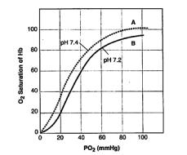

Based on your knowledge of biology and the information in the graph, which statement about hemoglobin is correct? a. Hemoglobin at pH 7.2 has a greater affinity for oxygen and therefore binds more easily to the oxygen in the lungs. b. Hemoglobin at pH 7.4 is characteristic of a mammal that evolved at sea level where oxygen levels are high.

c. Carbon dioxide causes the blood to be more acidic, which causes hemoglobin to drop off oxygen more readily at body cells.
d. Oxygen causes the blood to be more basic, which causes hemoglobin to drop off oxygen more readily at body cells.

- In a classic experiment, a scientist grafted a cell from the dorsal (back) side of one amphibian embryo onto the ventral (stomach) side of a second embryo. A second notochord and neural tube developed at the location of the graft. This experiment shows that

a. embryonic development does not follow any particular developmental pathway and can be easily altered b. the dorsal side of an embryo can be transformed into the ventral side
c. the dorsal side of an embryo can develop into an organ or structure
d. the dorsal side of an embryo signals adjacent tissue to transform into specific structures during development

- Below is a graph depicting a person’s first exposure to antigen A, after being given a vaccine on day 1, with a subsequent immune response. A second exposure to antigen A on day 30 results in a secondary immune response. There is also a first exposure to antigen B on day 30.
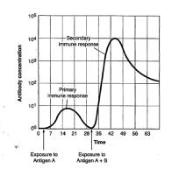

Which of the following graphs accurately depicts the immune response to antigen B and the reason for it?
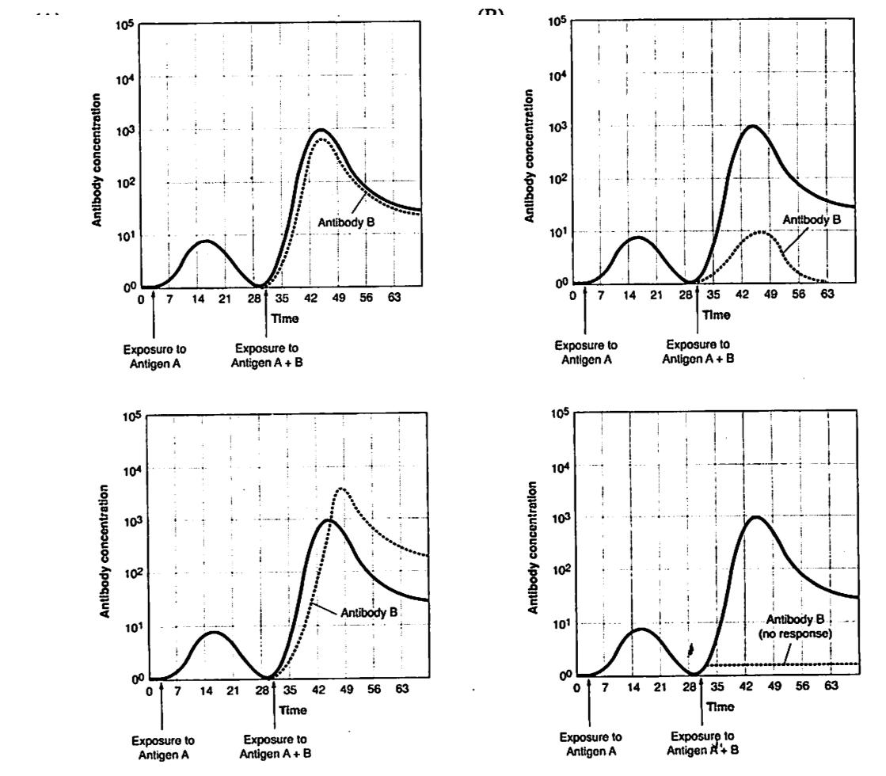

a. b.

c. d.

a. Graph A. The primary response to antigen B is almost as fast and large as the secondary immune response to antigen A because the entire immune system was activated by the first exposure to antigen A.

b. Graph B. Immune responses are specific. An earlier exposure to antigen A will only cause a heightened immune response to this antigen, not antigen B.

c. Graph C. The response to antigen B on day 30 is larger than the secondary immune response to antigen A because the immune system has already been activated and all new responses are heightened.

d. Graph D. There is very little immune response to antigen B because the immune system is fully engaged in a secondary response to antigen A.

25. Below is a diagram of a molecule of the sex hormone, testosterone, which is derived from cholesterol.
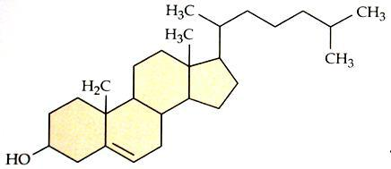

Which of the following statements best describes the action of this hormone on cells of the human gonads?

a. The hormone acts as the first messenger when it binds to and activates the G protein-coupled receptor in the surface of cells in the testes. This activates the mobile G protein located inside the cell.

b. The hormone enters the cells in the testes by first binding with a membrane receptor, which causes a channel to open in the membrane, allowing the testosterone to flood into the cell

c. The hormone readily passes through the cell membrane and binds to a receptor in the cytoplasm. The hormone and receptor then enter the nucleus and act as a transcription factor that turns on one or more genes.

d. The hormone binds with cAMP on the surface of the cell. Once attached to cAMP, the hormone enters the cell and initiates a signal transduction pathway.

26. Mice are endotherms, while lizards are ectotherms. Which of the following graphs correctly depicts this?
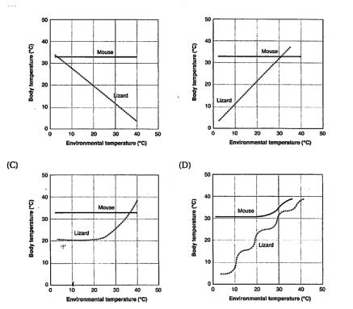

a. b.

c. |  | d.

- The enzyme phosphofructokinase (PFK) is an allosteric enzyme at a critical step in glycolysis. PFK is also allosterically inhibited by ATP. Which of the following best explains why the interaction between PFK and ATP is an efficient means of controlling glycolysis and cell respiration?

a. This is an example of positive feedback; the presence in the cell of large amounts of ATP further increases the production of ATP

b. This is an example of negative feedback; the presence in the cell of large amounts of ATP shuts down the process to produce more ATP

c. This is an example of positive feedback; an increase in PFK increases the rate of glycolysis and further increases the production of ATP

d. This is an example of negative feedback; a decrease in PFK shuts down glycolysis and also stops the further production of ATP

- Which would be associated with the parasympathetic nervous system?
a. increase in blood sugar
b. increase in adrenaline
c. increase in breathing rate.
d. increase in digestion

Practice Long Response Questions:

- An important defense against diseases in vertebrate animals is the ability to eliminate, inactivate, or destroy foreign substances and organisms. Explain how the immune system achieves THREE of the following:
  - Provides an immediate nonspecific immune response
  - Activates T and B cells in response to an infection
  - Responds to a later exposure to the same infectious agent
  - Distinguishes self from nonself

- Homeostasis, maintaining a steady-state internal environment, is a characteristic of all living organisms. Choose three of the following physiological parameters and for each, describe how homeostasis is maintained in an organism of your choice. Be sure to indicate what animal you have chosen for each parameter. You may use the same animal or different animals for your three descriptions.
  - Blood-glucose levels
  - Body temperature
  - pH of blood
  - Osmotic concentration of the blood
  - Neuron resting-membrane potential

- a. Communication occurs among the cells in a multicellular organism. Choose THREE of the following examples of cell-to-cell communication, and for each example, describe the communication that occurs and the types of responses that result from this communication.

  - Communication between two plant cells
  - Communication between two immune-system cells
  - Communication either between a neuron and another neuron or between a neuron and a muscle cell
  - Communication between a specific endocrine-gland cell and its target cell

b. Compare the cell-signaling mechanisms of steroid hormones and protein hormones.

4. Reproduction can be either asexual or sexual.

- Using a specific example, describe how organisms can reproduce asexually. Discuss TWO evolutionary advantages of asexual reproduction.

- Identify THREE ways that sexual reproduction increases genetic variability. For each, explain how it increases genetic diversity among the offspring.

- Discuss TWO prezygotic isolating mechanisms that prevent hybridization between two species. Include in your discussion an example of each mechanism.

Name: _____________________________________________ Date: ____________________________

AP Biology Exam Review 7: Animal Behavior and Ecology

Helpful Videos and Animations:

- Bozeman Biology: Ecosystems
- Bozeman Biology: Ecosystem Change
- Bozeman Biology: Ecological Succession

- Bozeman Biology: Populations
- Bozeman Biology: R and K Selection

- Bozeman Biology: Cooperative Interactions
- Bozeman Biology: Communities
- Bozeman Biology: Niche

Relevant Objectives:

- Describe the difference between innate and learned behaviors, and explain the evolutionary advantages of both
- Describe the difference between kinesis and taxis, and explain the evolutionary advantages of both

- Describe animal responses to various stimuli (food, habitat, mates)

- Explain animal behaviors (cooperation, territoriality, conditioning, altruistic) in terms of evolutionary advantage to the animal or group of animals

- Describe plant behaviors in terms of response to stimulus (light, gravity) and explain the evolutionary advantage of these behaviors

- Know the levels of organization within the biosphere from largest to smallest
- Define population
- Define biotic, abiotic, exponential and logistic growth, carrying capacity, and limiting factors

- Define range, spacing, and size of a population, and explain the factors that affect each of these components
- Describe the three major types of survivorship curves, and explain what their shape means

- Be able to interpret age structure diagrams
- Discuss the trade-offs of reproduction, and explain how these lead to different life strategies (r vs. k selected species)
- Describe conditions that lead to both exponential and logistic growth

- Explain the difference between density dependent and density independent limiting factors

- Define invasive species and describe their impact on an area
- Explain how the predator-prey relationship leads to cycles in population size

- Explain how human growth has changed over time, and discuss problems that could arise from this
- Describe different methods of estimating population size (quadrat vs. mark-recapture)

- Explain how mark-recapture allows for estimating population size, and describe factors that can affect results of this method

- Define community, niche (fundamental & realized), competitive exclusion, resource partitioning, symbiosis, mimicry, species diversity and keystone species
- Describe interspecific competition and explain the effects it has on populations

- Explain the competitive exclusion principle, describe the effects it has on niches, and explain how populations use resources partitioning to live in the same habitat
- Describe the three types of symbiosis and how they effect each organism in the interaction

- Explain the evolutionary significance of mimicry, and describe the difference between batesian and mullerian mimicry
- Describe how coevolution occurs
- Explain how high biodiversity leads an ecosystem to be healthier
- Explain the effects of a keystone species on an ecosystem
- Describe the changes that occur in an ecosytem during ecological succession

- Define ecosystem
- Explain what a trophic level is and be able to name the trophic levels in an ecosystem
- Describe how energy changes as it flows through trophic levels, and explain why this change occurs

- Describe the cycling of nutrients in ecosystems
- Compare chemosynthesis to photosynthesis

- Define primary productivity, and describe aspects affecting it
- Be able to calculate primary productivity (given conversion factors)

- Describe the ecological problems caused by humans including global warming, ozone depletion, deforestation, acid precipitation, loss of biodiversity, and overharvesting

- Explain solutions to human caused ecological problems

- Describe the characteristics of each of the major biomes and explain adaptations that organisms have to living in these biomes

- Describe the major threats to each of the biomes

Topic Outline:
- Behavior
  - Plant
o Phototropism – bend toward light (due to auxin)

o Photoperiodism – plants only bloom at certain times, based on length of night o Gravitropism – roots grow towards gravity, shoots grow away from
o Chemical defenses – herbivory induces plants to start producing toxic/unpalatable chemicals
  - Animal

o Innate – behavior animal is born with, instinctive; controlled by genes; help animal to survive and/or reproduce
    - All animals of species exhibit behavior regardless of environment

    - Kinesis vs. Taxis

      - Kinesis – change in rate of movement in response to a stimulus (ex: water); helps animal to find necessary resources & avoid danger

      - Taxis – directed movement toward or away from a stimulus (ex: predator pheromone); helps animal to find necessary resources & avoid danger
    - Fixed action pattern – sequence of behaviors, unchangeable from start to finish (ex: egg rolling)

    - Migration, Imprinting

- Learned behavior – behavior that is changeable and modified by experience; flexible with a changing environment
  - Operant vs. classical conditioning

    - Operant – associate behavior with reward or punishment (rats push lever, given treats)
    - Classical – connect behavior to stimulus (Pavlov’s dogs)
  - Problem solving
    - Social behavior – interactions between individuals that develop as an evolutionary advantage
      - Altruistic – keep family alive (pass on some of your genes)

      - Cooperation – pack hunting

      - Dominance hierarchy – pecking order

      - Agnostic behavior – territoriality, fighting

      - Communication – see populations below

- Populations
  - Population Growth

    - Density dependent limiting factors (competition for resources, parasites & diseases, waste products, stress, predation)

      - Change based on population size

      - Leads to intraspecific competition for resources

  - Density independent limiting factors (climate = temperature & rainfall, natural disaster) o Exponential growth (J-shaped, unlimited) vs. logistic growth curve (S-shaped, limited)

    - Logistic more realistic, takes into account carrying capacity and density-dependent limiting factors o Carrying capacity = maximum population supported by habitat
- Using age structure to study human populations – life tables, etc.
- Spacing patterns

o Random – randomly spaced; caused by there being no interactions between individuals o Clumped – typically clumped around a resource, or for protection
o Uniform – caused by negative interactions between species; territoriality
- Survivorship curves

o Type I – many live in infancy, high death rate later in life o Type II – constant mortality rate throughout life
o Type III – many deaths at young age, few survivors live often
- R vs. k selection

o R – rapidly growing, small offspring, many offspring, little parental care; very good at being invasive – opportunistic
o K – slow growing, large offspring, few offspring, high parental care; very good in a stable environment

- Population ability to respond to changes in the environment is affected by genetic diversity. Species and populations with little genetic diversity are at risk for extinction.

  - Communication within populations
o Cooperative behavior (ex: predator warnings)

o Behaviors to enhance reproductive success (ex: territory marking)

o Different types of behaviors and reasons for behaviors: Animals use visual, audible, tactile, electrical and chemical signals to indicate dominance, find food, establish territory and ensure reproductive success. (ex: bee dances)

- Communities
  - Niche (fundamental vs. realized)
o Fundamental – niche that is possible for species to occupy

o Realized – niche that species actually occupies due to competition
    - Interspecific competition

  - Be able to analyze food chains and food webs/identify trophic levels o Producer – does chemosynthesis or photosynthesis
o Consumer – consumes food (primary, secondary, tertiary)
o Decomposer – breaks down dead organisms and recycles nutrients

  - Location of decomposers on a food chain – feed on every level
  - Primary productivity (gross vs. net)
o Measure of amount of carbon fixed; net takes into account loss of carbon due to respiration

  - Trophic Efficiency: energy pyramids, pyramids of biomass
o Rule of 10 – only 10% efficiency, 90% lost between each level due to metabolic processes and heat

  - The importance of species diversity in a community (determined by species richness and relative abundance) o Keeps ecosystem stable

  - Types of symbiosis: mutualism, commensalism, parasitism,
  - Protection mechanisms – mimicry, Batesian vs. Mullerian; aposematic coloration; herding

  - The effect of removing a dominant or keystone species – large impact on an ecosystem, keystone species keep other populations in check (ex: otter)

  - Invasive species – no predators in new area, grow very quickly, outcompete native species for resources o Severely reduce biodiversity (ex: zebra mussel, purple loostrife)

- Ecosystems
  - Levels of ecology: population, community, ecosystem, biome, biosphere
  - Abiotic vs. biotic factors (non-living vs. living)
  - Effect of human activities on ecosystems (ex: invasive species)
  - Effect of geological/meteorological events on ecosystems (ex: meteor causing extinction of dinosaurs)
  - Free Energy
o Laws of thermodynamics

      - First law – energy is neither created nor destroyed, just changes form

        - What goes in must come out somewhere

      - Second law – some energy is “lost” as heat during every conversion; considered “lost” because heat is a “useless” energy

        - Leads to rule of 10
  - Nutrient Cycling

o Carbon cycle – photosynthesis and respiration; sinks are fossil fuels and plants; released by burning fossil fuels

o Nitrogen cycle – N fixation, nitrification, denitrification; sink is atmosphere o Phosphorus cycle – no gaseous phase; sinks in rocks

o Water cycle – transpiration, evaporation, condensation, precipitation, runoff o CHNOPS = limiting nutrients
o Excess N or P can lead to eutrophication of waters

      - Algal bloom, decaying algae decomposed by bacteria, bacteria use oxygen to respire → hypoxia
  - Ecological succession
o Primary succession – starts from no soil

o Secondary succession – starts with soil, after a disturbance

o First plant species either create (primary) or change (secondary) the soil so that the environment becomes more suitable for other producers; increased producers leads to increased biodiversity

  - Human Impact

o Climate change – increased CO2 in atmosphere due to burning fossil fuels; increases greenhouse effect; rising temperatures; rising sea level, melting ice, etc

o Ozone depletion – CFC use depletes ozone layer; ozone essential to block out harmful UV rays; Montreal Protocol banned CFC use

o Deforestation – cutting of forests causes increased CO2 due to loss of sink; habitat loss, biodiversity loss o Overharvesting/overfishing – overuse of an area leads to reduced biodiversity

o Pollution – biomagnification, more concentrated pollutants higher up the food chain; eutrophication from fertilizers

- Biomes – characterized by precipitation and temperature (overall climate)
    - Tropical Rain forest
  - Near equatorial regions; abundant precipitation; high temperatures; high humidity
  - Large storage sink for carbon; most biodiverse biome on earth
  - All nutrients in trees/leaf litter; lost when deforestation occurs

- Desert
  - 30º N or S of equator; very little precipitation; most extreme fluctuations of any biome – can get very cool
at night, very hot during day
  - Plants adapted to be drought resistant – deep roots; thick, waxy cuticle; small needles to minimize loss

  - Animals adaptations to stay cool – active at night; large SA:V ratio accomplished through large ears etc.
- Grasslands
  - Huge areas in temperate and tropical regions
  - Low rainfall or uneven seasonal rainfall; conditions inhospitable for forests
  - Grasses are producers; consumers include bison, prairie dogs

- Temperate Deciduous
  - North America, South of Taiga
- Trees drop leaves in winter (deciduous)
  - Vertical stratification – small, medium, and large trees; allows for diversification of animals
  - Rich soils
- Coniferous Forest (Taiga)
  - Located in northern Canada and much of world’s northern regions; very cold winters; heavy snowfall

  - Dominated by conifers (do not drop leaves in winter – needle-like); trees shaped with branches slanted downwards to prevent heavy accumulations of snow

- Tundra
  - Northern parts of world
  - Characterized by permafrost – permanently frozen subsoil; large carbon sink
  - “Frozen desert” – very little rainfall, very little vegetation

  - Vegetation is very small, guards against the winds
- Aquatic – cover 75% of earth
  - Freshwater vs. saltwater

- Estuaries – mouths of rivers where freshwater and saltwater mix; mangroves and salt marshes are very diverse, serve as nurseries for fish
- Wetlands – extremely biodiverse, prevent against floods, naturally filter water

Practice Multiple Choice Questions:

- Long-term studies of Belding's ground squirrels show that immigrants move nearly 2 km from where they are born and become 1% –8% of the males and 0.7% –6% of the females in other populations. On an evolutionary scale, why is this significant?

a. These immigrants make up for the deaths of individuals, keeping the other populations' size stable.

b. Young reproductive males tend to stay in their home population and are not driven out by other territorial males. c. These immigrants provide a source of genetic diversity for the other populations.

d. Those individuals that emigrate to these new populations are looking for less crowded conditions with more resources. e. Gradually, the populations of ground squirrels will move from a clumped to a uniform population pattern of dispersion.

- Approximately how many kg of carnivore (secondary consumer) biomass can be supported by a field plot containing 25,000 kg of plant material?

- 250,000
- 2,500
- 250
- 25
- 2.5

- Which of the following graphs illustrates the REALISTIC growth curve of a small population of rodents that has grown to reach a static carrying capacity?
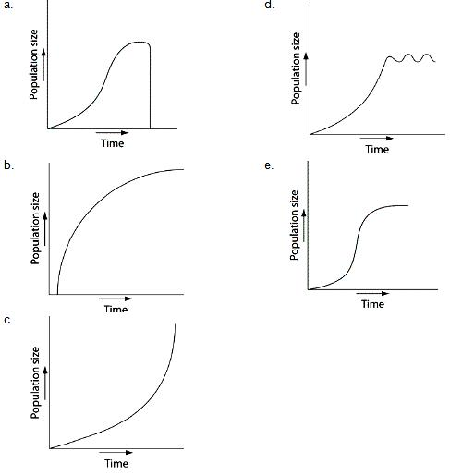

- Why is net primary production (NPP) a more useful measurement to an ecosystem ecologist than gross primary production (GPP)?
- NPP can be expressed in energy/unit of area/unit of time.
- NPP can be expressed in terms of carbon fixed by photosynthesis for an entire ecosystem.
- NPP represents the stored chemical energy that is available to consumers in the ecosystem.
- NPP is the same as the standing crop.
- NPP shows the rate at which the standing crop is utilized by consumers.

- Elephants are not the most dominant species in African grasslands, yet they influence community structure. The grasslands contain scattered woody plants, but they are kept in check by the uprooting activities of the elephants. Take away the elephants, and the grasslands convert to forests or to shrublands. The newly growing forests support fewer species than the previous grasslands. Which of the following describes why elephants are the keystone species in this scenario?

- Essentially all of the other species depend on the presence of the elephants to maintain the community.
- Grazing animals depend upon the elephants to convert forests to grassland.
- Elephants prevent drought in African grasslands.
- Elephants are the biggest herbivore in this community.
- Elephants help other populations survive by keeping out many of the large African predators.

- Researchers in the Netherlands studied the effects of parental care given in European kestrels over five years. The researchers transferred chicks among nests to produce reduced broods (three or four chicks), normal broods (five or six chicks), and enlarged broods (seven or eight chicks). They then measured the percentage of male and female parent birds that survived the following winter. (Both males and females provide care for chicks.)
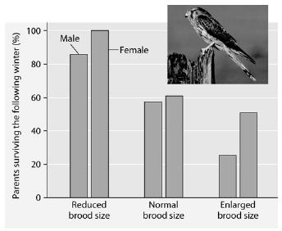

Which of the following is a conclusion that can be drawn from this graph?

- Female survivability is more negatively affected by larger brood size than is male survivability.

- Male survivability decreased by 50% between reduced and enlarged brood treatments.

- Both males and females had increases in daily hunting with the enlarged brood size.

- There appears to be a negative correlation between brood enlargements and parental survival.

- Chicks in reduced brood treatment received more food, weight gain, and reduced mortality.
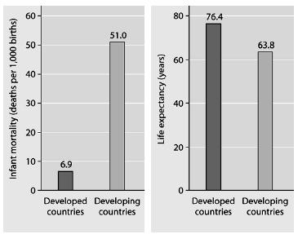

6. What is a logical conclusion that can be drawn from the graphs above?

- Developed countries have lower infant mortality rates and lower life expectancy than developing countries.
- Developed countries have higher infant mortality rates and lower life expectancy than developing countries.
- Developed countries have lower infant mortality rates and higher life expectancy than developing countries.
- Developed countries have higher infant mortality rates and higher life expectancy than developing countries.
- Developed countries have a life expectancy that is about 42 years more than life expectancy in developing countries.

8. Food chains are sometimes short because

- only a single species of herbivore feeds on each plant species.
- local extinction of a species causes extinction of the other species in its food chain.
- most of the energy in a trophic level is lost as it passes to the next higher level.
- predator species tend to be less diverse and less abundant than prey species.
- most producers are inedible.

- Consider the food chain grass → grasshopper → mouse → snake → hawk. How much of the chemical energy fixed by photosynthesis of the grass (100%) is available to the hawk?

- 0.01%

- 0.1%
- 1%
- 10%
- 60%

- If the figure to the right represents a terrestrial food web, the combined biomass of C + D would probably be
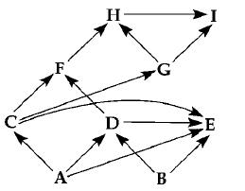
- greater than the biomass of A.
- less than the biomass of H.
- greater than the biomass of B.
- less than the biomass of A + B.
- less than the biomass of E.

- All of the following are density-dependent factors that limit animal populations EXCEPT
a. weather d. food competition
b. predation e. mortality

c. birthrate

- During the carbon cycle, which of the following carbon compounds would be utilized as an energy source by heterotrophs?

a. calcium carbonate b. carbonic acid

c. organic molecules d. carbon dioxide e. carbon monoxide

- All of the following statements concerning characteristics of predator-prey relationships are correct EXCEPT: a. A rise in the population of prey is often followed by a rise in the population of predators.

b. A rise in the population of predators is followed by a decrease in the population of prey. c. Camouflage is an adaptation that protects prey.

d. The production of large numbers of offspring within very short periods of time ensures the survival of some prey populations.
e. The population of predators most often eliminates the population of prey.

- In the nitrogen cycle, the transformation of gaseous nitrogen into nitrogen-containing compounds is performed primarily by
a. fungi b. bacteria
b. green plants e. herbivores

c. carnivores

- The organic and inorganic materials in all the organisms in the diagram will eventually return to the environment by the action of
a. decomposers d. producers

b. primary consumers e. secondary consumers
c. top carnivores
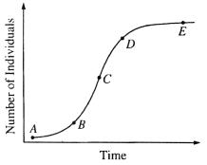

Questions 16-18 Refer to the graph to the right.

- Represents the carrying capacity of the ecosystem

- Represents exponential growth of a population

- Represents the effect of density-dependent resources

- The high level of pesticides in birds of prey is an example of a. the principle of competitive exclusion

b. cycling of nutrients by decomposers c. exponential growth
d. biological magnification

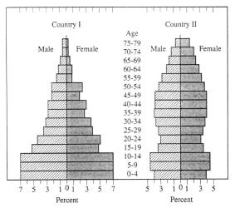
Questions 20-21. The illustrations to the right show the age and sex of the human populations in Country 1 and Country 2. The ages are grouped by 5-year classes, and the sexes are represented separately. The percentages in the different age classes are shown by the relative widths of successive horizontal bars.

- In Country 2, approximately what percentage of the individuals are younger than fifteen years of age?

a. 10% b. 26% c. 45% d. 60%
e. It cannot be estimated from this graph

- Which country is likely experiencing population growth? a. Country I

b. Country II

c. Neither country I or country II d. Both country I and country II

- Which of the following is NOT an abiotic factor
- air
- water
- decomposers
- temperature

- Which of the following lists the biomes as they appear as you move from the equator to the North Pole in the northern hemisphere?

a. tropical rainforest → desert → temperate deciduous forest → taiga → tundra b. desert → tundra → taiga → temperate deciduous forest → tropical rainforest c. taiga → temperate deciduous forest → tundra → desert → tropical rain forest d. tundra → taiga → temperate deciduous forest → desert → tropical rainforest
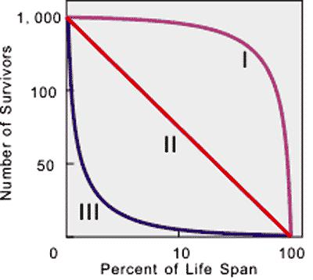

Questions 24-26. Refer to the survivorship curve shown to the right.

- This curve best describes a K-strategist a. Type I

b. Type II c. Type III
d. Type I and II
e. None of the above

- This curve best describes a starfish
a. Type I
b. Type II

c. Type III
d. Type I and III
e. None of the above

- Which curve best describes an organism that invests a lot of energy in parenting? a. Type I

b. Type II c. Type III
d. Type I and II
e. None of the above

- What would most likely be the cause of one species growing in area in a uniform spacing pattern? a. random distribution of offspring

b. interactions among individuals in a population c. chance

d. varied nutrient supplies in the area

- You want to train your puppy to wait at the curb until you tell him to cross the road. Your friend advises you to give
your dog a treat every time he does as you ask. Your friend is advising that you train the dog using

a. operant conditioning c. classical conditioning b. imprinting d. fixed action pattern

29. Animals that help other animals are expected to be

a. stronger than other animals c. related to the animals they help
b. male d. female

30. Eutrophication in lakes results from

a. an increase in temperatures
b. an increase in carbon dioxide in the air

c. a decrease in temparatures

d. an increase in nutrients in the lake

- A scientist recorded the amount of dissolved oxygen produced by elodea, an underwater plant, as 52 mg O2/L. How much carbon (in mg/L) was fixed by this plant? Round your answer to

the nearest tenth.

- A hypothetical population has a carrying capacity of 1,500
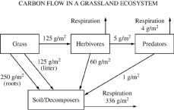
individuals and rmax is 1.0. What is the population growth rate for a population with a size of 1,600 individuals? Round your answer to the nearest hundredth. What is happening to this population?

- Using the diagram to the right, determine how much carbon (in g/m2) is released into the atmosphere as a result of the metabolic activity of herbivores. Give your answer to the nearest whole number.

- A growth curve for a population of rabbits that were accidentally

introduced into a region of New Zealand is shown to the right. Calculate the mean growth rate of the population of rabbits from day 30 to day 40. Give your answer to the nearest whole number.
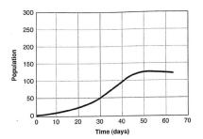

Practice Long Response Questions

- Ecological succession describes the pattern of changes in communities over time. The graph below shows changes in plant diversity following the abandonment of an agricultural field in a temperate biome.

  - Discuss the differences in plant diversity shown in the graph and explain how the changes affect the animal species composition between years 0 and 120.

  - Identify TWO biotic and TWO abiotic factors and discuss how each could influence the pattern of ecological succession.
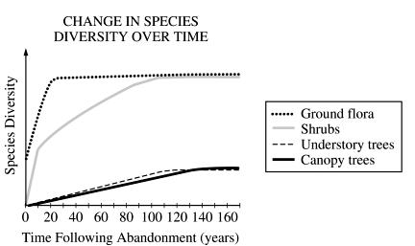

- In many ways, all organisms in a food web can said to be solar-powered. The producer level of the food web is responsible for the transformation of the solar energy into a form that can be used by other living organisms.

a. Discuss the role of green plants in transforming the Sun’s energy into a form that can ultimately be used by heterotrophs.

b. discuss the flow of energy from producers through top carnivores in a food web in terms of the laws of thermodynamics.

c. An energy pyramid for an ecosystem is shown below. Label each trophic level of the pyramid and provide an example of an organism found at each level of this pyramid. Explain why the energy available at the top layer of the pyramid is a small percentage of the energy present at the bottom of the pyramid.
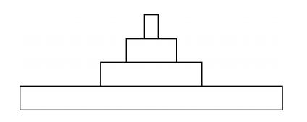

3. The element carbon is contained in all organic compounds.
- Discuss the role of photosynthesis and cellular respiration in carbon cycling in the biosphere.
- For TWO of the following, predict and explain the effect on the carbon cycle if:

  - decomposers were absent o deforestation occurred

o volcanic dust accumulated in the atmosphere o the average ocean temperature increased

- Explain how increased CO2 in the atmosphere results in greater acidification of oceans and describe the effect on marine organisms. Include in your discussion TWO examples of how human activity can increase atmospheric CO2.

- Referring to the diagram below, discuss how TWO of the following processes are accomplished: o process A

o process B o process D o process E
