AP BIO Full Year NOTES

Evolution 4
Natural Selection 4
Pre-Darwin Thinkers/Ideas 4
Darwin Era 4
How Natural Selection Works 5
Darwinian Conclusions 6
Examples of Evolution 6
Antibiotic Resistance 6
Darwin’s Finches 7
The Modern Synthesis 7
How Genetic Info is transmitted 7
Alleles: Different Versions of a Gene 7
Gene Pool 8
Evolutionary Forces 8
Natural Selection 8
Sexual Selection 8
Genetic Drift 8
Gene Flow 9
Evidence for Evolution 9
Earth’s History 9
Fossils 10
Anatomy and Morphology 10
Comparative Biochemistry 11
Evidence for Common Ancestry 11
Universal Characteristics of Life 11
Phylogeny 12
Measuring Evolution 14
Hardy-Weinberg Principle (Maintaining Genetic Equilibrium) 14
How is HW Equilibrium Useful? 15
The Effects of Selection in Population 15
Stabilizing Selection 15
Directional Selection 15
Disruptive Selection 16
Speciation 16
How Seperation Happens 16
Species Barriers 17
Prezygotic Barriers (before sperm & egg come together) 17
Post-zygotic barriers 18
Speciation Examples 18
Models of Speciation 19
Origin of Life 19
Patterns in Life’s History 20
Matter 21
Matter 1: Matter Cycles 21
Matter 2: Water 22
Matter 3 & 4: Biological Molecules 23
Matter 5: Membrane Structure 25
Matter 6: Membrane Function 25
Matter 7: Cell Size 27
Matter 8: Prokaryotic vs. Eukaryotic Cells 27
Matter 9: Eukaryotic Cell Systems 28
Animal-like vs. Plant-like Eukaryotes 29
Endomembrane System 29
Energy 30
Energy and Metabolism 30
Free Energy 30
Laws of Thermodynamics 31
Macro-Metabolic Strategies 32
Ectotherms & Endotherms 32
Temperature Regulation Strategies 32
Metabolism and Size 33
Micro-metabolic Considerations 33
Chemiosmosis 33
Enzymes 34
Environmental Effects 34
Induced Fit Model 35
Control of Metabolism Through Enzyme Regulation 35
Cellular Respiration 36
Aerobic Cellular Respiration 36
Anaerobic Cellular Respiration 38
Photosynthesis 38
The Light Reaction 39
Calvin Cycle 40
Metabolic Considerations 41
Information 42
Historical Development of the DNA Model 42
DNA Replication! 43
Transcription 46
Translation 48
Mitosis 50
Cell Cycle 50
Chromosomes 51
Mitosis 51
Meiosis 53
Meiosis 1 53
Meiosis 2 54
Mendelian Genetics 54
Mendel’s Laws 54
Beyond Mendelian Genetics 55
Co-dominance 55
Incomplete Dominance 55
Blood Type: Multiple Alleles & Codominance 56
Linked Genes 56
Nonmendelian Inheritance 57
Inheritance Patterns 58
Pedigree Analysis 58
Environment’s Role 58
Viruses 59
Viral Anatomy 59
Viral Life Cycle 59
Example: HIV (Retrovirus) 59
Viral Evolution 60
Biotech Tools 60
Restriction Enzymes (Cutting DNA) 60
Discovery 60
Gel Electrophoresis (Separating DNA) 60
PCR - Copying DNA 61
DNA Sequencing: Reading DNA 61
Biotech Applications 61
Plasmids 61
Other Applications 62
Scientific Skills 63
Chi-squared testing 63
Scientific Calculation Skills 64
Water Potential Calculations 65

Evolution

Natural Selection

Pre-Darwin Thinkers/Ideas
- Thomas Malthus (1776-1834)
  - Malthusian Theory = populations grew faster than resources they depended on; humans would exhaust all resources available to them, then starve to death (keeping population in check)
    - Darwin realized this applied to organisms - why some survive, why some don’t - overproduction of offspring led to struggle for existence
    - Wrote essay titled On Population
- Charles Lyell (1797-1875)
  - Uniformitarianism = Idea that processes on earth today are the same ones that shaped earth throughout time
    - Our earth is very old, and geological processes are constantly shaping our earth
      - Darwin thought what if this happened to organisms too?
        - Enough time for evolution to produce great diversity of life
- Jean-Baptiste Lamark (1744-1829)
  - Concept of Use/Disuse = organisms changed over time by using certain parts of their body (which will strengthen and pass on) while disused parts would atrophy and pass on in a weaker form
  - Inheritance of Acquired Characteristics = idea that organism can pass on characteristics that it has acquired through use/disuse in its lifetime to its offspring
    - Wrong, but was one of the first scientists to propose species change over time
- Idea of Artificial Selection
  - Darwin was aware that humans could breed plants/animals to have useful traits
    - By selecting which organisms could reproduce, could change an organism's’ traits
    - Some offsprings have variations that occur by chance, which can be inherited

Darwin Era
- Charles Darwin (1809-1882)
  - Ship’s naturalist on the H.M.S. Beagle’s trip around the world
  - Specifically influenced by trip to Galapagos Islands
    - Saw 13 species on birds; hypothesized about selection pressures causing different msized beaks
  - Darwin developed scientific theory of biological evolution
    - Explains how modern organisms evolved over long period of time through descent from common ancestors
    - Survival of the fittest (fit: how well species is able to reproduce in its env.)
- He noticed that:
  - different, yet ecologically similar animals and species inhabited separated, but ecologically similar habitats around the globe
  - different yet related animal species often occupied different habitats within an area
  - some fossils of extinct animals were similar to living species
- **Darwin’s Theory of Evolution: all species of organisms arise and develop through the natural selection of small, inherited variations that increase the individual's ability to compete, survive, and reproduce.**
- Alfred Russel Wallace (1823-1913)
  - Wallace also developed the same basic theory of evolution
  - Sent Darwin a paper 20 years after, sharing a theory almost identical to Darwin’s
    - Confirmed Darwin’s ideas
  - Darwin compelled to share - wrote On the Origin Of Species

How Natural Selection Works
- Natural selection is a cycle; occurs in situation where 1) more individuals are born than can survive, - overpopulation 2) there is natural heritable variation, and 3) there is variable fitness among individuals
- Natural Selection is a major mechanism for evolution
  - 1) Variation
    - Each organism is different from one another
      - 1 possible cause = genetic mutations in an organism’s DNA
    - Raw material for evolution
      - A diverse gene pool is important for the survival of a species in a changing environment
  - 2) Overproduction
    - Every generation produces more offspring than can be supported, so only very few survive
  - 3)Competition
    - Organisms compete for resources
  - 4) Differential Success
    - Some organisms are better @ surviving and reproducing than others (variable fitness); some organisms have adaptations that are better suited for the environment
  - 5) Reproduction
    - The fittest among the population, or the ones that are most suited for the environment, survive and reproduce, passing on the well adapted traits
  - 6) Repetition
    - The cycle is repeated
- Natural selection leads to adaptation
  - The environment (or niche) determines which organisms survive (environment is selective mechanism) ; over time, the population evolves (getting more and more adapted to its environment)
  - Fitness = the ability to contribute genes to the next generation
- Misconception: Natural selection is goal-oriented
  - Teleology: The notion of A PURPOSE in evolution
    - There is NO PURPOSE in natural selection, merely to drive adaptation
    - NO final goal to evolution
- Misconception: Natural selection is random
  - Natural selection is NOT random; it is the driving adaptation of organisms based on phenotypes
    - Selection is like a fitness search engine, environment filters the search

Darwinian Conclusions
- Principle of Common Descent
  - All species - living or extinct - have descended from 1 common ancestor
- Deep History of Earth
  - The earth is older than you can conceive; around 4 billion years old

Examples of Evolution

Antibiotic Resistance
- Antibiotics = group of chemicals that damage/destroy bacterial cells
- Before selection = some bacteria have resistance because of mutations in their DNA (natural heritable variation)
- During exposure = the bacteria that are resistant to antibiotics are more adapted to the environment, so will survive, while those that are less resistant will die off (differential success)
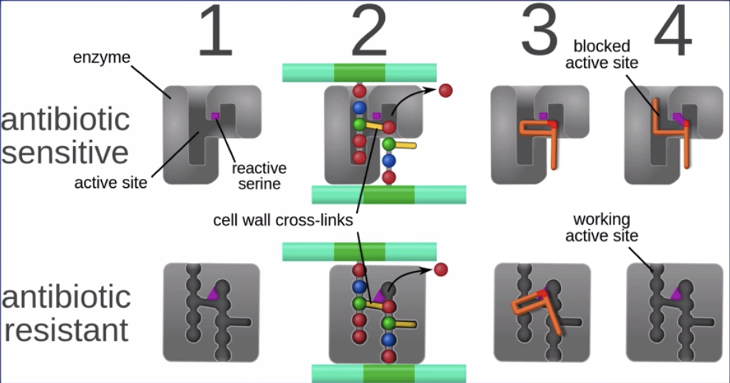
- After exposure = those resistant to the bacteria survived and reproduce (feature of natural selection), leading to a final resistant population
- Cellular details of Antibiotic resistance:

  - Antibiotic resistance bacteria have a different enzyme structure, so unaffected by the antibiotic
    - Resistance is direct product of enzyme structure phenotype

Darwin’s Finches
- 10 different species; classified on shape of beaks, what they eat
- Medium Ground Finch - ongoing research done by Rosemary Peter Grant
  - Every year for 30 years, trapped them and recorded characteristics, then let them go again
    - Observed many things
  - 1 example: Drought in 1977 - statistically significant difference between those who survived the drought (greater beak depth) and those who didn’t (smaller beak depth)
  - **Natural selection acting upon the phenotypes

The Modern Synthesis
- Merger of Darwin’s theories of evolution with mendelian genetics
- Definition of evolution changed (change in allele frequency over time)
- Forces of evolution OTHER THAN natural selection recognized

How Genetic Info is transmitted
- DNA gene is transcribed to RNA and translated to proteins
  - Proteins created drive production of traits → phenotypes
    - ** environment also plays a role in phenotype

Alleles: Different Versions of a Gene
- Allele = different versions of a gene that codes for certain proteins
  - There are 2 alleles for every gene (1 from the father, 1 from the mother)
- Dominant Allele = the allele that expresses the phenotype when homozygous and heterozygous
- Recessive Allele = Both of these are needed to express the phenotype
- Genotype determines Phenotype

Gene Pool
- Gene pool = All of the alleles among ALL of the members of the population in a particular environment
- Evolution = the change in a population’s allele frequencies over time
- **Misconception: Individuals evolve**
- Evolution is a property of population of organisms; gene pool frequencies have to change

Evolutionary Forces
- 4 main = Natural Selection, Sexual Selection, Gene flow, Genetic Drift

Natural Selection
- Nonrandom and adaptive
  - Makes a population increasingly adapted to its environment

Sexual Selection
- Nonrandom and reproductively adaptive
  - Any trait that enables a population to reproduce will be favored
- Can sometimes by maladaptive for survival
  - Ex: male peacocks with more ornate feather arrangements are slower, harder to move, but since females prefer to mate with those with ornate tails, sexual selection drives evolution of ornate tails

Genetic Drift
- Random, Not adaptive
- Genetic Drift = Random changes in allele frequencies of a gene pool due to chance events
  - Bottleneck Effect = Change in allele frequency after sharp reduction in size of population
    - Can be due to environmental events/human activities
    - Leads to drastically different gene pool
  - Founder Effect = Loss of genetic variation that occurs when new population is established by small # of individuals from a larger population
    - Migration of small subgroup; different allele frequencies from population
    - Ex: Amish population → The Amish population was established from about 200 German immigrants. Individuals of this founding population carried gene mutations that cause inherited disorders such as Ellis-van Creveld syndrome. This form of dwarfism is found in a large concentration in the Amish population today because the immigrants that established the population had a high concentration of the disorder in a very small population.
  - **Smaller population drift more, as each member is larger % of alleles in gene pool **
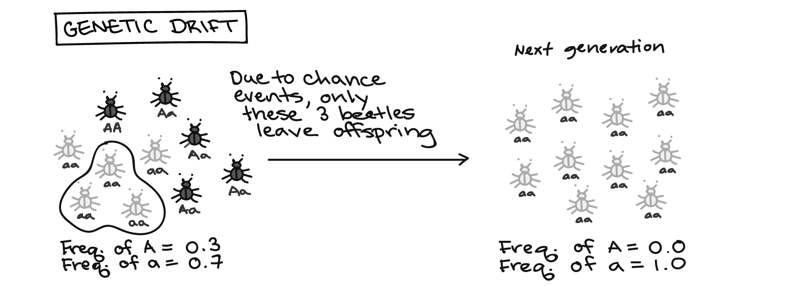

Gene Flow
- Gene flow = movement of alleles from one population to another
  - Individuals from different population come in contact; equalizes allele differences
  - Tends to reduce genetic differences between populations bc alleles are being transferred
    - Ex: mix race human population
  - If extensive enough, can result in 2 populations combining into 1 with a single gene pool

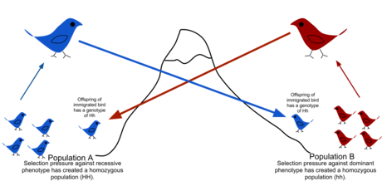

Evidence for Evolution
- Earth’s history, fossils, morphology/comparative anatomy, comparative biochemistry

Earth’s History
- Radiometric Dating = process using radioactive isotopes to estimate the age of natural and manmade materials
  - Use ½ life; different isotopes for different time periods
- Continental Drift = Theory that explained how continents shifted position on earth’s surface
  - Long term motion can help us understand what world looked like before (distribution of organisms now)
- Biogeography = Study of how and why animals and plants live where they do
  - Organisms we find in one area of the planet
  - The global distribution of organisms and the unique features of island species reflect evolution and geological change
    - Ex: Darwin’s Finches
      - Adaptive Radiation = each adapted to a different type of food
  - #1: Closely related species differentiate in slightly different climates
  - #2: Very distantly related species develop similarities in similar environments
- ** All support the notion of old earth → enough time for evolution to occur

Fossils
- Fossil record document evolutionary history of organisms throughout time
  - Document stages in evolution of groups of modern species
    - Can see transitional fossils/intermediate forms
      - Evidence for continual branching throughout life
      - Can show us how much/how little organisms change throughout time
- Can be dated by a variety of methods to provide evidence for evolution
  - Radioactive dating, mathematical calculations, age of rocks

Anatomy and Morphology
- Comparative Anatomy = Study of similarities and differences in anatomy of different species
  - Homologous Structures = structures shared by related species & inherited from common ancestor; however, they have divergent functions
    - adapted to different purposes as result of descent with modification from common ancestor & different selection pressures
    - Ex: Bird Wing, Bat Wing, Human Arm, Whale Flipper are all homologous
      - While insect wing is analogous (phylogenetically independent)
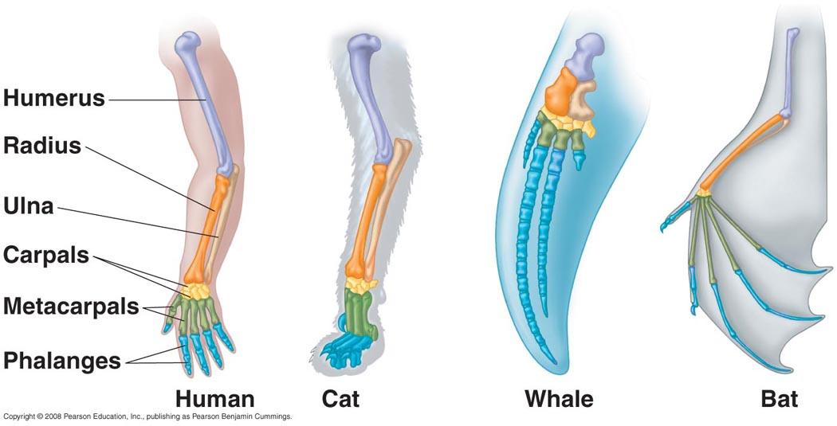
  - Analogous Structures = Structures that have the same function, but evolved independently (different structure)
    - Ex: Insect wing and bird wing
  - Vestigial Structures = Structures that are inherited from ancestors, but lost much/all of original function because of selection pressures
    - Appendix in humans, pelvic bones of whales similar to humans etc.
    - Shows common ancestry

Comparative Biochemistry
- Comparing DNA, RNA, and Protein sequences of different organisms can tell you how genetic sequences of species change as they evolve (evidence of evolution & ancestry)
  - The longer 2 organisms evolve away from each other, the more changes in DNA, RNA, and protein sequences will accumulate
- Normally more reliable than morphology because it directly shows genetic makeup. In addition, analogous structures may indicate similarities even when there are differences in the DNA sequences (same function, but evolved independently)
  - **Exception: unless morphology uses multiple pieces of evidence as opposed to 1 in biochemistry

Evidence for Common Ancestry
- Two Piles for evidence for common ancestry
  - Evidence of Evolution (previous)
  - Universal Characteristics of Life

Universal Characteristics of Life
- Life is made out of cells , All cells process info in the same way, All Cells have Common Biochemistry
- 1) Life is made out of cells
  - All life is either prokaryotic & eukaryotic cells
    - Evidence for common ancestry of all living things
    - Structural evidence supports relatedness of all eukaryotes
- 2) All cells process info in the same way
  - Central Dogma = genetic info stored as DNA, copied into RNA through transcription, then turned into proteins through translation (then process is repeated)
    - mRNA broken up into codons (3 consecutive RNA bases) - each codon codes for a specific amino acid to be brought to ribosome
- 3) All Cells have Common Biochemistry
  - Common metabolic pathways, similar proteins
  - Ex: Glycolysis = an energy releasing pathway
    - All cells use glycolysis to generate ATP from food
  - Stereoisomers = biological molecules can exist in 2 forms, ‘L’ and ‘D’ (like left and right hands)
    - All cells use L-amino acids and D-sugars (same bias/preference)
- Common ancestry is @ every branch of the tree of life
  - Ex: Plants & animal eukaryotic cells share common ancestor
    - Evidence: Shared organelles: nucleus, ribosomes, ER, golgi apparatus etc.

Phylogeny
- Phylogeny = history of the evolution of a species or a group
- Goal = to group species into larger categories based on evolutionary descent
- Phylogenetic Tree =a diagram depicting evolutionary relationships between different species/groups; graphical representations of evolutionary history that can be tested
  - Time is either represented/implied on the tree
    - Common ancestor shown in most trees
  - Extant species: species currently living (on one side of the tree)
- Evidence used to build trees:
  - Shared derived characteristics
  - Molecular data (most accurate; no analogous structures; concrete evidence)
  - Morphological data
  - More evidence used, the better!
  - AVOID analogous structures
- Utilizes “Shared Derived Characteristics” → traits shared in species derived from common ancestor
- Maximum Parsimony: Unless there is evidence suggesting otherwise, assume a trait/mutation only occurs once, and is passed down to all descendants
  - Ex: Birds and mammals both have 4 chambered hearts, but arose as analogous structures

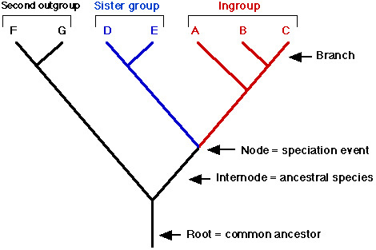
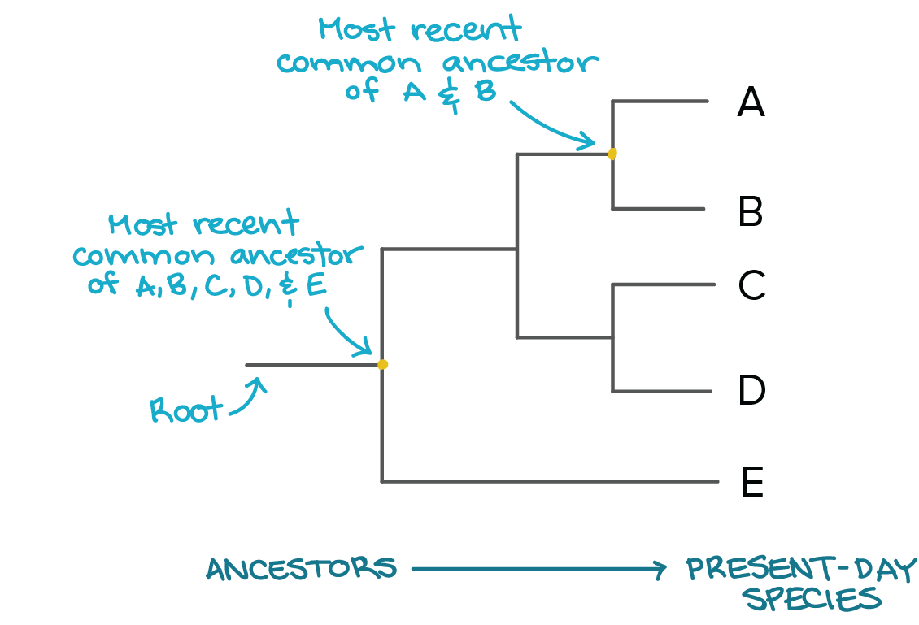
- Modern phylogenies depend on Molecular Data
  - genes/nucleic acids/amino acids
    - Morphological data (fossils etc.) is still useful for supporting molecular data and dating divergences
  - Evolutionarily related organisms share common ancestor with ancestral DNA sequence
    - As organisms develop and diverge, their DNA accumulates differences (mutations)
      - Single Nucleotide Polymorphism (SNP) = one type of mutation that can be used to track common ancestry
      - Indels = Insertion/deletions; one/more nucleotide pairs in DNA strand is lost or gained
    - More distantly related species have more time for mutations to accumulate in their DNA
      - ** NOTE: Must compare homologous DNA segments (aligned segments of DNA)
    - Alignment of DNA = so that most of the bases match
- Each branch point represents common ancestor of species above the point
  - Node = the last point which 2 lineages share common ancestor/speciation event; common ancestor on all the species on the branches
  - Root = bottom of cladogram; common ancestor of all organisms (in cladogram)
    - How recently organisms share common ancestor = how closely related
- Scientists use fossil record, comparative anatomy of homologous structures, and molecular evidence (based on sequence similarity) to construct phylogenetic trees
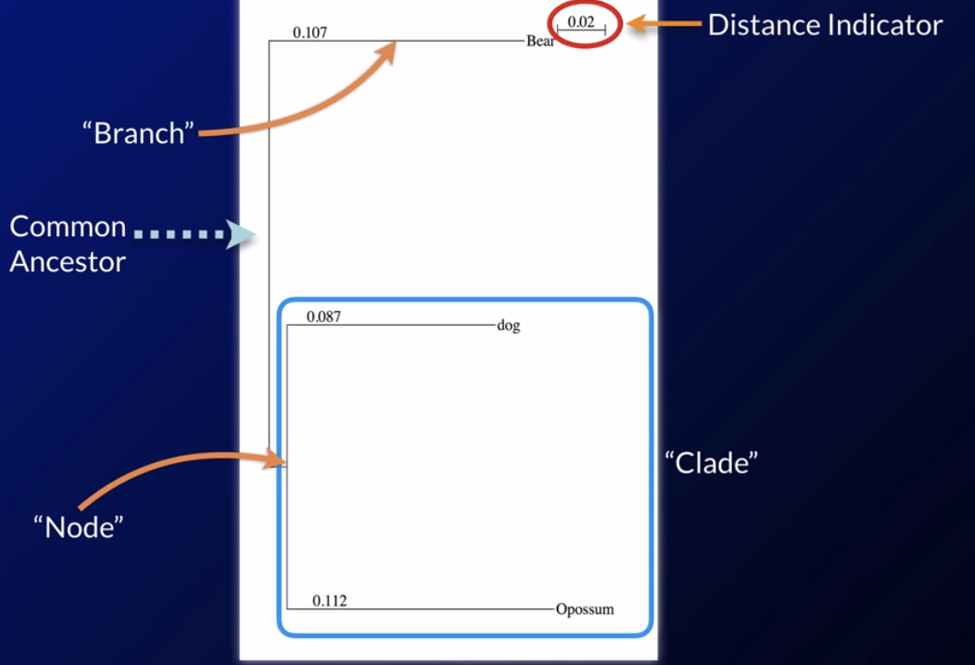
  - More features shared, more likely species are related evolutionarily

- For vertical distance trees (see above), add the numbers; the greater the numbers, the farther away the species are (greater horizontal distance)
- The vertical distance simply to separate the species, no significance
Different representations, same meaning
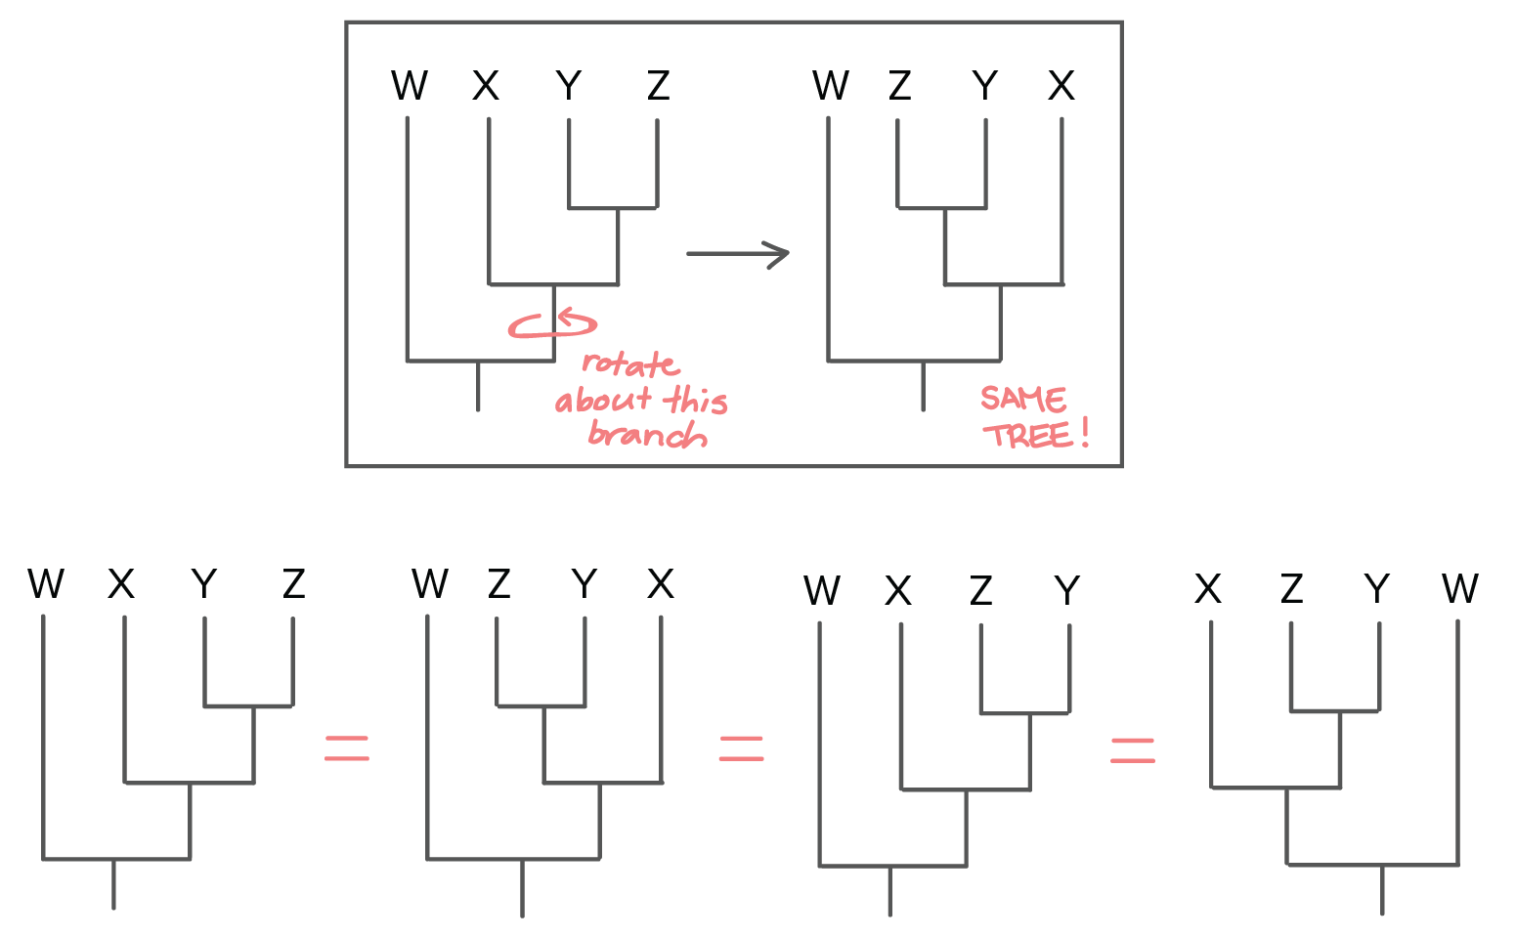

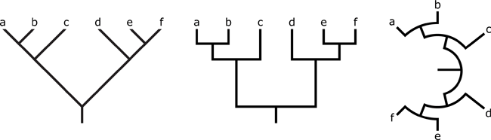
NOTE: Trees are merely hypotheses; they can be revised!

Measuring Evolution

Hardy-Weinberg Principle (Maintaining Genetic Equilibrium)
- Genetic Equilibrium = when populations are not evolving, allele frequencies do not change
- Gene Shuffling, Reproduction, Meiosis & fertilization doesn’t change allele frequencies
  - Sexually reproducing organisms can stay in equilibrium
- Hardy-Weinberg Equilibrium = Describes allele frequencies in a hypothetical, non-evolving population
  - Hardy-Weinberg Equation
  - 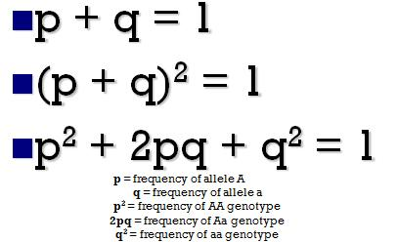
  - Number of homozygous recessive individual/total = q^2 NOT q
  - P = 1-q
- ** NO real population is in hardy-Weinberg Equilibrium
  - To be true, HW equilibrium population must have :
    - No natural selection = completely stable environment
    - No sexual selection = completely random mating
    - No genetic drift = large population
    - No gene flow = no immigration/emigration
    - No mutations (spontaneous changes in alleles)

How is HW Equilibrium Useful?
- Comparing real population to HW population can inform scientific investigation
  - Test how much it deviates from HW baseline
- Real population can approximate HW population
  - Some are close enough that we can use HW to model allele frequencies in a population

The Effects of Selection in Population
- Natural selection on polygenic traits (traits determined by multiple genes) can produce 3 types of selection

Stabilizing Selection
- The stabilizing of extremes towards the middle
- When the individuals @ middle of curve have higher fitness than those @ the ends
  - Ex: mass of infants at birth; too large or too small is dangerous
  - Ex: lizard tail length

Directional Selection
- Natural selection that favors one extreme of the distribution over the other
  - When the range of phenotype shifts ; when individuals @ one end have higher allele frequency than other end
  - EX: giraffe necks

Disruptive Selection
- Natural selection favors both extremes; the phenotypes @ the extremes are more fit than the middle
  - Ex: shell color
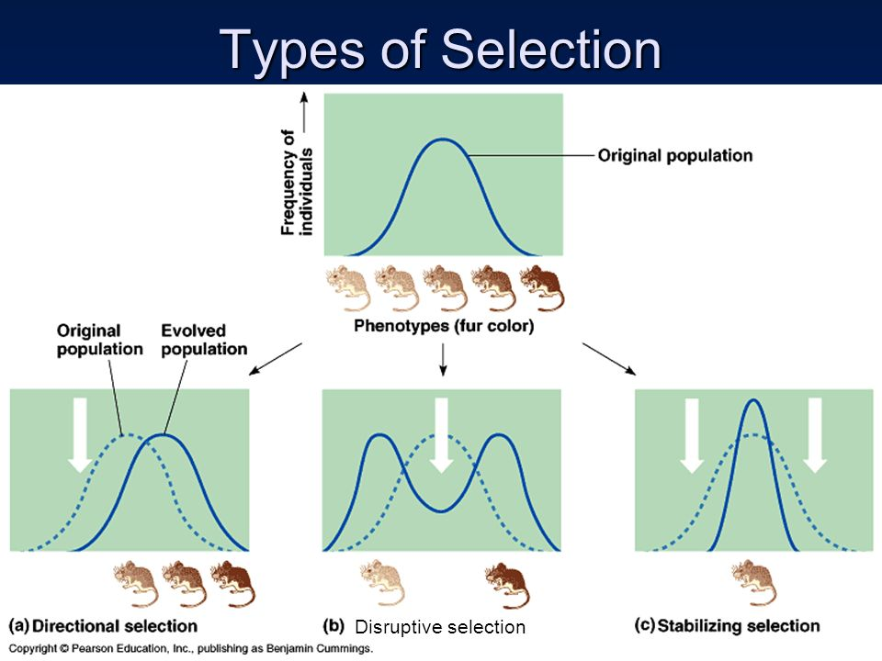

Speciation
- Biological Species = A group of individuals that can successfully reproduce with each other
  - ** NOT 100% true, but a testable definition

How Seperation Happens
- Allopatric Speciation
  - Also known as geographic speciation; occurs when 1 population is separated & no longer can mate w/ each other, leading lineages to speciate
  - Ex: when 2 populations are separated by geographical barriers
    - Rivers, Mountain Ranges, Seas
    - Ex: Abert's squirrels lives in S.West; around 10,000 yrs ago, small population became isolated @ north grand canyon
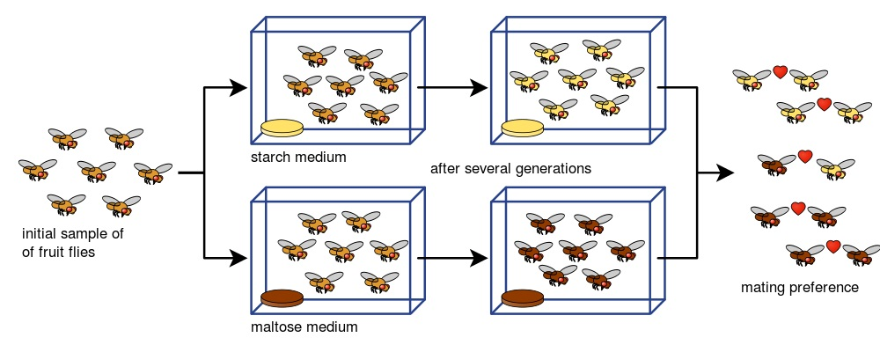
      - Separate gene pools formed - subspecies Kaibab squirrel

- Sympatric Speciation
  - When speciation happens even when population is in contact w/ each other
    - A particular group has genetic polymorphism and is reproductively isolated, even though not physically separated 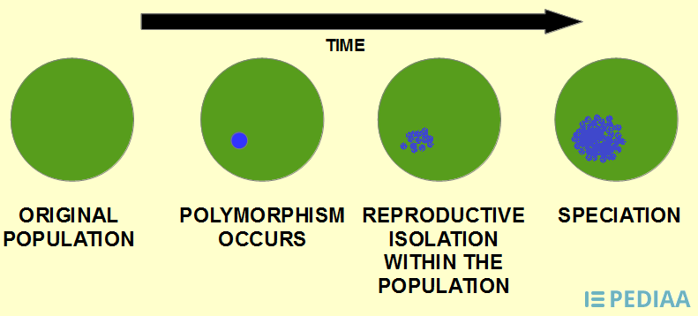

Species Barriers

Prezygotic Barriers (before sperm & egg come together)
- Habitat Isolation
  - Occurs when 2 populations are separated by geographical barriers
    - Rivers, Mountain Ranges, Seas
    - Ex: Abert's squirrels lives in S.West; around 10,000 yrs ago, small population became isolated @ north grand canyon
      - Separate gene pools formed - subspecies Kaibab squirrels
- Temporal Isolation
  - Occurs when 2 or more species reproduce @ different times, so are reproductively isolated
    - Ex: American toad vs. Fowler’s toad
- Behavioral Isolation
  - Species capable of interbreeding act in different ways so they don’t reproduce with each other
    - Ex: blue footed booby and red footed booby have different mating dances
- Mechanical Isolation
  - Reproductive apparatus of different species don’t fit together/can’t come in contact with each other
    - Ex:Elephant and a fly; flowers with different pollinators (orchids)
- Gametic Isolation
  - Animals come in contact/physically close, but gametes (reproductive cells) aren’t compatible; no fertilization takes place
    - Ex: corals release sperm & egg into open water; sperm recognize egg of their own species through chemical markers on the surface

Post-zygotic barriers
- Hybridization Problems
  - Reduced Hybrid Viability
    - The genes of different parent species may interact in ways that impair the hybrid's development or survival in its environment (Grolar Bear)
  - Reduced Hybrid Fertility
    - When hybrids are sterile (Liger)
  - Hybrid Breakdown
    - When the first hybrid is fine but when it attempts to mate, it can not produce viable, fertile offspring
  - Loss of Hybrid Traits
    - Subsequent rounds of reproduction reduces the hybrid trait
      - Ex: Cockapoo

Speciation Examples
- Example 1: Rhagoletis pomonella
  - The apple maggot; originally used to live in hawthorn plants, but when apples were imported, a population broke off and lived in apple plants
    - Some of the insects started to be specialized on apples, showing slight morphological differences, even though they were accessible (sympatric speciation)
    - Since the plants don’t flower at the same time (reproduction time changes); when put together, they have reproductive preferences → IN PROCESS of speciation
- Example 2: Drosophila (fruit fly speciation)
  - An initial sample of flies were seperated and fed on different mediums (starch and maltose) for 2 generations, then brought back together
    - The flies preferred to mate with those who fed on the same medium
- Example 3: Polyploidy
  - Polyploidy plants (cell organisms that contain more than 2 pairs of homologous chromosomes-) can reproduce with each other but not with original plants/other plants; as a result they become biologically isolated from original group of plants and considered a different species.
    - Rapid speciation
- REPRODUCTIVE ISOLATION CAUSES SPECIATION

Models of Speciation
- 2 models: Phyletic gradualism & Punctuated equilibrium
- Phyletic gradualism = many small changes over time; slow, uniform, gradual

- Punctuated equilibrium = long period of no change, followed by short bursts of intense change

Origin of Life
- There are 2 major models of life: Panspermia (originated from elsewhere) & Abiogenesis (from nonliving components on earth)
- The 4 hypothetical steps for life’s origin are:
  - 1) Origin of Biological Molecules
    - Evidence: Miller-Urey Experiment
      - Energy source (lightning); predicted gases - inorganic - in primitive atmosphere (NO oxygen)
        - After interaction, gases were passed through water (simulate oceans) → repeat ; formed organic compounds (glycine, alanine)
      - Can simulate reactions of what ‘early earth’ might have looked like; and given right conditions can spontaneously form compounds necessary for living systems
  - 2) Origin of Cells
    - Evidence: Stromatolites in Fossil Record
    - Stability of Biological Organization
      - Naturally form into compartments
      - ** Natural tendency of molecules to form into compartments suggest the feasibility of cell formation
  - 3) Origin of Info Storage
    - Info storage molecules must have developed in order for life to exist
    - Evidence: Catylic & info storage capacity of RNA
  - 4) Origin of reproduction
    - For life to exist, cells must reproduce
    - Evidence: ??
- No oxygen on primitive earth

Patterns in Life’s History
- 1 evidence of the past is the evolution of photosynthesis
  - Fossil Record: stromatolite fossils (made by cyanobacteria - photosynthetic bacteria) date back ~ 3.2 b.y.a.
  - Heterotroph Hypothesis: life initially evolved as heterotrophic organisms (obtain energy by feeding on others) , and photosynthesis evolved later
    - since organisms that introduced it to atmosphere so O2 in earth’s atmosphere increases
  - Geological Record: Banded Iron formation (Iron reacting with O2 precipitating, forming banded layers on the ocean floor)
  - Evidence of photosynthetic organism: have chloroplast/photosynthetic membrane; maybe have high presence of oxygen/oxides surrounding rock
- “Accelerated Returns” in Life’s History
  - Life hits critical points where complexity & diversity increase exponentially
    - Most evolution in last ¼ of earth’s history → lots of processes needed to be first figured out
  - Ex: Development of Eukaryotes - Endosymbiosis
    - All organisms were prokaryotes
      - when ancient anaerobic prokaryote engulfed aerobic prokaryote → evolved in modern day Mitochondria
      - When modern aerobic eukaryotes engulfed photosynthetic prokaryote → evolved into chloroplast
  - Evidence for Endosymbiosis
    - Similarities between prokaryotes, mitochondria, and chloroplast
      - Internal membrane structure, ribosomes like modern day prokaryotes, sequences of internal chromosomes more similar to prokaryotes than eukaryotes’ nucleus DNA
    - Chloroplast Genome: most similar to Cyanobacteria (photosynthetic)
    - Mitochondrial Genome: Similar to Proteobacteria (can carry out cellular respiration)
      - Similar DNA structure - one circular chromosome
  - Endosymbiosis ALSO shows: time leading up to eukaryotic life was LONG
    - many exchanges of info & structures between unicellular lineages BEFORE modern 3 domain of life
- Patterns in Life’s History
  - Extinctions → caused by catastrophic events
  - Adaptive Radiation → Rapid divergence and speciation to occupy available niches
- Anthropocene = decline in large mammals after human arrival and huge increase in human population

Matter

Matter 1: Matter Cycles
- Where Atoms Come From
  - Atoms made from nuclear fusion reactions in stars
  - Most common elements = CHNOPS
- Matter Cycles On Earth → moves from nonliving (abiotic reservoir) to biosphere (food chain) of earth
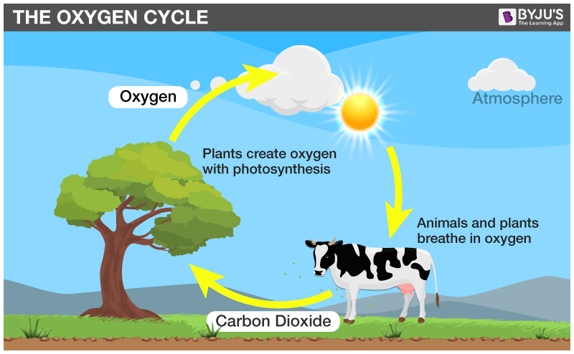
  - C & O Cycle
    - Abiotic = Atmosphere
    - Biosphere = Food chain (incorporated into macromolecules)
    - Process = Metabolism (photosynthesis, cellular respiration)

  - Nitrogen Cycle
    - Abiotic = Atmosphere
    - Biosphere = Food chain (incorporated into protein, DNA, RNA)
    - Process = Nitrogen fixation (taking N2 out of atmosphere into biologically useful forms in food chain- incorporate into proteins, DNA, RNA → done by nitrogen fixing bacteria or lightning -atmospheric nitrogen fixation), denitrification (return nitrogen back to atmosphere by bacteria)
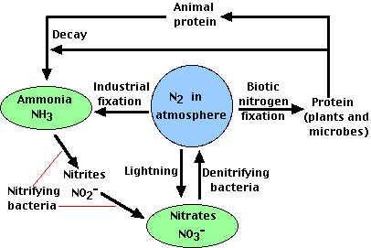

  - Phosphorus Cycle
    - Abiotic = Rocks/Soil
    - Biosphere = Food chain (DNA, RNA)
    - Process = Weathering from rocks (into biosphere) → assimilation (by animals and humans) → Decomposition (back to soil) → sediments → phosphate rocks → uplifted
    - **DON’T include atmosphere
  - Water Cycle
  - 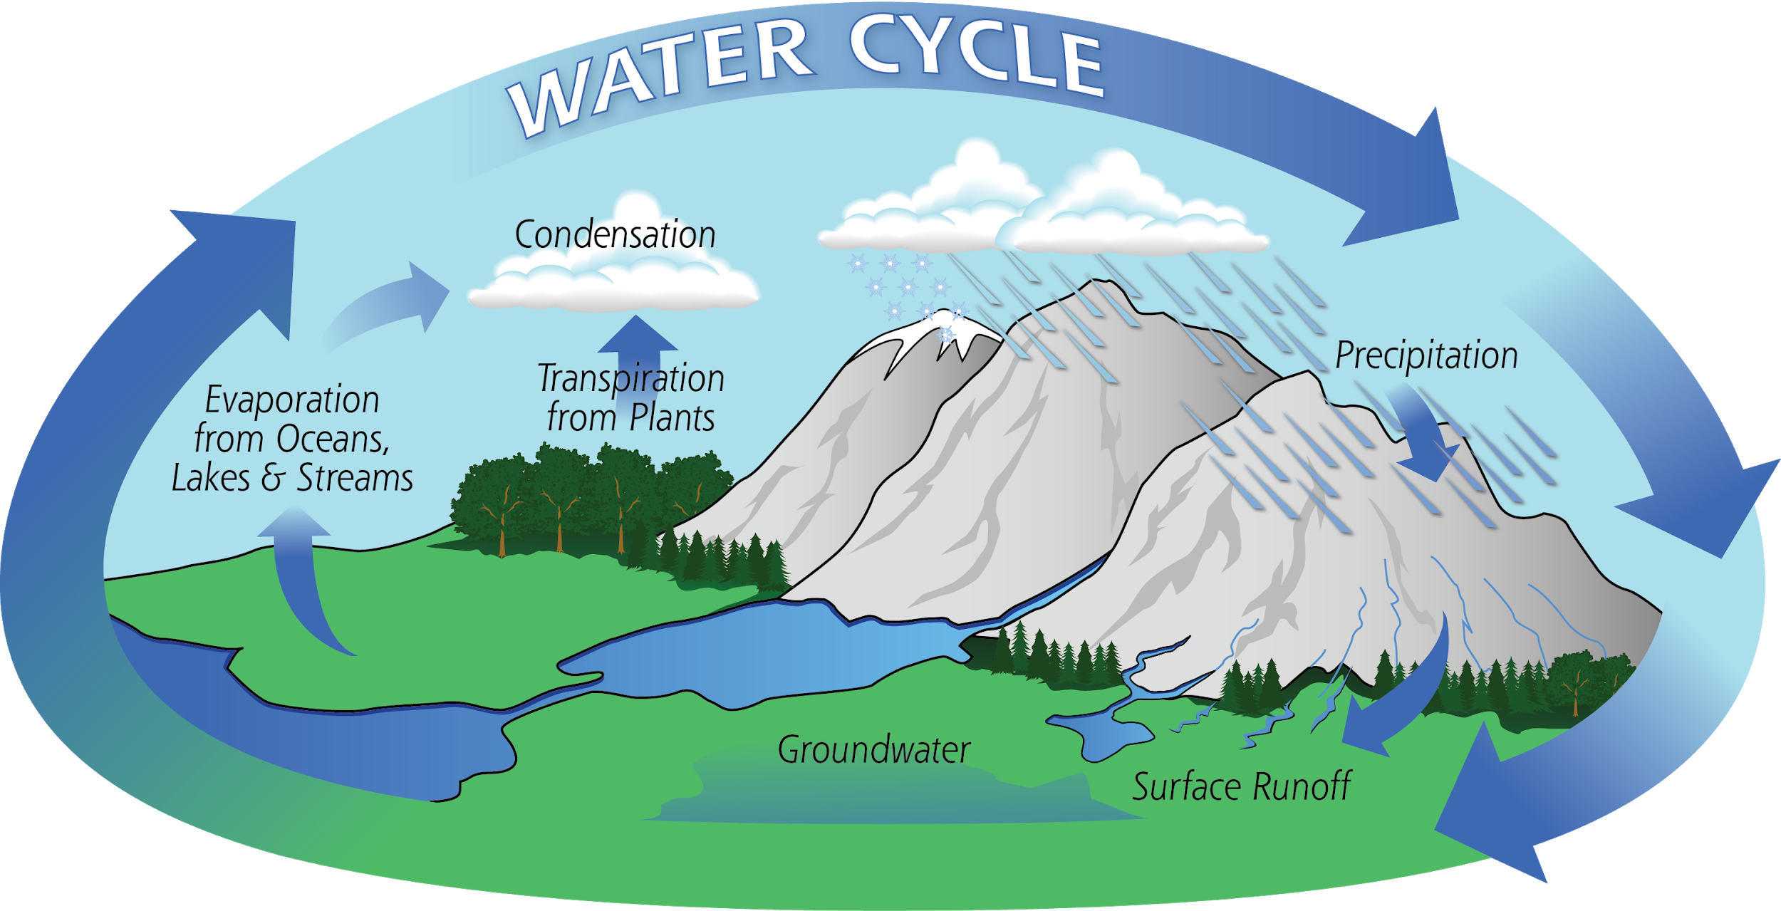
    - One impact of human activity on water cycle: Deforestation leads to decreased transpiration and possible climate effects such as an excess of greenhouse gas

Matter 2: Water
- Properties of Water
  - Water is polar covalent molecule (partially positive on one side, partially negative on other)
  - Can H-bond (each H2O molecule can have 4 bonds)
    - H-bonds: IMF; partially electrostatic attraction between H & N,O,F
- Polar Nature of Water Explains:
  - 1) High Specific Heat
    - Must disrupt H-bonds, so needs more energy to increase temp
    - Acts as TEMP BUFFER - moderates temp
    - Moderates body temp & temp of earth (people sweat to remove heat → transfer to water)
  - 2) Ice Floats
    - Solid form less dense than liquid form (max amount H-bonds)
    - Ice on surface acts as insulator, slowing down freezing of water below
  - 3) Adhesive/Cohesive Properties
    - Adhesion (other molecules) & Cohesion (to itself) → Capillary Action
  - 4) Water’s solvency
    - Water dissolves both polar & ionic compounds (partially & fully charged)
    - It is a very good solvent: Like dissolves like
      - Surrounds solute with hydration rings and breaks the IMF
  - 5) Dissociation of Water
    - OH- and H+ → moderates pH
- Water Participates in Biological Reactions
  - Dehydration Synthesis (removal of water to synthesize) & Hydrolysis (addition of water to seperate)
- Water both makes conditions of life necessary AND participates in life’s processes

Matter 3 & 4: Biological Molecules
- Urea molecule = waste molecule; first molecule created w/ biological system from inorganic molecules
- Carbohydrates (CH2O format→ hydrophilic)
  - Monomer = monosaccharide (ex: glucose)
  - Polymer = polysaccharides (ex: cellulose, glycogen) ; combined by glycocytic linkage
    - Glycocytic linkage = a type of covalent bond that joins a carbohydrate (sugar) molecule to another molecule through dehydration synthesis
      - Glucose+ Glucose = maltose
    - Structure & function of polysaccharides dependent upon sugar monomers and position glycocytic linkages
  - Carbohydrate functions
    - mono/disaccharide = quick energy production
    - Amylose (starch - plants) /Glycogen (humans) = energy storage
    - Cellulose: structural support (plant cell walls)
      - Kinked shape → lower freezing temp
    - **Starch & Cellulose both polymers of glucose; difference in glycocytic linkages → humans can’t digest cellulose
  - Glucose + fructose = sucrose + water (dehydration synthesis)
- Lipids (C,H,O,P → hydrophobic)
  - NO lipid polymers
  - Formed mostly of hydrocarbons (which form nonpolar covalent bonds)
  - Glycerol + Fatty Acids = Lipids
    - Saturated: all single bonds → solid at room temp
    - Unsaturated: at least 1 double/triple bond - kinked → liquid at room temp (harder to freeze bc shape makes it harder to stack together)
  - Glycerol + 3 Fatty Acids = Triglyceride (Energy storage, insulation)
  - Glycerol + 2 Fatty Acids = Phospholipid → 2 fatty acids + phosphate head
    - Amphipathic (hydrophobic tail, hydrophilic polar head)
  - Fused Rings = Steroids (signaling and temp buffering)
  - Cholesterol, an important steroid, is a component in animal cell membranes

- Nucleic Acids (C,H,N,O,P)
  - Monomer = nucleotide
  - Polymer = Nucleic Acids
    - Ex: DNA,RNA etc.
  - Structure = Phosphate group + 5 carbon sugar + nitrogenous base (A,T,G,C or A,U,G,C)
    - Base pairs joined by H-bonding
  - RNA & DNA Differences
    - 1 vs. 2 strands
    - Ribose vs. deoxyribose
    - Nitrogenous bases
  - Function: Info Storage and expression (Transcription, Translation)
- Proteins (C,H,N,O,S)
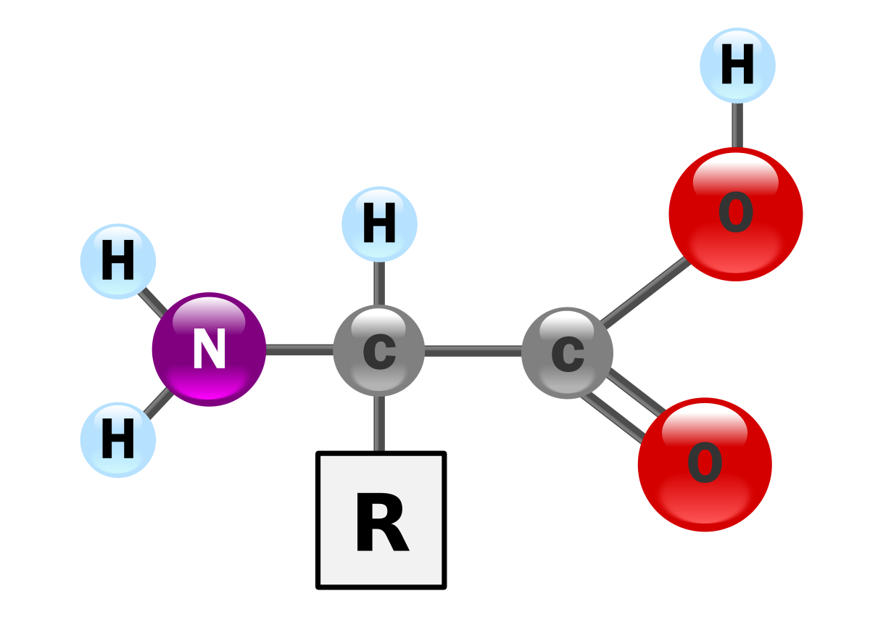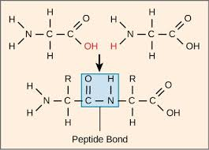

  - Monomer = Amino acids (20 different R-groups)
    - Contains amino group (contains N), carboxyl group, and functional R group
      - R group is what is different in each group (leads to the 20 different amino acids)
  - Polymer = Polypeptide Chains
    - Joined by peptide bonds (through dehydration synthesis)
  - Protein Structure
    - Primary: sequence of A.A. in polypeptide chain
    - Secondary: H-bonding in non-R group atoms (alpha helix, beta pleated sheet)
    - Tertiary: Overall 3D structure (conformation) of polypeptide; interactions of R-groups of amino acids
    - Quaternary: made of >1 polypeptide chain (ex: hemoglobin 4 subunits)
    - **ALL Work together to form the confirmation (3D structure) of the proteins ; 3D shape (confirmation) of protein is what enables its function
  - Accomplish ALL cellular work
    - Defense, transport, signaling, metabolism, structural support
  - Denaturation of Protein Structure
    - Disruption of both secondary and tertiary structure of proteins
    - Factors: Heat, pH, Salt concentration etc.
      - Interrupt the bonds that hold the 3D structure (confirmation) together
  - Sickle-cell disease: Change in protein’s primary structure
    - Change in single amino acid substitution in hemoglobin can affect protein’s structure and ability to function

Matter 5: Membrane Structure
- Membranes are REQUIREMENT for life
  - Controls transport of materials in/out of cell; boundary from environment
- Structure of Cell Membrane
  - Phospholipid Bilayer → fluidity, selectively permeable, barrier from environment
  - Fluid Mosaic Model
    - phospholipid bilayer gives fluidity (constantly moving in 2 dimensions, in a fluid fashion); Mosaic = patchwork of proteins found within
      - Factors: temperature, cholesterol, saturated (solid at room temperatures) vs. unsaturated (kinked - liquid at room temperature )
    - In the plane of the membrane, all the substances are moving constantly (fluid); just surrounded by water
    - If saturated fatty acids (straight) are compressed by decreasing temperatures, they press in on each other to create a more dense and rigid membrane; if unsaturated fatty acids (kinked) do the same, they are able to still make space between each phospholipid (liquid at room temp)
  - Membrane Proteins → embedded in membranes
    - Peripheral proteins: appear on one side of bilayer
    - Integral proteins (transmembrane): go through both sides of bilayer
      - Ex: transport proteins: transport ions and bigger molecules through membrane
    - BOTH may serve as enzymes, structural attachments, or cell’s recognition sites
  - Other membrane elements
    - Glycolipids = lipids + carbohydrates; for stability & cellular recognition
    - Glycoproteins = protein + carbohydrates
    - Cytoskeleton = network proteins that extend through entirety of cell cytoplasm
    - Cholesterol = temp buffer, moderates fluidity and stabilizes membrane

- Cell Walls
  - Plant-like Eukaryotes & Prokaryotes have them; animal cells do not
  - Function = maintain structure of Cell (animals have skeletal system)
  - **Metabolically inactive

Matter 6: Membrane Function
- Cell Membrane is selectively permeable
  - Diffuse through: Small and nonpolar substances
  - Can’t diffuse: large & charged/polar substances
- Types of Diffusion
  - 1)Passive Transport
    - Simple diffusion (through bilayer directly)
    - facilitated diffusion (use channel & carrier proteins specific to molecules/ions; can also have sodium potassium transport - through proteins)
      - Ex: aquaporins are channel proteins that allow water to pass through
    - [high] → [low]
    - No input of E needed
  - 3) Active Transport
    - Against concentration gradient; [low] → [high]
    - E needed → Ex: Pump proteins (Na+ K+ pump→ uses ATP )
    - 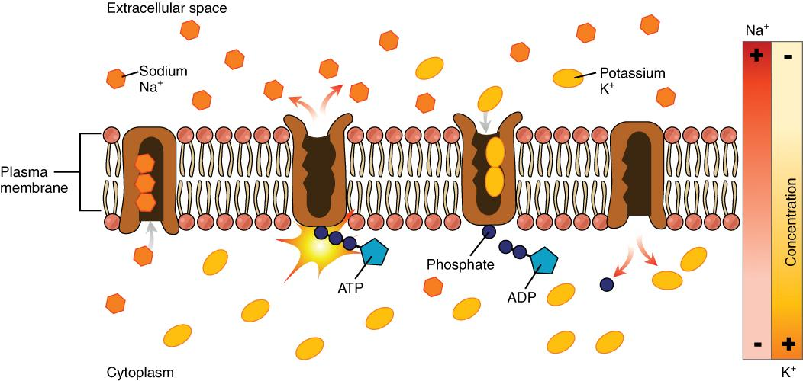
    - Conformational change in pump proteins
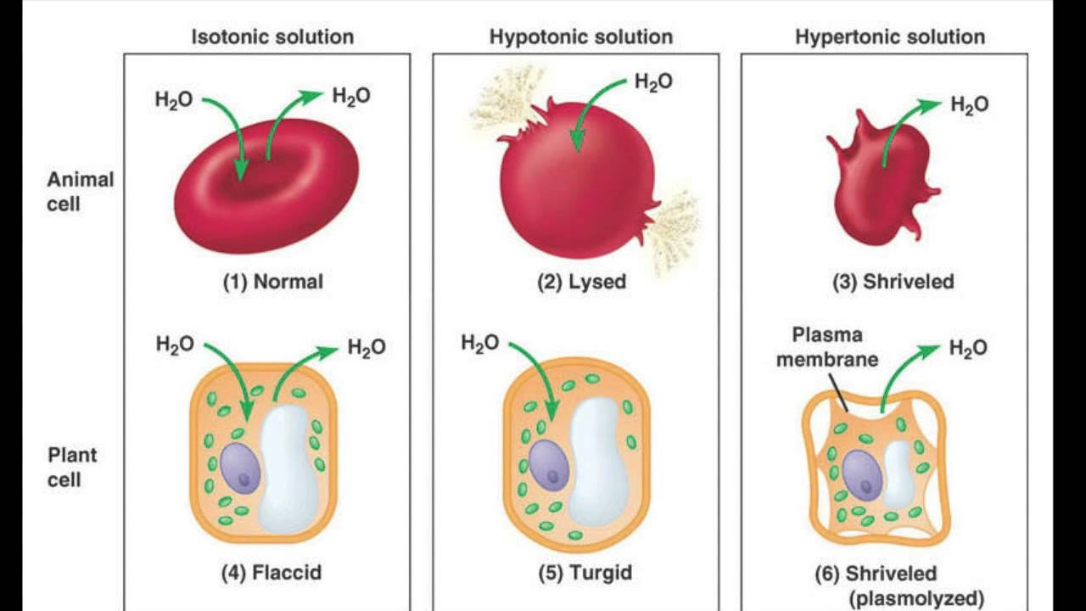
  - Transport is an EMERGENT property → net movement of molecules, not individual

- Tonicity = measure of osmotic pressure gradient (comparative to other solutions)
- osmosis= water moves from lower concentration to higher concentration solute

- Plant cells adapted to hypotonic solution (turgor pressure); animal cells isotonic
- Hypertonic solution = higher [solute], lower [solvent]; hypotonic = lower [solute], higher [solvent]
- **solvent is always water
- Solvent goes from hypotonic to hypertonic solution until reaches isotonic

- Bulk Transport
  - Transport of large amounts of substances into/out of cell
    - Endocytosis (into cell ) and exocytosis (out into extracellular)

Matter 7: Cell Size
- Cell Size & Limits
  - 1mm = 1000µm
  - Eukaryotic cells ~100µm; Prokaryotic ~ 10 µm
- Lower Limits on Cell Size
  - Min amount of stuff needed to function in a cell
  - Smallest cell = mycoplasma
- Upper Limits on Cell Size
  - Larger = less efficient @ transporting materials
  - Efficiency limits transport of materials
    - Volume increases exponentially faster than SA
      - As side length inc, SA: Volume Ratio decreases
        - Also means larger organisms have lower relative metabolic rate, smaller organisms have higher relative metabolic rate (release more heat, need more energy)
  - If cell can’t efficiently GET RID OF WASTE and BRING IN NEW MATERIALS, can’t live
    - SA eventually not great enough to bring in enough material for the volume it holds
- Maximizing SA
  - Ex: Plant cells = root hairs & Mycorrhizal (Fungal species on plant roots)
    - Root hairs on plant roots (where plants exchange materials w/ environment) inc efficiency
  - Ex: Villi and Microvilli (animal cell)
    - Surface of intestines covered in villi; increase absorption of production of digestion from food
  - LOTS of adaptations to maximize SA (can fit more stuff if you have more surface area)
- Relative efficiency - calculation of SA:Volume Ratio
  - You want high SA to volume ratio!!

Matter 8: Prokaryotic vs. Eukaryotic Cells

Prokaryotic | Eukaryotic
- Strictly unicellular  - Lacks nucleus and membrane bound organelles  - Have to be relatively uniform bc all conditions are equal (no compartments)  - ⅔ domains on earth  - **NOT disorganized or inefficient  - MOST functions occur in cytosol | - Unicellular and multicellular  - Plant-like and animal-like  - Many membrane bound organelles, multiple linear chromosomes  - Compartmentalization allows for varying conditions in different organelles  - Can provide conditions for processes to occur @ varying levels without affecting other cells → increased control and efficiency
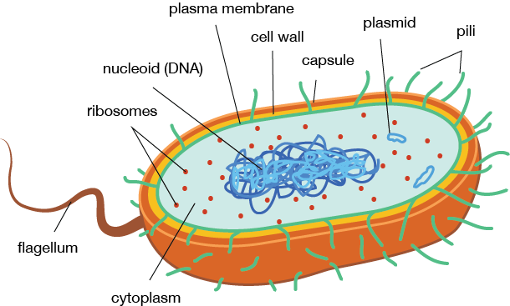  Cell Wall: provides structural support (made out of peptidoglycan) → gives them their shape  Flagellum: helps with movement  Pilli: Helps attach to surfaces  Nucleoid: DNA in 1 circular chromosome  Ribosomes: synthesizes all proteins; present in BOTH prokaryotes AND eukaryotes  Pilli: helps attach to surfaces | 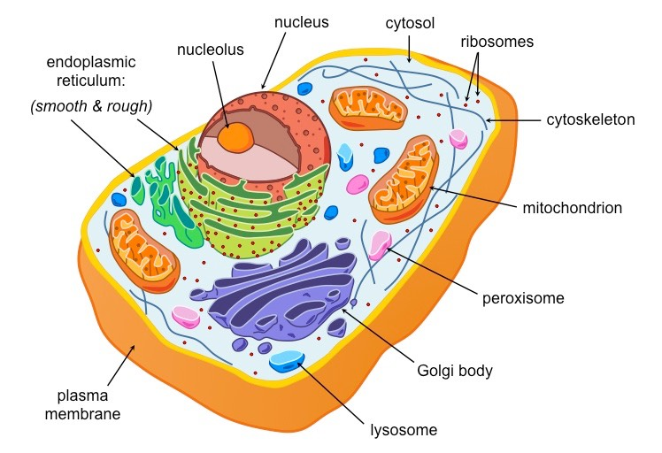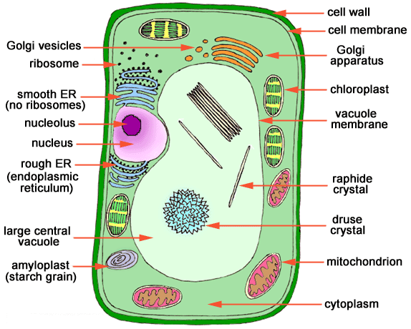

Matter 9: Eukaryotic Cell Systems
Cytoplasm: entire region of cell between plasma membrane & nuclear envelope
Cytosol: The gel-like substance organelles are suspended in
Nucleus: Stores the cell’s DNA (in multiple linear chromosomes) and directs the synthesis of ribosomes and proteins
- Nuclear envelope: double-membrane structure that constitutes outermost portion of nucleus ; contains pores that control passage of ions, molecules, and RNA
- Nucleolus: dark staining area within nucleus that specifically functions to produce rRNA units
Ribosomes
- Cellular structures responsible for protein synthesis; made up of a large and small subunit
Mitochondria
- Site of aerobic cellular respiration; responsible for making ATP, the cell’s main energy-carrying molecule
- Like chloroplast, it has its own ribosomes and prokaryotic-like DNA; reproduces independently of the cell; has highly folded membranes
Peroxisomes: small, round organelles that break down fatty acids and amino acids; also detoxifies many poisons that may enter the cell body
Vesicles/Vacuoles: Membrane-bound sacs that function in storage and transport
*Chloroplasts: plant cell organelles that carry out photosynthesis (to make glucose)
- have own DNA and ribosomes
*Cell Wall: Rigid covering that protects the cell, provide structural support, and gives shape

Animal-like vs. Plant-like Eukaryotes

Plant-like | Animal-like
- Has cell wall made of cellulose  - Large central vacuole: key role in regulating cell concentration of water in changing environments  - Contains chloroplast and mitochondria | - Contains no cell wall  - Small vacuoles  - No chloroplast (only mitochondria)

Endomembrane System
- Endomembrane system in eukaryotic cells work to modify, tag, package, and transport proteins and lipids
- Nucleus → Endoplasmic Reticulum (ER) → Lysosomes → Golgi Apparatus → Cell Membrane

ER: series of interconnected membranous sacs and tubules that collectively modify proteins and synthesize lipids
- Rough ER: covered in ribosomes that make proteins embedded in membrane/secreted from the cell
  - Abundant in cells that secrete proteins (ex: liver)
- Smooth ER: continuous with RER but no ribosomes
  - Lipid & carbohydrate synthesis; detoxification
Golgi Apparatus: series of flattened membranes which sort, tag, pack, and distribute lipids and proteins
- Modify proteins into functional final versions
- Transport vesicles travel to the cis face (and fuse), then travel out through the trans face
- Abundant in cells that engage in secretory activity (ex: cells of salivary glands that secrete digestive enzymes)
Lysosomes: vesicles filled with digestive enzymes; destroys pathogens that might enter the cell
- Digests macromolecules, recycle worn-out organelles, and destroy pathogens

Energy

Energy and Metabolism
- Bioenergetics: the concept of energy flow through living systems
- Metabolism: All of the chemical reactions that take place in a cell
Metabolism of Carbohydrates
- Photosynthesis (CO2 and H2O with light energy to produce sugar)
- Cellular Respiration (breakdown of glucose to produce CO2, H2O, and energy)
Metabolic Pathways
- Metabolic Pathway: a series of interconnected biochemical reactions that convert substrate molecule through a series of metabolic intermediates to yield a final product
  - Anabolic pathway: REQUIRE ENERGY to synthesize complex molecules from simple ones (photosynthesis)
  - Catabolic pathway: breakdown complex molecules into simpler ones to produce ATP; RELEASE ENERGY (cellular respiration)

Free Energy
- Free energy: Gibbs free energy; the energy available to do work (delta G)
  - Work: any movement of matter at any level in an organism
- ΔG = ΔH - TΔS
  - Exergonic reactions: ΔG < 0; releases free energy
    - Spontaneous; occurs without addition of energy (breaking bonds)
  - Endergonic reactions: ΔG > 0; requires free energy
    - Non-spontaneous; products will have more free energy than reactants (form bonds)
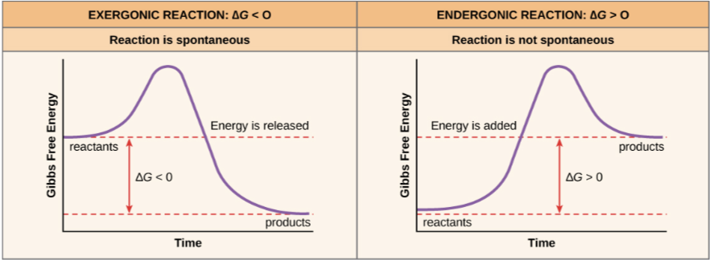
- Activation Energy: Small amount of energy input necessary for all chemical reactions to occur
  - Typically heat energy from surroundings
  - When reaction is catalyzed, activation energy is lowered (occurs at a faster rate)
  - Transition state: high-energy, unstable state (top of curve)
- Ex: Production of ATP
  - ATP is energy carrier of cell
  - Bonds that connect the phosphate have high energy content, and energy released from hydrolysis of ATP (ATP → ADP + Pi + free energy; -7.3kcal.mole ) is used to perform cellular work
    - Cells use ATP by coupling exergonic rxn of hydrolysis with endergonic reactions (ATP donate phosphate group to another molecule via phosphorylation)
  - Regeneration of ATP (ADP + Pi + free energy → ATP + H2O)
- Reaction Coupling: Process in which an energetically favorable reaction (like ATP hydrolysis) is coupled with a endergonic reaction
  - Linking happens through shared intermediate - product of one reaction is “picked up” and used as reactant in another
  - 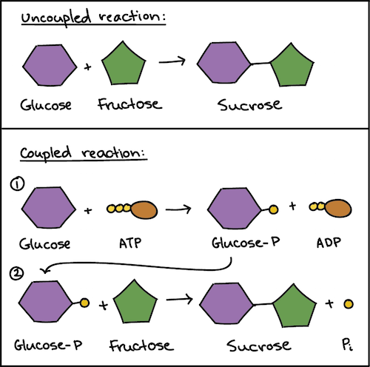

Laws of Thermodynamics
- 1: Energy can’t be created or destroyed, only transformed
  - Result: Must eat/ produce own food (continual energy input)
  - Chemical energy stored within organic molecules (sugars and fats) transformed through series of cellular chemical reactions into energy within molecules of ATP
    - Does work: build complex molecules, transport materials, contract muscle fibers etc.
- 2: Every transfer of energy increases entropy (disorder) of universe
  - Heat energy: energy transferred from one system to another that is not doing work
  - The more energy lost by a system to its surroundings, less ordered and more random it is
  - Consequence: You need to eat and you will die
    - Entropy of body is increasing, so we need to consume highly ordered food
  - ** Living systems can decrease entropy of SYSTEM as long as increase entropy of SURROUNDINGS (open system)
    - Ex: Humans produce waste products that aren’t useful energy sources
    - Even though living things are highly ordered and maintain state of low entropy, entropy of universe in total is constantly increasing b/c of loss of usable energy w/ each energy transfer
- Living Systems & Open Systems
  - Living systems are open systems - have input and output, and continually exchange both matter and energy with the environment
  - Living systems try to be in homeostasis - a stable, non-equilibrium state
  - In a living cell, chemical reactions are constantly moving towards equilibrium but never reaching it (b/c living cell is an open system)
    - If reached equilibrium, would die off

Macro-Metabolic Strategies

Ectotherms & Endotherms
Ectotherms | Endotherms
- Also known as “thermoconformer”  - Depends mainly on external heat sources  - Body temp changes with temperature of the environment  - Doesn’t spend much energy (typically lower metabolic rates)  - Can survive bigger temp changes (wider range!)  - All other than mammals & birds | - Also known as “thermo-regulator”  - Use internally generated heat to maintain body temp/high E level  - Body temp same regardless of environment  - Can engage in activities that require greater E in acceptable temperature  - Mammals and birds

Temperature Regulation Strategies
Ectotherms | Endotherms
- Seek shade  - Marine Iguanas sunbathe on rocks, which allow for short ‘bursts’ of activity  - Ectotherms CANNOT hibernate - can’t actively downgrade body temp/metabolic rate | - Increase metabolic heat production -thermogenesis- in response to cold environments  - Can produce metabolic heat through shivering  - Nonshivering thermogenesis depends on brown adipose tissue  - Hibernation: state of metabolic depression in endotherms; functions to conserve energy when sufficient food unavailable  - Decrease metabolic rate and body temp
- Evaporation of sweat absorbs energy, drawing heat out of body

Metabolism and Size
- Smaller animals have larger SA:V ratio; therefore LARGER relative heat loss to environment per unit time
  - THe larger the SA, the quicker the organism dissipates heat (energy), therefore has to eat more
  - Small endotherms (specifically) must eat constantly
    - Ex: hummingbird
- **Less mass = higher relative metabolic rate**

Micro-metabolic Considerations
Sequential Metabolism
- Why don’t cell burst into flames?
- Combustion = organic molecule + O2 → CO2 + H2O + Energy (FIRE!)
  - Respiration is combustion, but cells don’t burst into flames bc of sequential, enzyme-controlled metabolism
- Cells use specific molecules to regulate enzymes in order to promote/inhibit certain chemical reactions
Electron Shuttles
- e- shuttles: short term electron storage/release molecules, used in respiration and photosynthesis
  - Takes electrons from things being oxidized & temporarily store in “intermediate” molecules
  - Serve as electron carriers in redox reactions; reduce inputs and oxidize outputs
- Ex: NAD⁺ + 2e⁻ + H⁺→ NADH
  - OIL RIG (oxidation is loss, reduction is gain)
- Important e-shuttles:
  - NAD⁺ / NADH
  - FAD/ FADH₂
  - NADP⁺ / NADPH

Chemiosmosis
- Chemiosmosis: movement of ions across a semipermeable membrane (down electrochemical gradient) to generate ATP
  - e- shuttles (NADH, FADH₂) are oxidized, releasing high energy e⁻ and protons
  - Free energy from series of redox reactions (from ETC) is used to pump H+ ions across the membrane into intermembrane space
  - Uneven distribution of H+ ions across membrane establishes electrochemical gradient
  - H+ molecules can’t diffuse through nonpolar regions of phospholipid membrane without aid of ions channels, so H+ pass through integral membrane protein ATP synthase, turns & adds phosphate group to ADP, forming ATP
- Chemiosmosis is widely distributed for ATP production - in mitochondria, chloroplast, bacteria etc.
  - ATP drives all cellular work !
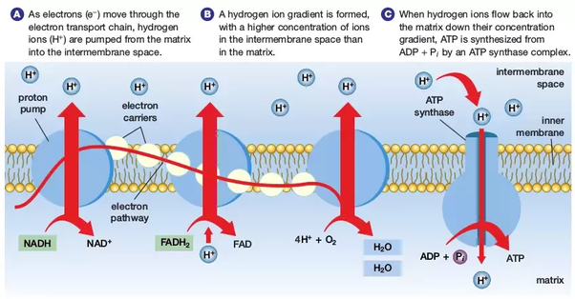

Enzymes
- Enzymes: macromolecules (most often proteins) that speed up chemical reactions by lowering activation energy barriers
  - Specific to the reactions they catalyze
  - They remain unchanged (can be reused)
  - Total Energy released/absorbed in catalyzed/uncatalyzed reaction remains the same
- Substrates bind to the enzyme at the active site
  - Active site: where the “action” happens; unique combination of amino acid residues, their positions, sequences, structures, and proteins create a very specific chemical environment within the active site
  - “Best fit” model = active site is specific for each substrate

Environmental Effects
- Substrates are subject to influences by local environments
  - Increasing environmental temp generally increases reaction rate (until a certain point)
- Temperature
  - Optimal temps are different for different enzymes
  - Different organisms have different optimal metabolic temperatures
  - HIgh temperatures will eventually cause enzymes to denature (lose its conformation)
- pH
  - Optimal pH varies by location in an organism
  - Enzymes are suited to function best within a certain pH range -> extreme pH values can cause enzymes to denature
- Substrate Concentration
  - As substrate concentration goes up, the rate of enzyme activity levels off
    - There are not enough active sites for the substrates to bind to; it is saturated

Induced Fit Model
- Expands upon the lock-and-key model; states that as enzyme and substrate come together, their interaction causes mild shift in both enzyme and substrate conformation that confirms an ideal binding arrangement between enzyme and transition state of substrate
- When enzyme binds to substrate, enzyme-substrate complex is formed (transition stage)
  - Lowers the activation energy of reaction (for example by contorting substrate molecules in ways as to facilitate bond-breaking, or by participating in chemical rxn itself)
  - Brings the substrates together in optimal orientation
- After enzyme done catalyzing reaction, released it’s product

Control of Metabolism Through Enzyme Regulation
- Enzymes can be regulated in ways that promote or reduce their activity
  - Competitive Inhibition: When a molecule that mimics shape of substrate (an inhibitor) occupies the active site, preventing the actual substrate from entering active site
  - Allosteric Inhibition: When inhibitor molecules bind to enzymes in location other than active site and changes shape of active site so substrate can’t bind to it
    - Similarly, allosteric activation is the same but when the active site conformation change increases the affinity of substrate
- Molecules that help enzymes
  - Cofactors: inorganic ions such as iron and magnesium that promote optimal conformation and function for respective enzymes
  - Coenzymes: organic helper molecules required for enzyme action (Ex: dietary vitamins)
- Feedback Inhibition in Metabolic Pathways
  - In a efficient and elegant way, cells have evolved to use products of their own reactions for feedback inhibition of enzyme activity
  - Feedback Inhibition: involves use of a reaction product to regulate its own further production
    - Ex: abundance of specific products leads to slowing down of production (ex: by changing conformation)
    - ATP is an allosteric regulator of some enzymes involved in catabolic breakdown of sugar, which produces ATP
      - When ATP is abundant, cell prevents further production, as too much ATP would go to waste
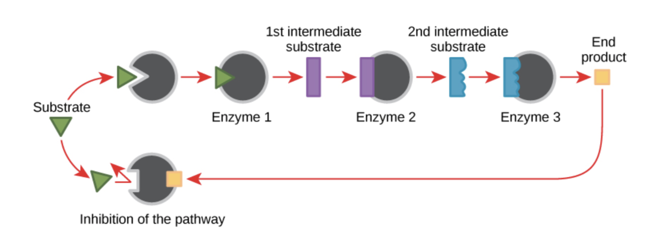

Cellular Respiration
- Performed by all organisms; ATP is produced through the breakdown of nutrients
- C₆H₁₂O₆ + 6O₂ → 6CO₂ +6 H₂O + ATP
  - Oxygen is the final electron acceptor (+ protons and becomes H2O)

Aerobic Cellular Respiration
- Glycolysis
- Formation of acetyl CoA
- The Krebs/Citric Acid Cycle
- Oxidative Phosphorylation/ETC

- Glycolysis: the splitting of glucose; location= cytoplasm
  - Glucose split into 2 pyruvic acid (3 carbon) and yields 2 NET ATP and 2 NADH
    - Requires series of enzyme catalyzed reactions
  - Located in Cytoplasm
IN | OUT
1 Glucose | 2 pyruvate
2 ATP | 4 ATP
2 NAD+ | 2NADH
- Formation of Acetyl-CoA
  - Each pyruvic acid is converted to acetyl coenzyme A (2 Carbon) and releases 1 CO₂
    - 2 pyruvic acid → 2 acetyl COA, releases 2 CO₂ + 2 NADH
- The Krebs Cycle
  - 1 Turn; x2 for each glucose
In | Out
Acetyl-CoA | 2 CO₂
3NAD⁺ | 3 NADH
1 FAD | 1FADH₂
1ADP | 1 ATP
  - Since cycle begins with 4 carbon molecule (oxyacetate) + Acetyl to form Citric Acid( 6 carbon), also has to end with 4 carbon molecule, so loses 2 CO2
  - Acetyl-CoA oxidized, electron carriers reduced
- Oxidative Phosphorylation: process in which ATP is formed by transferring electrons from electron carriers to O₂
  - Electron Transport Chain
    - Electron carriers split apart, and high energy electrons pass down the ETC through a series of redox reactions
    - Free energy produced by moving of electrons; pumps protons from matrix to intermembrane space
      - Hydrogen ions can only diffuse across inner membrane by passing through channels ATP synthase; therefore flow of protons through channels produces ATP by combining ADP and phosphate on matrix side of channel 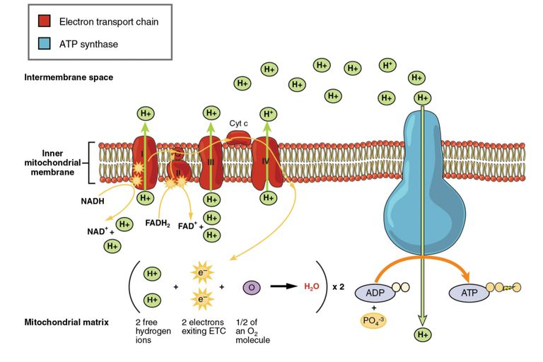
      - If there is not enough oxygen, ETC stops working and high energy molecules NADH and FADH2 can’t be oxidized back to be used again (becomes like a limiting reagent)

Process | Location | Input | Output
Glycolysis | Cytoplasm | 1 Glucose  2 ATP  2 NAD⁺ | 2 pyruvate  4 ATP  2 NADH
Formation of Acetyl-CoA | As pyruvate transported into mitochondria | 2 pyruvates  2 NAD⁺  2 Coenzyme A | 2 Acetyl-CoA  2 NADH  2 ATP
Krebs Cycle | Matrix | 2 Acetyl-CoA  4 NAD ⁺  2 FADH | 6 NADH  2 FADH 2  2 ATP
Oxidative Phosphorylation; Chemiosmosis | Inner mitochondrial membrane | 10 NADH  2 FADH₂  2 O₂ | 2 H₂O  32 ATP (varies)
 |  |  | OVERALL: 36 ATP

Anaerobic Cellular Respiration
- ATP produced through breakdown of nutrients in ABSENCE of oxygen
- Carry out initial step of glycolysis and fermentation
  - Pyruvic acid converted to either lactic acid/ethyl alcohol (ethanol) and CO₂
  - Results in 2 net ATP; and NAD⁺ is regenerated through fermentation (NADH oxidized)
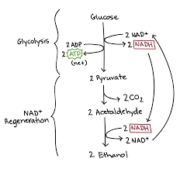
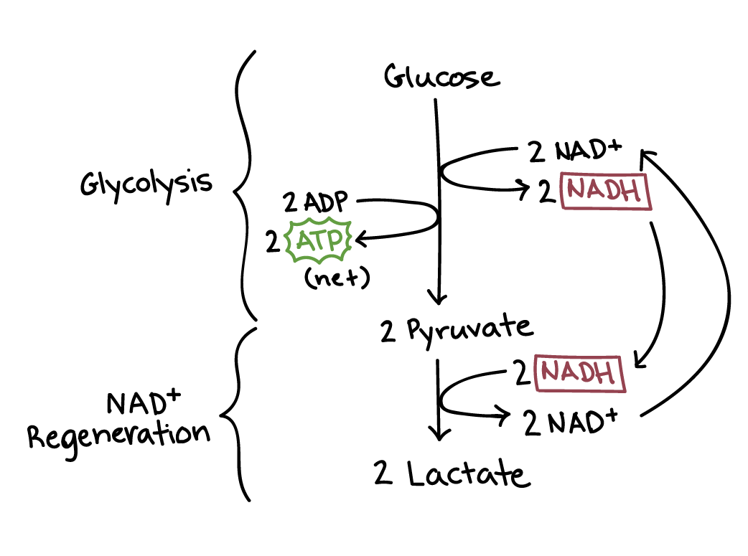

Photosynthesis
- Process in which light energy is converted to chemical energy
- 2 stages:
  - Light dependent reactions
  - Light independent reactions/ Calvin Cycle

The Light Reaction
- Visible light of specific wavelengths are requires (Ex: Green is reflected, that’s why plants are green)
- Light-absorbing pigments like chlorophyll a, chlorophyll b, and carotenoids complexed with proteins makes up Photosystems

- Noncyclic Phosphorylation (1st step needs Water)
  - Produces ATP using both PSI and PS II
  - Photons hit PSII, and chlorophyll in it produces high energy electrons which are passed to a molecule called primary acceptor
  - Electrons then pass down to carriers in ETC to PSI; some energy that dissipated through this process is used to pump protons across membrane from stroma and thylakoid lumen
    - *Photolysis: when PSII absorbs light, it splits water into Oxygen, H⁺ ions, and electrons; replaces the missing electrons in PSII
  - Hydrogen ions accumulate inside thylakoids, and proton gradient is established; protons diffuse through ATP synthase to create ATP in the stroma
  - PSI captures light and passes excited electrons down ETC to produce NADPH
- 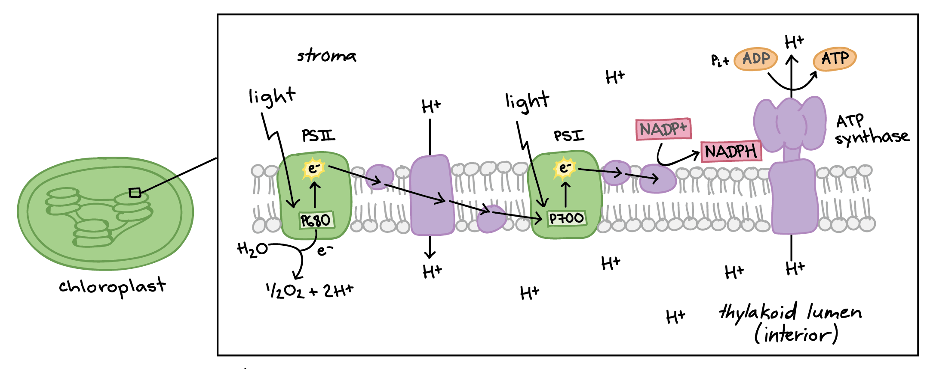
- Cyclic Photophosphorylation (Doesn’t require H2O; doesn’t produce oxygen)
  - Electrons in PSI are excited, passed to carrier in ETC, and eventually returns to PSI
    - At end, only ATP is produced; doesn’t produce NADPH
  - Plants use this when there aren’t enough NADP molecules to accept electrons!
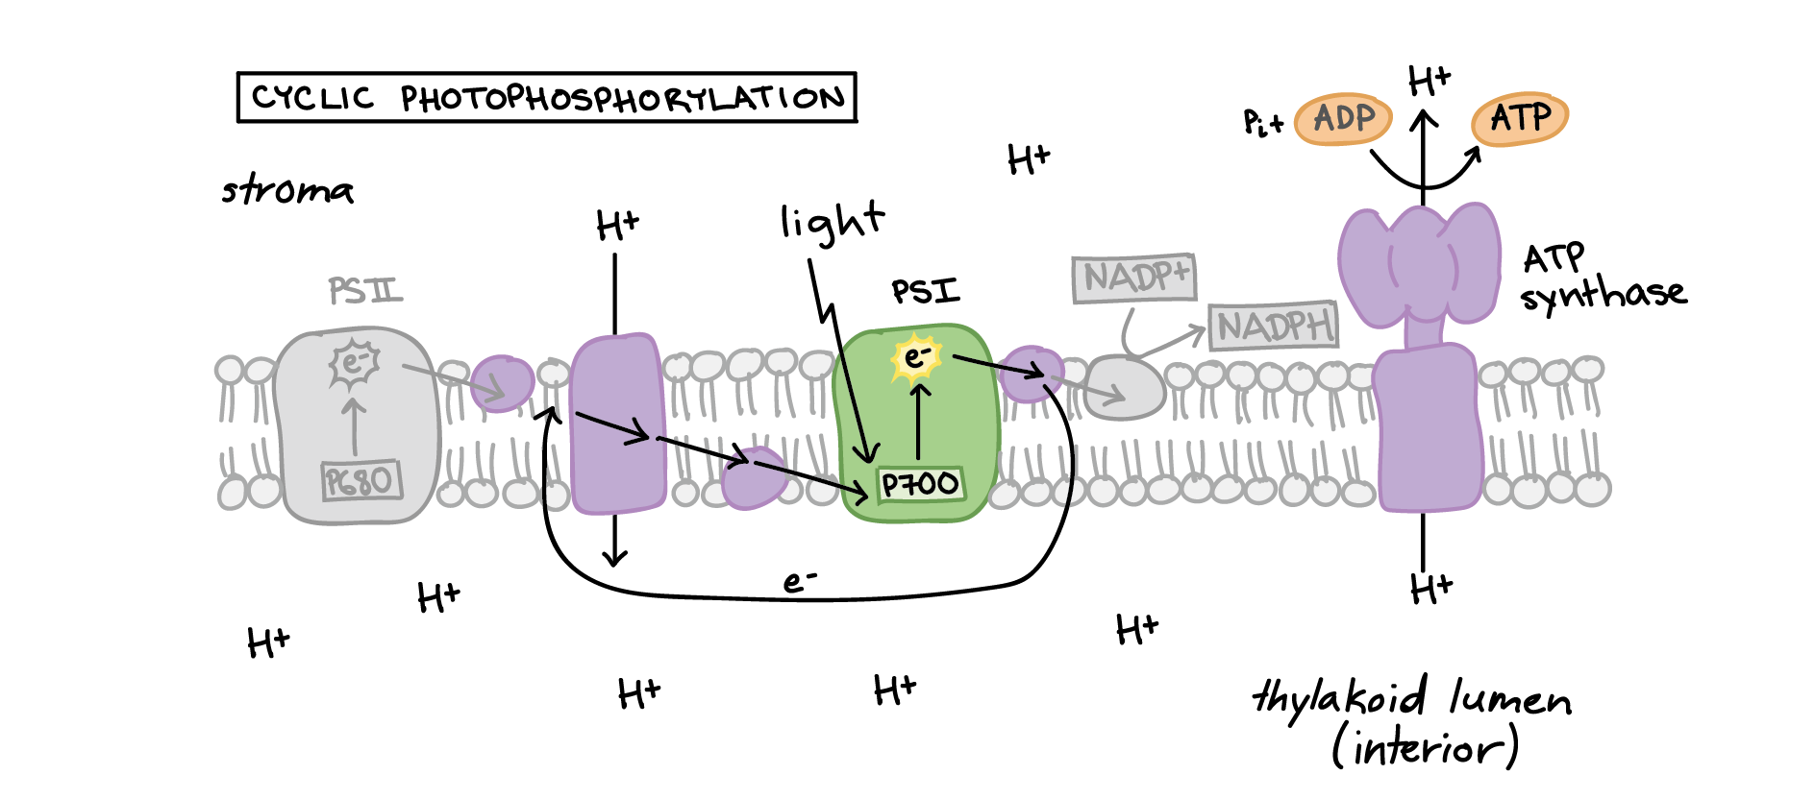

Calvin Cycle
- CO₂ brought into cycle and combines with RubP through series of enzymes controlled reactions to produce G3P (3 carbon molecule, precursor of glucose)
- Take molecules produces after C-fixation and use ATP & NADPH to convert back to RubP 5 carbon molecule (to be used again!)
  - 3 turns of the cycle to produce 1 NET G3P molecule (2 G3P → 1 sugar)
- Enzyme RuBisCO carries out the carbon fixation step; inefficient so lots of it is needed
- ATP that is produced in light reactions (released to stroma) is used
- 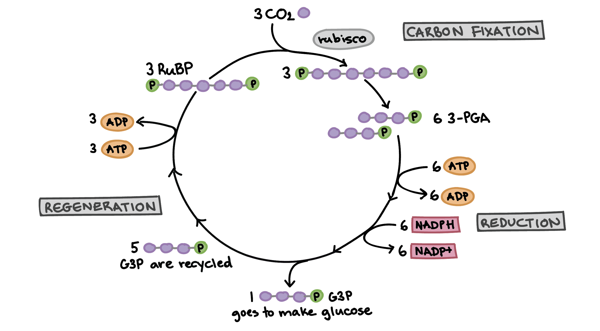

Stages of Photosynthesis | Location | Input | Output
Light Dependent Rxns | Thylakoid Membrane of chloroplast  PSII, PSI | Photons  H₂O | NADPH, ATP, O₂
Light Dependent Rxns (Cyclic Flow) | Thylakoid Membrane of chloroplast  PSI | Photons | ATP
Light INdependent Rxns/Calvin cycle | Stroma | 3 CO₂  3 RubP  9 ATP  6 NADPH | 6 NADP⁺  9 ADP  1 G3P

Significance of Photosynthesis:
- Only after photosynthesis that other metabolic pathways (like aerobic CR) could evolve!
  - All oxygen needed for C.R. comes from photosynthesis
  - Produces biological molecules that every organism on PLANET consumes to remain alive!

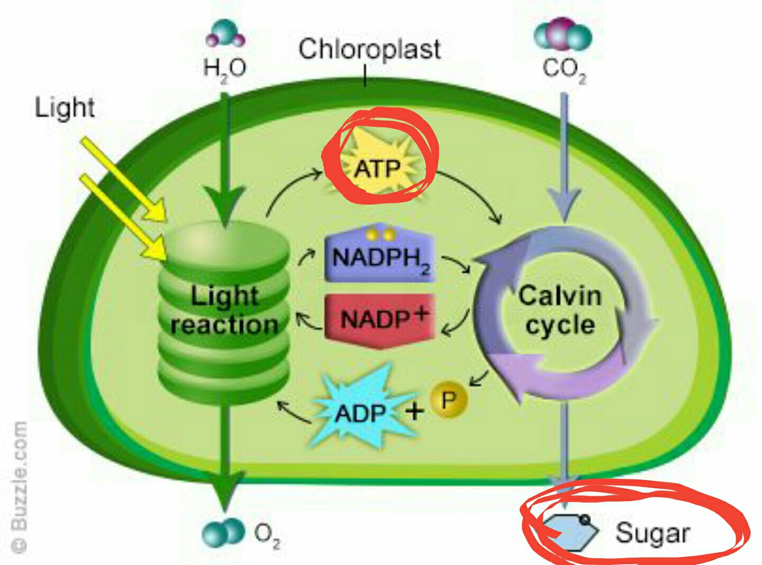

Metabolic Considerations
- Increased complexity requires increased cooperation
  - Ex: inc compartmentalization of eukaryotic cells leads to increased cooperation
- **NOTE: Aerobic Respiration & Photosynthesis DO NOT require eukaryotic organelles; can occur with any part with membranes
- Animal Complexity requires cooperation
  - Cells → Tissues → Organs → Organ Systems
  - Organ systems are tightly coupled
    - Ex: Intestinal Villi (Digestion/Circulation Interface)
      - food enters into circulatory system by diffusing through cells that make up villi, entering circ system via capillaries
    - Ex: Lung Alveoli (Respiration/Circulation Interface)
      - Air enters through alveolus, diffuses through walls to circulatory system, while waste (co2) diffuses out of capillaries into the air
- Cooperation in plants
  - Shoot system & root system
  - 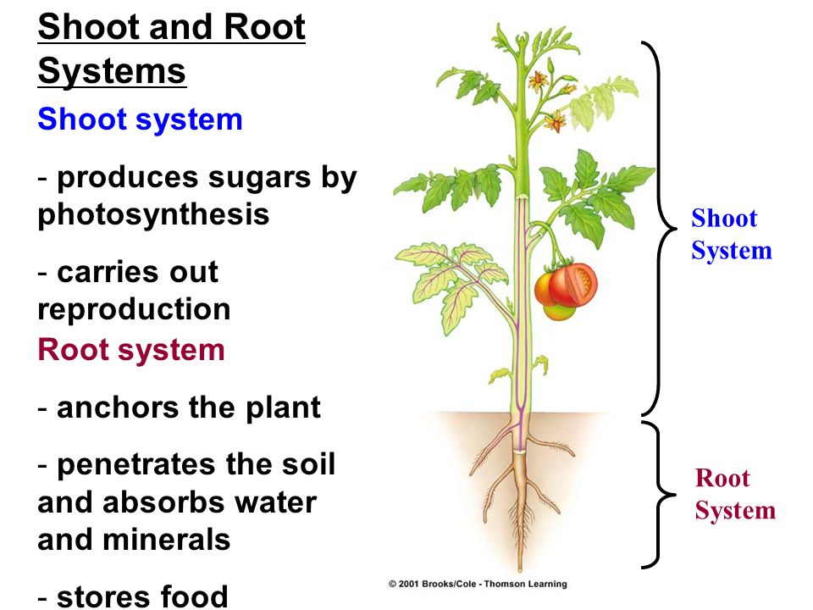
- Cooperation in microbes
  - Ex: Rumens w/ 4 stomachs

Information

Historical Development of the DNA Model
  - Understanding the Nature of Inheritance
    - Gregor Mendel found that inheritance patterns are scientifically investigated and predictable
      - Pea plant Experiment
  - Understanding Role of Chromosomes
    - Walter Sutton & Theodore Boveri proposed that chromosomes bear hereditary factors in accordance with Mendelian Laws
      - In eukaryotic cells, remain in nucleus as chromatin until separates into chromosomes during cell division
        - Chromosome: DNA + Proteins
  - Understanding Nature of Inheritance
    - Griffith’s Bacterial Transformation
      - S-strain (pathogenic) and R-strain (nonpathogenic)
      - When mice injected with live r strain (live), live s-strain (die), heat killed s-strain (survive) all acted normally
      - When injected w/ live r-strain + DEAD s-strain, mice died! Means some sort of transformation occurred
      - Particulate Nature of Inheritance: some sort of molecule is allowing for transfer & heritability
  - Avery, McCarty, McLeod - Identifying the transforming principle
    - Isolated purified S-strain protein and S-strain DNA, and added R-strain bacteria
      - Purified protein solution didn’t transform,purified DNA solution transformed
      - Observed that proteases (enzymes that degrade proteins) did not affect transformation
  - DNA as Genetic Material
    - Hershey-Chase Experiment: demonstrated heritability of DNA
      - Grew phages in radioactive P (DNA) and S (Protein) to tag
      - Allowed phages to infect 2 diff cultures, and see which bacteria now radioactive
        - P transferred in, but not sulfur
      - CONCLUSION: DNA is heritable material, NOT protein!
  - Composition and Structure of DNA
    - Chargaff observed Diff % of 4 bases in diff organisms, with %A=%T and %G=%C
      - RULE: Any DNA from any organism should have 1:1 ratio of pyrimidine (one ring-C,T) and purine(two ring- A,G); more specifically %A=%T and %G=%C
    - Maurice Wilks and Rosalind Franklin
      - used X-ray crystallography (when X-ray shone, creates diffraction pattern); found that DNA created helical, 2 stranded structure
    - Watson & Crick’s Model of DNA!
      - Sugar Phosphate backbone, and H-bond in nitrogenous bases between strands which holds them together
      - Nucleotides within one strand connected by covalent phosphodiester bonds
      - Base Pairing: A&T, G&C allows for each strand to be a template for opposite strand
        - For replication
      - 2 strands ‘antiparallel’ in orientation; in opposing directions
        - 5’-->3’ end (hydroxyl group)
          - DNA synthesized in this direction → added to 3’ end
        - 3’-->5’ end (phosphate group)
          - DNA is READ in this direction

DNA Replication!
  - Different Models of Replication
    - Semi-conservative Model: each strand of DNA molecule serves as template for new strand (1 strand old, 1 strand new)
    - Conservative Model: existing DNA molecules stay as it is, synthesis of entirely new double-strand molecule (1 full old, 1 full new)
    - Dispersive Model: each o.g. Strand replicates portion of each of the 2 new molecule (combo of old + new in 1 strand)
  - Meselson-Stahl Experiment
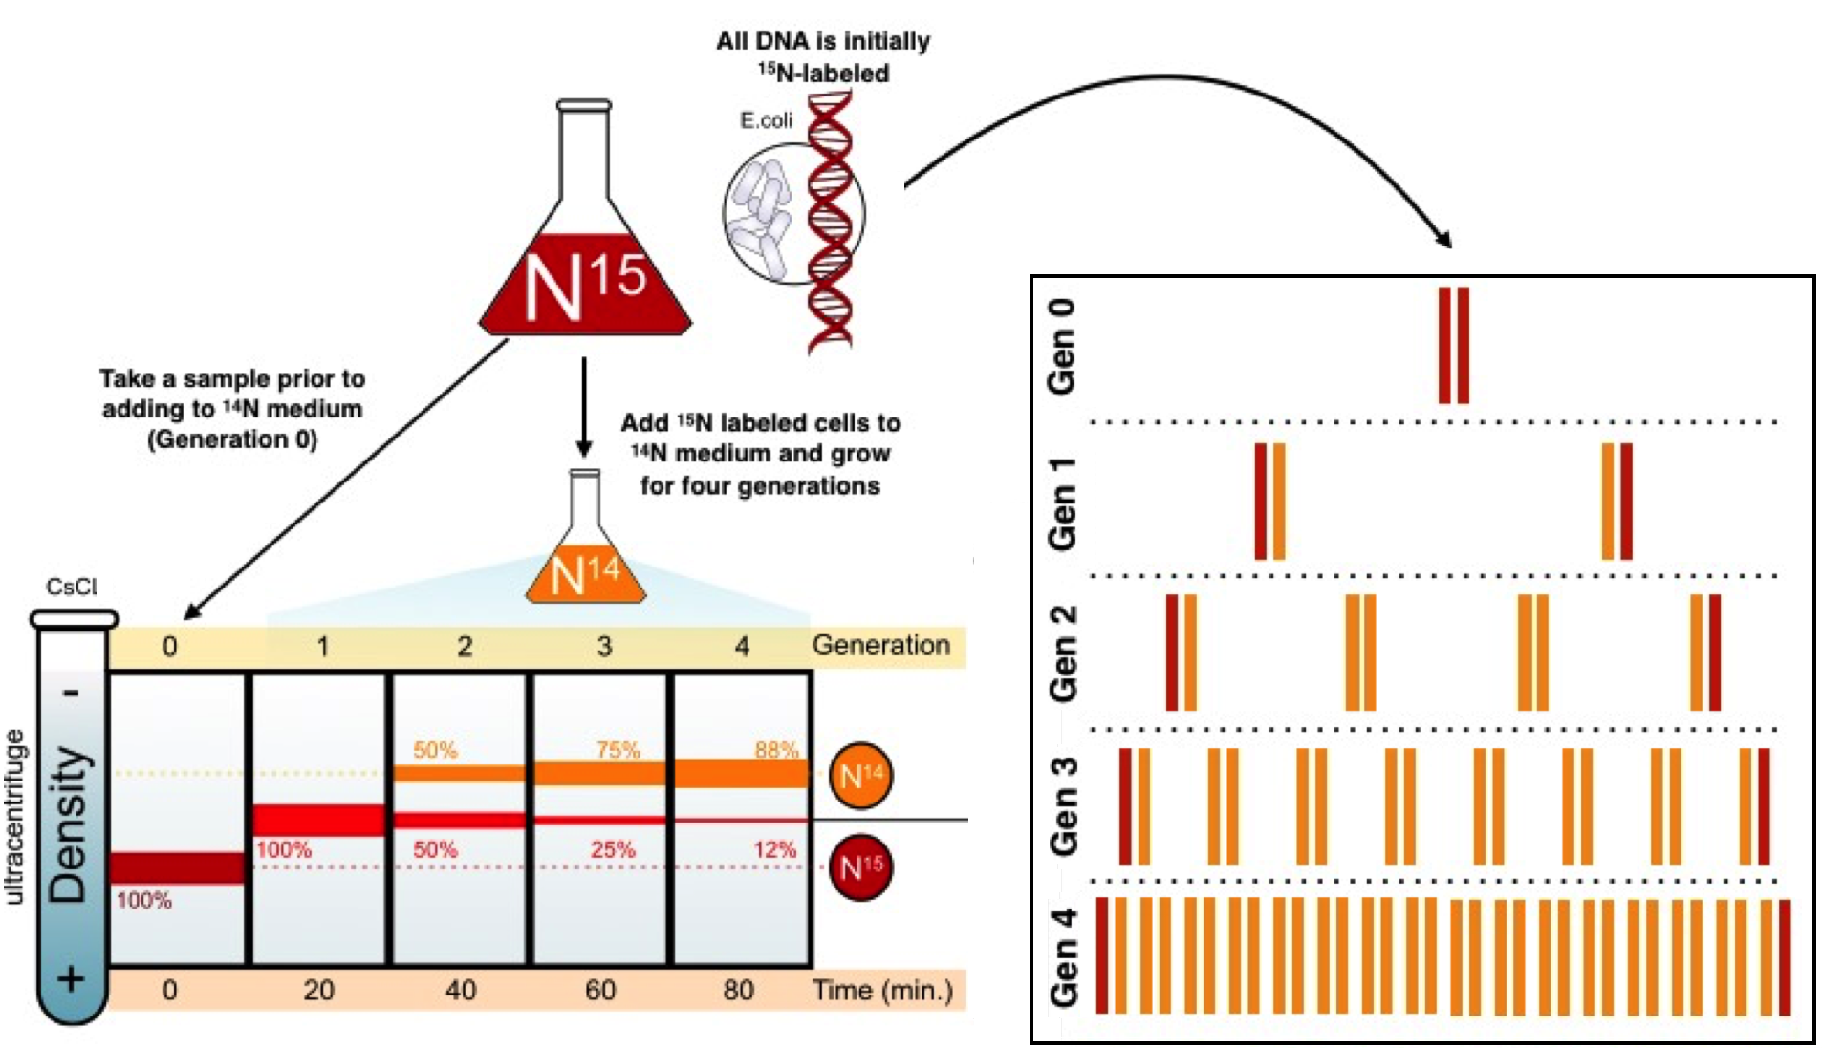
    - Proved Semiconservative Model
      - The results of the density centrifugation after many generations supports semiconservative and refutes other models
        - Refutes dispersive (no band w/ only light nitrogen), conservative - one entire conserved, new one made (no band w/ only heavy nitrogen)

  - Replication Process
    - Replication starts @ origin sequence and proceeds bi-directionally, creating replication bubble
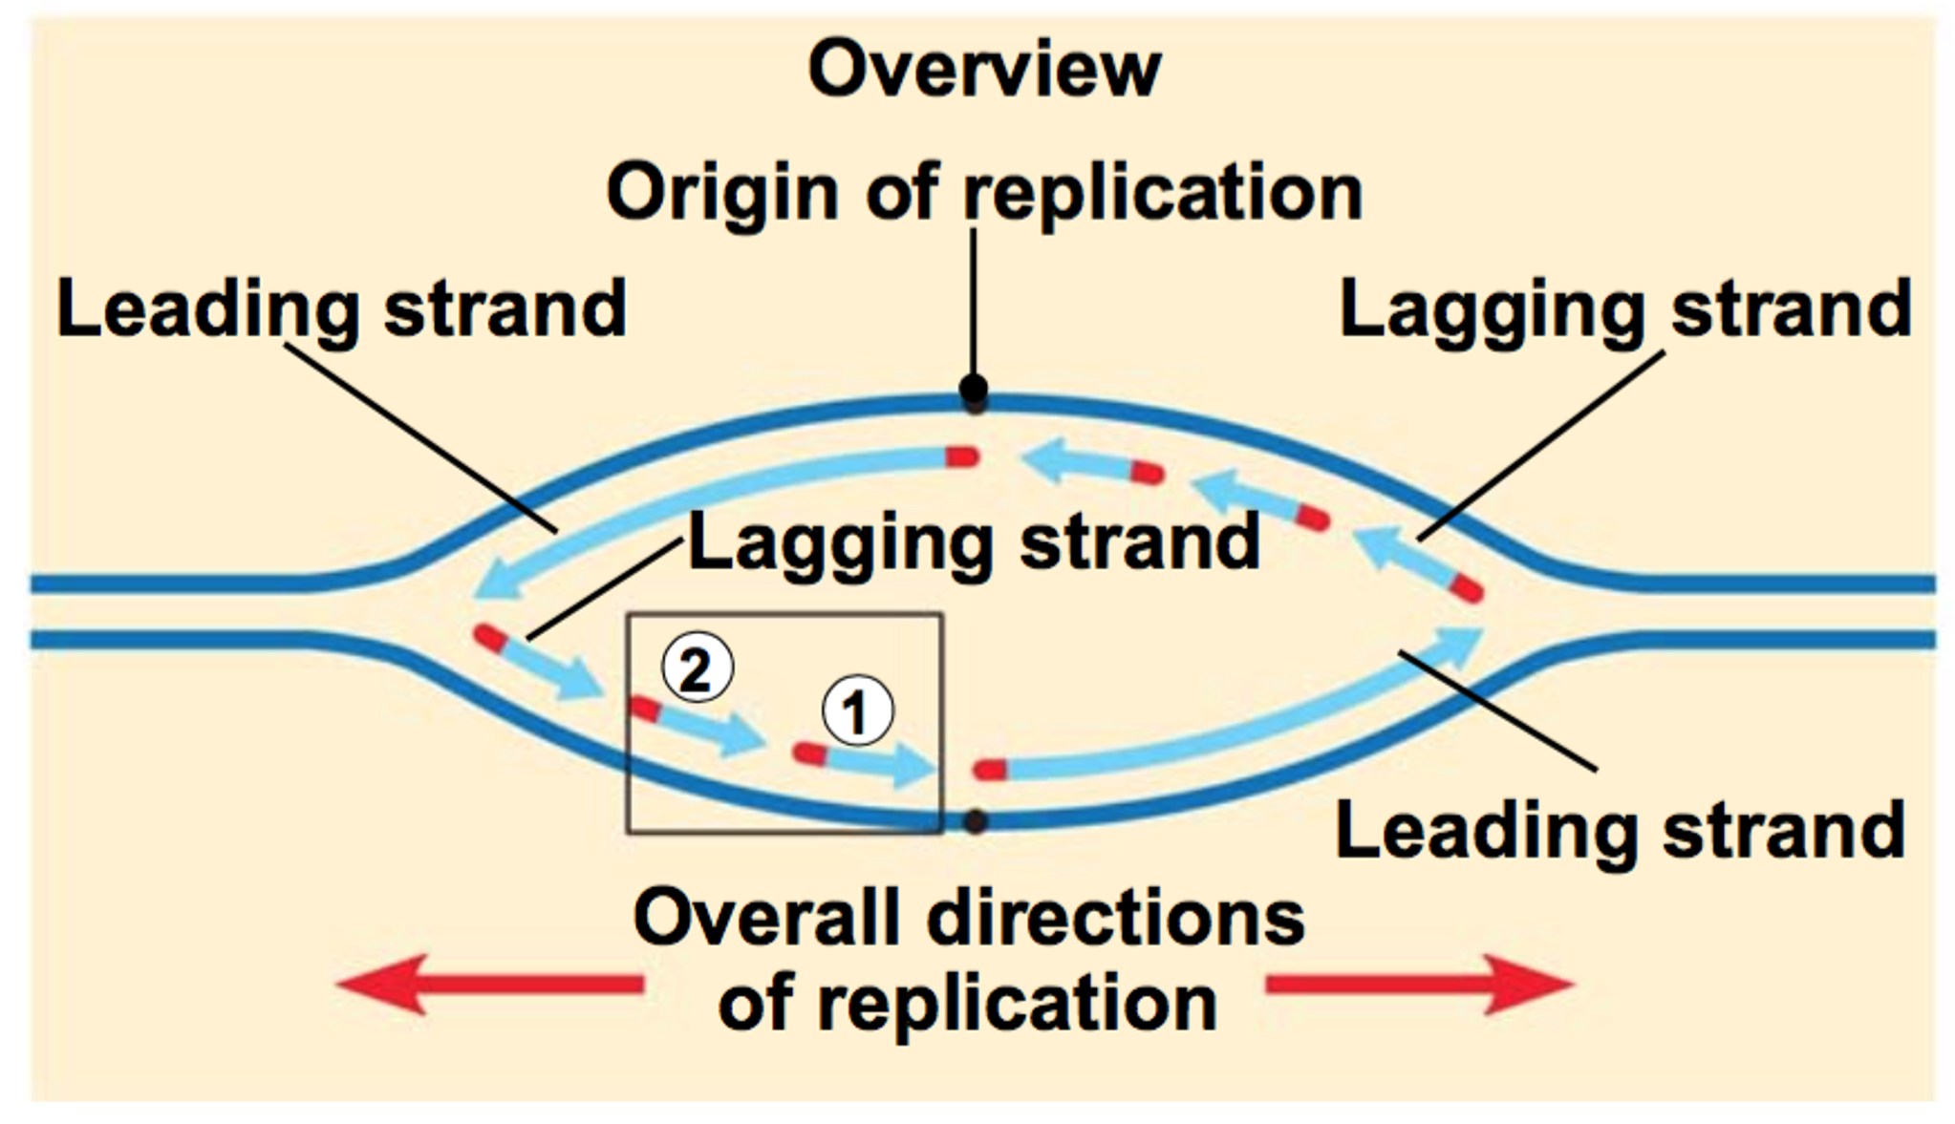
    - @ either end, contains replisome: all of enzymes functioning together to enable DNA replication
      - Helicase= opens up double helix structure
      - Topoisomerase= rotates helix to release tension by creating nicks
      - Primase = makes an RNA primer (short stretch of nucleic acid complementary to template) to provide 3’ end for DNA polymerase to start working on
        - RNA primer later replaced w/ DNA
      - DNA Polymerase = adds nucleotides to growing strands on the 3’ end
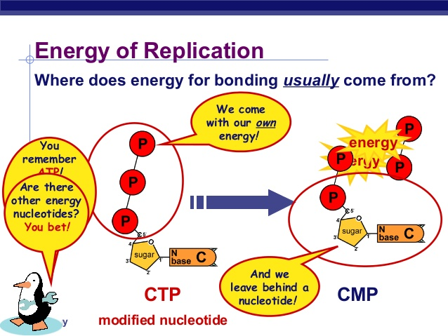
      - Ligase = repairs breaks (phosphodiester bonds) in strands
    - DNA Polymerase
      - Using pre-existing strand, takes free flowing nucleotides and incorporates into sequence
        - Autocatalytic: energy to form bonds comes from breaking off terminal 2 phosphates on new nucleotide
      - Sometimes makes mistakes; other DNA polymerase do proofreading, reducing error rates to 1/1 billion base pairs
  - Leading and Lagging Strands
    - DNA polymerase can only make DNA in 5’--> 3’ direction, so 2 strands synthesized differently
      - Leading Strand: continuously synthesized strand (runs 5’--> 3’ towards replication fork)
      - Lagging Strand: synthesized discontinuously, creates fragments
        - Okazaki Fragments connected by DNA ligase
        - Needs new primer every time
        - Playing “catch up”
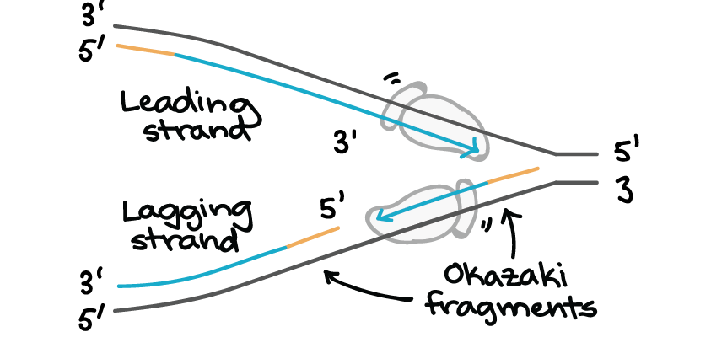

Transcription
  - Types of RNA
    - mRNA = carries A.A. sequence info from DNA to ribosome
    - tRNA = brings specific A.A. to ribosome
    - rRNA= structural components of ribosomes
  - Goal of Transcription: make a RNA copy of a gene’s DNA sequence
    - RNA Polymerase = uses a single strand of DNA to synthesize complementary RNA strand, in 5’-->3’ direction (add on 3’ end)
  - 3 phases of Transcription
    - Initiation
      - RNA polymerase binds to promoter, then separates DNA strands
    - Elongation
      - One strand of DNA (template strand) acts as template for RNA polymerase
      - RNA transcript holds the same info as the non-template (coding) strand of DNA except T replaced with U
    - Termination
      - Sequences called terminators signal RNA transcript is complete; transcript is released
  - Eukaryotic RNA modifications
    - 5’Cap and a 3’ Poly-A Tail added to pre-mRNA
    - Introns (contains unnecessary info) are spliced out, while exons are stuck together
      - If introns not removed, creates ‘rubbish’ polypeptide
    - Alternative Splicing
      - Process where more than 1 mRNA can be made from the same gene
        - Can encode more diff proteins than we have genes
  - Prokaryotes vs. Eukaryotes
    - Transcription Location
      - Eukaryotic = nucleus; Prokaryotic = nucleoid
    - mRNA processing → eukaryotes
    - Coupling w/ translation
      - Only in Prokaryotes (not in nucleus)
      - Direct Coupling: As RNA polymerase produces transcript, ribosome simultaneously translates transcript as it is produced
  - Gene Regulation in Eukaryotes
    - Transcription Factors
      - Proteins that help turn specific genes “on” or “off” by binding to nearby DNA at certain target sequence
      - RNA polymerase can attach to promoter only w/ help of proteins called general transcription factors
      - Other transcription factors, once it’s bound, makes it either harder/easier for RNA polymerase to bind to promoter of the gene
        - Activators: Transcription factors that activate transcription; can help general transcription factors & RNA polymerase assemble
        - Repressors: Repress transcription; blocks general transcription factors & RNA Polymerase
    - Turning genes on/off in specific body parts
      - Enhancers = regulatory items that increase rate of transcription
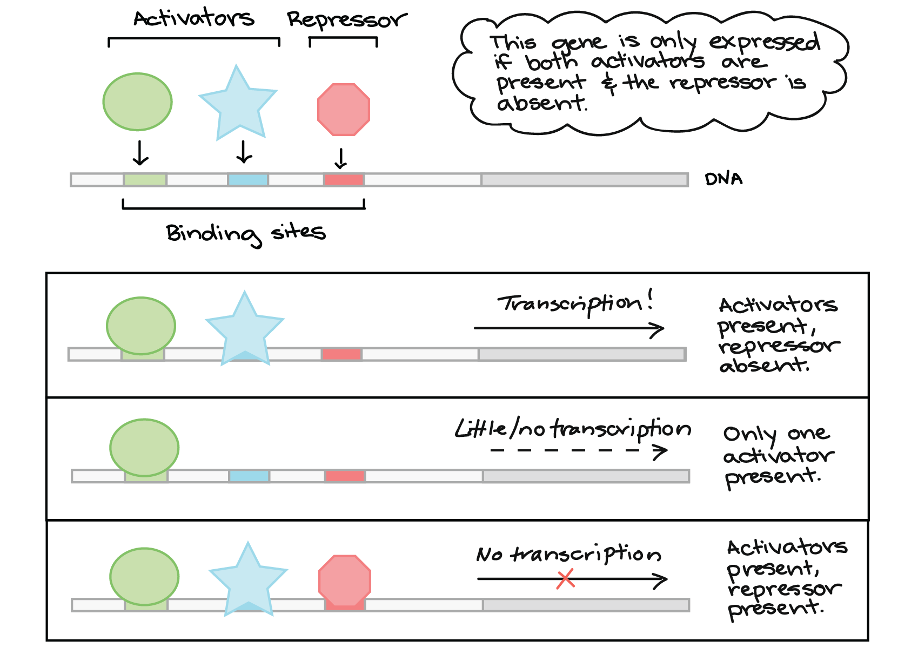
      - Silencers = regulatory items that decrease rate of transcription

  - Gene Anatomy
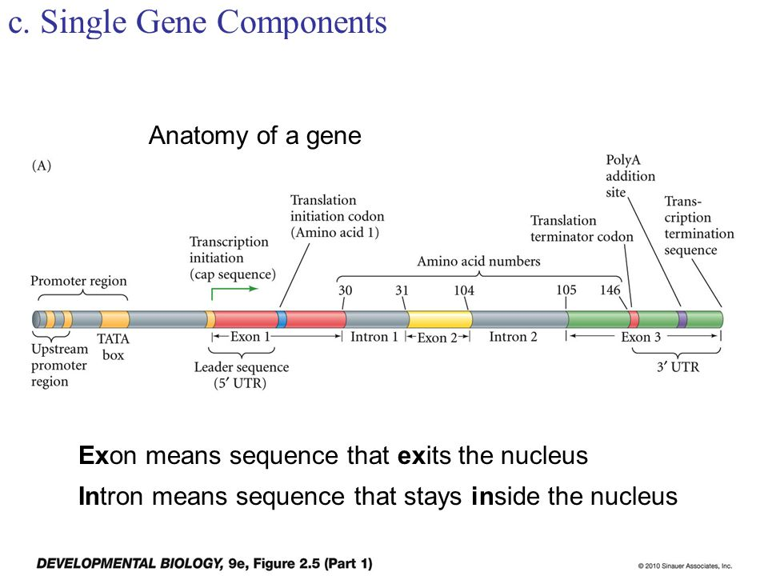
    - UTR: transcribed but not translated (Untranslated region)
    - Gene: A DNA sequence that is going to be transcribed into RNA, and the sequences that regulate its transcription
    - Upstream: elements of a gene that exist prior to start of transcription
    - Downstream: elements of a gene that exist after end of transcription

Translation
  - The Genetic Code
    - 4^3 = 64 unique codon combinations→ 20 diff A.A.
      - Some diff codons code for the same A.A. (redundant)
      - Each codon codes for only 1 specific thing (unambiguous)
      - Start codon = AUG; stop Codon = UAA, UAG, UGA (punctuated)
      - **Codon: a sequence of three DNA or RNA nucleotides that corresponds with a specific amino acid or stop signal during protein synthesis
  - tRNA
    - Made of 1 continuous strand of RNA, base pairs w/ itself to create 3D conformation
    - Diff tRNA
      - Bring in diff amino acids
      - Have a diff anti-codon loop (@ bottom of tRNA) → complementary to 3 bases of codons on mRNA
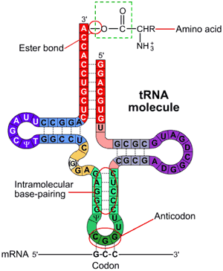
    - Major Steps of Translation
      - Initiation: ribosomes (2 parts) forms around mRNA, so start codon AUG ( start codon) is in the ‘P’ site
        - Met-tRNA binds to first AUG codon
        - Ribosome assembles so that met-tRNA is on P site
        - Remaining tRNA enters @ A site
      - Elongation: peptide bond forms between A.A. chain (P site) and A.A. (A-site), and creates a longer and longer A.A. chain
        - Ribosome then moved, so that A site → P, site, and P site → E (exit) site and dissociate from ribosome
      - Termination
        - Release factor binds to stop codon @ A-site
        - Since peptide bond can’t be formed w/ release factor, polypeptide chain is released and ribosome assembles

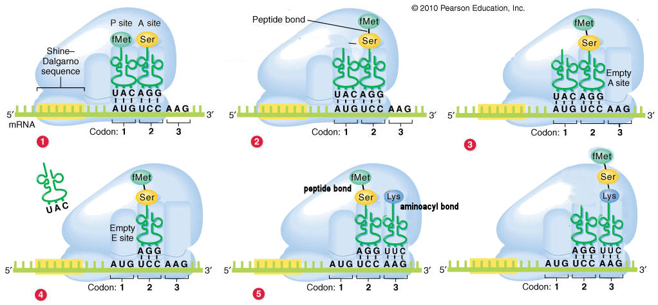

Mitosis
- A type of cell division, resulting in 2 daughter cells having same # and kind of chromosomes as parent nucleus

Cell Cycle
- Most of cell’s life is spent in Interphase (cell grows & replicates its DNA)
  - G1= cell grows, prepare to replicate DNA
  - S= synthesis/replication of DNA
  - G2= preparation for Division
- In mitotic (M) phase, cell divides, producing 2 genetically identical daughter cells
- Many cells are in terminal, non-dividing state (G0)
  - Apoptosis: Cell death
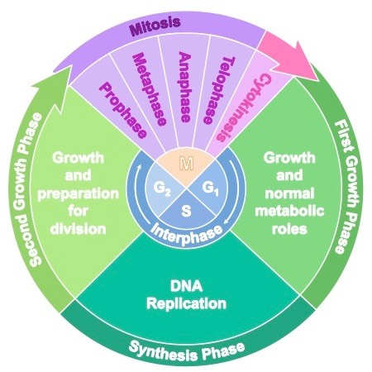

Chromosomes
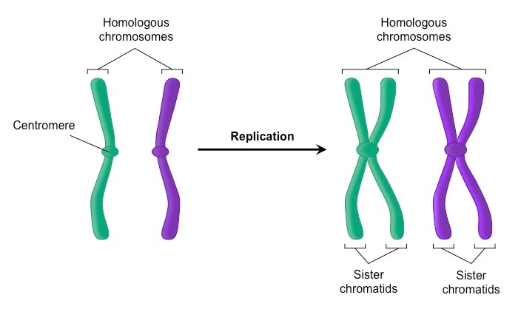

Mitosis
- n= haploid number, which is # of unique chromosomes found in organism (n= 23 in humans; 46 chromosomes in diploid cells (2 pairs of 23))
  - Diploid: 2 complete sets of chromosomes (ex: 23 pairs - 1 mom 1 dad - 46 total in humans)
    - Homologous chromosomes: same genes - length, what it codes for- but different alleles
    - 2n = 2 sets of number of haploid
  - Haploid: single set of chromosomes (23 chromosomes; gamete cells in humans)
- Replication occurs before mitosis
- Prophase, Prometaphase, Metaphase, Anaphase, Telophase ([Please] Pee on the MAT)

Phase | Description | Image
Prophase | Chromosomes condense, mitotic spindle starts to form, and nucleolus disappears | 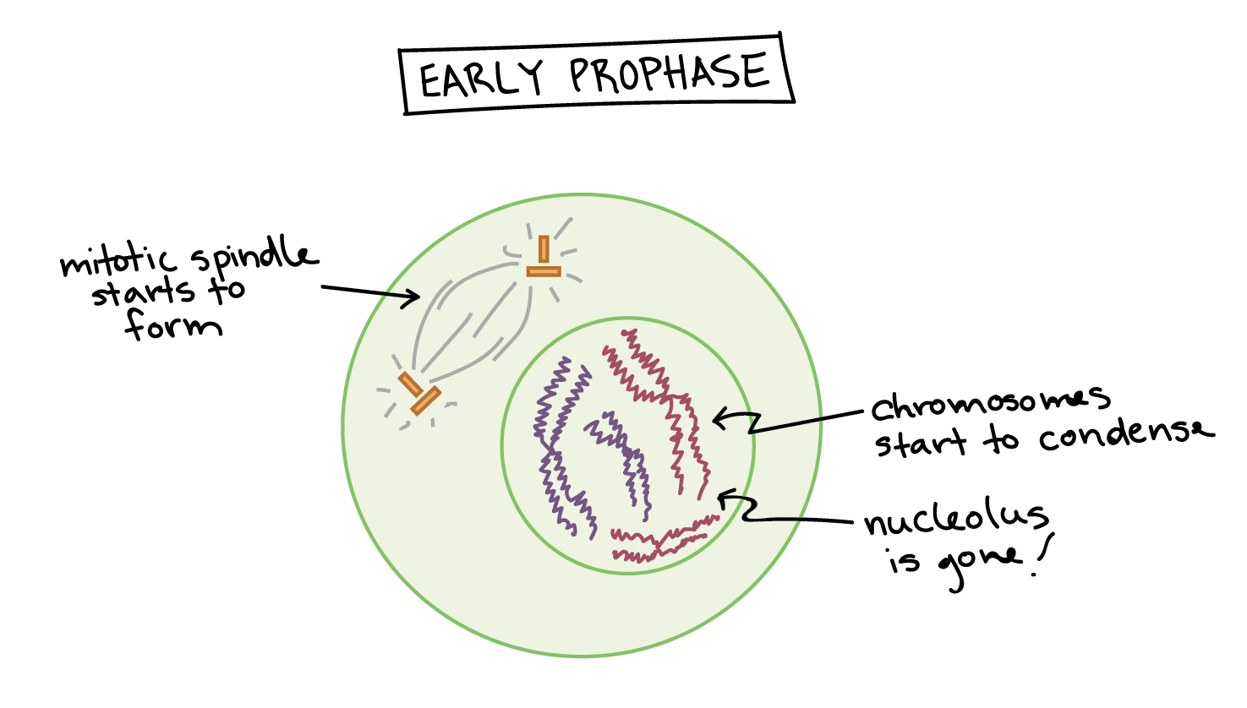
Prometaphase  (before metaphase) | Chromosomes finish condensing, nuclear envelope breaks down | 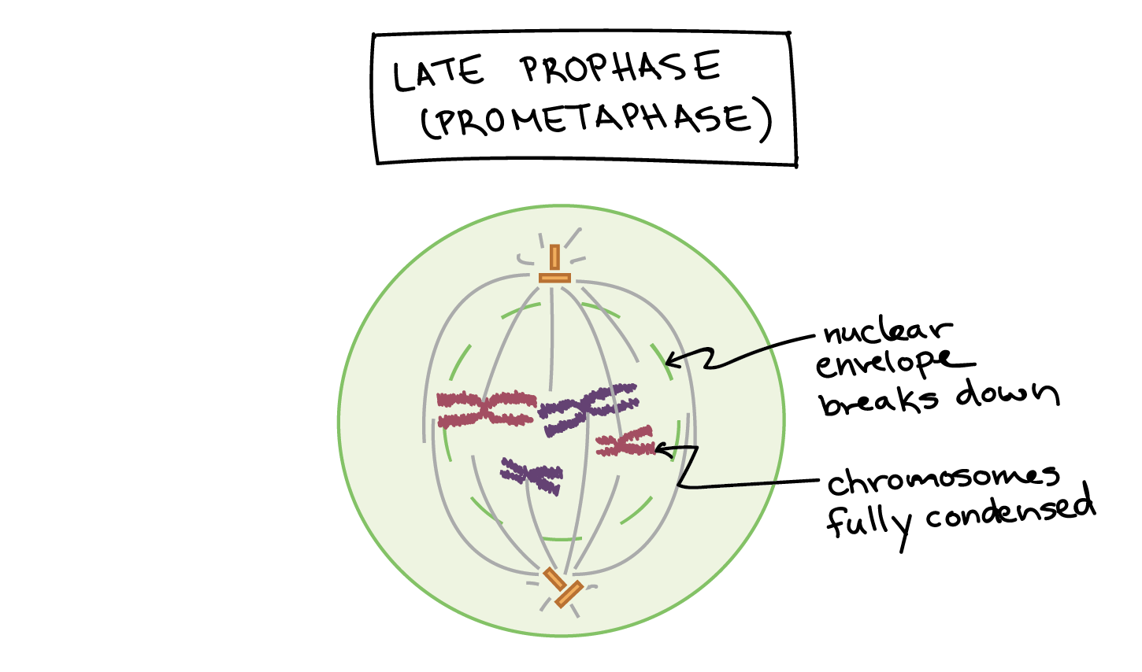
Metaphase | Chromosomes align @ metaphase plate and attach to spindle (@ kineticore) | 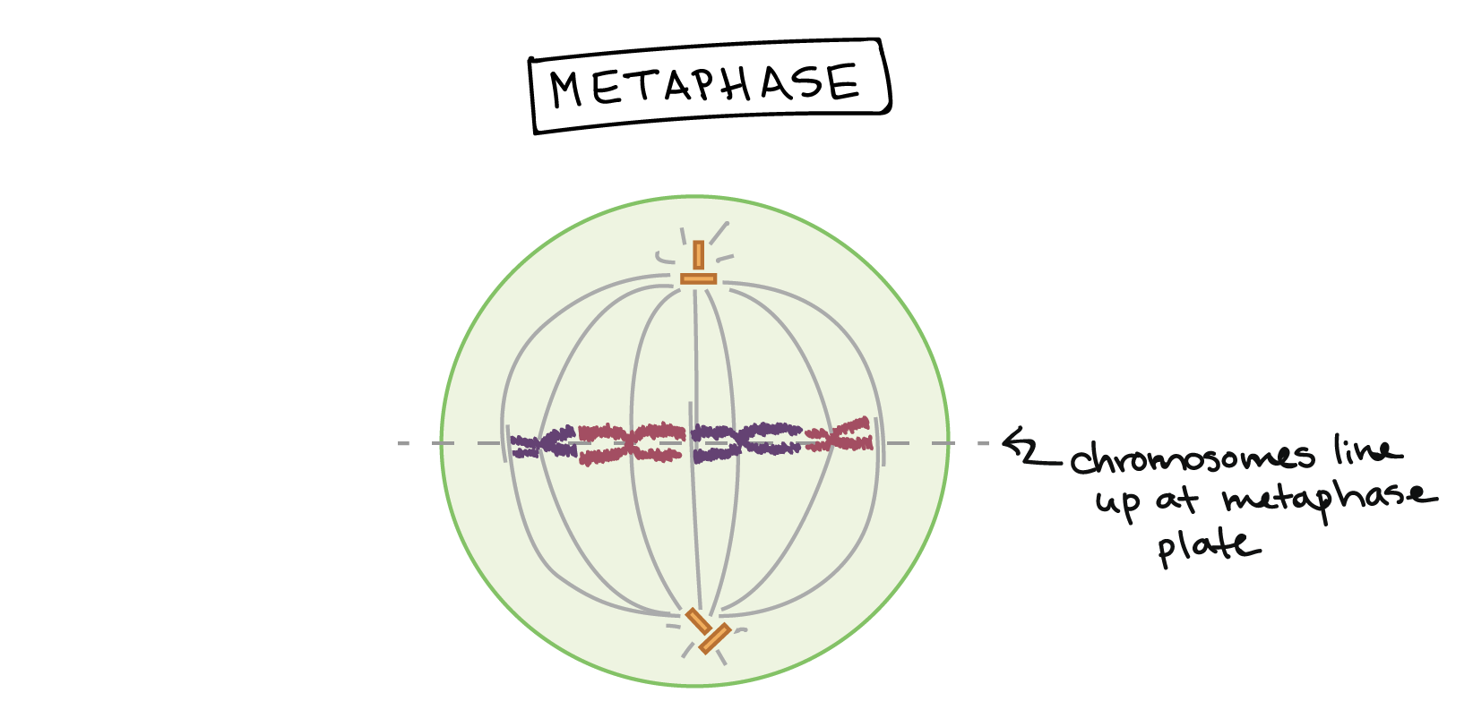
Anaphase  (back-phase) | Sister chromatids separate @ centromere, migrate to poles of the cell | 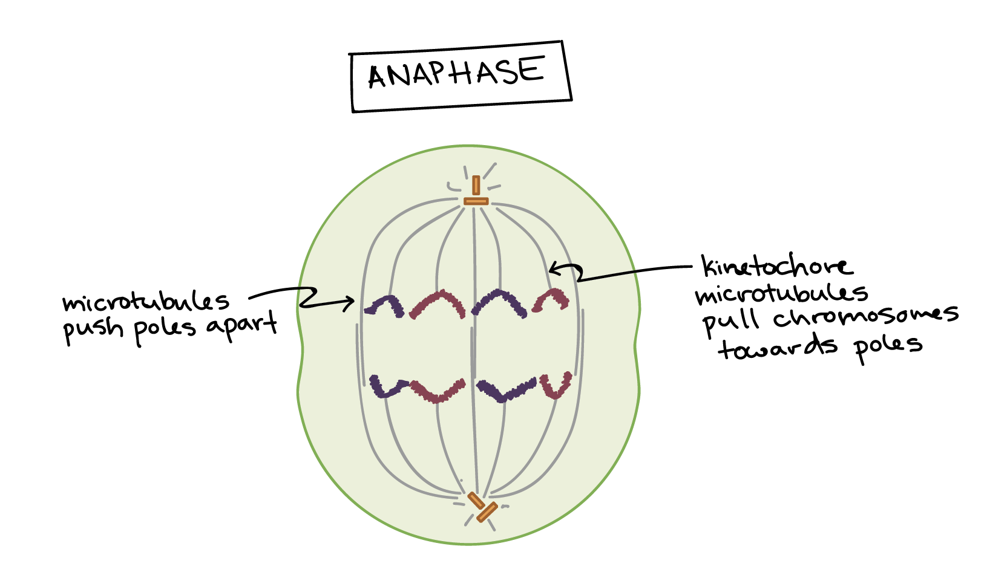
Telophase & Cytokinesis (cell movement) | Nuclear membrane reforms; chromosome decondense, spindle disintegrates and membranes divide  Creates daughter cells, both with 2n amount of material | 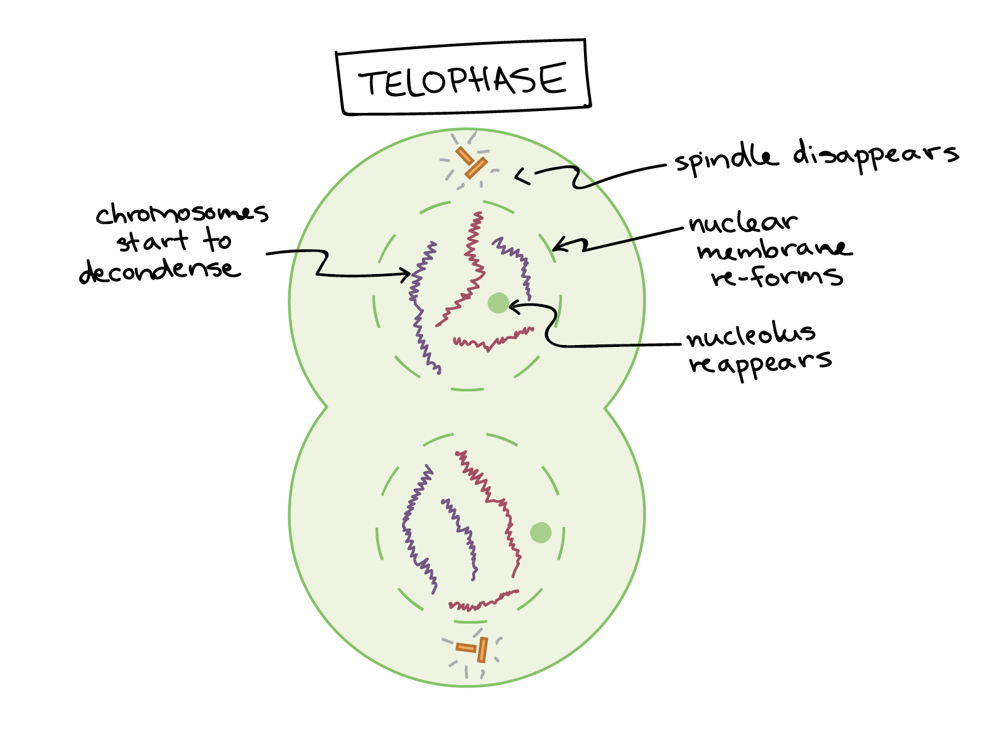
- In plant cells, there are no centrioles, and new cell wall plate also forms

Meiosis
- Meiosis: produces 4 genetically unique gametes with half the normal amount of genetic material/half as many chromosomes as starting cell (haploid cell)
  - All sexual life cycles require Meiosis
  - 2 rounds of cell division, no replication between Round 1 and Round 2

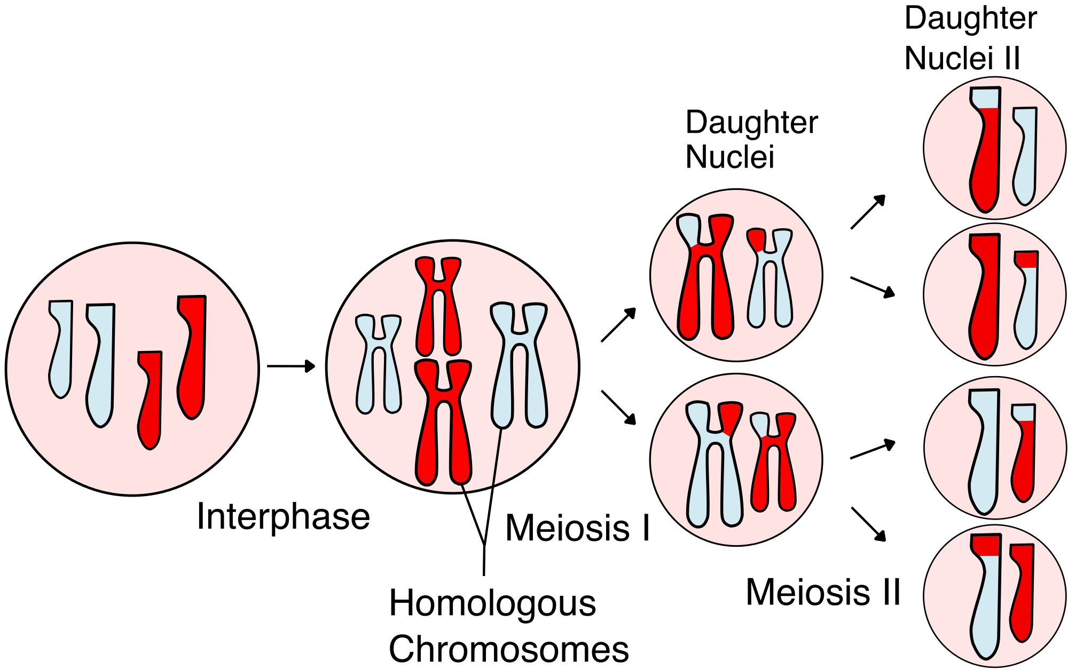

Meiosis 1
- Prophase 1: Crossing over occurs: homologous pairs of chromosomes exchange genetic info (form tetrad)
  - Homologous pairs (one from mom, one from dad) are similar but not identical: same genes in same order, but alleles might be different

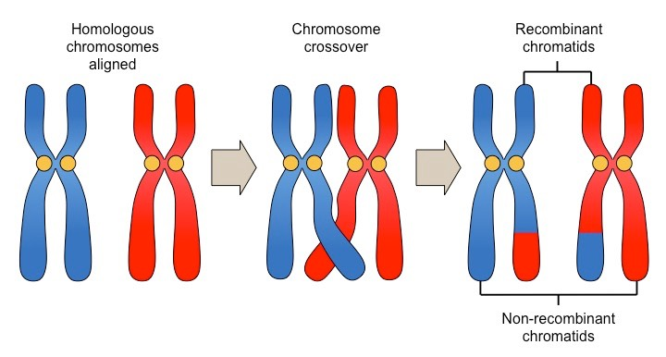
- Metaphase 1: Independent assortment
  - Homologous pairs align while still attached to each other (like tetrad); each pair aligns independent of each other
  - It’s random which ‘side’ of metaphase plate each pair ends up on
  - Variation due to independent assortment = 2^n (where n in # of homologous pairs)

Meiosis 2
- No replication occurs between Meiosis 1 & 2
- Meiosis creates around functionally infinite variation of gametes (which is why each is unique!)
  - b/c of crossing over, independent assortment, and fertilization
- Creates major source of variation for natural selection!

Mendelian Genetics
- Mendel’s Experiment
  - Used peas b/c easy to grow, short generation time, lots of offspring, and obvious traits
  - Developed purebred lines for 7 diff traits
  - Control mating between diff lines
  - Counted F1 generation offspring
    - Found that only 1 phenotype observed
  - Self crossed F1
  - Count # and type of F2 generation
    - He found that phenotype that disappeared reappeared, in ratio (3:1)

Mendel’s Laws
- Law of Segregation: only one of two gene copies present in an organism is distributed to each gamete it makes, and allocation of the gene copies in random
  - Only transmit 1 allele to offspring (Punnett Square)
- Law of Dominance: In organisms that have 1 copy of each allele (heterozygous), dominant allele determines the phenotype
  - Biological reason for dominance: proteins are created in presence of dominant allele
    - Ex: Purple pigment made with P, but with p no pigment is made
  - Dominant != Good/Strong
- Law of Independent Assortment: alleles of 2 (more more) diff genes sort into gametes independently of one another
  - Ex: Dihybrid crosses - probabilities for each trait are determined independently
  - 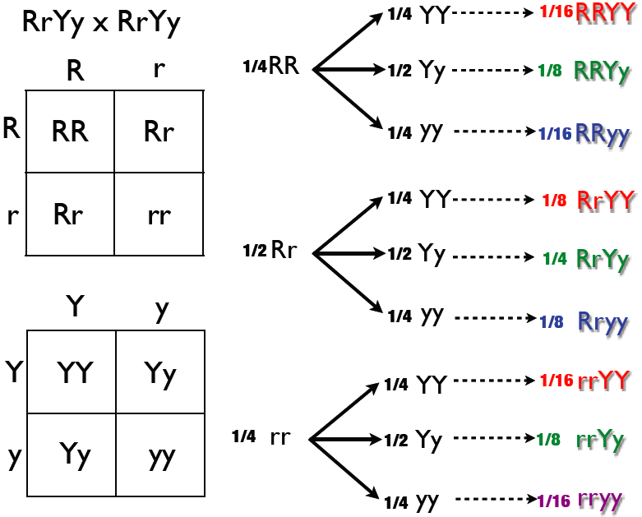
  - Biological Reason for independent assortment: Metaphase 1 (each also an independent event!)

Beyond Mendelian Genetics

Co-dominance
- When heterozygotes express BOTH phenotypes (Ex: Roan Cattle)
  - Genotypic ratio: 1 homo dominant, 1 heterozygous,1 homo recessive
  - Phenotypic ratio, 1 Red, 2 Roan , 1 White 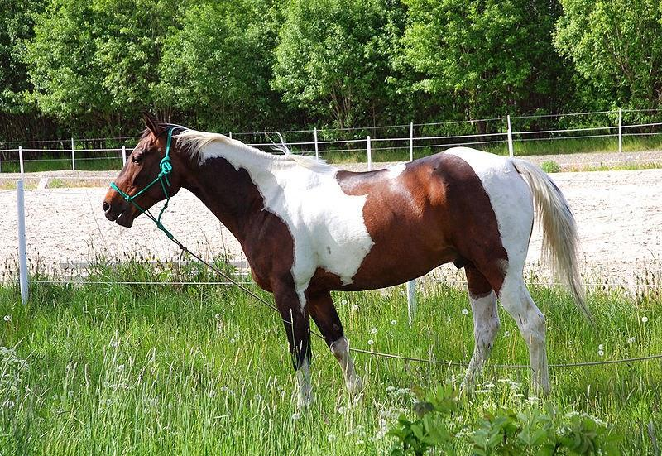

Incomplete Dominance
- When heterozygous expressed a 3rd (new) phenotype → usually a blend
- Ex: Snapdragons
  - 1 homo dom.; 1 hetero; 1 homo rec.
  - 1 red, 1 pink, 1 white

Blood Type: Multiple Alleles & Codominance
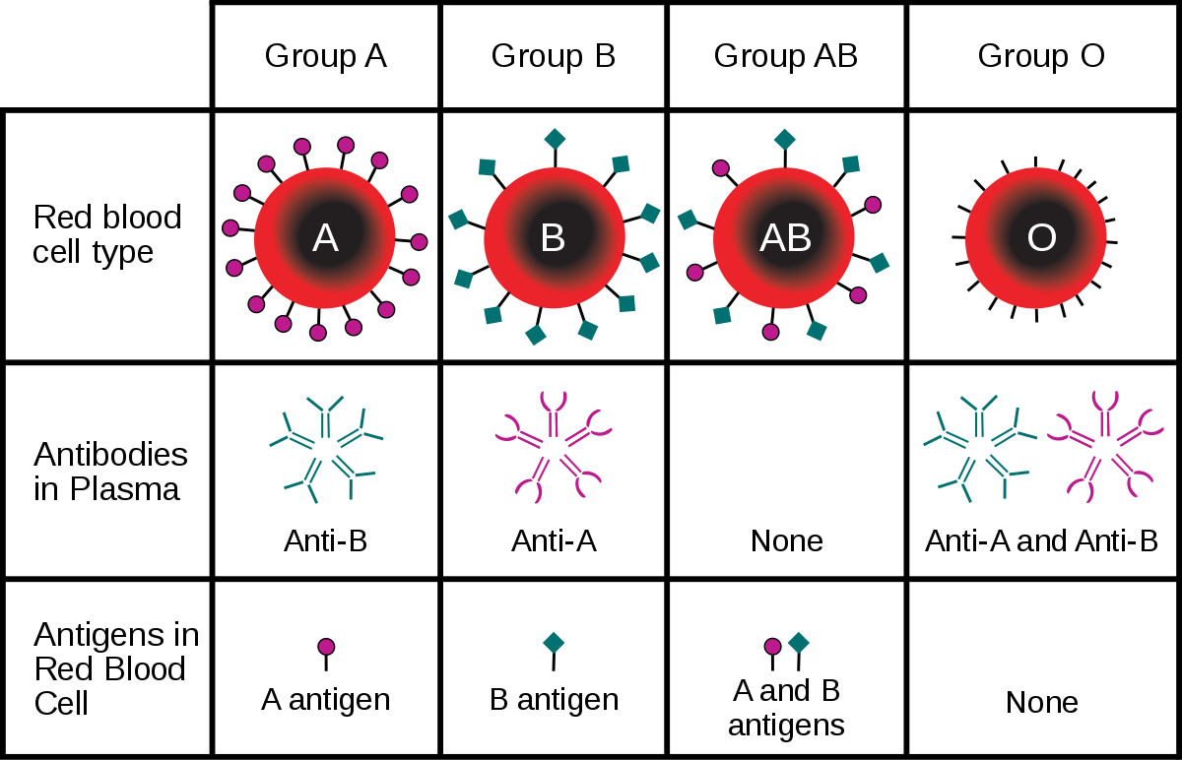
- 6 different combinations: (I^{A}I^{A}, I^{A}i , I^{B}I^{B} , I^{B}i, I^{A}I^{B}, ii)
  - Type A can only get type A/O blood; type B: type B/O; type AB (universal acceptor); type O (universal donor)
  - A & B are codominant (show up together)
- Type A= A antigen, B antibody
- Type B= B antigen, A antibody
- Type AB= A & B antigen
- Typeo O= A & B Antibody
- Multiple Alleles: 3 or more alternative forms of alleles that can occupy the same locus

Linked Genes
- Linked Genes: Genes that are on the same chromosome that are close together
  - Will be inherited as a unit more frequently than not
- Thomas Morgan used fruit flies, found that white-eyed and male type was linked
- Sex Linkage
  - Phenotypic expression of an allele dependent on gender of individual
    - Normally comes out with males (because if it is X-linked, males only have 1 X chromosome)
- Gene Linkage
  - Genes on same chromosome sometimes travel together
  - Increased distance between genes on a chromosome lead to increased cross-over
    - The nearer 2 genes are on a chromosome, lower chance of recombination between them, more likely they will be inherited together and vice versa
    - Further genes are apart on a chromosome, higher chance of recombination

Nonmendelian Inheritance

Transformation | Bacterial cells take in genetic material from its environment | 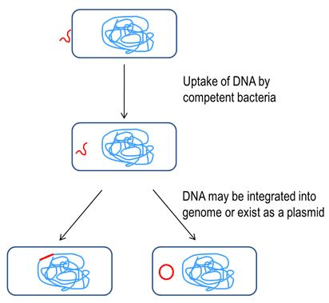
Transduction | Process in which foreign DNA is introduced into cell by virus/viral vector (ex:horizontal gene transfer) | 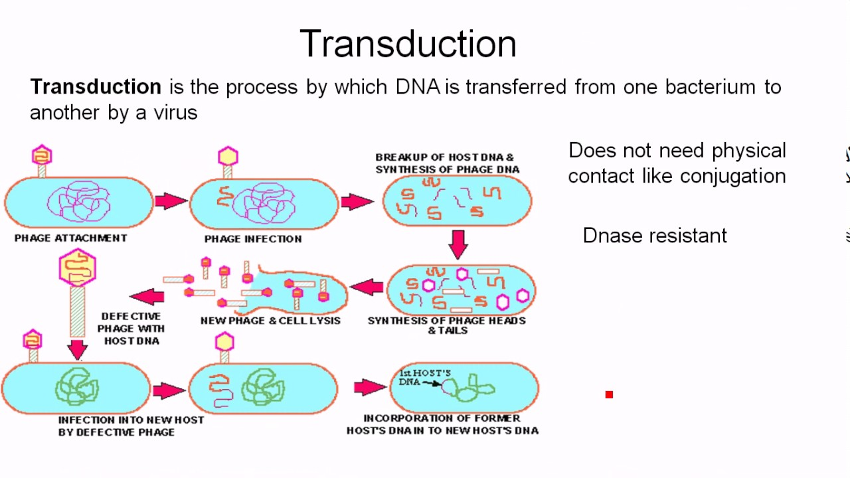
Conjugation | Where bacterial cells grow sex pilus, and transfer plasmid to other cells

Inheritance Patterns

Pedigree Analysis
  - 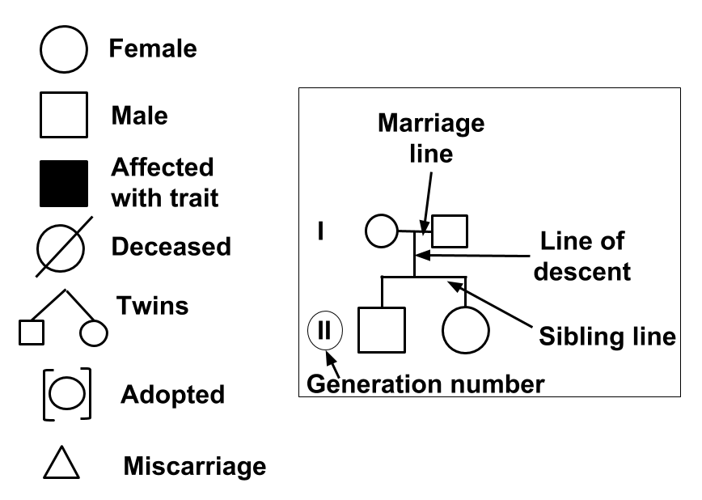
  - Used to analyze pattern of an inheritance of a trait throughout a family
  - Autosomal Dominant
    - When affected offspring have at least 1 affected parent
    - Normally appears in every generation; equal # of males and females
    - Ex: Freckles, Achondroplastic Dwarfism
  - Autosomal Recessive
    - Affected offspring can be from unaffected (carrier) parents
    - Sometimes ‘skips’ a generation
    - Ex: Cystic Fibrosis, Sickle Cell Anemia (sickle shaped red blood cells - lead to lung & heart injury, fatigue) PKU (can’t produce phenylalanine)
  - X-linked Recessive
    - Generally more affected MALES than females
    - Affected offspring can be from unaffected parents
- Karyotype Analysis: When you isolate cells in metaphase (from fetus), and display chromosomes
  - Down syndrome → Trisomy 21 (3 21st chromosome)

Environment’s Role
  - Environment can play a part in gene expression, equally as important as genes that make it up
    - Ex: Sex-determination in Reptiles by Temp; in turtles, eggs from cooler nests = males, warmer nests=females

Viruses
- Debates about whether Viruses are living organisms or not - but doesn’t really matter!
  - Some say viruses are not alive bc rely on cells to ‘exist’; others say they do bc they have genetic material and evolve
  - New viruses will only be present with presence of host bacteria

Viral Anatomy 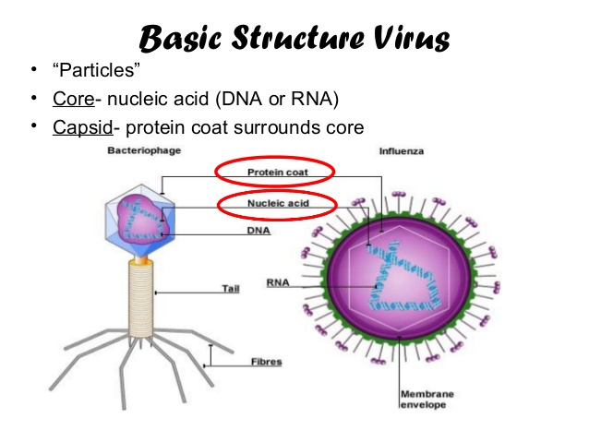
  - Parts of the Virus
  - Wide Variety of Viral Genomes → Diversity!
    - Double-stranded DNA, single stranded, RNA, double stranded RNA, single stranded DNA …
    - Eukaryotic viruses normally have RNA → Instant translation!
  - Membrane Envelope: viruses “borrow” a patch from host cell to create this external lipid membrane; helps viral particles bind to host cells

Viral Life Cycle
  - Virus: An infectious particle that reproduces by “commandeering” a host cell using its machinery to make more viruses
  - Lytic (burst) Phages
    - Infection → Synthesis (using host cell’s material, degradation of host DNA) → Release
      - Interaction between host cell membrane protein & viral infection (viral attachment to host cell)
      - When specific proteins on viral capsid binds to receptor proteins on target cell membrane
    - Infecting phage will ultimately kill host cell to produce own progeny
    - The new viruses are synthesized using host cell material → virus ‘hijacks’ resources of cell
    - 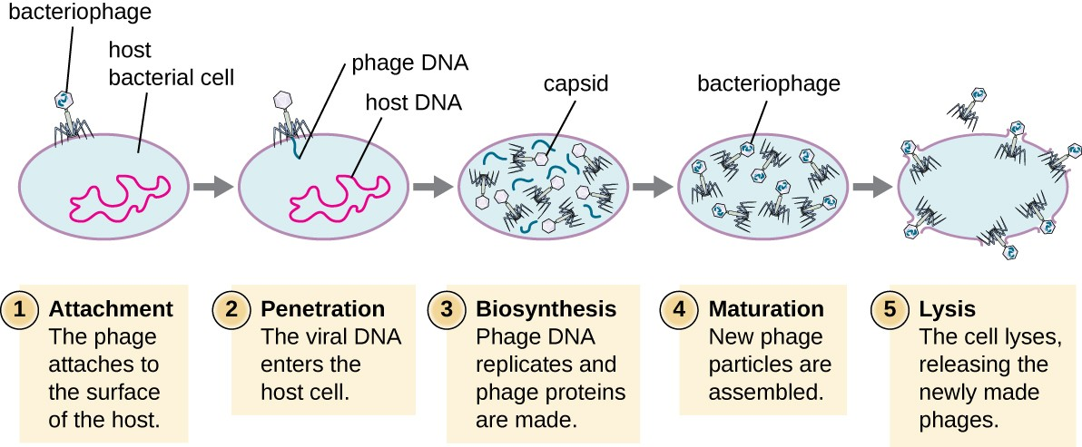
  - Lysogenic Phages
    - Infection → Incorporation → Excision → Synthesis → Release
    - Doesn’t kill host cell, instead uses it as refuge where it exists in dormant state
      - Phage DNA is incorporated into host cell’s genome & divides for as long as it remains there
    - When exposed to stressors (UV light, certain chemicals), will excise, initiate lytic cycle, release
      - Lysogenic → Lytic cycle 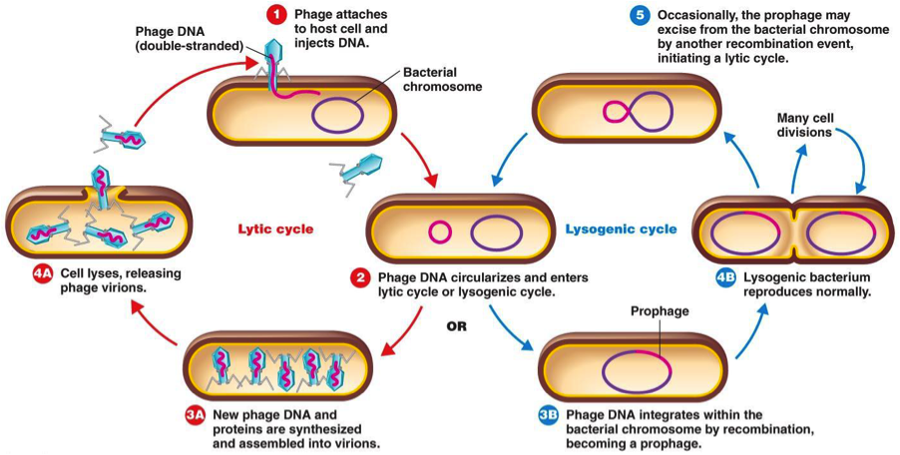

Example: HIV (Retrovirus - contains RNA)
  - Infection → Reverse Transcription → Integration → Synthesis → Release
  - Retrovirus genome: Single stranded RNA, comes in 2 copies per viral molecule
  - Infection: Infect Helper T-cell host, glycoproteins on virus coat bind to complementary receptors on host cell
      - Infect human eukaryotic cells
    - Reverse Transcription: Viral RNA genome turned back into DNA (for integration)
      - Many uses - captures processed mRNA insulin back into DNA
      - Viral RNA → Viral DNA → Host DNA → Host RNA → Protein
      - High error rate → lots of mutations ; evolve by natural selection
    - Integration: DNA genome integrated into host cell genome (called integrase)
    - Synthesis: More infection, more HIV proteins
    - Release: Bud off one at a time as HIV particles
  - Anti-HIV drugs inhibit viral replication @ many different phases of HIV cycle
    - Fusion inhibitors (block fusion of HIV envelope with membrane of host cell), reverse transcriptase inhibitors, integrase inhibitors, protease inhibitors (blocks processing of viral proteins)
      - Multiple drugs together most effective @ slowing profession of infection and keeping viral levels low
  - Hard to have vaccine because mutation rates high (infinite # of strains); need to use active form of HIV, which is risky bc can easily revert back to virulent form

Viral Evolution
  - Viruses evolve very quickly
    - Bc of rapid replication, large poplulation size, & error-prone polymerases → high mutation rates & allows them to quickly adapt to their environment
      - Why we need to continue to get new vaccines and stuff
    - Genetic Variation normally comes either from Recombination or random Mutation
      - RNA viruses have higher mutation rates; RNA polymerase don’t proofread
  - Antigenic Shift = process where 2/more strains of virus combine to form new subtype having different surface antigens (proteins)
  - Viral recombination = when 2 related viruses co-infect
  - Transduction = viruses move genetic info from one cell to the next
  - Combo of different drugs increases likelihood that viruses (even though resistant to one drug) will be selected against

Biotech Tools

Restriction Enzymes (Cutting DNA)
  - Cut DNA @ specific sequences (restriction sites)
    - Ex: Eco-R1 Restriction Site GAATTC
      - Leads to “sticky ends”

Discovery
    - First function as bacterial “immune system” → when bacteriophage injects cells, the restriction enzymes cut bacterial phage genome into segments (no longer effective)
      - DNA methyltransferase adds methyl group to bacteria’s genome (signal - don’t cut!)
  - Uses
    - Isolate DNA fragments to get “sequence of interest”
    - The complementary “sticky ends” can be recombined easily (w/ ligase) → recombinant DNA

Gel Electrophoresis (Separating DNA)
  - Isolate DNA molecules by size by running them through agarose gel
    - Can compare with a marker for size/identification
  - Can be used for sequence isolation, in forensics, paternity cases, diagnose genetic diseases
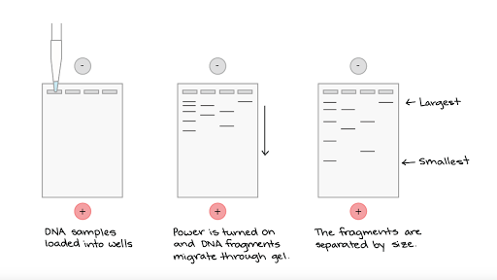

PCR - Copying DNA
  - Uses special Taq-Polymerase that can resist the heat
  - Process:
    - Denaturation: strands heated, denature & separate (~95 celsius)
    - Annealing: forward/reverse primers add attach to strands (~68 celsius)
    - Elongation: Taq polymerase binds to primers, replicate DNA strand (~72 celsius)
  - Tools: Target DNA, primer, nucleotides, Taq polymerase, buffer, Thermocycler
  - 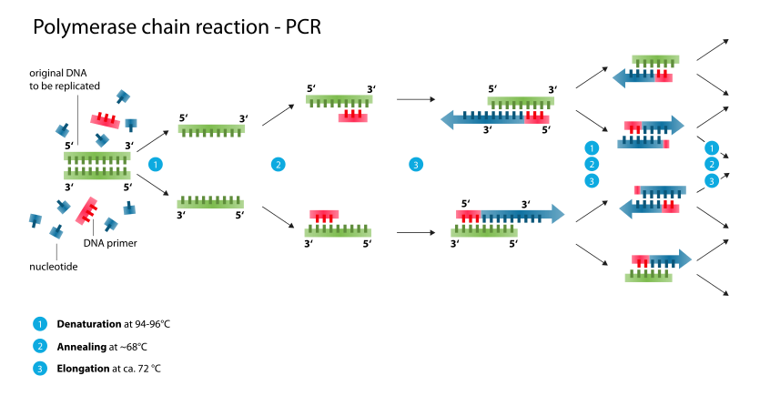

DNA Sequencing: Reading DNA
  - Sanger Sequencing: target DNA copied many times, making fragments of different lengths.
    - Fluorescent “chain terminator” nucleotides (ddNTPs) marks ends of the fragments, allows sequence to be determined
      - Primer + Target + ddNTP + Polymerase
  - Modern Sequencing: fluorescence interpreted by laser in computer
    - Cheaper, much less time, 1 tube
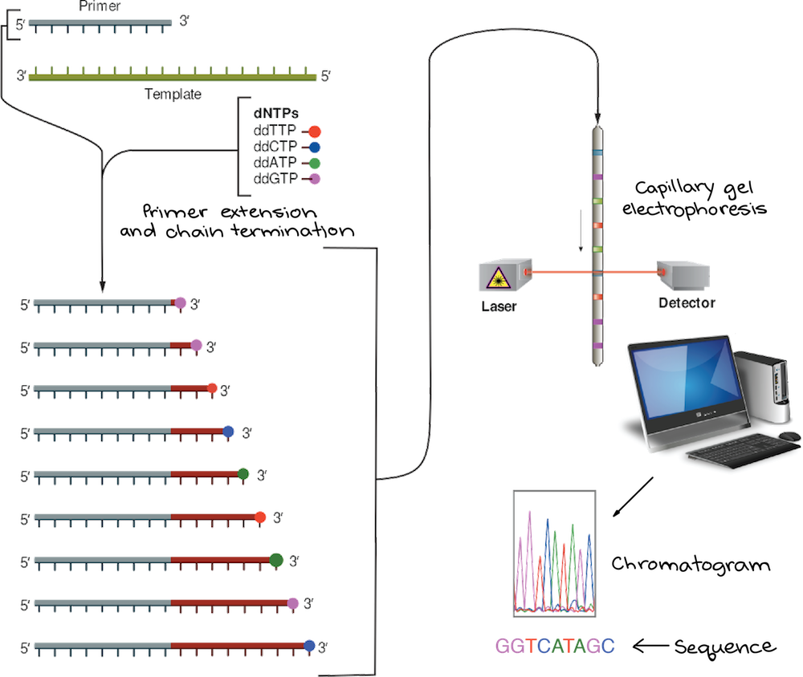

Biotech Applications
- Used for genetic engineering: direct manipulation of organism’s genes

Plasmids
  - A small DNA molecule within a cell but separated from chromosomal DNA & can replicate independently; also a vector (construct that holds & delivers DNA sequence of interest)
  - Uses same restriction enzymes to isolate & integrate target sequence (sticky ends!!)
  - Reverse transcription used on isolated mRNA of eukaryotic genes (introns already REMOVED) & put into plasmid → DNA ligase to form bonds
  - Can screen out bacteria with successful recombination by inserting something like GFP or antibiotic resistance gene (a visual tag)
    - Put antibiotic, only those with resistance (have plasmid!) will survive
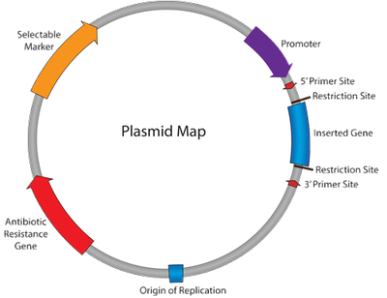

Other Applications
  - Golden Rice : insert protein that produces beta-carotene (more vitamin A)
  - Gene Therapy
  - CRISPR/Cas-9: “pinpoint” DNA editing - @ any location in genome
  - Synthetic Biology: construct new genetic constructs
  - Genetic Testing
    - SNP= differences @ single loci in genome; analyze using gene chips
    - RFLPs = put restriction enzymes to cut regions of DNA with known variability, run in agarose gel for # of fragments & sizes
  - Cloning
    - Somatic Cell Nuclear Transfer
      - Somatic cell nucleus + enucleated egg cell + surrogate + shock = CLONE!
    - Therapeutic Cloning: produce stem cells through embryonic stem cells
- Lots of ethics surrounding this!

Scientific Skills

Chi-squared testing

- We can’t rely on ‘gut feeling’ when making claims
- Chi-squared test evaluates inherent variability in the world by comparing data collected vs. data predicted
  - Null hypothesis: claim that can lead to clear predicted experimental outcome; normally it is that the ‘thing’ observed is random/due to chance; or if punnett square, then ratio of dominant trait to recessive trait is 3:1 (example)

Chi-Squared value = Sum (o-e)^2/e

 | Obs | Exp | (o-e) | (o-e)^2 | (o-e)^2/e
Category 1
Category 2..

Sum the last column values to get chi-squared value
- Identify degrees of freedom = amount of categories - 1
- Each column is a different probability level; scientists agree significant level of probability is 0.05 (5%)
  - Basically means that if scientists replicated experiment many times, they would see that chi-squared value 5% of the time if null hypothesis is true
  - Differences between what you observe and expect NOT large enough to reject null hypothesis
- Any chi-squared value < critical value fail to reject the null hypothesis; not statistically significant difference
- Chi squared value > critical value; we CAN reject the null hypothesis; difference is statistically significant

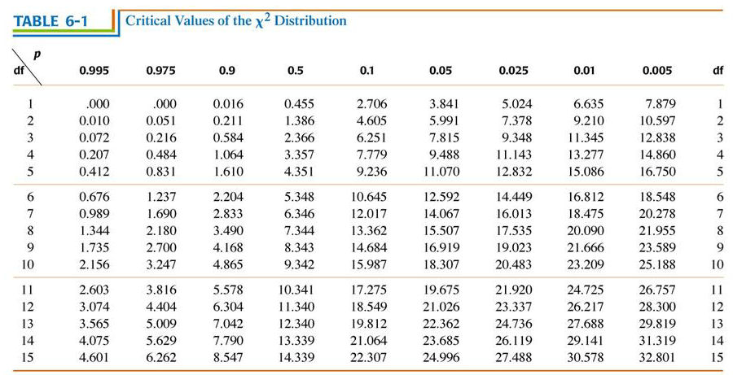

Scientific Calculation Skills
Standard Error = a measurement of variance in the means of data sets taken from the same population
- The range is 95% confidence level
- no overlap = statistically significant difference
- overlap = can’t determine if data is statistically significant (not statistically significant)
- Standard Error =
Standard Deviation
n

n= sample size

- SE * 2 = 95% confidence level (interval + and - on either sides of the mean)
  - 2 Standard Errors away = 95% confidence interval
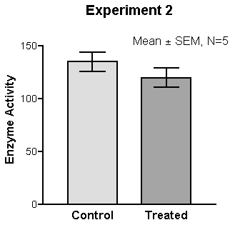Example graph

Water Potential Calculations
Water Potential = Potential energy of water per unit area compared to pure area
- If more negative, water more likely to flow into the cell
- Highest water potential on earth is pure water (0)
- Water flows from high concentration to low concentration; high water potential to low water potential
- High water potential = less solute, more water
- Low water potential = more solute, less water
- PURE WATER = 0
- Water potential = Pressure potential + Solute potential
- Solute potential = -iCRT
  - C= molarity
  - R= 0.0831

