Chapter 21 Protists Name ____________________Period_____
1. What are protists?
- Eukaryotes that are not members of the plant, animal or fungi kingdoms
- They were the first eukaryotes (nucleus).

2. Characteristics of protists
- Most are _________________________
- Can be heterotrophic or autotrophic
- Most live in _______________ (some live in soil, animals, …)
- ALL are _________________________ (have a nucleus)
- Some can move – cilia, flagella, passive (float)
- Many reproduce by ___________________________ (asexual)
- Some can reproduce sexually and asexually
- Some exchange genetic information by _________________________ (paramecium)

3. Type of protists
A. ______________________________ protists (amebas and paramecium)
- Engulf and digest their food or absorb it from their environment

Ameba
- Lives in ______________________
- Appear like ____________________
- Moves using pseudopodia – “false feet”
- Reproduce by _________________________
- Ingests food by surrounding and engulfing it (___________________________)
- __________________________________________ – removes excess water
- Can cause amebic dysentery – diarrhea and stomach upset from drinking contaminated water
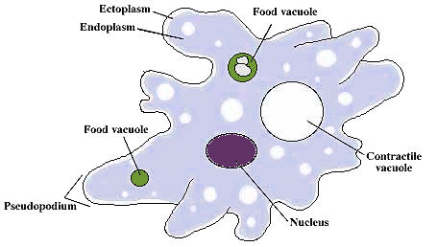
Paramecium
- Live in water
- Move using ________________
- Exhibits avoidance behavior
- Reproduces _______________________(binary fission)
- Reproduces ____________________ (conjugation)
- Ingests food through a mouth pore, gullet, then forms a food vacuole which fuse with lysosomes for digestion
- ________________________________________________________ – the paramecium stays the same shape (like a shoe)
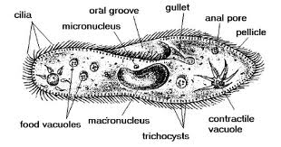

B. _____________________________ (“algae”, phytoplankton, kelp and euglena)
- _______________ of the photosynthesis on earth is done by protists (producers)
- Provide energy through photosynthesis to _________________
- Provides ___________________ to other organisms (kelp – 60m)
- _______________________ waste

Euglena
- Live in water
- Have ______________________ for movement
- Use ___________________________ for photosynthesis
- Can turn into ______________________________________ if they are kept in the dark
- Has an _____________________ used for sensing light and dark
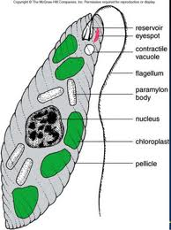

4. Protist diseases
_____________________ - an organism that lives on or in a host organism and causes harm to that organism
_____________________ - an organism that can carry a parasite, and infect other organisms

Disease | Protist | Vector (carrier) | Symptoms | Details
Amebic Dysentery | Entamoeba | water | diarrhea | can get from tap water in  some places
Giardiasis ("beaver fever") | Giardia | water | diarrhea, vomiting | don't drink water from  streams
African Sleeping Sickness | Trypanosoma | tse tse fly | uncontrolled sleepiness,  confusion | Only found in isolated areas  lives in blood
Malaria | Plasmodium | anopholes mosquito | fever, chills, death | can be treated with quinine  lives in blood  results in millions deaths per year
Toxoplasmosis | Toxoplasma | cats | fetal death or brain damage | pregnant women should avoid  cat litter

Malaria life cycle - Found in hot, wet, tropical places
