PLANTS Chapter 22-23 Name _________________ Per_____

What are plants?
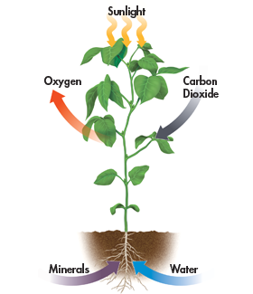
- ____________________ (have a nucleus)
- Have cell walls made of _________________
- Carry out ________________ using the pigment chlorophyll a and chlorophyll b
- Belong to the kingdom ______________

What do plants need to survive?
- ____________ – make food through photosynthesis
- __________________ (CO2 and O2)
- ________________ and ____________________

Plant evolution
- The ancestor to today’s plants were similar to ___________________
- Plants are divided into ___________ major groups
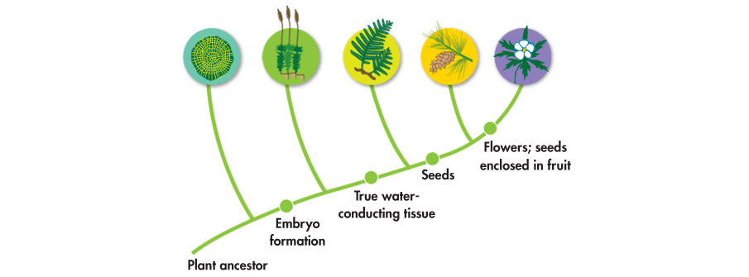

Alternation of generations
- The lifecycle of plants has 2 phases
  - ____________________ (haploid – N)
  - _________________ (diploid – 2N)
- During evolution – the size of the gametophyte decreased and sporophyte increased

Types of plants
- Green Algae
- Mostly ______________________
- Found in fresh water, seawater, and moist areas
- Absorb __________________ from surroundings
- Many form colonies
  - Spirogyra
  - Volvox

2) Bryophytes
- Found in damp places
- Have specialized reproductive cells that require _____________ for reproduction.
- Lack ___________________ – water/nutrient carrying tissue supported by lignin
  - Lack support to grow ______________________
- Moss life cycle pg 642

3) Ferns and relatives – pg 643
- Have vascular tissue which makes it possible to move fluids through the plant (against gravity)
  - ____________ = carries nutrients
  - _____________ = carries water
- Do __________ have seeds – reproduce through __________________
- Reproductive cells need _____________ for fertilization

- Gymnosperms – cone bearing plants
- First _________________ plants – allows the plant to
  - Reproduce without ________________
  - ______________ the embryo in a ________________
  - Provide _______________ to the embryo
- Reproduction occurs through pollination
  - ______________ (the male gametophyte) is transferred to the female cone

5) Angiosperms – flowering plants
- Reproduce sexually through _____________________
  - ____________ in flowers develop into _____________ to help disperse seeds
  - Flowers attract pollinators and reproduction is more _________________ than the wind pollination of gymnosperms
- Monocot vs. dicot
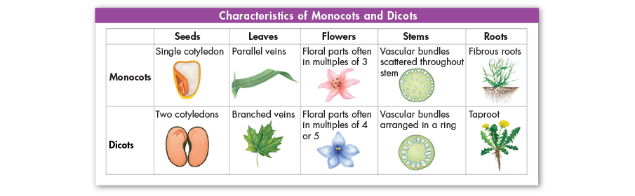
- Annuals, biennials, perennials (pg 654)
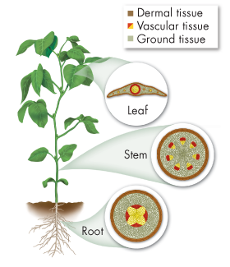

Chapter 23 Plant Structure and Function
Plants have tissues and organs too!!!!!
  - ______________ = dermal, vascular and ground
  - _______________ = Roots, stems and leaves

3 Types of tissue
1) Dermal tissue = the ________________ outer covering in a plant
  - Epidermis – outer layer of cells
  - Cuticle – waxy covering
2) Vascular Tissue = ___________ the body and transports water and nutrients
  - Xylem – transports ______________
    - Tracheids (lignin in cell wall to give structure)and vessel elements
  - Pholem – transports ____________________
    - Sieve tube elements and companion cells
3) Ground Tissue = produces and stores ____________ and contributes to the support of the plant
  - Parenchyma = thin cell walls, contain a large vacuole, in leaves have chloroplasts
  - Collenchyma = thicker cell walls (make up “strings” of celery
  - Sclerenchyma = thickest cell walls – nutshells, seed coats

Where do plants grow????
- _______________ = regions of cells in which mitosis produces new cells that are ready for differentiation
  - ______________ meristem = rapidly growing regions at the tip of the stem and roots
Roots
- Root Function
  - ______________ a plant
  - ______________ it to the ground
  - Store _______________
  - Absorb ______________ from the soil
  - Absorb __________________ from the soil
- Types of roots
  - Taproot – carrots, beets, dandelions
  - Fibrous root - grasses
- _______________ – roots actively pump nutrients into the root. Water moves in by osmosis. This causes a pressure that causes water to move up the plant into the stem
Stems
- Functions of stems
  - _______________ leaves, branches and flowers
  - Hold up the leaves to the _____________
  - ___________________ substances throughout the plant
- Formation of wood and tree rings
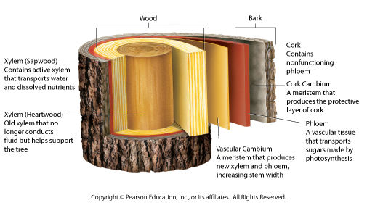

Leaves (pg.681)
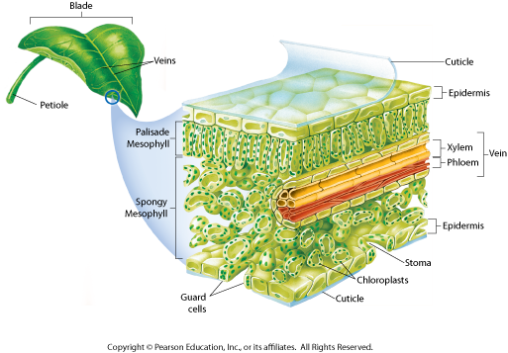
- Anatomy of a Leaf - Leaves are optimized to absorb light and carry out photosynthesis
- _______________ – waxy cover to protect/prevent water loss
- ___________________ – where photosynthesis occurs
- _____________ – openings in the leaf that allow CO2, water, and O2 to diffuse in and out of the leaf
- _________________________ = cells that surround the stomata and regulate their opening and closing
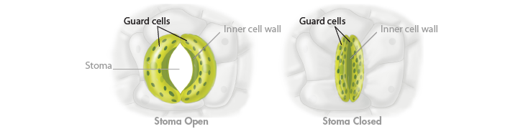
Homeostasis and stomata
- Plants keep stomata open just enough so that gas exchange can occur for photosynthesis but not so much that they lose too much water
- When water is ______________ water flows into the leaf. This increases water pressure in the guard cells and ____________ them.
- When water is __________________, pressure decreases and the stomata ______________

Water transport in plants
- Transpiration = ___________________________________________________________
  - Water leaves through open ____________________
  - Dry cell walls pull water from deeper in the leaf and pulls water from the roots, stem and leaf through xylem
  - Water “sticks” to water (cohesion) and other molecules (adhesion)
  - Even small trees can lose 100L of water/day
  - What conditions increase transpiration???
    - _______________
    - _______________
    - _______________
- _____________ action – the tendency of water to rise in a thin tube
CHAPTER 24
Reproduction in flowering plants
- Parts of a flower
  - ____________ = enclose the flower before the bud opens and protects the flower
  - _____________ = attract pollinators to the flower often brightly colored inside the sepals
  - Stamen = _______ parts of the flower
    - Anther – produce ________
    - ____________ – a stalk that holds up the anther
  - Carpels (pistil) = ______________ parts of the flower
    - _______ – sticky structure designed to capture pollen
    - ____________ – a stalk that holds up the stigma

Angiosperm gamete production - Figure 24-3 pg. 699
Angiosperm lifecycle - Figure 24-6 pg. 701

Fruit and seed development
- Fruit = a thickened ___________________ that encloses seeds
- Seed Dispersal =
  - ____________ = seeds with tough coats are encased in a sweet fleshy fruit
    - Apples, grapes
  - _________ = lightweight fruits that allow them to be carried in the air
    - Dandelions
  - ___________ = buoyant fruits that allow them to float
    - coconuts

Seed Dormancy and Germination
- Dormancy = the embryo is ____________ but __________________
- _____________________ = growth of the plant embryo following dormancy
  - Advantages of Dormancy
    - Allows for _____________________ dispersal
    - Allows seeds to germinate in ___________________________
    - Some seeds only germinate under __________________ conditions
      - Some pine cones remain sealed until the high temps generated by forest fires cause the cones to open

Plant Hormones
- ____________________ = chemical signals produced by an organism that affect the growth, activity, and development of cells and tissues
  - _____________ – stimulate cell elongation and growth of roots
    - Produced in the shoot apical meristem and transported
    - When light hits a part of a plant, auxins build up in the shaded region, causing the plant to bend toward the light
    - Growth of lateral buds is inhibited by auxin (if you cut off the top of a plant, the lateral buds grow more quickly.

  - ____________ - hormones produced in the growing roots and developing fruits and seeds.
    - Often produce effects opposite of auxins
    - Stimulate cell division
    - Interact with auxins to balance root and shoot growth
    - Stimulate regeneration of tissues damaged by injury
  - ______________
    - Found in meristems of shoot, root, and seed embryo
    - Stimulate growth, promote germination
  - _________________
    - Found in terminal buds and seeds
    - Inhibits cell division
    - Promotes seed dormancy
  - ______________
    - Found in fruit tissues and aging leaves and flowers
    - Stimulates fruits to ripen
    - Causes plants to seal off and drop leaves

Tropisms
- Tropism = ___________________________________
  - Phototropism – tendency of a plant to grow toward _____________
  - Gravitropism – response of a plant to ___________
  - Thigmotropism – response of a plant to _____________

Rapid responses
- Some plants can also adjust quickly to their environment
  - Venus fly trap
  - Mimosa (folds leaflets in a few seconds when touched)

Response to seasons
  - How do plants know when to flower, drop leaves, etc?
__________________ = the number of hours of light/dark a plant receives (pigment phytochrome)
  - Winter Dormancy -
    - Deciduous plants turn off photosynthetic pathways
    - Transport materials from leaves to roots
    - Seal off leaves
    - Chlorophyll breaks down allowing other pigments to be seen (brown, yellow, etc.)

