2nd Semester Review – Use these questions to help you review the second semester of AP Biology. I included chapters for each unit on this sheet. Revisit the website for video links for each topic.

Unit 7 – DNA, RNA, Transcription, Translation, DNA Replication and Biotechnology (this is a big one!) Chapters 16, 17, and 18 (if you have time you might want to review viruses in Chapter 19.

1. What did the following scientists contribute to molecular biology? (Do a quick review of these – there is a PowerPoint on my site with all of them).
2. Griffith’s experiment (1928)
3. Avery, MacLeod, McCarty (1944)
4. Hershey-Chase (1952)
5. Chargaff (early 1950s)
6. Maurice Wilkins & Rosalind Franklin (early 1950s)
7. Watson and Crick (1953)
8. Matthew Meselson & Franklin Stahl (late 1950s)
9. Describe the structure of DNA using the following terms
10. Nucleotide, 3’, 5’ deoxyribose, phosphate, nitrogenous base, A, T, C, G, double helix, hydrogen bond, purine pyrimidine, antiparallel
11. Describe similarities and differences in the DNA of prokaryotes and eukaryotes.
12. Use the following terms in describing an eukaryotic chromosome – histone, DNA, nucleosome
13. Compare and contrast DNA and RNA
14. What is the difference between tRNA, rRNA, and mRNA?
15. Model DNA Replication using the following terms
16. Semi-conservative, leading strand, lagging strand, Okazaki fragment, DNA polymerase, DNA ligase, helicase, RNA primer, primase (others to know topoisomerase, single stranded binding proteins).
17. What are the similarities and differences between prokaryotic and eukaryotic DNA replication?
18. TRANSCRIPTION
19. Describe the process of transcription in 1-2 sentences
20. Where does transcription happen in prokaryotes? Eukaryotes?
21. Model transcription using the following terms

* Initiation – promoter, RNA polymerase, (transcription factors and TATA box in eukaryotes)
* Elongation – Describe how RNA nucleotides are added on the new strand, 5’ to 3’,
* Termination

1. RNA editing/processing (**Eukaryotes** only)

* When and where does RNA editing occur?
* Explain how each of the following is related to RNA editing in eukaryotic cells – 5’ cap, poly-A tail, RNA splicing, exon, intron, spliceosome, alternative RNA splicing

1. TRANSLATION
2. Model translation using the following terms - tRNA, rRNA, mRNA, codon, anticodon, A site, P site, E site, amino acid, polypeptide (if you have these down you can add aminoacyl-tRNA synthetase, wobble, polyribosome, signal peptide)
3. Describe the structure of ribosomes. How do prokaryotic and eukaryotic ribosomes differ?
4. What is the difference between free and attached ribosomes? Give two examples of the final location of a protein made at a free vs. attached ribosome.
5. In prokaryotic cells, translation starts before transcription ends. List two reasons this isn’t possible in eukaryotic cells.
6. Mutations
7. What can cause mutations in DNA?
8. What is the difference between a substitution mutation and a frameshift mutation?
9. The three substitution mutations are silent, missense, and nonsense. What’s the difference?

Transcribe and translate the following sequence:

GTG CAC CTC ACT CCA GAG GAG (Normal Hemoglobin)

mRNA →

amino acids →

GTG CAC CTC ACT CCA GTG GAG (Sickle Cell Hemoglobin)

mRNA →

amino acids →

Identify the type of mutation that is represented AND EXPLAIN, IN DETAIL, what effect this would have on the protein/pigment (be sure to mention the types of functional groups on the amino acids and how this would affect shape of the molecule).

1. pGLO Lab and Bacterial Transformation
2. Distinguish between conjugation, transformation, and transduction
3. [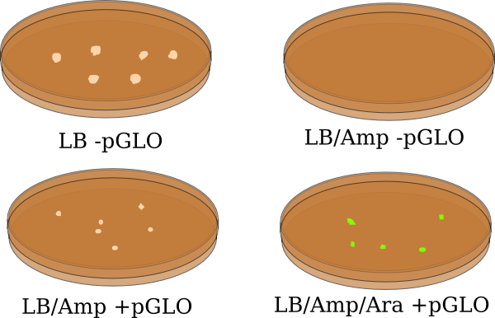](https://www.google.com/url?sa=i&rct=j&q=&esrc=s&source=images&cd=&cad=rja&uact=8&ved=0ahUKEwjS5uXQvczTAhVIwGMKHX6UD1kQjRwIBw&url=http%3A%2F%2Fwww.clker.com%2Fclipart-pglo-1.html&psig=AFQjCNG1DiHCxC8K7hnUD2q4cXGK1AMcyw&ust=1493651906627530)Describe the results of the pGLO lab.

LB = the type of agar

Amp = Ampicillin

Ara = Arabanose sugar.

* Explain the purpose of each of these three substances (LB, amp and ara).
* Explain why bacteria on each plate either grow/don’t grow and why they either glow/don’t glow.

1. [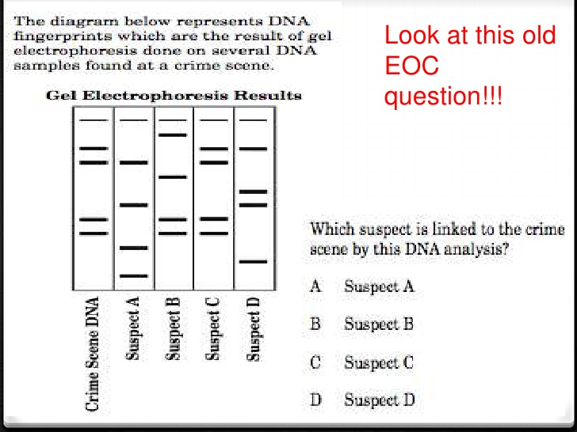](https://www.google.com/url?sa=i&rct=j&q=&esrc=s&source=images&cd=&ved=0ahUKEwiZyofXv8zTAhVDKWMKHQcHASIQjRwIBw&url=https%3A%2F%2Fwww.slideshare.net%2Fwendyhilburn%2Fdna-fingerprinting-12946953&psig=AFQjCNF4sHucV7RBonpaGxgo_BXhi4r6-g&ust=1493652537209335&cad=rjt)DNA Electrophoresis
2. Is DNA positively or negatively charged?
3. Circle the shortest band on the gel. Explain how you know this.
4. What molecules cut the DNA?
5. How many restriction sites did suspect “B” have for the specific enzyme?
6. Which suspect matches the crime scene? Explain.
7. Gene Regulation -
8. Prokaryotic gene regulation

* What is an operon?
* What is the difference between an inducible operon and a repressible operon?
* Here are the two “textbook examples” of an inducible and repressible operon. Explain!
* An example of a repressible operon (trp operon)
* [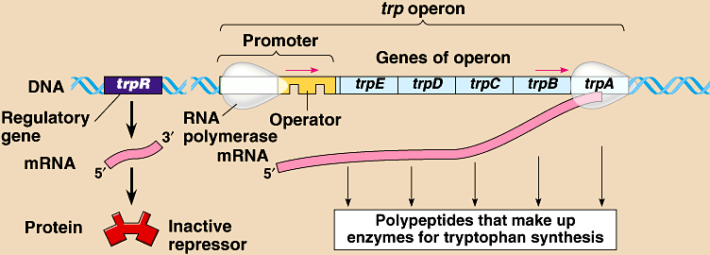](https://www.google.com/url?sa=i&rct=j&q=&esrc=s&source=images&cd=&cad=rja&uact=8&ved=0ahUKEwjgy_CFw8zTAhUD6GMKHX05BXIQjRwIBw&url=http%3A%2F%2Fwww.hammiverse.com%2Flectures%2F18%2F4.html&psig=AFQjCNGl84tp4SWSCm4vyH82eoqrBQmHVA&ust=1493653484483662)

An example of an inducible operon (lac operon)

[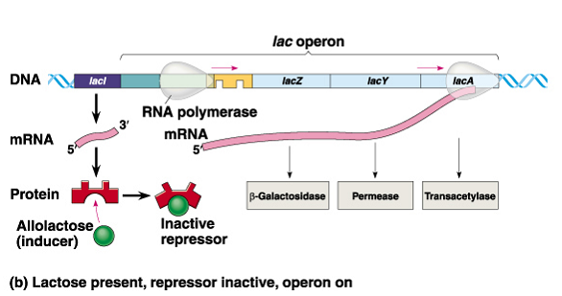](https://www.google.com/url?sa=i&rct=j&q=&esrc=s&source=images&cd=&cad=rja&uact=8&ved=0ahUKEwjoivLUwszTAhVE3WMKHWW0A6IQjRwIBw&url=http%3A%2F%2Fwww.namrata.co%2Flac-operon-regulation-of-gene-expression-in-prokaryotes%2F&psig=AFQjCNEa_mQg3XLa7NG71NwSJAQ0K_NKHQ&ust=1493653372659880)

1. Eukaryotic gene regulation (see figure 18.6 on pg. 356 for overview).

* Eukaryotes regulate gene expression by regulating chromatin structure, epigenetics (DNA methylation), gene regulation by control (non-coding) regions in DNA including enhancer sequences and general transcription factors (figure 18.10), and RNA and protein modifications.

Unit 8 – Evolution – Chapters 22-26 – (Review Chapters 22 and 26 in Unit 1) These questions focus on chapters 24-25).

1. Explain the 5 requirements for Hardy-Weinberg.
2. Explain the parts of the H-W – p, q, p2, q2 and 2pq.
3. As a field researcher you are sent to the Arizona desert to study the prairie dog species *C. ludivincianus* to determine if the population is in Hardy-Weinberg equilibrium. Specifically, you are studying this population with respect to the gene that determines the coat color in *C. ludivincianus*. This trait is coded for by a single gene (the NDY6 gene) with two alleles (N, n) and is passed down from one generation to the next. After sampling 170 of these prairie dogs, you find that 36% of the *C. ludivincianus* population is homozygous recessive for coat color. Assuming the population is in Hardy-Weinberg equilibrium.
4. What is the allele frequency of the N allele?

b. What is the frequency of homozygous dominant prairie dogs?

c. What is the frequency of heterozygous prairie dogs?

1. Sixty flowering plants are planted in a flowerbed. Forty of the plants are red-flowering homozygous

dominant. Twenty of the plants are white-flowering homozygous recessive. The plants naturally pollinate and reseed themselves for several years. In a subsequent year, 178 red-flowered plants, 190 pink-flowered plants, and 52 white-flowered plants are found in the flowerbed. Use a chi-square analysis to determine if the population is in Hardy-Weinberg equilibrium.

1. Natural selection can lead to directional, disruptive, and stabilizing selection. Give an example of each
2. What is meant by the term “species” and speciation?
3. What is the difference between prezygotic and postzygotic isolating mechanisms and why are they important in speciation?
4. Explain 3 different prezygotic isolating mechanisms (there are 5).
5. Explain postzygotic isolating mechanisms.
6. How are isolating mechanisms related to allopatric and sympatric speciation?
7. How are the bottleneck effect and founder effect related to genetic drift?
8. Five new species of bacteria were discovered in Antarctic ice core samples. The nucleotide (base) sequences of rRNA subunits were determined for the new species. The table below shows the number of nucleotide differences between the species. Draw a phylogenetic tree indicating the relatedness of these 5 species.

|  |  |  |  |  |  |
| --- | --- | --- | --- | --- | --- |
| Species | 1 | 2 | 3 | 4 | 5 |
| 1 | X | 2 | 23 | 19 | 17 |
| 2 |  | X | 24 | 19 | 18 |
| 3 |  |  | X | 23 | 23 |
| 4 |  |  |  | X | 1 |
| 5 |  |  |  |  | X |

1. Peppered moths have wings that vary in color, ranging from white to dark gray. During the Industrial

Revolution through the mid-20th century, factories and power plants, which burned coal, produced large quantities of soot and smog. Near industrialized areas, black powder covered surfaces, including the moth habitat.



a. Use this information to explain the changes seen in light and dark peppered moths from 1800-

1950, as shown in the graph below.

b. Propose an explanation for the return of the peppered moth population to more light than dark

moths by the year 2000.

1. For the past 10 to 25 years, farmers have planted crop seeds that have been genetically modified to

withstand treatment with a common weed killer called Roundup®. This allows the farmers to spray their fields to get rid of weeds without harming their crops. Recently, more and more farmers have discovered that their fields have Roundup-resistant pigweed growing along with their crop. Describe what has most likely happened over time to lead to this.

Unit 9 – Animal Behavior (Chapter 51) and Ecology (Chapters 52-55) – YOU MADE IT!!!!

1. A student set up an experiment testing which concentration of glucose a pill bug would prefer. She put a solution of 0%, 10%, 20% and 30% glucose on cotton balls and placed them in four regions of a choice chamber. She then placed 80 pill bugs in the middle of the chamber. After 30 minutes she obtained the following results. Write a null hypothesis, complete the chi-square test, and answer the questions.

Df = ______ p = ________ critical value = __________ x2 = _________

Null hypothesis =

|  |  |
| --- | --- |
| % Glucose | Number of flies after 30 minutes |
| 0% | 5 |
| 10% | 28 |
| 20% | 37 |
| 30% | 10 |

|  |  |  |  |
| --- | --- | --- | --- |
|  | Observed | Expected | (o-e)2/e |
| 0% |  |  |  |
| 10% |  |  |  |
| 20% |  |  |  |
| 30% |  |  |  |
| TOTAL |  |  |  |

Explain the results of the experiment including the chi-square test.

1. Distinguish between abiotic and biotic features in an ecosystem.
2. [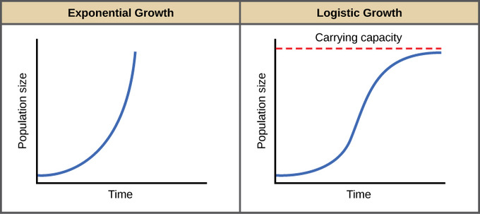](https://www.google.com/url?sa=i&rct=j&q=&esrc=s&source=imgres&cd=&cad=rja&uact=8&ved=0ahUKEwiKx7mS0czTAhUK-GMKHYTECIkQjRwIBw&url=https%3A%2F%2Fwww.boundless.com%2Fbiology%2Ftextbooks%2Fboundless-biology-textbook%2Fpopulation-and-community-ecology-45%2Fenvironmental-limits-to-population-growth-251%2Flogistic-population-growth-930-12186%2F&psig=AFQjCNFTBip8AB7ZdLWMagBEXOHDT5bQMw&ust=1493657288844011)Review the terrestrial and aquatic biomes (pg. 1153-1162)
3. Distinguish between logistic and exponential growth and explain the conditions of each. Label each graph to the left with the appropriate title.
4. What is the difference between r-selected and k-selected species?
5. What is meant by carrying capacity? Limiting factor? Keystone species?
6. What are each of the following – predation, symbiosis, mutualism, commensalism, parasitism
7. Know the following terms - food chains, food webs, trophic levels, consumers, producers, energy pyramids, biomass pyramid, pyramid of numbers, invasive species, and population dynamics. Use the following questions to help review!
8. Invasive species are species that are introduced into an environment but are not naturally found in that environment. One example of an invasive species is the American gray squirrel, introduced into Britain at the end of the 18th century. Until 1876 the only native squirrel in Britain was the European red squirrel, which was found in deciduous and coniferous forests. By 1940 the gray squirrel had displaced the red squirrel across most of the British Isles, and by 1984 the red squirrel was only found in isolated coniferous woodland areas. After its initial introduction, the gray squirrel population increased rapidly; however, in recent years population sizes within specific environments have become stable.

* Explain why the newly-introduced gray squirrel initially showed rapid population growth and why the native red squirrel showed a population decline.

- Why has the population size of the gray squirrel become stable in recent years?

1.  Interdependence in nature is illustrated by the transfer of energy through trophic levels. The diagram below depicts the transfer of energy in a food web of an Arctic lake located in Alaska.
2. Identify an organism from each of the 5 trophic levels (producer, primary consumer, secondary consumer, tertiary consumer and decomposer) and explain how energy is obtained at each level.
3. Describe the efficiency of energy transfer between trophic levels of this food web.
4. Explain how the amount of energy available at each trophic level affects the size of the population.
5. If the cells in the dead terrestrial plant material that washed into the lake contained a commercially produced toxin, what would be the likely effects of this toxin on this food web?
6. If all of the Sculpin in this ecosystem were removed, predict how it would impact the following and

explain each prediction:

• The population of lake trout

• The population of snails

• The population of algae

• The amount of oxygen produced in the ecosystem

• The amount of light energy absorbed by the ecosystem

1. Explain the nitrogen, phosphorus, and carbon cycles. Why are each needed in living organisms? How do producers and consumers get each?

