Review Questions – Chapter 4 Name _____________________

1. What 3 things do all cells have in common?

2. What are the differences between prokaryotic and eukaryotic cells? What types of organisms make up each group?

3. As a cell increases in size, what happens to the surface area to volume ratio? What affect does this have on the cell?

4. Which organelles are found in plants but not animals?

5. Which organelles are found in animals but not plants?

6. Which organelles are described by the following:
- converts light energy into food
- support of the cell, contains cellulose
- breaks down glucose, forms ATP
- forms subunits of ribosomes
- modification of proteins
- contains enzymes that carry out intracellular digestion
- organelle compared to a whip
- made up of lipid bilayer and proteins
- part of its membrane pinches off to form vesicles for storage or transport
- may be rough or smooth
- polypeptide chains or proteins are constructed here
- contains DNA
- fluid filled sacs – may store food or water
- the rough ER has these on its surface
- organelle within the nucleus of a cell

7. What is the difference between a nucleus and a nucleoid?

Label each of the following organelles with the correct name.

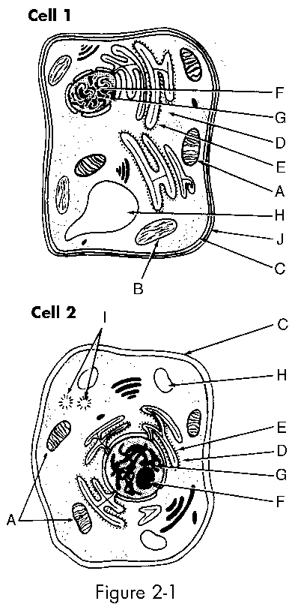

8. Which cell is a plant cell and which cell is an animal cell?

