CELLS - Chapter 7
7-1 Life is Cellular
- Cell Theory
- All living things are made of ____________
- ___________ are the basic units of structure and function in living things
- New __________ are produced from existing ___________
- Microscopes
- _________________________ microscope – allows light to pass through a specimen and uses two lenses to form an image
  - Magnifies to 1000x
  - Stains or dyes are used to show specific features
  - Fluorescent dies are used to tag molecules produced by cells
- ________________ microscopes – use beams of electrons that are focused by magnetic fields – can be used to see objects one billionth of a meter
  - Transmission electron microscopes – thin slices , electrons pass through the specimen - 2D image
  - Scanning electron microscopes – a pencil-like beam is scanned over the surface – makes a 3D image
- Prokaryotes and Eukaryotes
- All cells have a cell membrane - _________________________________________________________
- Not all cells have a nucleus – a large membrane-enclosed structure that contains genetic material in the form of DNA and controls many of the cells activities
- _________________________ - do not have a nucleus - Typically smaller and more simple
2) _________________________= have a nucleus - Typically larger and more complex
- Can be unicellular or multicellular

7.2 Cell Structure – Eukaryotic Cells
- The cytoplasm is the fluid ________________________________________________.
- Many cellular structures act as if they are specialized organs. These structures are known as organelles, literally “______________________.”
- The eukaryotic cell is much like a living version of a modern factory.
- The specialized machines and assembly lines of the factory can be compared to the different organelles of the cell.
- Cells, like factories, follow instructions and produce products.

A. The nucleus
- The nucleus = the _______________________________________
  - It contains most of the cell’s __________, the instructions for making proteins and other important molecules
- ______________________________ = surrounds the nucleus
  - contains pores (holes) that allow material to go in and out of the nucleus
- Chromosomes – carry the cell’s ___________________________ (DNA) - Found in the nucleus
- ________________________– a small dense region in the nucleus
  - ___________________ are assembled here

B. Organelles that store, clean up, and support
1) Vacuoles –large saclike _____________________________________
- Store water, salt, proteins, and carbohydrates
- In plants there is often 1 vacuole filled with liquid
- Also found in unicellular organisms and animals for storing and moving materials
2) _________________________ – small organelles filled with enzymes
- Break down lipids (fats) , carbohydrates, and proteins
- Help break down _______________________ - removes “_______________” from the cell
- Found in animal cells and some plant cells
3) ___________________ – a network of protein filaments that give cells shape and internal organization
- Helps maintain cell shape and involved in movement
4) Microfilaments – form a framework that supports the cell and help them move
5) Microtubules – hollow structures made of proteins called tubulins
- are involved in maintaining cell shape and in cell division
- Also form cilia and flagella
6) Centrioles – located near the nucleus and _________________________ in animals (made of tubulins)

C. Organelles that build protein
- ______________________ – the “___________________________” - where proteins are assembled
- small particles of RNA and protein found throughout the cytoplasm in all cells.
- produce proteins by following coded instructions that come from DNA.
- Each ribosome is like a small machine in a factory, turning out proteins on orders that come from its DNA “boss.”
- Endoplasmic reticulum (________) – an internal membrane system where lipids are assembled and proteins and other materials are exported from the cell.
- _________________ endoplasmic reticulum (rough ER) – the ER where __________________ occurs
- ________________________ on its surface
- Proteins made in the rough ER can be exported out of the cell or transported to other places in the cell
- _________________ endoplasmic reticulum (smooth ER) – the ER where no ribosomes are found
- Contains enzymes to do tasks like making ______________________ or detoxification of drugs
- Golgi Apparatus - ______________________________ proteins and other materials from the ER for storage in the cell or transport out of the cell.
- Looks like a stack of flattened membranes
- “_________________” proteins to their final destination

D. Organelles that capture and release energy
- Chloroplasts – capture the _________________________ and convert it into food (photosynthesis)
- Found in _______________ and some other organisms
- “______________________________________”
- Mitochondria – “_____________________________”
- convert the chemical energy stored in food into compounds easier for the cell to use
- In humans, you inherit most of your mitochondria from your ______________
- Contain small DNA molecules which suggest they may have been descended from independent microorganisms.

E. Cellular Boundaries
- Cell Wall – ________________________________________________________
- Allow water, oxygen, carbon dioxide to pass through
- Found in prokaryotes and eukaryotes (NOT ANIMALS)
- Provides ______________________ in plants (wood is made of mostly cell walls)
- Cell Membrane – controls what ______________________________________ and supports
- Made of a _________________________ (see the next slide)
- The cell membrane is made of a double layered sheet with lipids and proteins
- The cell membrane is ___________________ – some substances are allowed to pass and some are not.
PLANT VS ANIMAL CELLS pg 206

7.3 Cell Transport
A. Passive Transport = The movement of materials across the cell membrane without using cellular energy
1) Diffusion - The process by which _________________ from an area of _______________________ to an area of _________________________________
2) ________________________Diffusion – the process where molecules that cannot directly diffuse across the membrane pass through special ___________________________
3) Osmosis –the ________________________ through a ___________________________ membrane
- Water moves across a membrane until equilibrium is reached

Types of Solutions
Isotonic = When the concentration is the ___________ on both sides of the membrane
____________________ = The more concentrated solution
___________________ = The dilute solution
Osmotic pressure = the net movement of water out of or into a cell exerts a force
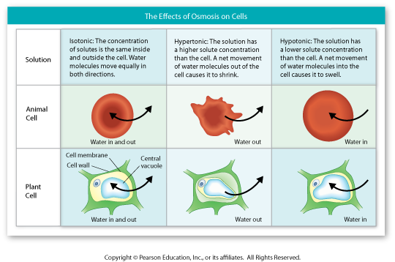

B. Active transport = movement of materials _________________________ difference (requires ___________
Movement of large molecules
