AP Biology Semester 1 Review – SAVE THIS ALL YEAR! Start by reviewing your reading guide and the PowerPoints for each unit. Also look at linked resources on each section of my website. The chapters in your book that cover each Unit are listed. The videos are the Bozeman AP Biology videos (found at http://www.bozemanscience.com/ap-biology/) If you would like more information on specific topics, additional videos can be found on the Bozeman Biology non-AP site (http://www.bozemanscience.com/biology-main-page/)
Unit 1 – Introduction to Biology and Evolution – Chapters 1, 22, and 26 Bozeman Biology # 1, 2, 4, 5, 6, 9, 10, 11
- What is natural selection? What steps need to occur for natural selection to happen?
- What is meant by fitness?
- Describe how each of the following are evidence for evolution
- Fossils, vestigial structures, homologous structures, analogous structures, biochemical/DNA
- What was the purpose of Stanley Miller’s experiment? Understand this experiment.
- List and describe the 3 domains
- List the taxons from the most inclusive to the least inclusive.
- Explain what information you can determine from a scientific name Ex. Homo sapiens
- What information can you learn from a phylogenetic tree?
- Remember those brine shrimp and standard error and standard error of the mean. You will not be required to calculate it on this test, but you will need to know how to interpret each.
Unit 2 – Chemistry, Water and Organic Chemistry – Chapters 2-5 - Bozeman Biology 42, 48, (Bozeman Chemistry – Chemical bonds, Acids Bases and pH, Water A Polar Molecule)
- What are the most common elements in all living matter?
- Explain the different types of bonding and identify them in macromolecules (nonpolar covalent, polar covalent, hydrogen, ionic).
- What is pH? What pHs are considered acidic/basic? How many more H ions are in a liquid with a pH of 3 than a pH of 6?
- Draw 3 water molecules. Label the partial positive end, partial negative end, and hydrogen bonds. and
- Understand the properties of water - polarity, cohesion(attraction to other water molecules), adhesion (attraction to other charged compounds), low density when frozen, versatile solvent, high heat of fusion/vaporization, surface tension
- What are the 4 groups of macromolecules? Name a monomer of each. How are monomers put together to make polymers? How are they broken apart?
- Carbohydrate –
  - What are the major characteristics of carbohydrates?
  - Are each of the following a monosaccharide, disaccharide or polysaccharide and what is the function of each? Glucose, starch, cellulose, sucrose, glycogen
- Lipids –
  - What are the major characteristics of lipids and at least 3 examples?
  - Draw and label a phospholipid (and a bilayer)
  - What is the difference between a saturated, monounsaturated and polyunsaturated fatty acid?
- Protein –
  - What is the monomer of proteins? Draw one and label the carboxyl group, amine group, and “R” group.
  - How do “R” groups impact protein structure and function? Use a membrane protein as an eample.
  - Distinguish between the primary, secondary, tertiary, and quaternary structure of proteins.
  - What roles do proteins play in organisms? Give at least 3 examples.
  - What are enzymes?
    - Explain the following as they relate to enzymes – active site, substrate, product, -ase, specificity, denature, temperature, pH, allosteric site, competitive and noncompetitive inhibition, feedback inhibition
- Nucleic Acids –
  - Draw and label a nucleotide.
  - How are DNA and RNA similar? How are the different?
Unit 3 – Cell Structure and Function – Chapters 6-7 – Bozeman Biology 15, 16, 43, 44,
- Distinguish between prokaryotes and eukaryotes (BE SPECIFIC). What do they have in common?
- Know structure and function of the following organelles
- Nucleus, nucleolus, mitochondria, ribosome, smooth and rough ER, golgi, cytoskeleton (microfilaments, microtubules, intermediate filaments), vacuole, lysosome, centriole, chloroplast, cell wall
- Give evidence for the endosymbiotic theory.
- Draw and label a cell membrane (phospholipid, hydrophobic, hydrophilic, protein).
- Which of the following molecules diffuse through the phospholipid bilayer? Oxygen, salt, hydrophobic molecules, hydrophilic molecules, carbon dioxide, sodium, water, protein, small lipids, sugar
- Distinguish the types of transport – diffusion, facilitated diffusion, osmosis, active transport, passive transport, endocytosis, exocytosis
- How does the Na/K pump work? You can wait and answer this one with action potential in Unit 5)
- What is a hypotonic, hypertonic, and isotonic solution? What happens when a cell is placed in a hypotonic solution? Hypertonic solution? Use the terms turgor pressure and plasmolysis
- What is water potential?
- At 20°C, a plant cell containing 0.6 M glucose is placed in distilled water. What is the distilled water and cell’s ΨP? Which way will water move? Describe in terms of water potential.
Unit 4 Cellular Respiration and Photosynthesis – Chapters 9 and 10 – Bozeman Biology 12, 13
- What is free energy?
- What is the formula for cellular respiration? What are the reactants and products?
- What is the formula for photosynthesis? What are the reactants and products?
- Which of the following can do cellular respiration? Photosynthesis? Animals, plants, fungi, protists
- Which coenzymes are the electron carriers in respiration? Photosynthesis?
- Where does respiration occur in eukaryotes? Where does photosynthesis occur in eukaryotes?
- Describe each of the following steps of respiration in 1-2 sentences. Include starting and end products and location.
  - Glycolysis b. Kreb’s cycle c. Electron transport chain
- What is the function of oxygen in respiration?
- Label the following on the diagram – mitochondria, cytoplasm, glycolysis, Kreb’s cycle, Electron transport chain, inner membrane space, ATP, ADP, pyruvate, mitochondrial matrix, glucose, carbon dioxide, NAD, NADH, FAD, FADH2, ATP synthase, O2, H20, H+, H+ pumped, chemiosmosis, cytoplasm
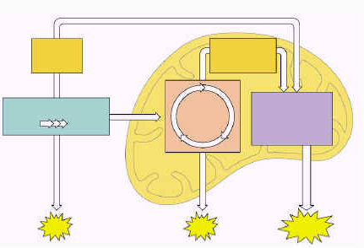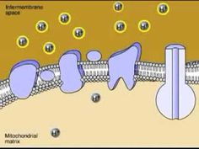
- What wavelengths of light are visible? Which color of light has the highest energy? (Look at the spectra on page 191 if you need help.)
- What are plant pigments? Why are leaves typically green (or yellow or orange)?
- Which colors of visible light yield the highest rate of photosynthesis?
- Label the following on the diagram – chloroplast, stroma, thylakoid, thylakoid membrane, Calvin cycle, light-dependent reaction, light-independent reaction, ATP synthesis, NADP, NADPH, Photosystem I, Photosystem II, chlorophyll, thylakoid space,
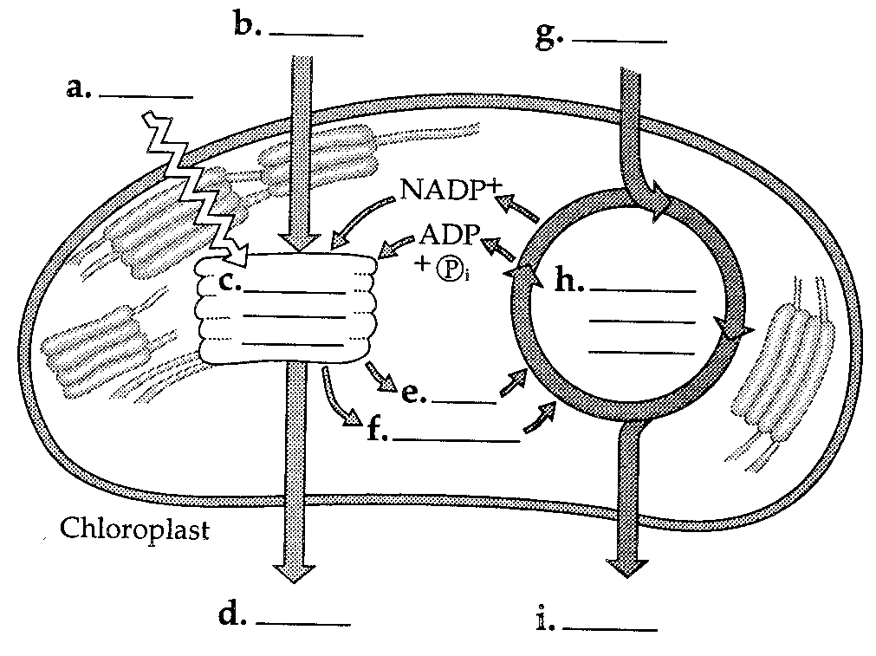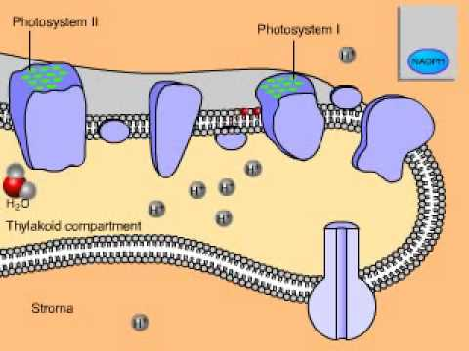

- Prokaryotes are also capable of photosynthesis and respiration. How is this possible if they don’t have chloroplasts and mitochondria?
- Differentiate between the types of fermentation. How are they different than respiration? How are the similar?
Unit 5 – Cell Communication and Mitosis –Bozeman Biology # 18, 19, 23, 25, 28, 32, 36, 37, 38, 39, 40, 41
Cell communication - Chapters 11, parts of 39 (plants), 43 (Immune), 45 (Endocrine), 48 (Nervous)
- What is the difference between negative feedback and positive feedback?
- Explain the three parts of a signal transduction pathway.
- What are each of the following: ligand, G protein, hormone, kinase, secondary messenger (cAMP, Ca)
- Understand as many of the following cell signaling pathways as possible (and others!!!!)
  - Plant hormones (auxin, ethylene)
  - Phytochrome
  - Immune system – T Cells and B Cells
  - Insulin and diabetes
  - Neurotransmitters and overall nerve structure
  - Epinephrine
- ACTION POTENTIAL (polarization, depolarization, Na/K pump, Na and K ions and channels)
Cell Cycle and Regulation – Chapter 12
- Explain how surface to volume ratio is an important factor in limiting cell size. Be able to use the formulas from your sheet to calculate surface area and volume.
- List and explain the stages of the cell cycle (interphase and mitosis).
- What are the products of mitosis?
- Label/define the following terms. Cytokinesis, cleavage, cell plate, sister chromatid, spindle, (kinetochore, motor protein, microfilaments)
- How is the cell cycle regulated? Explain cyclins, cyclin-dependent kinases and the mitosis-promoting factor (MPF)
Unit 6 – Meiosis and Genetics (Chapters 13-15) Bozeman Biology # 28, 29, 30, 33, 34
- Explain meiosis. Describe what you start with and the end product.
- Describe 3 aspects of meiosis and sexual reproduction that increase genetic diversity
- Explain crossing over. Where and when does it happen? Draw a cell in prophase of meiosis 1 with 6 chromosomes. Label the sister chromatids, homologous chromosomes, and chiasmata.
- Explain Mendel’s Laws
  - Law of Dominance b. Law of Segregation c. Law of Independent Assortment
- What is a genotype, phenotype, heterozygous, homozygous, genotypic ration, phenotypic ratio, probability
- Distinguish the different types of inheritance and be able to solve/distinguish the following.
  - Monohybrid cross
  - Dihybrid cross
  - Incomplete dominance
  - Codominance
  - Multiple alleles (Blood typing)
  - Sex linked (color blindness, hemophilia)
  - Linked genes
- Use a pedigree to determine inheritance patterns.
- Explain how linked genes are used for chromosome mapping.
- You have performed a dihybrid cross of plants and got the following data: 206 purple tall, 65 white tall, 83 purple short, 30 white short. Perform a chi-square analysis to test the null hypothesis that purple coloring is dominant to white and tall height is dominant to short height.
- In fruit flies, wild-type = “normal”. Gray body and normal wings are dominant)
A wild-type fruit fly (heterozygous for gray body color and normal wings) was mated with a black fly with vestigial wings. The offspring had the following phenotypic distribution: wild type, 401; black-vestigial, 385; black-normal, 62; gray-vestigial, 58. What is the recombination frequency between these genes for body color and wing type?

Modified from http://www.ptbeach.com/cms/lib02/NJ01000839/Centricity/Domain/113/ap%20biology%20pages%20and%20worksheets/AP-Biology-Exam-Review.pdf

Practice Problems
1. Refer to the diagram at the right to respond to the following questions.
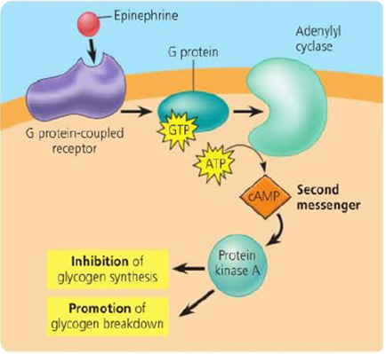
a. Is the hormone hydrophobic or hydrophilic? How do you know?

b. Explain how the action of the hormone might be different if it could
move through the cell membrane.

c. Explain what is happening in this picture and make a prediction about
what will be the end result in the cell to which this hormone has bound.

2. Under laboratory conditions, muscle cells were broken up and separated into fractions of mitochondria and cytoplasm in an attempt to learn more about cellular respiration. Each fraction was incubated with glucose or pyruvate. Tests were carried out during incubation for the presence of either carbon dioxide or lactic acid. The results are shown below:
Cell Fraction | CO2 | Lactic Acid
Mitochondria incubated with glucose | Absent | Absent
Mitochondria incubated with pyruvate | Present | Absent
Cytoplasm incubated with glucose | Absent | Present
Cytoplasm incubated with pyruvate | Absent | Present
a. What does the presence of lactic acid in a sample indicate about what process is occurring in each cell fraction?

b. Explain why lactic acid was produced by the cytoplasm fraction incubated with glucose, but not the mitochondrial fraction.

c. Why was no carbon dioxide produced by either fraction incubated with glucose?

d. Why did the cytoplasm fraction produce lactic acid in the presence of both glucose and pyruvate?

e. Why did the mitochondria produce carbon dioxide in the presence of pyruvate but not in the presence of glucose?

3. The figures to the right display the absorption range for several different pigments found in plants (left) and the rate of photosynthesis at varying conditions of wavelength in one plant species (right):
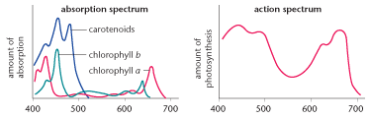
a. What color and wavelength of light is reflected by the plant species tested? How do you know?

b. What wavelength(s) increase the rate of photosynthesis in the plant species tested? What pigment does this
correspond to? How do you know?

4. Five new species of bacteria were discovered in Antarctic ice core samples. The nucleotide (base) sequences of rRNA subunits were determined for the new species. The table below shows the number of nucleotide differences between the species. Draw a phylogenetic tree indicating the relatedness of these 5 species.
Species | 1 | 2 | 3 | 4 | 5
1 | 0 | 2 | 23 | 19 | 17
2 |  | 0 | 24 | 19 | 18
3 |  |  | 0 | 23 | 23
4 |  |  |  | 0 | 1

5. True breeding tall, with antennae creatures were crossed with true breeding short, without antennae creatures. ALL of the F1 offspring were tall, with antennae. These F1 offspring were crossed with true breeding short, without antennae creatures. The F2 data is in the table below.
F2 Pheontype | Male | Female
Tall WITH antennae | 2360 | 2220
Tall WITHOUT antennae | 220 | 300
Short WITH antennae | 260 | 220
Short WITHOUT antennae | 2240 | 2180
What conclusions can be drawn from cross IV? Explain how the data supports your conclusions (Hint! You might need to do a chi square analysis to support conclusions!)
3. Two students debate about proteins that regulate the cell cycle. One argues that MPF triggers the production of cyclin, while the other argues that cyclin triggers the production of MPF.
a. Based on the figure to the right, which statement is correct and why?
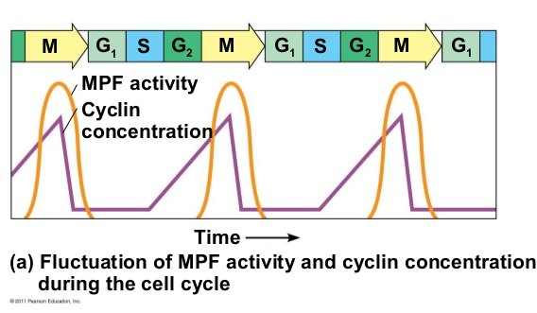

b. Propose a possible function of MPF, based on when it is produced
in the cell cycle.

6. Label the following macromolecule with the appropriate label
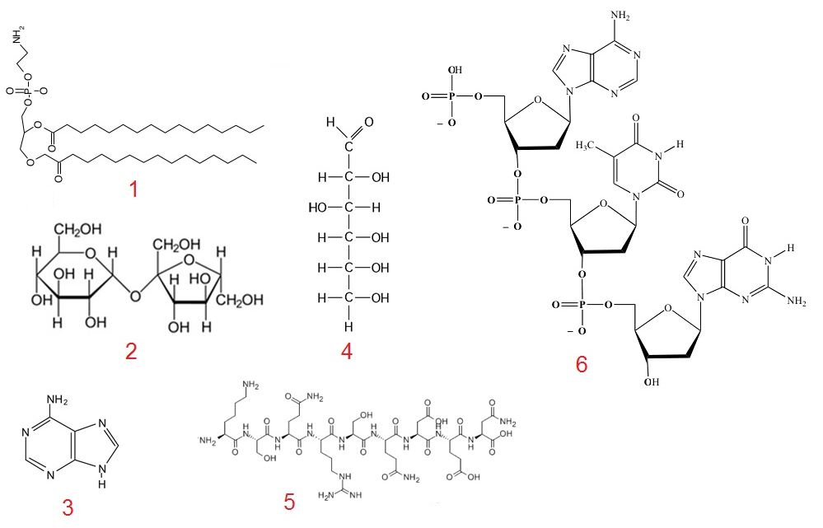
7. Interpret each of the following graphs.

8. Describe the structure and function of FOUR eukaryotic membrane-bound organelles other than the nucleus.

Prokaryotic and eukaryotic cells have some non-membrane-bound components in common. Describe the function of the following and discuss how each differs in prokaryotes and eukaryotes. DNA, Cell wall, ribosomes.

