AP Literature Summer Reading Assignment 2020-21
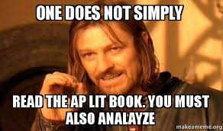
To build on your knowledge of the English literary canon, you will read and analyze one novel over the summer. To prepare for a later essay, you will do a thorough and thoughtful job completing a “AP Literature Analysis form” which is on my teacher site (. This means thinking deeply, citing page #s precisely, and writing in complete, concise sentences.
This AP Literature Analysis form will prepare you to write your first Fiction Prose Analysis essay for AP Literature which I will assign in the fall. In addition to filling out this form, I would advise annotating the novel as you read (in the text itself if you purchase your own copy, or using sticky notes if you use a school copy) so that you can easily remember and locate key quotations and passages for your writing.
The work assigned for this summer is
- Novel: The Round House by Louise Erdrich
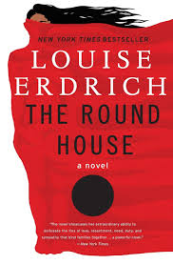

Come to class on the first day ready to discuss and write about The Round House!

