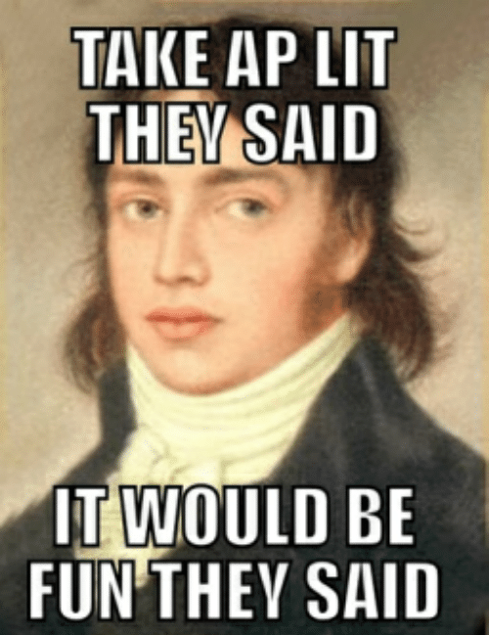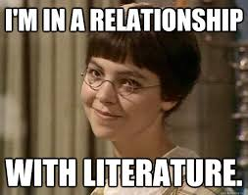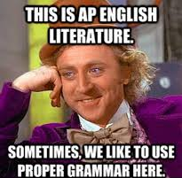

AP Literature/English IV 2020-21

Instructor: Rebecca Leaphart
Email: rleaphart@helenaschools.org
Classroom: CHS Room 112*
Phone: 406-324-2533
*I teach 0 period, so my “office hours” when you can catch me on Teams are 1:51 pm to 2:33 (DLI period) and 2:33 to 2:50.

Welcome to a year that will go down in the history books! I am looking forward to all of the news things each of us will learn this year including patience, flexibility, and virus proof cleanliness. The hybrid nature of the District’s Phase 1 opening means that we’ll each spend at least half of the week engaging online. I will offer a mix of live classes/discussions, videos, online discussion forums and other platforms for submitting work and interacting with the class. If you are a Digital Learning Student, or if you’re on your off days, you’ll need to follow the Weekly Plan, which I’ll post on Teams & on my teacher site. This will tell you whether you need to login to a live Teams meeting or work more independently and submit online.

Course Description:
AP English Literature and Composition course focuses on reading, analyzing, and writing about imaginative literature (fiction, poetry, drama) from various periods. Students engage in close reading and critical analysis of imaginative literature to deepen their understanding of the ways writers use language to provide both meaning and pleasure. As they read, students consider a work’s structure, style, and themes, as well as its use of figurative language, imagery, and symbolism. Writing assignments include expository, analytical, and argumentative essays that require students to analyze and interpret literary works.
The AP English Literature and Composition course aligns to an introductory college-level literature and writing curriculum.
Big Ideas and Enduring understandings:
The big ideas serve as the foundation of the AP English Literature and Composition course and enable students to create meaningful connections among course concepts. They are threads that run throughout the course and revisiting them and applying them in a variety of contexts helps students to develop deeper conceptual understanding. Below are the big ideas of the course, along with the enduring understanding associated with each one:
- CHARACTER (CHR)Enduring Understanding CHR-1: Characters in literature allow readers to study and explore a range of values, beliefs, assumptions, biases, and cultural norms represented by those characters.
- SETTING (SET)Enduring Understanding SET-1: Setting and the details associated with it not only depict a time and place, but also convey values associated with that setting.
- STRUCTURE (STR)Enduring Understanding STR-1: The arrangement of the parts and sections of a text, the relationship of the parts to each other, and the sequence in which the text reveals information are all structural choices made by a writer that contribute to the reader’s interpretation of a text.
- NARRATION (NAR)Enduring Understanding NAR-1: A narrator’s or speaker’s perspective controls the details and emphases that affect how readers experience and interpret a text.
- FIGURATIVE LANGUAGE (FIG)Enduring Understanding FIG-1: Comparisons, representations, and associations shift meaning from the literal to the figurative and invite readers to interpret a text.
- LITERARY ARGUMENTATION (LAN)Enduring Understanding LAN-1: Readers establish and communicate their interpretations of literature through arguments supported by textual evidence.

Materials:
Students will need the following supplies for this class:
- Writing utensils & paper
- Sticky notes!
- Devoted space (digital and/or physical) to store AP Literature materials. I would suggest dividing it into 5 sections: (Poetry, Fiction, Drama, Vocabulary, Syntax)
- Devoted AP Literature notebook
- Turnitin, NoRedInk, Perusall, and AP Classroom accounts (We’ll create in class)
Probable Texts Include:
- Austen, Jane. Emma.
- Bronte, Emily. Wuthering Heights.
- Ellison, Ralph. Invisible Man.
- Erdrich, Louise. The Round House.
- Kafke, Franz. The Metamorphosis.
- Kennedy, X.J. and Dana Gioia, editor. Literature: An Introduction to Fiction, Poetry, Drama and Writing. Pearson Longman, 2009.
- Morrison, Toni. Beloved. Everyman’s Library, 2006, New York.
- Shakespeare, William. Hamlet. Washington Square Press, 1992, New York.
- Shelley, Mary. Frankenstein. Penguin Group, 1983, New York.
- Stoppard, Tom. Rosencrantz & Guildenstern are Dead. Grove Press, 1967, New York.
- Williams, Tennessee. A Streetcar Named Desire. New Directions, 2004, New York.
- Various short stories and poems

Classroom Structure and Expectations
Above all else, be respectful & be responsible. I expect open-minded, kind and honest behavior in class and on the page.
Covid Safety Measures
As students and teachers in a classroom together we are a community, and we will take care of one another by following all health and safety protocols set out by the Helena School District and Lewis & Clark County Health Department. This includes properly wearing masks, maintaining 6 foot distancing, washing hands, and not coming to school sick.

Academic Honesty
Capital High adheres to high standards of academic integrity. Plagiarism, cheating and other forms of academic dishonesty are prohibited. In the event that a student’s work is academically dishonest, the student will receive a zero/F on the assignment and his or her parents will be notified. Depending on the nature of the assignment and infraction, a student may have the opportunity to revise for credit.

Plagiarism is the act of stealing someone else’s words or ideas and passing them off as one’s own (not crediting the source). We will discuss plagiarism throughout the year so that students feel confident avoiding it; if students have questions regarding plagiarism, they should consult me before submitting an assignment.

Food and Drink
It is important to stay hydrated, so drinking water from a container with a secure lid is acceptable during class. It is acceptable to raise your mask to drink in class, just be sure to lower the mask right away. Otherwise, no food in the classroom outside of the lunch period.

Electronic Devices
Before entering my classroom, students need to put their cell phones away so that they are neither visible nor evident (through signs such as ear buds).
At the beginning of each quarter, I enter ~85 participation points into the grade book for each student (2 per day in the quarter). These are listed as “Management” points. If a student’s cell phone is visible/evident inside my classroom, that student will lose points (2 per violation of the policy). More than one infraction in a class period will mean I refer the student to the office and contact the student’s parents/guardians.
What ifs…
What if I’m expecting/receiving a possible emergency call?
Mention this to me at the beginning of class so that I’m aware and/or ask to go to the hall/bathroom and answer your phone.
What if I want to listen to music while I work?
We can listen to music as a class. I will do my best to accommodate different tastes in music styles by rotating student requests. On work days, it’s ok to bring head phones and plug in to your laptop/Chromebook.
What if I need to look up a definition/other information?
You will have appropriate resources (Chromebooks/dictionaries/internet) for all tasks.
What if I want to take a picture of an assignment or notes on the board for later use?
Writing the information down by hand will help you to process and store the information.
Attendance and Participation
Attendance and participation are critical elements of this class. Some in-class work, such as discussions and group-work, cannot be made up exactly as we do them in class, but due to the hybrid nature of Phase I, I will provide digital alternatives to in-class work. Check the Weekly Plan as these digital alternatives will be posted there for DLI Students. Students should report absences (particularly school-related absences!) to me prior to class; Be responsible by contacting me about missed work. Chronic absences will adversely affect the student’s grade.

Participation will count for 15% of your grade. Simply attending class is not the same as participating in a meaningful way. To receive full participation credit, you will need to come prepared, listen, work well alone as well as in small groups, ask questions, volunteer ideas and opinions, present in front of the whole class, and otherwise contribute to the activity.

Assessments and Grading
Daily Assignments, Thought Pieces & Quizzes 30%
Essay Revisions & Presentations 55%
Participation 15%

Grading Scale:
93-100% A
90-93% A-
87-89% B+
83-86% B
80-82% B-
77-79% C+
73-76% C
70-72% C-
67-69% D+
63-66% D
60-62% D-
59-below F

Essays
Students will write a number of process pieces (proceeding through several stages and drafts) over the course of the year. In addition, they will write shorter, less formal essays and thought pieces that will not necessarily need to be revised.

Please follow MLA style guidelines for all essays: 12” font, Times New Roman, 1” margins.

Students will turn essays in through Turnitin.com.

Over the course of the year we will practice all three types of Timed Writes that will appear on the AP Exam: the argumentative essay, the rhetorical analysis essay, and the synthesis essay. Practice Timed Writes are meant to help students prepare for the exam. I will score those to give students a sense of their progress, but I will not include those scores in the gradebook as grades. (Exception: At some points in the year I may assign students to revise a timed write and I will grade the revisions, and there will be graded timed writes as part of the semester exams).
Revisions
You will be required to revise a number of essays for final credit and may revise additionally for grade improvement and feedback. All revisions will:

•be submitted in print, attached to all previous drafts of the essay containing peer and teacher comments, and highlighted and annotated to show the changes.
•reflect significant, serious, thoughtful revision (at least 1/3 changed or added material).

To ensure that revisions don’t waste students’ time or mine, I reserve the right not to accept revisions that do not meet these requirements.

Late Work
Assignments for the week will be posted on Teams, on my teacher site, and in the room on a board at the beginning of each week. Students are expected to come to class prepared to meet each day’s requirements, including homework, tests, etc. Late work is disrespectful of my time. Late homework will be penalized one letter grade per day unless you clear the tardiness with me in advance. Essays turned in late will not receive full credit on the “Process” section of the rubric. Also, I will not guarantee the same quality of comments to help the student revise, and the revision deadlines will not change. Students cannot pass the course missing two or more major writing assignments.
Attendance and Participation

The AP Exam
This year’s exam will take place on Wednesday, May 5 at 8 am.
All students are encouraged to take the exam, which will cost $95. Assistance is available for students who cannot afford the cost of the test

In the weeks leading up to the test, we will do intensive writing practice and have the opportunity to review.

AP English Literature Exam Format:
Section 1: Multiple Choice
55 Questions | 1 Hour | 45% of Exam Score
- Includes 5 sets of questions with 8–13 questions per set.
- Each set is preceded by a passage of prose fiction, drama, or poetry of varying difficulty.
- The multiple-choice section will always include at least 2 prose fiction passages (this may include drama) and at least 2 poetry passages.
Section 2: Free Response
3 Questions | 2 Hours | 55% of Exam Score
- Students write essays that respond to 3 free-response prompts from the following categories:
  - A literary analysis of a given poem
  - A literary analysis of a given passage of prose fiction (this may include drama)
  - An analysis that examines a specific concept, issue, or element in a work of literary merit selected by the student

