CHAPTER 5 CELL MEMBRANE AND TRANSPORT 11-16-18
DIFFUSION – MOVEMENT OF PARTICLES FROM A HIGH TO LOW CONENTRATION.
THREE FACTORS THAT AFFECT DIFFUSION:
- PARTICLE SIZE – SMALLER PARTICLES CAN DIFFUSE EASIER
- TEMPERATURE – HIGH TEMP. = FASTER DIFFUSION
- CONCENTRATION – STEEPER CONCENTRATION GRADIENT = FASTER DIFFUSION
PASSIVE TRANSPORT – MOVEMENT ACROSS MEMBRANE W/OUT ENERGY.
MOVE THROUGH LIPID BILAYER: $O_{2}$ , $CO_{2}$ , (SMALL NON-POLAR MOLECLUES)
FACILITATED DIFFUSION – PASSING THROUGH PROTEIN CHANNEL
OSMOSIS – MOVEMENT OF $H_{2}O$ THROUGH SELECTIVELY PERMIABLE MEMBRANE
WATER WILL MOVE UNTIL EQUALIBRIUM IS REACHED
HYPERTONIC = MORE CONCENTRATED (MORE PARTICLES DISOLVED IN SOLUTION)
HYPOTONIC = DILUTE SOLUTION
ISOTONIC = CONCENTRATION IS EQUAL

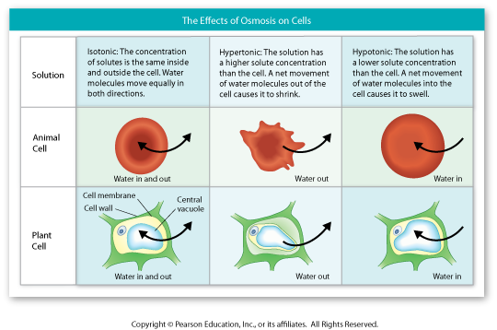
ATP (ADENOSINE TRIPHOSPHATE)
STORES POTENTIAL ENERGY FOR CELLULAR ACTIVITY
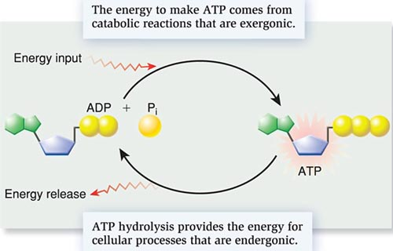
ATP SYNTHASE – ENZYME THAT CREATES ATP
MOVES H+ ions ACROSS A CONCENTRATION GRADIENT IN THE MITOCHONDRIA.

PLANTS – USE LIGHT ENERGY TO FORM ATP IN CHLOROPLASTS
AND RESPIRATION IN MITOCHONDRIA

ANIMALS – USE ENERGY FROM RESPIRATION IN THE MITOCHONDRIA

3 USES FOR ATP
- ACTIVE TRANSPORT (EXAMPLE: SODIUM/POTASIUM PUMP)
- MUSCLE CONTRACTIONS
- POLYMER SYNTHESIS (MAKING LARGE MACROMOLECULES LIKE PROTEINS)
LUCA: LAST UNIVERSAL COMMON ANCESTOR
ALL CELLS CONTAIN:
– ATP – RNA & DNA – GLUCOSE
– PROTEINS – RIBOSOMES – MEMBRANES – ION CHANNELS

