math 8

weekly Agenda
Date: Monday Oct. 19 – Friday Oct. 23
Time: 2nd period
Teacher: Ms. Sebastian
Contact Information:
YSebastian@helenaschools.org
(406)324-1045
You may message me on TEAMS or video chat (please set-up a time to chat)

I have started to include an answer key for assignments on Teams under the files tabs in the answer key folder. These answer keys will also have the work provided for each problem. When you are checking your work, you can see how the answer was determined. I will upload the answer key the day after the assignment is due.

All, “A”, “B”, and “DLI”, students will follow the same schedule this week.

Time | Item
Monday  Oct. 19 | Watch the lesson video for section 1.5 – Solving Two-Step Equations  https://web.microsoftstream.com/video/3afd2461-c535-4541-b12c-93cffea7cf82  After watching the lesson video do the assignment for 1.5 on page 22-23 problems #1-9, 11-15, 17, 20  Do the assignment on notebook paper, you will check your assignment tomorrow on TEAMS. | Due  Tues  Oct 6
Tuesday Oct. 20 | First, upload the assignment and check answers on the teams’ assignment for 1.5  Second, take the quiz for 1.5 – Solving Two Step Equations.  Finally, for those in class today, if you get finished before the end of class log onto IXL and work on the diagnostic until the end of class. | Quiz due today
Wednesday Oct. 21 | Work for 30 minutes on IXL on the Diagnostic test the instructions to get to IXL are below. Check PowerSchool to see if you have missing assignments or quizzes. Work on your missing assignments and quizzes (if you have any). | Make-up day!
Thursday Oct. 22 | Watch the lesson video for section 1.6 part 1– Solving Multi-Step Equations  After watching the lesson video do the assignment for 1.6 part 1 on page  Do the assignment on notebook paper, you will check your assignment tomorrow on TEAMS.
Friday  Oct. 23 | First, upload the assignment and check answers on the teams’ assignment for 1.6 part 1  Second, take the quiz for 1.6 part 1 – Solving Multi-Step Equations.  Finally, for those in class today, if you get finished before the end of class log onto IXL and work on the diagnostic until the end of class.

DO YOU HAVE ANY HOMEWORK QUESTIONS?
I have created a Q&A Padlet to ask questions on the homework and receive answers to those questions. It will be more efficient if I do not have to answer the same question 30 times. Asking a question is anonymous. No one will know who asked the question. I will answer every question. I will check the Padlet every day at the end of the day. The link to the Padlet is: https://padlet.com/ysebastian/bumwgg3ug1zr61r6

HOW TO GET TO IXL
Go to clever.
Scroll down and click on the IXL icon under middle school class resources
Click on Diagnostic at the top of the screen
Click step into the arena
Then choose a question.
To access the book online
Go to www.corefocusonmath.com
Find
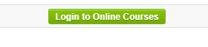
Username: helena
Password: math

Scroll down to
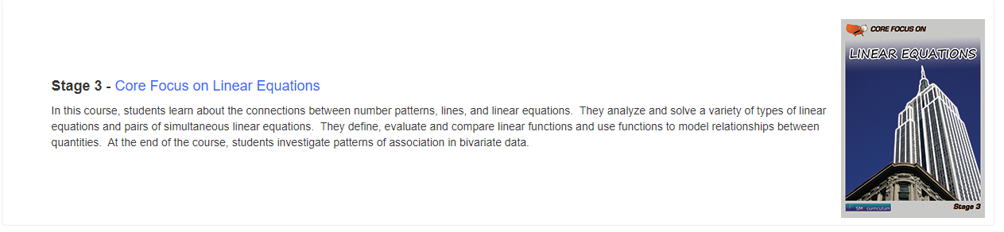
Click on the textbook icon on the screen

Select Block 1 – Expressions and Equations

Go to the lesson section you need
Here is an example:
Section 1.1
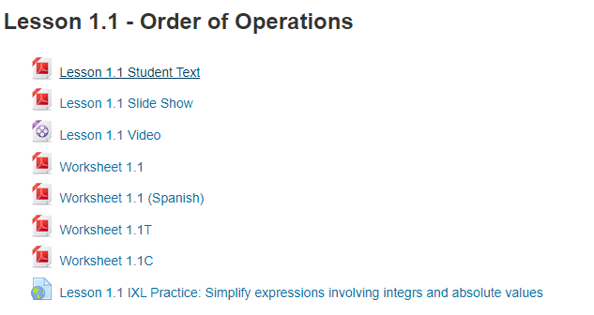
The first file is the textbook pages for the section
Middle School Daily Schedule

Middle School Daily Schedule |  |  | Go to 1st period as soon as you get to school every day.  Teachers will be using time after 6th period to connect with the remote learners whether they are “A” students or “B” students or “DLI” students.  At the end of the day, it is important for students to leave as soon as dismissed. “Hanging out” with friends afterschool is not allowed.
Period | Start | End
1 | 8:05 | 8:55
2 | 8:58 | 9:48
3 | 9:51 | 10:41
Advisor/Lunch | 10:41 | 11:01
4 | 11:04 | 11:54
5 | 11:57 | 12:47
6 | 12:50 | 1:40 dismissal
Digital Learning | 1:40 | 2:50

