math 8

weekly Agenda
Date: Monday Sept. 21 – Friday Sept. 25
Time: 2nd period
Teacher: Ms. Sebastian
Contact Information:
YSebastian@helenaschools.org
(406)324-1045
You may message me on TEAMS or video chat (please set-up a time to chat)

I am doing things a little differently this week to help cut down on confusion of what we are doing each day. I have tried to give you all the material at once with a timeline on the agenda and it did NOT work well. I only had about 28 students read the agenda completely last week. I know this because there was an extra credit opportunity at the very end of the agenda for students to take advantage of. Only 28 of my 113 students took advantage of the opportunity. The extra credit opportunity ended on 9/20. You have to read the agenda every day and completely. So now I have a new plan.

I will give you a new assignment each day. I will upload the new agenda each morning before school starts, and it will have the assignment and/or quizzes for the day. I will upload the assignment to TEAMS when the class starts after I take attendance. DLI students will have access to the assignments during the time their class is held (a daily schedule is at the end of this agenda). I will try this new plan and see how it goes. If you have any suggestions let me know.

All, “A”, “B”, and “DLI”, students will follow the same schedule this week.

Time | Item
Monday Sept 21 | Grade Check! Everyone needs to check their grade on PowerSchool. If you are missing assignments work on those. If you are not missing assignments move to Tuesday’s assignment. | Grade check!
Tuesday Sept 22 | Watch the lesson video for section 1.1 – Order of Operations  https://web.microsoftstream.com/video/420d40df-98cc-4bb9-8a64-86835cd6c015  After watching the lesson video do the assignment for 1.1 on page 5 problems #1-7, 11-13, 18-19, 21  Do assignment 1.1 on notebook paper you will check answers on teams tomorrow.  Go to www.corefocusonmath.com to access the book online. There are instructions at the end of this agenda. | Due Wed. Sept 23
Wednesday Sept 23 | Finish your assignment for 1.1  Go to the TEAMS assignment tab and enter answers for 1.1.  Take the quiz for 1.1 | Quiz due today!
Thursday Sept 24 | Section 1.2 – Evaluating Expressions  Lesson video for 1.2  https://web.microsoftstream.com/video/97f70c80-eeee-4229-8ca7-171a6aa2c6bc  Assignment for 1.2 page 8-9 problems#1-11, 15, 17-19, 23, 24, 27, 30, 31. Do the assignment on notebook paper you will check your assignment tomorrow on TEAMS. | Due Fri. Sept 25
Friday  Sept 25 | Finish your assignment for 1.1  Go to the TEAMS assignment tab and enter answers for 1.2.  Quiz 1.2 | Quiz due today!

DO YOU HAVE ANY HOMEWORK QUESTIONS?
I have created a Q&A Padlet to ask questions on the homework and receive answers to those questions. It will be more efficient if I do not have to answer the same question 30 times. Asking a question is anonymous. No one will know who asked the question. I will answer every question. I will check the Padlet every day at the end of the day. The link to the Padlet is: https://padlet.com/ysebastian/bumwgg3ug1zr61r6

To access the book online
Go to www.corefocusonmath.com
Find
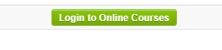
Username: Helena
Password: math

Scroll down to
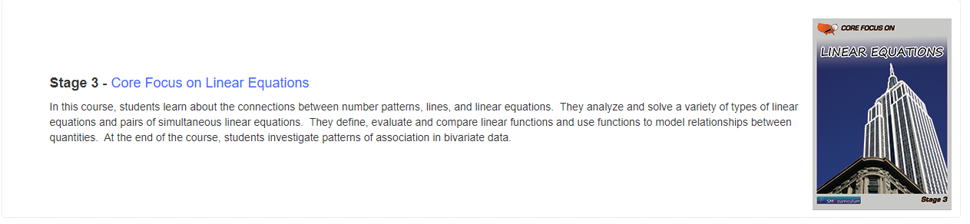
Click on the textbook icon on the screen

Select Block 1 – Expressions and Equations

Go to the lesson section you need
Here is an example:
Section 1.1
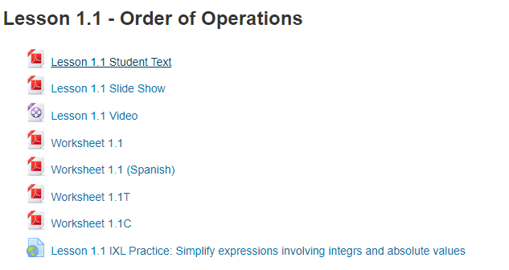
The first file is the textbook pages for the section
Middle School Daily Schedule

Middle School Daily Schedule |  |  | Go to 1st period as soon as you get to school every day.  Teachers will be using time after 6th period to connect with the remote learners whether they are “A” students or “B” students or “DLI” students.  At the end of the day, it is important for students to leave as soon as dismissed. “Hanging out” with friends afterschool is not allowed.
Period | Start | End
1 | 8:05 | 8:55
2 | 8:58 | 9:48
3 | 9:51 | 10:41
Advisor/Lunch | 10:41 | 11:01
4 | 11:04 | 11:54
5 | 11:57 | 12:47
6 | 12:50 | 1:40 dismissal
Digital Learning | 1:40 | 2:50

