Names: _______________________________________________________

Apportionment and Gerrymandering

Apportionment: Use the website http://redistricting.lls.edu/ to help you fill in the blanks below.

- Representation in the House of Representatives is based on ___________________________.

- To determine representation in the House, the government conducts a _____________ every 10 years.

- After the population is formally counted, the House seats are apportioned among the ______________.

- State _____________________ draw district lines, in a process called redistricting.

Gerrymandering

5) Define gerrymandering:

6) Give your interpretation of this famous political cartoon and its message in the space below:
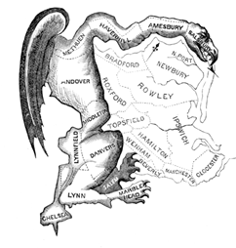

Activities
You and your partner will complete the activities together and answer the questions that go along with the activities.

Activity one: Redistricting Puzzles
http://www.slate.com/articles/news_and_politics/map_of_the_week/2013/08/gerrymandering_jigsaw_puzzle_game_put_the_congressional_districts_back_together.html

7) What information did you find out about the following states while completing the puzzles? Choose three states to explain
Iowa:

Michigan:

North Carolina:

Pennsylvania:

Maryland:

Ohio:

8) What impact does gerrymandering have on a democracy?

Activity Two: Redistricting Game
http://www.redistrictinggame.org/

9) What is the goal of Mission 1?

10) What are the goals of Mission 2 and 3?

11) How does the Voting Rights Act complicate redistricting?

12) What is the Tanner reform proposal?

13) What is the redistricting approval process?

14) Supreme Court Cases Define Main Idea:
Baker v. Carr, Reynolds v. Sims, Shaw v. Reno, Gill v. Whitford

