Blast Lab Answers NAMES:
- Use the following data to construct a cladogram of the major plant groups: (If you have a hard time drawing, you can make one on a white board, take a picture, and insert it into the document.
Table 1. Characteristics of Major Plant Groups
Organisms | Vascular Tissue | Flowers | Seeds
Mosses | 0 | 0 | 0
Pine trees | 1 | 0 | 1
Flowering plants | 1 | 1 | 1
Ferns | 1 | 0 | 0
Total | 3 | 1 | 2

- GAPDH (glyceraldehyde 3-phosphate dehydrogenase) is an enzyme that catalyzes the sixth step in glycolysis, an important reaction that produces molecules used in cellular respiration. The following data table shows the percentage similarity of this gene and the protein it expresses in humans versus other species. For example, according to the table, the GAPDH gene in chimpanzees is 99.6% identical to the gene found in humans, while the protein is identical.

- Why is the percentage similarity in the gene always lower than the percentage similarity in the protein for each of the species? (Hint: Recall how a gene is expressed to produce a protein.)
Table 2. Percentage Similarity Between the GAPDH Gene and Protein in Humans and
Other Species
Species | Gene Percentage  Similarity | Protein Percentage  Similarity
Chimpanzee (Pan troglodytes) | 99.6% | 100%
Dog (Canis lupus familiaris) | 91.3% | 95.2%
Fruit fly (Drosophila melanogaster) | 72.4% | 76.7%
Roundworm (Caenorhabditis elegans) | 68.2% | 74.3%

- Draw a cladogram depicting the evolutionary relationships among all five species (including humans) according to their percentage similarity in the GAPDH gene.

Continue to the next page for #3 (describing where the fossil belongs on the cladogram).
3) BLAST LAB: Describe where you think the fossil belongs on the cladogram.
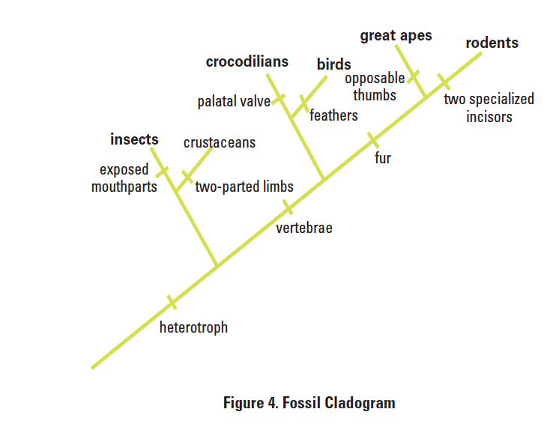
For each of the genes, answer the following questions:
Gene | What species in the BLAST result has the most similar gene sequence to the gene of interest? Give both the scientific name and the common name. | Where is that species located on your cladogram? (you may describe it or place it on the cladogram) | How similar is the gene sequence? | What different species has the next most similar gene sequence to the gene of interest?
1
2
3
4

After you have BLASTed all of the genes, answer the following questions
1. Based on what you have learned from the sequence analysis and what you know from the structure, decide where the new fossil species belongs on the cladogram with the other organisms. Why did you place it there?

2. What other data could be collected from the fossil specimen to help properly identify its evolutionary history?

3. Describe at least three ways researchers could use the BLAST database in research.

PART II Questions EXTRA CREDIT:
1) Title the cladogram based on your gene of interest, you can insert it into your Google Doc, WORD, or copy it on your paper.

2) What is the function in humans of the protein produced from the gene you selected?

3) Would you expect to find the same protein in other organisms? If so, which ones – why? Which other organisms had gene sequences most similar to the human gene you selected?

4) Is it possible to find the same gene in two different kinds of organisms but not find the protein that is produced from that gene? Why might this happen?

5) If you found the same gene in all organisms you test, what does this suggest about the evolution of this gene in the history of life on earth?

