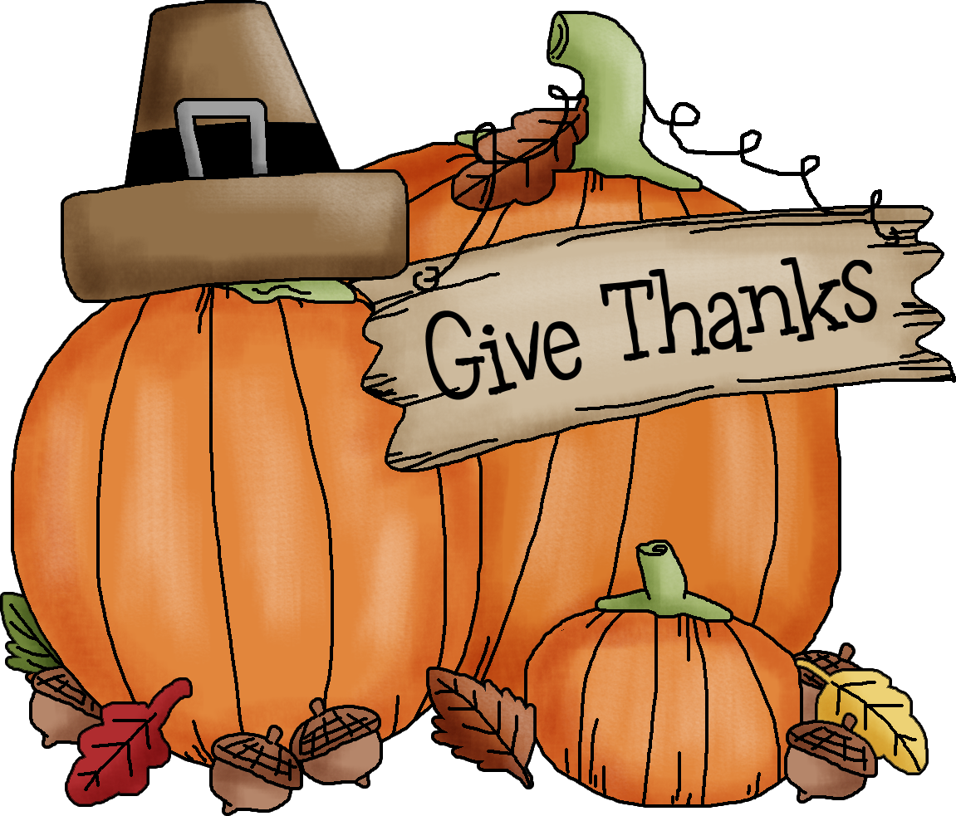
November
2020
Sunday | Monday | Tuesday | Wednesday | Thursday | Friday | Saturday
1 | Beginning of Q2 2 | 3 | 4 | 5 | 6 | 7
 | Bell Ringer/Attendance Check  Cheer/Dance tryouts 3:30-6:30 | Bell Ringer/Attendance Check  Cheer/Dance tryouts 3:30-6:30 | CC Lab check-in form  Cheer/Dance tryouts 3:30-6:30 | Bell Ringer/Attendance Check  Cheer/Dance tryouts 3:30-6:30 | Bell Ringer/Attendance Check
8 | 9 | 10 | 11 | 12 | 13 | 14
 | Bell Ringer/Attendance Check | Bell Ringer/Attendance Check | CC Lab check-in form | Bell Ringer/Attendance Check | Bell Ringer/Attendance Check
15 | 16 | 17 | 18 | 19 | 20 | 21
 | Bell Ringer/Attendance Check | Bell Ringer/Attendance Check | CC Lab check-in form | Bell Ringer/Attendance Check | Bell Ringer/Attendance Check
22 | 23 | 24 | 25 | 26 | 27 | 28
 | Bell Ringer/Attendance Check | CC Lab check-in form | No School | Thanksgiving  No School | No School
29 | 30
 | Bell Ringer/Attendance Check

