Name(s): ______________________ Period: _______ Celebrity: ________________________
Celebrity Google Graveyard Project
DIRECTIONS: Each student will work alone or with one partner. First you will sign up for a celebrity and complete all the research required for that celebrity. You will then answer the research requirements about your celebrity. Once you have finished your research questions you will create a tombstone of your celebrity. Lastly, you will interview two other celebrities and write a reflection about what you have learned.
RESEARCH REQUIREMENTS:
- Tombstone Items
  - Celebrity’s name
  - Date of birth
  - Date of death
  - Picture of celebrity
  - Six Word Memoir that best describes the celebrity you are studying
- Personal Life
  - 15 personal facts about the celebrity, including information about family, school, hobbies, relationships, etc. Paint a vivid picture with quotes, photos etc.
- Celebrity’s Accomplishments
  - Explain what the celebrity is famous for (be specific and be thorough)
  - Major professional contribution(s) to society (awards, albums sold, movies done, charities etc.)
- Drug Use
  - Research and report of the history of your celebrity’s drug use. Describe such key facts such as when did they start using drugs and what drugs, if any did, they progress to using.
- Death
  - What drug caused their death and the specific circumstances behind their death
  - Drug Information: street names, what it looks like, how it’s used, social/mental/physical effects
- Accolades
  - What did the media, peers and family have to say about this celebrity? Paint a vivid picture with quotes, photos etc.
- Reflection
  - Write a thoughtful response to the following questions:
    - Why would your celebrity, who was adored by millions, ever decide to use drugs?
    - What changes would you have made in your celebrities’ life to make their life healthier both physically and mentally?
    - How might these changes impact your celebrity’s future, be specific?
- Citations
  - At least 2 Cited Sources using proper MLA format and proper spelling and grammar.

PROJECT COMPOSITION:
- Google Graveyard Due: ______________________

- Peer Review Due: ______________________

- Celebrity Graveyard Peer Interview Due: ______________________

Citations:

Celebrity Death Interviews
DIRECTIONS: Now that you have finished your research on your celebrity, you are going to find out about other celebrities who died and exactly what drug(s) caused their death.

Your task is to interview 2 different celebrities and have them answer the questions below as they walk you through their Google Graveyard

Celebrity #1
Celebrity Name:__________________________________________________________________
- How old were you when you died? ________________

- What was your greatest professional accomplishment? __________________________________________ _______________________________________________________________________________________

- Tell me 5 facts about yourself.
_______________________________________________________________________________________
_______________________________________________________________________________________
_______________________________________________________________________________________
_______________________________________________________________________________________
_______________________________________________________________________________________

- Tell me about your family. ______________________________________________________________________________________________________________________________________________________________________________

- Tell me about your drug/alcohol use. _______________________________________________________________________________________ _______________________________________________________________________________________

- What was different about your drug use on the day that you died? _____________________________________________________________________________________________________________________________________________________________________________________________________________________________________________________________________

- Who were you closest to in your life?_________________________________________________________

- What were the circumstances of your death? __________________________________________________ _______________________________________________________________________________________

- What did other people have to say about you? _________________________________________________ _______________________________________________________________________________________

- What were you like in high school? _______________________________________________________________________________________ _______________________________________________________________________________________

Conclusion:___________________________________________________________________________________________________________________________________________________________________________________________________________________________________________________________________________________________________________________

Celebrity # 2
Celebrity Name:__________________________________________________________________
- How old were you when you died? ________________

- What was your greatest professional accomplishment? __________________________________________ _______________________________________________________________________________________

- Tell me 5 facts about yourself.
________________________________________________________________
________________________________________________________________
________________________________________________________________
________________________________________________________________
________________________________________________________________

- Tell me about your family. ______________________________________________________________________________________________________________________________________________________________________________

- Tell me about your drug/alcohol use. _______________________________________________________________________________________ _______________________________________________________________________________________

- What was different about your drug use on the day that you died? _____________________________________________________________________________________________________________________________________________________________________________________________________________________________________________________________________

- Who were you closest to in your life?_________________________________________________________

- What were the circumstances of your death? __________________________________________________ _______________________________________________________________________________________

- What did other people have to say about you? _________________________________________________ _______________________________________________________________________________________

- What were you like in high school? _______________________________________________________________________________________ _______________________________________________________________________________________

Conclusion:___________________________________________________________________________________________________________________________________________________________________________________________________________________________________________________________________________________________________________________
What is a Six Word Memoir?

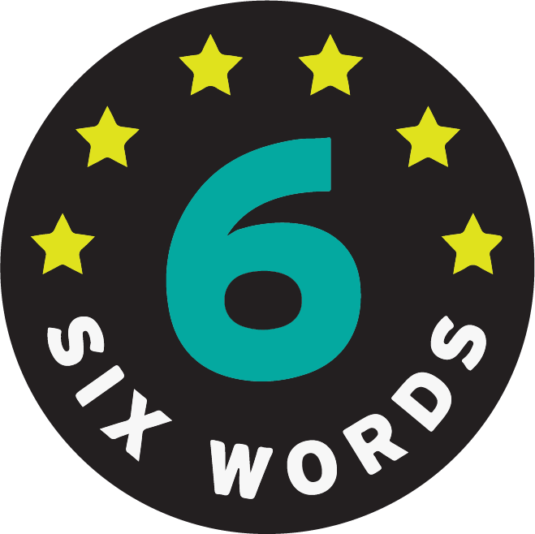
You are going to write a memoir about your celebrity, using only six words to capture the essence of who they were as a person. This will also be what you share with your peers to get them interested in your celebrity.

Category | 4 | 3 | 2 | 1
1. Tombstone | All five elements were present, and the six-word memoir fully captured the essence of the celebrity. | All five elements were present, and the six-word memoir somewhat captured the essence of the celebrity. | Less than five elements were present, and the six-word memoir somewhat captured the essence of the celebrity. | All five elements were not present nor did the six-word memoir captures the essence of the celebrity.
2. Personal Life | Elaboration consists of specific, developed details | Elaboration consists of some details | Elaboration consists of general and/or undeveloped details | Elaboration is sparse; almost no details
3. Accomplishments | Elaboration consists of specific, developed details | Elaboration consists of some details | Elaboration consists of general and/or undeveloped details | Elaboration is sparse; almost no details
4. Drug Use | Elaboration consists of specific, developed details | Elaboration consists of some details | Elaboration consists of general and/or undeveloped details | Elaboration is sparse; almost no details
5. Death | Elaboration consists of specific, developed details | Elaboration consists of some details | Elaboration consists of general and/or undeveloped details | Elaboration is sparse; almost no details
6. Accolades | Elaboration consists of specific, developed details | Elaboration consists of some details | Elaboration consists of general and/or undeveloped details | Elaboration is sparse; almost no details
7.Reflection  2.12.9 Analyze how some health risk behaviors can influence the likelihood of engaging in unhealthy behaviors. | Fully recognizes relevant influences--both internal and external. Accurately and completely explains how the influence impacts the celebrity, their family, and/or their community. | Recognizes relevant influences--both internal and external. Accurately and completely explains how the influence impacts the celebrity, their family, and/or their community. | Recognizes the influences but may not include both internal and external. Does not provide an effective explanation of how the influence affects them personally, their family, and/or their community. | No relevant influences are identified. Explanation is missing or a misunderstanding of the impact of the influence
8.Citations | Student has completed at least two citations that are in correct MLA format and everything is spelled correctly | Student has completed at least two citations that are in correct MLA format – one or two mistakes on spelling, grammar, or mechanics | Student has completed at least one citation in correct MLA format with no mistakes | Student has completed at least one citation in correct MLA format – one or two mistakes on spelling, grammar, or mechanics
Valid Sources  3.12.2 Use resources from home, school, and community that provide valid health information. | Able to locate very specific sources that are relevant and accurate for enhancing health in each situation. | Locates general accurate sources that may enhance health in each situation. | Locates general accurate sources that does not specifically support health-enhancing behaviors in each situation. | No sources located OR the information does not support health-enhancing behaviors in each situation.
Peer Review | Excellent review completed with very constructive feedback about what worked well and what could be improved. | Very good review completed with constructive feedback about what worked well and what could be improved. | Good review completed with limited feedback about what worked well and what could be improved. | Brief review but no useful feedback about what worked well and what could be improved.
Celebrity Interview 1 | Student accurately answered all questions | Student accurately answered most questions | Student accurately answered 75% of questions | Student appears to have insufficient answers
Celebrity Interview 2 | Student accurately answered all questions | Student accurately answered most questions | Student accurately answered 75% of questions | Student appears to have insufficient answers

Score________________________________/100 Points
Comments_______________________________________________________________________________________________________________________________________________________________________________________________________________________________________________________________________________________________________________________________________________________________________________________________________________________________________________________________________________________________________________________________________________________________________________________________________________________________________________________

Peer Review
Category | 4 | 3 | 2 | 1
1. Tombstone | All five elements were present, and the six-word memoir fully captured the essence of the celebrity. | All five elements were present, and the six-word memoir somewhat captured the essence of the celebrity. | Less than five elements were present, and the six-word memoir somewhat captured the essence of the celebrity. | All five elements were not present nor did the six-word memoir capture the essence of the celebrity.
Comments

2. Personal Life | Elaboration consists of specific, developed details | Elaboration consists of some details | Elaboration consists of general and/or undeveloped details | Elaboration is sparse; almost no details
Comments

3. Accomplishments | Elaboration consists of specific, developed details | Elaboration consists of some details | Elaboration consists of general and/or undeveloped details | Elaboration is sparse; almost no details
Comments

4. Drug Use | Elaboration consists of specific, developed details | Elaboration consists of some details | Elaboration consists of general and/or undeveloped details | Elaboration is sparse; almost no details
Comments

5. Death | Elaboration consists of specific, developed details | Elaboration consists of some details | Elaboration consists of general and/or undeveloped details | Elaboration is sparse; almost no details
Comments

6. Accolades | Elaboration consists of specific, developed details | Elaboration consists of some details | Elaboration consists of general and/or undeveloped details | Elaboration is sparse; almost no details
Comments

7.Reflection  2.12.9 Analyze how some health risk behaviors can influence the likelihood of engaging in unhealthy behaviors. | Fully recognizes relevant influences--both internal and external. Accurately and completely explains how the influence impacts the celebrity, their family, and/or their community. | Recognizes relevant influences--both internal and external. Accurately and completely explains how the influence impacts the celebrity, their family, and/or their community. | Recognizes the influences but may not include both internal and external. Does not provide an effective explanation of how the influence affects them personally, their family, and/or their community. | No relevant influences are identified. Explanation is missing or a misunderstanding of the impact of the influence
Comments

8.Citations | Student has completed at least two citations that are in correct MLA format and everything is spelled correctly | Student has completed at least two citations that are in correct MLA format – one or two mistakes on spelling, grammar, or mechanics | Student has completed at least one citation in correct MLA format with no mistakes | Student has completed at least one citation in correct MLA format – one or two mistakes on spelling, grammar, or mechanics
Comments

Valid Sources  3.12.2 Use resources from home, school, and community that provide valid health information | Able to locate very specific sources that are relevant and accurate for enhancing health in each situation. | Locates accurate general sources that may enhance health in each situation. | Locates general accurate sources that does not specifically support health-enhancing behaviors in each situation. | No sources located OR the information does not support health-enhancing behaviors in each situation.
Comments

Peer Review | Excellent review completed with very constructive feedback about what worked well and what could be improved. | Very good review completed with constructive feedback about what worked well and what could be improved. | Good review completed with limited feedback about what worked well and what could be improved. | Brief review but no useful feedback about what worked well and what could be improved.
Comments

Celebrity Interview 1 | Student accurately answered all questions | Student accurately answered most questions | Student accurately answered 75% of questions | Student appears to have insufficient answers
Comments

Celebrity Interview 2 | Student accurately answered all questions | Student accurately answered most questions | Student accurately answered 75% of questions | Student appears to have insufficient answers
Comments

Helpful comments:
_____________________________________________________________________________________________________________________________________________________________________________________________________________________________________________
Was this site easy to navigate through and get the information?
_____________________________________________________________________________________________________________________________________________________________

Peer Reviewer(s)__________________________________________________________________

