Cell Types Lab

Introduction: The cell is the basic unit of life, and all living things are made up cells. The cells of different organisms have some basic similarities. However, there are some
basic differences because of the differences in cell function and type. In this investigation, you will use the compound microscope to examine the cellular makeup of eukaryotic (plants and animals) and prokaryotic cells (bacteria)

Learning Target: I can compare eukaryotic and prokaryotic cells.
Part I – Plant Cells
A. Onion skin cells – Remove one single scale of onion and return the remaining onion to the water. Hold this onion scale so that the concave surface is toward you. On this surface is a transparent, paper-thin layer of epidermis that you can peel off.
1. Make a wet mount slide and examine the onion cells on 4X (low/scanning power), using the coarse adjustment knob. Then rotate the microscope nosepiece to put the 10X objective in place. Focus clearly on 10X, using the fine adjustment knob! Then, go to the 40X objective and take a look-see.
2. Some cell parts show up better when the cell is stained with a biological stain. To stain your onion cells, do the following:
- Return the knob to 4x.
- Remove the slide from the microscope stage.
b. Lift the cover slip and add one drop of iodine.
c. Carefully put the cover slip in place.
3. Examine and scan many cells on 4X, using the coarse adjustment knob.
4. Then go to 40X and draw a few cells. Locate and label the following:
cell wall – Makes the perimeter of the cell.
nucleus – You should be able to see this. It will appear as a round, dark- stained object, either in the middle of the cell or at the edge of the cell. This is the control center of the cell.
cytoplasm – granular/looks like dots
vacuole – This area will be seen only indirectly as an absence of the "granular" cytoplasm in a large portion of the center of the cell.
cell membrane – This will be pressed against the inside of the cell wall and will not be visible, but label where it is.

Part II – Animal Cells
A. Human skin cells – It is easy and painless to obtain epithelial skin cells from inside of the cheek. Place a drop of water on a clean glass slide. Then scrape the inside of your cheek gently with a clean toothpick. The loose epithelial cells will come off onto the end of the toothpick. You will not see them on the toothpick. Place the toothpick end, with the cells, into the water on your slide. Knock the toothpick against the slide and swirl it around in the water until the water becomes slightly cloudy. Add 1 full drop of methylene blue and then add a cover slip.

1. Examine on 4X (low power) and scan to find various cheek cells. They will appear irregular in shape, and some can be found in clusters. The nucleus will be stained darkest and will be very apparent.
2. Then go to 40X. Draw a few cheek cells, and sketch, and label the following:
cell membrane – this will be the outer covering in animal cells. Animal cells DO NOT have a cell wall. The cell membrane is much thinner than the cell wall of plant cells. The cell membrane controls the movements of molecules into and out of the cell.
nucleus – round, dark-stained objects near the center of the cell. The nucleus is the control center for the cell.
cytoplasm – clear-appearing, watery substance that fills the cell in most animal cells.

Part III- Prokaryotic Cell
- Examine this single-celled organism found below and draw the cell. Label the cell wall, cytoplasm, cell membrane and flagella .

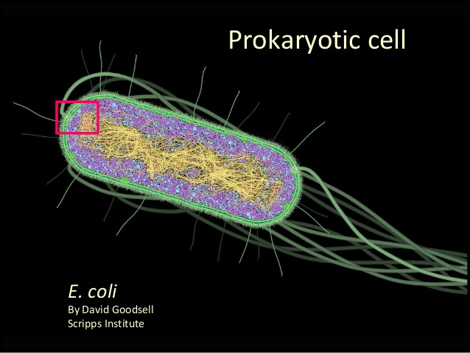

Analysis and conclusion: Answer these questions in your notebook in complete sentences.
1. Why do you think onion cells do not contain chloroplasts? (Hint: think about where you find onions growing. Keep in mind that chloroplasts capture the sun's energy.)

2. How is the basic general shape of the plant cells different from the general shape of
the animal cells?

3. Make a chart comparing plant cells with animal cells. Show all structures they have in common (the structures found in both) within the middle.

4. Are your cells and onion cells prokaryotes or eukaryotes? Provide your rationale.

5. In paragraph form, compare prokaryotes and eukaryotes.

