Observing Cancer Cells Activity
Did you know that half of all men and one-third of all women in the United States will develop cancer in their lifetimes? Cancer is the second leading cause of death in the United States, second to heart disease. Healthy cells that make up the body’s tissue constantly grow, divide, and replace themselves in an orderly process. For example, blood cells are replaced about every 120 days. Normally, cell division is an orderly process, but sometimes cell division control mechanisms fail, resulting in cancer.
Regulation of the cell cycle is a complex process involving regulator genes. All cancer involve the malfunction of these genes. All cancers express alterations in one or more of these genes, which often results from exposure to carcinogens. However, occasionally genetic mutations are passed down through families.
The cause of cancer is not always clear, but there are certain risk factors that increase the chances a person will develop cancer.
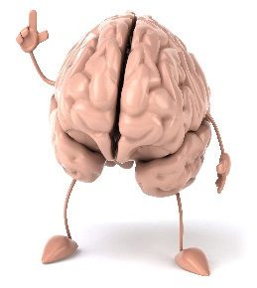 | - Brainstorm with your table buddy and list risk factors you can think of.
Normal cells and cancer cells look very different under the microscope. Follow the steps below and draw normal cells and cancer cells from the slides provided.
- Use a compass to draw a field of view for normal cells and cancer cells below.
- Find the cells using low power and the coarse adjustment knob.
- Find the normal cells under 40X magnification then move to 100X and observe.
- If you can find them on 400X draw them in the circle below.
- Repeat with the cancer cells.
- List all the differences noticed between the normal and cancer cells.
- Repeat the process above for a second set of slides.
Analysis
B). Develop a chart that has differences and similarities for both types of cells.
Wrap-up
C). Think about risk factors from class notes and the ones you and your table buddy came up with. List all the ways to decrease your risk of developing cancer.

