Biomes and Levels of Organization Classroom Copy
The project will illustrate two biomes (one terrestrial and one aquatic) and their levels of ecological organization.
- Look at levels of organization on page 64 - 65.
- Look at information about the biomes on pages 110 - 121.
- Set up the poster to represent two biomes. You may use columns, circles, etc. The poster should accommodate the six levels of organization.
- List representative biotic and abiotic factors for each biome on the back of the poster.
- Label each level – individual (species), population, community, ecosystem, biome, and biosphere.
- Research what types of animals and plants live in each biome.
- Individual - Choose one individual from a species and draw or paste into the first level. Identify it.
- Population - Show a group of individuals from the same species from #7 (3 to 4 individuals) in the population level.
- Community - Show this species (from #7) in a community with populations of other species. Include both plants and animals. Identify what you draw. Label three of the organisms in each community as biotic.
- Ecosystem - The ecosystem should be almost the same as the community, except ecosystems include both biotic and abiotic factors. Draw, paste, etc., the populations and the abiotic factors. Label three abiotic factors in each ecosystem.
- Biome - Choose one location where the biome is found and draw or paste a picture into the biome section.
- Biosphere - One biosphere for both biomes is sufficient.

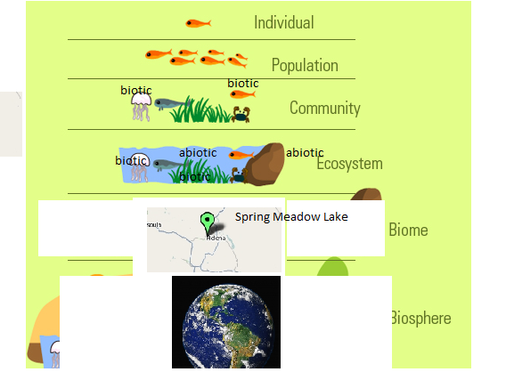

Requirements | Check
Two biomes compared and labeled (2) – one terrestrial and one aquatic
6 levels of organization labeled properly: Individual (species), population, community, ecosystem, biome and biosphere (4)
At least two plants and two animals are included in the community (2)
The ecosystem includes the community animals along with important abiotic factors of the ecosystem (read page 110 to 112 to find abiotic factors) (4)
The difference between community and ecosystem clearly shown – biotic only in community and biotic and abiotic in both. (4)
Label two living organisms within the community and ecosystem of both biomes biotic. Label two non-living factors biotic in the ecosystem (4)
Craftsmanship and Effort (5)
Total | 25 Points

Requirements | Check
Two biomes compared and labeled (2) – one terrestrial and one aquatic
6 levels of organization labeled properly: Individual (species), population, community, ecosystem, biome and biosphere (4)
At least two plants and two animals are included in the community (2)
The ecosystem includes the community animals along with important abiotic factors of the ecosystem (read page 110 to 112 to find abiotic factors) (4)
The difference between community and ecosystem clearly shown – biotic only in community and biotic and abiotic in both. (4)
Label two living organisms within the community and ecosystem of both biomes biotic. Label two non-living factors biotic in the ecosystem (4)
Craftsmanship and Effort (5)
Total | 25 Points
Requirements | Check
Two biomes compared and labeled (2) – one terrestrial and one aquatic
6 levels of organization labeled properly: Individual (species), population, community, ecosystem, biome and biosphere (4)
At least two plants and two animals are included in the community (2)
The ecosystem includes the community animals along with important abiotic factors of the ecosystem (read page 110 to 112 to find abiotic factors) (4)
The difference between community and ecosystem clearly shown – biotic only in community and biotic and abiotic in both. (4)
Label two living organisms within the community and ecosystem of both biomes biotic. Label two non-living factors biotic in the ecosystem (4)
Craftsmanship and Effort (5)
Total | 25 Points

