Name: ____________________________________________ Date: _________ Class period: ______

**Part 1: Ecological Succession**

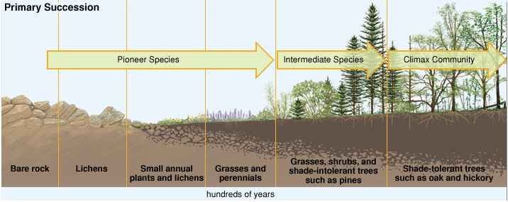Ecosystems are constantly changing in response to natural and human disturbances. As an ecosystem changes, older inhabitants gradually die out and new organisms move in, causing further changes in the community. This series of predictable changes that occurs in a community over time is called **ecological succession**. Succession is gradual; it occurs over a period of *many* years.

As ecological succession occurs, types of species (both plants and animals) present in a community will change in response to changing environmental conditions. The first species to colonize an ecosystem are called **pioneer species**. Pioneer species such as *lichens* (a fungus + algae that grows on rocks), mosses, and *bacteria* help break up bare rock and form a base of soil that can be used by plants. As environmental conditions change, the pioneers are replaced by **early successional** **species** such as herbs, grasses, wild flowers, and low shrubs.

Over time, this second set of species is replaced by yet *another* set of species. As time goes on, larger trees begin to grow in the environment and “shade out” the grasses and herbs. As each plant community changes, so do the animal communities. Animal species have adaptations that make them best suited for particular environments and habitats. The plants that are found in a given habitat will determine which animals can live there.

**Disturbances**, or changes in the pattern, will occur over and over throughout time in an ecosystem. Some, like an ice age, volcanic eruption, or soil-destroying fires can lead the ecosystem back to the “bare rock” starting point. These disturbances are called **primary succession** events because the ecosystem is reset entirely and may never recover. Other disturbances, like regular forest fires, extreme wind or weather events, earthquakes or human activities like farming, ranching, logging and mining, will send the successional pattern back to an earlier stage, but the ecosystem will regenerate in time. These disturbances are called **secondary succession** events.

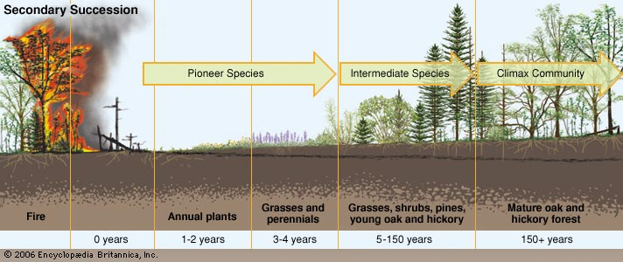

**Part 2: Connecting Ideas**

**Your Task:**

Imagine that Helena High School has been abandoned. There is no one to mow the grass, clean the hallways, or maintain the buildings. In the boxes provided, do the following:

1. **DRAW** the Vigilante stadium football field as you predict it will look after the number of years listed to the left. Use the same aspect as the original photo. **COLOR AND LABEL** your drawings.

2. **LIST** some of the types of plants and animals that you think would be present at each of these time increments.

|  |  |  |
| --- | --- | --- |
| **Time** | **Drawing** | **Plants/Animals** |
| **Today** |  |  |
| **10 Years from now** |  |  |
| **50 Years from now** |  |  |
| **200 Years from now** |  |  |

**Part 3: Applying Our Understanding**

1. What is **ecological succession**?

2. Compare and contrast primary and secondary succession.

|  |  |
| --- | --- |
| Similarities | Differences |
|  |  |

3. What is the general term for the first group of organisms to colonize an area? ________________

4. Which organisms can live on bare rock? _______________________________________________

5. What situations/conditions lead to primary succession in our Montana ecosystems? Describe 2.

7. What situations/conditions lead to the start of secondary succession in Montana? Describe 2.

8. **Think and Predict**: A windstorm in a forest blows down all the large trees in one part of the forest. Soon, sun-loving plants (like grasses and wildflowers) sprout up in the new clearing.

A) What type of succession is this? __________________

B) Describe what this patch of forest will look like in 5 years.

C) Describe what this patch of forest will look like in 100 years.

9) Watch the TedEd video online by HHS teacher Jim Schulz called **“Why Wildfires are Necessary.”** Take notes below.

10) Is wildfire necessary for succession in our Montana forests? _____Why or why not?

**BONUS:** On the back, draw the successional stages for Yellowstone Park in the present, then 1, 5, 50, 100 and 500 years after the caldera explosion. What type of succession is this?