***This is a sample note guide, be sure that all the information presented here makes sense to you***
Chapter 13 Notes
Role of DNA in Heredity
Heredity - the passing on of traits from parents to their offspring.
- Storing of Information: the order of nucleotides determines the coding of genes
- Copying Information: With the base-pairing rule DNA can be copied. A=T C=G
- Transfer Information: The structure of DNA permits it to easily be duplicated with the aid of several enzymes – namely DNA Polymerase.
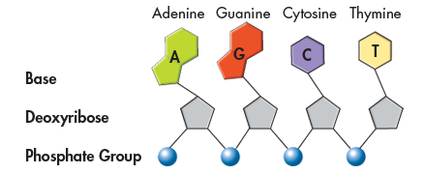 Covalent Bond between 5’ and 3’ carbons with phosphate
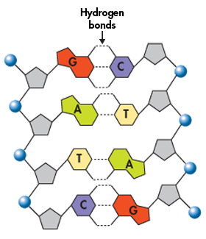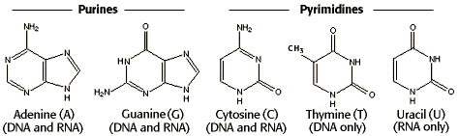
DNA Polymerase facilitates the formation of a covalent bond between nucleotides that complement the original “parent” strand following the base pairing rule (A=T C=G) in a 5’ to 3’ direction. The whole process of DNA replication can be considered “semiconservative” because each new daughter DNA molecule contains one strand from the original strand while the complementary strand is new.
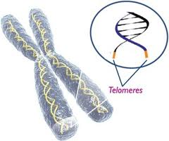
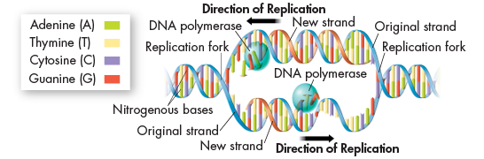
Four important enzymes for DNA replication
- DNA helicase: Breaks hydrogen bonds between DNA strands
- DNA polymerase: Joins free nucleotides into a new strand of DNA
- DNA ligase: Joins DNA segments on discontinuous strand
- Telomerase: adds short repeated DNA sequences to the ends of chromosomes, thus making it less likely that important gene sequences do not get lost during replication.

Chapter 14
- Compare and contrast DNA and RNA. What are three major differences between the two nucleic acids?

- Explain in order from start to finish how proteins are assembled from DNA instructions.
  - Include the following terms in your explanation: DNA, Nucleus, Transcription, Translation, Cytoplasm, mRNA, Codon, Amino Acid, anti-codon, tRNA, ribosome, rRNA.

- Transcribe and Translate the following DNA sequence i.e. write the mRNA strand and the correct amino acid for each codon (a codon chart can be found on page 221): TGAGGACTCCTCTTC

- What would happen if the second Thymine in the parent strand was mutated and replaced with an Adenine? (p. 224)

- Describe two types of mutations that can occur during protein synthesis and how these can be harmful.

