Chapter 6: Enzymes
Chemical reactions
Reactants – what you start with
Products – what you end with!
Substrates – reactants that are acted upon by an enzyme
Enzyme – molecules that make chemical reactions faster than they would be on their own (organic catalyst)
- most are proteins, some are RNA
- most are not used up in a reaction – they can be used again and again
-common ending = -ase
How Enzymes Work
Proteins (polypeptide chains) are folded into a 3D shape and have one or more active sites
Active sites = pockets where substrates bind to a protein and the reaction occurs
Reactions require a release of energy
- Endergonic (“energy in”) – Reactions that require a net input of energy
- Exergonic (“energy out”) – Reactions that end with a net release of energy
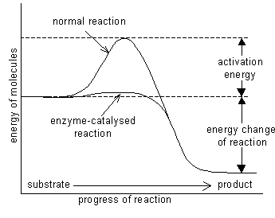
Activation energy
  - The minimum amount of energy needed to get a reaction started
  - Some reactions require a lot of activation energy, others do not
Mechanisms of Enzyme-Mediated Reactions
Binding at enzyme active sites may bring on the transition state by 4 mechanisms
  - Helping substrates get together
  - Orienting substrates in positions that favor reaction
  - Inducing a fit between enzyme and substrate (induced-fit model)
  - Shutting out water molecules
Effects of Temperature, pH, and Salinity
Raising the temperature boosts reaction rates by increasing a substrate’s energy
  - High temperatures denature enzymes
Each enzyme has an optimum pH range
  - In humans, most enzymes work at a pH of 6 to 8
Salt levels affect the hydrogen bonds that hold enzymes in their three-dimensional shape

