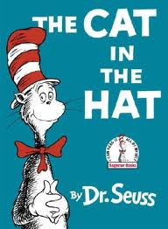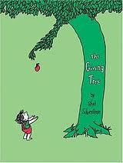
The Children’s Book/Graphic Novel: Group Assignment
Max of 3 people per group!
50 Points

Guidelines for the Children’s Book:

- Your book must be in a book-like form.
- Your book will follow proper book format: (Cover, end pages, contents etc.)
- Your children’s book must be appropriate for, well, children. If you don’t want to make it child appropriate, do the comic strip/graphic novel instead.
- Your book must be a minimum of 6 pages of story text, have a front cover, a credits page, and a back cover.
- Your book must have at least one developed character.
- Your book must have a basic plot line or a developed idea.
- Your book should have dialogue or character interaction.
- Your book must have pictures (These can be illustrations, clip art, cut outs, computer generated etc.)
- Your book must have a goal.
  - You can teach a lesson.
  - You can teach a task.
  - You can tell a story.

Children’s Book Health and Creative Writing

1. Take white paper or white computer paper (NOT construction paper) and fold it in half or staple it together to make a book.

2. Starting with the cover, write out or print the text and sketch or print the illustrations you will include on each page. Each page must contain one illustration.

For example, the below would be representative of each page:

(Book cover)

Barry the Bounce less Bunny

Written and Illustrated by Janet Matthews

Picture of Barry looking sad
Page 1:
Once there was a little bunny named Barry….
I will draw Barry, in his garden eating a carrot on a sunny day.
Pages 2-??
(sketch out picture and write out exact text for all pages)

Page 3 to Page 6+…

Continue this process for each page…

(Credits page)

Title:
Author:
Illustrator:
City of Publication:
Copyright Date:
(Back cover)

I will draw out a field with Barry bouncing in it.

Complete your book and be prepared to read the book to the class!

