February 15  No School  President’s Day | 16  Counting by 7s  Ch. 1-2 | 17  Counting by 7s  Ch. 3-4 | 18  Counting by 7s  Ch. 5-6 | 19  Counting by 7s  Ch. 7-9
22  Counting by 7s  Ch. 10-12 | 23  Counting by 7s  Ch. 13-16 | 24  30 minutes of Software | 25  Counting by 7s  Ch. 17-19 | 26  Counting by 7s  Ch. 20
March 1  Counting by 7s  Ch. 21-22 | 2  Counting by 7s  Ch. 23-25 | 3  30 minutes of Software | 4  Counting by 7s  Ch. 26-28 | 5  Counting by 7s  Ch. 29-30
8  Counting by 7s  Ch. 31-32 | 9  Counting by 7s  Ch. 33-35 | 10  30 minutes of Software | 11  Counting by 7s  Ch. 36-38 | 12  Counting by 7s  Ch. 39-40
15  Counting by 7s  Ch. 41-43 | 16  Counting by 7s  Ch. 44-45 | 17  30 minutes of Software | 18  Counting by 7s  Ch. 46-47 | 19  Counting by 7s  Ch. 48-50
22  Counting by 7s  Ch. 51-53 | 23  Counting by 7s  Ch. 54-57 | 24  Counting by 7s  Ch. 58-60 | 25  Counting by 7s  Ch. 61  Finish reading guide/review | 26  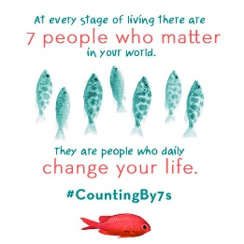  Reading Counts Quiz

