Doppler Effect Lab
Learning target: I can relate the Doppler Effect with sound waves to light waves and the red shift.
Introduction: The Doppler Effect is the apparent shift in frequency of a sound due to movement of either the source of the sound, the observer or both. In this lab you will record qualitative data and apply your knowledge to light waves and the red shift.
Part 1.
- Download a frequency generator app on your phone. You need one phone with the app per group of two or three students. The app is free and allows your phone to produce a tone at a specific frequency. In sound, frequency relates to the pitch of the sound, so a high frequency tone would be a high-pitched sound.
- Go outside with your group and begin by turning on your frequency generator to an audible tone, start with a high pitch. Have your lab partner run as fast as they can while holding the phone past the stationary observer. The observer should record the difference in tone when the person is approaching and when the runner is moving away. Create a data table like the one shown below.
 | Sound moving towards stationary observer | Sound moving away from stationary observer | Observer moving towards stationary source | Observer moving away from stationary source
Doppler shift(higher or lower tone)
Answer these questions in your notebook
- How does the speed of observer affect the shift in frequency?
- What happens if both the source and the observer are moving towards each other? Away?
- How does the tone on your phone affect the shift in frequency?
Part 2.
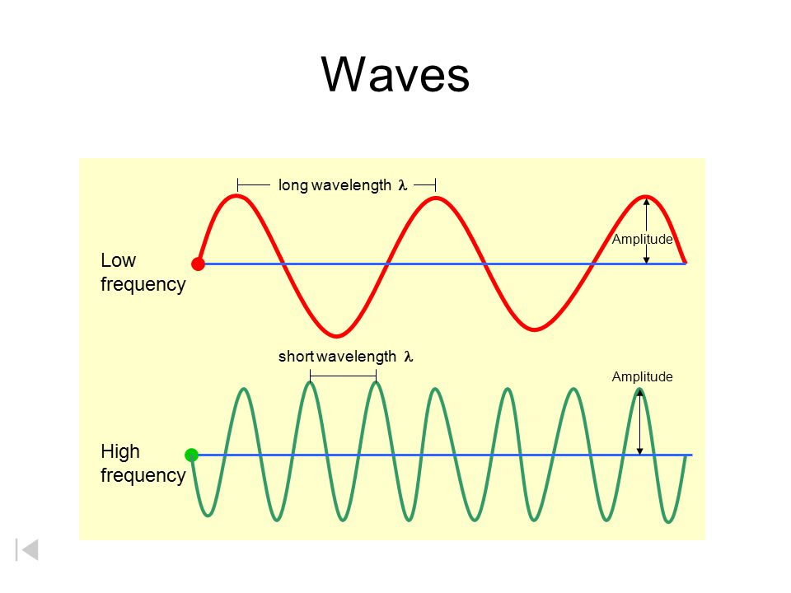
All waves follow something called the wave equation. (velocity of wave= frequency x wavelength) If the speed of sound is a constant at 343 m/s, then changing the frequency must be caused by the wavelength of the wave actually changing. Study the diagram on the first page.
- How does increasing wavelength affect the frequency? Define frequency.

- Draw a model of changing wavelength resulting in the doppler effect. Your model should explain how the frequency of the sound is changed when the source is moving towards the observer and how the frequency is changed when the source is moving away from the stationary observer. (Hint- when the source is moving it is catching up with the waves that it is producing)
The red shift is the doppler effect with light waves instead of sound. Instead of hearing a different tone when the source is moving, we see a different color. Study the diagram below.
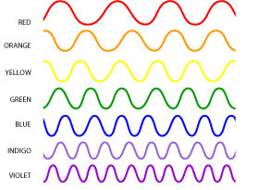
Notice how red colors have a larger wavelength and lower frequency and violet waves have a shorter wavelength and higher frequency, assuming all waves are traveling at the same speed. 3x10⁸ m/s aka speed of light.
- If a star emitting green light was moving towards the earth, what color would it appear to be? If the same star was moving away from Earth what color would it appear to be?
Astronomers use the term red shift to describe the doppler effect with light in our universe because all the light from stars appears to be shifted towards the red end of the visible spectrum. What does that tell us about how stars are moving with respect to earth?
- Draw a model of this phenomenon below which explains how the light becomes shifted to a different wavelength and color by the movement of a star.

