English 4C: Syllabus 2023-2024
SENIOR SCIENCE FICTION & FANTASY
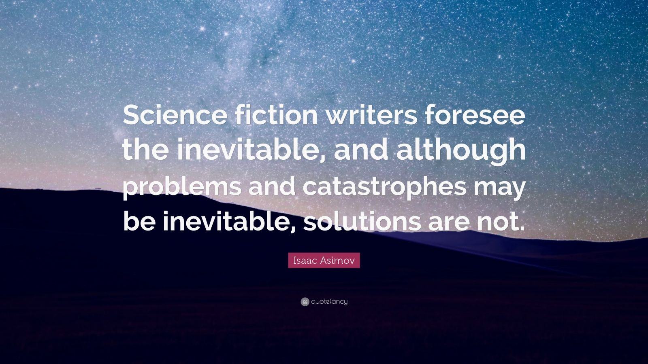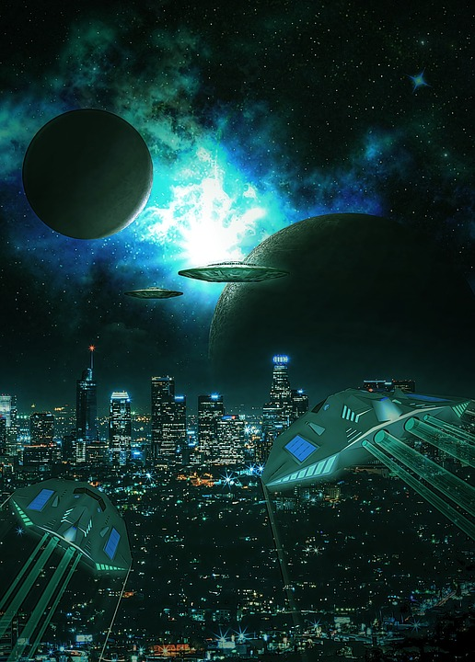
Instructor: Mrs. Cleveland
E-mail: ecleveland@helenaschools.org
Phone: 324-2537
Capital High School
Room 123
Species: Homo Sapien

Course Objectives:
Welcome to the Universe, good friends! This course will expose you to science fiction and fantasy from around the world and through the centuries. You will work on honing your creative and critical thinking skills through a multitude of physical, verbal, writing, and reading activities. Your imagination is calling...

Unit Descriptions:
Below is a list of units and novels that will be taught throughout the year. Based on student needs, this description is subject to change as the year progresses.
Quarter 1:
- Drama: Macbeth
- Macbeth modern parody scene
- College Essay/Narrative Essay
- Job Cover Letter/Resume
- Sci-Fi/Fantasy Short Stories and Flash Fiction
- “Nosedive” analysis
- Flash Fiction/Creative Writing
- Vocabulary
- Comma Usage Review
- Take a Line for a Walk: Poetry

Quarter 2:
- Drama: R.U.R. or Novel: I,Robot by Isaac Asimov
- Current robotics and technology
- Alien/Paranormal Research Project
- MLA/APA Citations
- Star Trek Philosophy and Analysis
- Vocabulary
- Semicolon/Colon Review
- Take a Line for a Walk: Poetry
- Semester Exam: Skills-based timed writing assessment

Quarter 3:
- Novel: Frankenstein by Mary Shelley
- Current Technology and TV Series Connections
- Literary Analysis Essay: Compare/Contrast
- Short Story connections
- Afrofuturism and Indigenous Futurism
- Vocabulary
- Take a Line for a Walk: Poetry

Quarter 4:
- Novel: The Martian by Andy Weir
- Vocabulary
- Grammar Practice and Review
- Take a Line for a Walk: Poetry
- Semester 2 Exam: Graduation Reflection paper and speech
Grading Scale:
100 – 90% = A, 89 – 80% = B, 79 – 70% = C, 69 – 60% = D, Below 59 % = F
Absences: If a student is absent, makeup work will always be posted in TEAMS. Please complete the assignment there in TEAMS and message me when you’ve turned it in so that I know to score it there. I always try to get each day’s assignment up during my 7th period prep, so it will be available at the end of that school day. TEAMS will also be the platform that I use to communicate with students via the chat option.

Grade Breakdown:

-Class Assignments

-Reading Points

-Participation Points

-Homework

-Quizzes

-Unit Exams

-Process Writing

-Timed Writing
Semester 1 Totals: Quarter 1= 45%, Quarter 2= 45%, Exam 1=10%
Semester 2 Totals: Quarter 3=40%, Quarter 4=40%, Exam 2=20%

Electronic Devices
Students will be checked out a Chromebook at the beginning of the year; these should be brought to class every day along with whatever text we are reading. Cell phones should only be used for educational purposes in class with my permission; otherwise, they are to remain tucked away during class time.

“Individual science fiction stories may seem as trivial as ever to the blinder critics and philosophers of today - but the core of science fiction, its essence has become crucial to our salvation if we are to be saved at all.”--Isaac Asimov

