Answer each of the following questions. The figure will be below the questions.
1a) At which pH(s) are each enzymes active?
1b) At which pH is each enzyme’s optimal pH?
1c) At hat pH is each enzyme denatured?
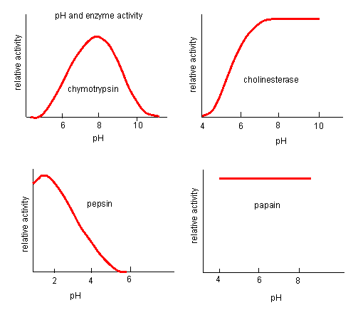

2a) Which enzyme has the largest range of pH values that it is most active?
2b) Which enzyme would you expect to find in your stomach?
2c) If you were doing a lab and wanted both enzymes to function, what pH would you have your reaction solution?
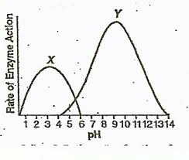

3a) Is this reaction endergonic or exergonic? How do you know?
3b) How does an enzyme impact activation energy?
3c) What is the name for the reactant in an enzyme mediated reaction?
3d) Does the reactant or product of this reaction store more energy?
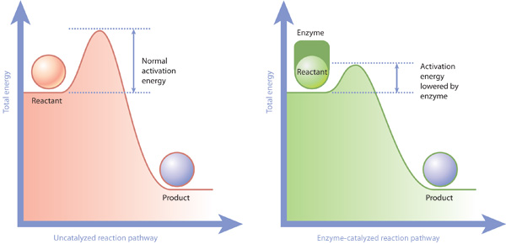

4a) What is the difference in the potential energy of the reactants vs products much more energy is stored in the reactants of this reaction than the products?
4b) How many kJ is the activation energy of this reaction?
4c) How would an enzyme added to this reaction change the curve below?
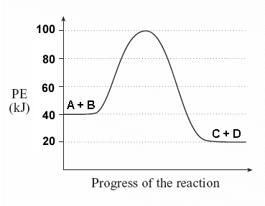

5a) At which concentration would the enzyme with open circles ( -o- ) be saturated?
