Name: __________________________________ Period: ___________
GRAPHING PRACTICE 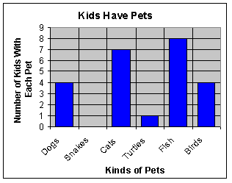

1. The ages of 7 trumpet players in a band are 13, 12, 11, 12, 11, 10, and 12. What type of graph would be
appropriate for comparing the ages of these trumpet players? _______________________

2. The federal hourly minimum wage was recorded each year from 1990 to 2007. What type of graph would
best show the changes in minimum wage during this time period? ______________________

3. When asked if “antidisestablishmentarianism” has 28 letters, 50 people said, “Yes,” 35 people said, “No,”
and 15 people said, “I don’t know.” What type of graph would best compare these responses to each
other and with the total? ____________________

4. The growth of 7 different plants was recorded in centimeters. What type of graph would be best for
comparing the growth of each plant? _____________________

5. In a city, the rainfall was recorded in inches each month for 12 months. What type of graph would best
display the change in rainfall? __________________________

6. Look at the data table. Decide what kind of graph you should use and then create it.

Favorite Type of Movie
Comedy | Action | Romance | Drama | SciFi
4 | 5 | 6 | 1 | 4

7. Look at the data table. Decide what kind of graph you should use and then create it.
Ice Cream Sales
Mon Tue Wed Thu Fri Sat Sun
$410 $440 $550 $420 $610 $790 $770

8. Look at the data table in #6. What kind of graph did you choose? It could be graphed another way. Do that
now.

