Human Skin Color: Evidence for Selection
Activity
Student Handout

INTRODUCTION
Our closest primate relatives have pale skin under dark fur, but human skin comes in a variety of shades from pinkish white to dark brown. How did this variation arise? Many biological traits have been shaped by natural selection. To determine whether the variation in human skin color is the result of evolution by natural selection, scientists look for patterns revealing an association between different versions of the trait and the environment. Then they look for selective pressures that can explain the association.
In this lesson, you will explore some of the evidence for selection by analyzing data and watching the film The Biology of Skin Color (http://www.hhmi.org/biointeractive/biology-skin-color), featuring anthropologist Dr. Nina Jablonski. In Part 1 of this lesson, you’ll discover the particular environmental factor correlated with the global distribution of skin color variations. In Parts 2 and 3, you’ll come to understand the specific selective pressures that have shaped the evolution of the trait. Finally, in Part 4, you’ll investigate how modern human migration is causing a mismatch between biology and the environment.

PROCEDURE
Read the information in Parts 1–4 below, watching segments of the film and pausing as directed. Answer the questions in each section before proceeding to the next.

PART 1: Is There a Connection Between UV Radiation and Skin Color?
Watch the film from the beginning to time stamp 5:49 minutes. Pause when Dr. Nina Jablonski asks the question, “Is there a connection between the intensity of UV radiation and skin color?”
In this segment of the film, Dr. Jablonski explains that the sun emits energy over a broad spectrum of wavelengths. In particular, she mentions visible light that you see and ultraviolet (UV) radiation that you can’t see or feel. (Wavelengths you feel as heat are in a portion of the spectrum called infrared.) UV radiation has a shorter wavelength and higher energy than visible light. It has both positive and negative effects on human health, as you will learn in this film. The level of UV radiation reaching Earth’s surface can vary depending on the time of day, the time of year, latitude, altitude, and weather conditions.
The UV Index is a standardized scale that forecasts the intensity of UV radiation at any given time and location in the globe; the higher the number, the greater the intensity. Examine Figure 1 on the next page and answer Questions 1–6.

- Describe the relationship between the UV Index (the colored bar in Figure 1) and latitude (y-axis).

UV radiation is most intense near the equator and least intense toward the poles. Students may also say it is most intense at lower latitudes and increasingly intense as latitude increases.

- How do you explain the relationship between the UV Index and latitude? (In other words, why does UV intensity change with latitude?)

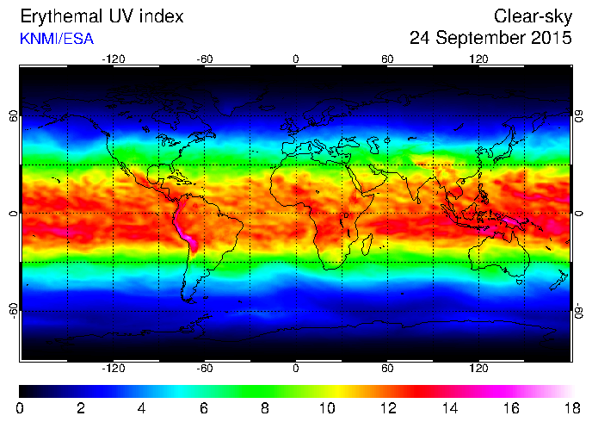
Human Skin Color: Evidence for Selection

Figure 1. Ultraviolet Radiation Index Across the World.
The colors on this map of the world represent Ultraviolet (UV) Index values on a particular day in September 2015. The UV Index is a standardized scale of UV radiation intensity running from 0 (least intense) to 18 (most intense). The y-axis values are degrees of latitude, which range from the equator (0°) to the poles (90° north and −90° south). The x-axis values are degrees of longitude, which range from the prime meridian (0°) to the antimeridian (180° east and
−180° west). (Source: European Space Agency, http://www.temis.nl/uvradiati on/UVindex.html.)
Student Handout

- Find your approximate location on the map. What is the primary UV Index value of your state on this particular day in September?
- Look at the regions that receive the most-intense UV (light pink). Site a specific piece of evidence from the map that a factor other than latitude was contributing to UV intensity on this day.

- In the film, Dr. Jablonski explains that melanin, located in the top layer of human skin, absorbs UV radiation, protecting cells from the damaging effects of UV. Genetics determines the type of melanin (i.e., brown/black eumelanin or red/brown pheomelanin) and the amount of melanin present in an individual’s cells. Based on this information, write a hypothesis for where in the world you would expect to find human populations with darker or lighter skin pigmentation (i.e., different amounts of melanin).

- Explain how scientists could test this hypothesis.

You will now look at another figure that has to do with skin color. One way to measure skin color is by skin reflectance. Scientists can shine visible light on a portion of skin (typically the inside of the arm) and then measure how much light is reflected back. Dark skin reflects less visible light than does light skin. The lower the reflectance value, therefore, the darker the skin. Examine Figure 2 and answer Questions 7–9.

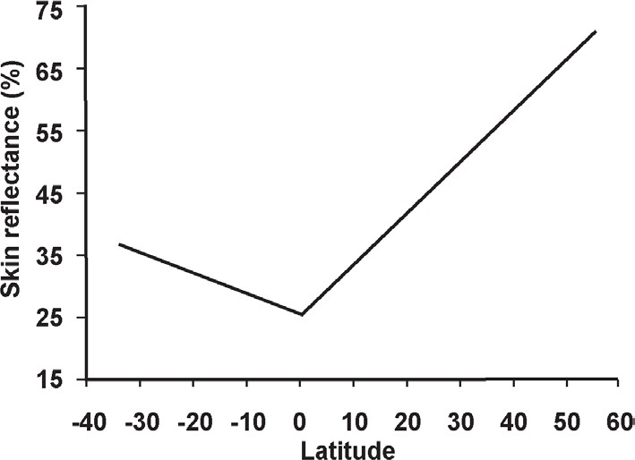
Figure 2. Relationship Between Skin Reflectance and Latitude.
This figure shows how skin reflectance changes with latitude. Negative latitudes are south of the equator (located at 0°), and positive latitudes are north of the equator. Available reflectance data from multiple sources were combined to form this graph. All combined data were obtained using a reflectometer with an output of 680 nanometers (i.e., a wavelength of visible light) and placed on the subjects’ upper or lower inner arms. (Source: Panel B of Figure 2 in Barsh (2003). Graph originally captioned as “Summary of 102 skin reflectance samples for males as a function of latitude, redrawn from Relethford (1997).” © 2003 Public Library of Science.)
- Why do you think that reflectance data are collected from a subject’s inner arm?

- Describe the relationship between skin reflectance (y-axis) and latitude (x-axis). Consider both the direction and steepness of the lines’ slopes.

- Do these data support your hypothesis from Question 5? Justify your answer.

Watch the film from time stamp 5:49 minutes to 9:08 minutes. Pause when Dr. Jablonski says, “That suggests that variation in human skin melanin production arose as different populations adapted biologically to different solar conditions around the world.” After watching this segment of the film, answer Question 10.
- Based on what you know about skin pigmentation so far, suggest a mechanism by which UV intensity could provide a selective pressure on the evolution of human skin color. In other words, propose a hypothesis that links skin color to evolutionary fitness.

PART 2: What Was the Selective Pressure?
Watch the film from time stamp 9:08 minutes to 12:19 minutes. Pause when Dr. Jablonski says, “For that reason, though it might cut your life short, it’s unlikely to affect your ability to pass on your genes.” After watching this segment of the film, answer Questions 11–13.
- What does it mean for a trait, such as light skin coloration, to be under negative selection in equatorial Africa? Relate negative selective pressure to what we know about MC1R allele diversity among African populations.

- Why does Dr. Jablonski dismiss the hypothesis that protection from skin cancer provided selection for the evolution of darker skin in our human ancestors?

- Revisit your hypothesis from Question 10. Based on the information you have now, does this seem like a more or less probable hypothesis than when you first proposed it? Provide evidence to support your reasoning.

Watch the film from time stamp 12:19 minutes to 13:32 minutes. Pause when Dr. Jablonski says, “That is what melanin does.” In this segment of the film, Dr. Jablonski references a paper she had read about the connection between UV exposure and the essential nutrient folate (a B vitamin), which circulates throughout the body in the blood. The paper, published in 1978, describes how the serum (blood) folate concentrations differed between two groups of light-skinned people. You will now look at one of the figures from that paper. Examine Figure 3 and answer Questions 14–17.
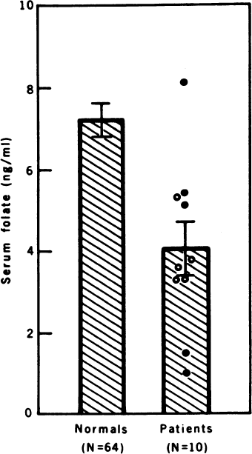
Figure 3. Folate Levels in Two Groups of People. In one group (“patients”), 10 individuals were exposed to intense UV light for at least 30–60 minutes once or twice a week for three months. Sixty-four individuals not receiving this treatement (“normals”) served as the control group. The difference between the two groups was statistically significant (p < 0.005). Brackets represent the standard error of the mean, and “ng/mL” means “nanograms per milliliter.” (Republished with permission of the American Assn for the Advancement of Science, from Skin color and nutrient photolysis: an evolutionary hypothesis, Branda, RF and Eaton, JW, 201:4356, 1978; permission conveyed through Copyright Clearance Center, Inc.)

- Describe the relationship between folate levels and UV exposure. Use specific data from the graph to support your answer.

- Dr. Jablonski describes learning that low folate levels are linked to severe birth defects as a “eureka moment.” Explain what she means by this.

- Based on this new information, revise your hypothesis to explain the selective pressure on the evolution of human skin color.

- Can the effects of UV light on folate explain the full variation of human skin color that exists among human populations today? Explain your reasoning.

PART 3: Why Aren’t We All Dark Skinned?
Watch the film from time stamp 13:32 minutes to 16:04 minutes. Pause when Dr. Jablonski says, “Support for the idea that the UV–vitamin D connection helped drive the evolution of paler skin comes from the fact that indigenous peoples with diets rich in this essential vitamin have dark pigmentation.”

Unlike many essential nutrients, vitamin D is produced by the human body. One type of UV radiation called UVB starts a chain of reactions that convert 7-dehydrocholesterol—a chemical found in skin—to vitamin D. Vitamin D is essential to the absorption of calcium and phosphorus from the foods we eat to make strong bones. It is also important for reproductive health and for the maintenance of a strong immune system. How much UVB exposure is necessary to synthesize sufficient vitamin D depends largely on two factors: UVB intensity and skin color. In general, at a given UV intensity, a dark-skinned individual must be exposed to UVB five times as long as a light-skinned individual to synthesize the same amount of vitamin D.
Dr. Jablonski and Dr. George Chaplin published a paper in which they theorize whether available UV around the world would enable individuals with different skin colors to synthesize an adequate amount of vitamin D. Figure 4 and Table 1 summarize the results. Analyze Figure 4 and Table 1 and answer Questions 18–21.

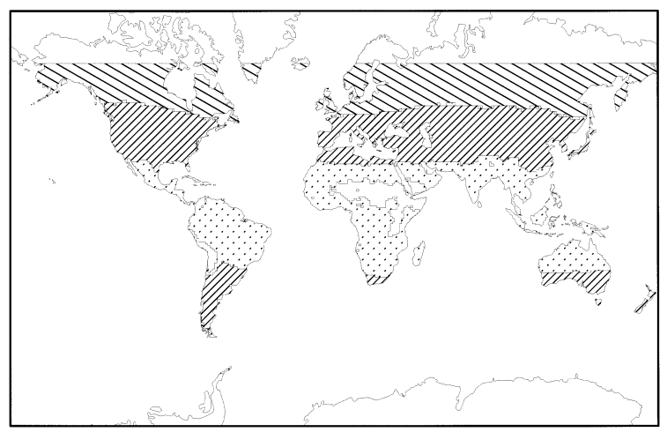
Human Skin Color: Evidence for Selection
Student Handout

Table 1. Key to Zones in Figure 4.
Figure 4. Comparison of Geographic Areas in Which Mean UVB Intensity Would Not Be Sufficient for Vitamin D Synthesis by Populations with Different Skin Colors.
Widely spaced diagonal lines show regions in which UVB radiation, averaged over an entire year, is not sufficient for vitamin D synthesis by people with lightly, moderately, and darkly pigmented skin. Narrowly spaced diagonal lines show regions in which UVB radiation is not sufficient for vitamin D synthesis by people with moderately and darkly pigmented skin. The dotted pattern shows regions in which UVB radiation averaged over the year is not sufficient for vitamin D synthesis in people with darkly pigmented skin. (Reprinted from The Journal of Human Evolution, 39:1, Nina G. Jablonski and George Chaplin, The Evolution of Human Skin Coloration, 57-106, Copyright 2000, with permission from Elsevier.)

Skin Pigmentation | Wide Diagonals | Narrow Diagonals | Dots
Light | N | Y | Y
Moderate | N | N | Y
Dark | N | N | N
Note: “Y” means that an individual with that skin pigmentation could synthesize sufficient vitamin D in the region indicated throughout the year. “N” means that the person could not.

- Based on these data, describe the populations least likely to synthesize sufficient levels of vitamin D. Explain your answer with data from the figure.

- How do these data support the hypothesis that the evolution of lighter skin colors was driven by selection for vitamin D production?

- For a person living farther away from the equator, would the risk of vitamin D deficiency be uniform or vary throughout the year? If it would vary, how would it vary? Explain your reasoning.

Human Skin Color: Evidence for Selection
Student Handout

- Vitamin D and folate levels in the blood are both affected by UV light. Describe the predicted effects of using a tanning booth (which exposes skin to UV light) on the blood levels of these two vitamins.

- Based on everything that you have learned so far, provide an explanation for how the different shades of skin color from pinkish white to dark brown evolved throughout human history.

PART 4: How Does Recent Migration Affect Our Health?
Watch the film from time stamp 16:04 minutes to the end. In this segment of the film, Dr. Jablonski and Dr. Zalfa Abdel-Malek explain that some people are living in environments that are not well matched to their skin colors. One example is vitamin D production. The recommended level of circulating vitamin D is 20 ng/mL (nanograms per milliliter). But, as you learned in Part 3, vitamin D production is affected by UV intensity and skin color.
Figure 5 shows the concentrations of serum 25(OH)D vitamin, which is the main type of vitamin D that circulates in blood. Measurements were taken among people living in the United States and were standardized to negate the effects of weight, age, and other factors. Examine Figure 5 and answer Questions 22 and 23.

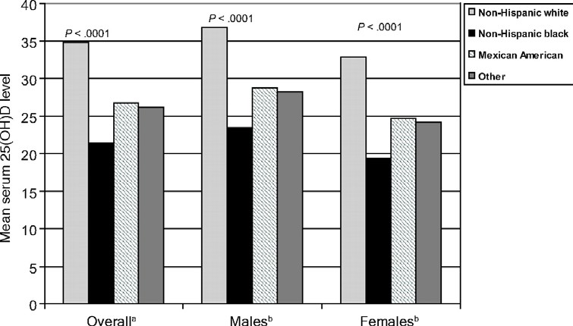
Figure 5. Adjusted mean serum 25(OH)D levels according to race/ethnicity and stratified according to gender (n = 2629). aAdjusted for gender, age, weight, education, income, urban, region; ^{b} adjusted for age, weight, education, income, urban, region. (Reproduced with permission from Pediatrics 123, 797-803, Copyright© 2009 by the AAP.)

- Describe the trends visible in the data. Which subpopulation (gender, race/ethnicity) is at the greatest risk for vitamin D deficiency? Which subpopulation is at the least risk for vitamin D deficiency?

- What is one of the consequences of recent human migrations on human health?

