Ecological Niche Partitioning
Niche – the total use of an organism’s use of biotic (living) and abiotic (non-living) resources in its environment.
Fundamental Niche – resources theoretically available under ideal circumstances for a population if organisms.
Realized Niche – resources a population of organisms actually use.
Tolerance – ability to survive and reproduce under a variety of environmental circumstances.
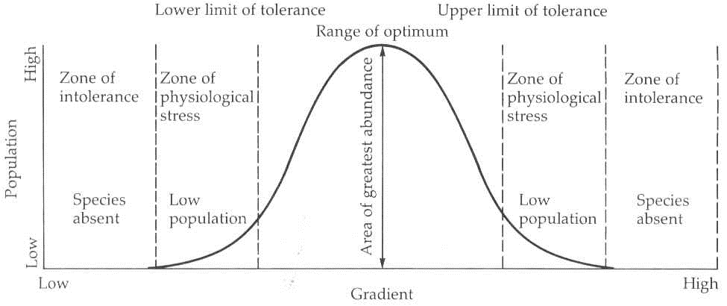

Figure 1. Shelford’s law of tolerance.
Competition:
Limiting resources shape an organism’s behavior and overall niche in a community.
Competitive Exclusion Principle:
No two species can occupy the same niche in exactly the same way at the same time.
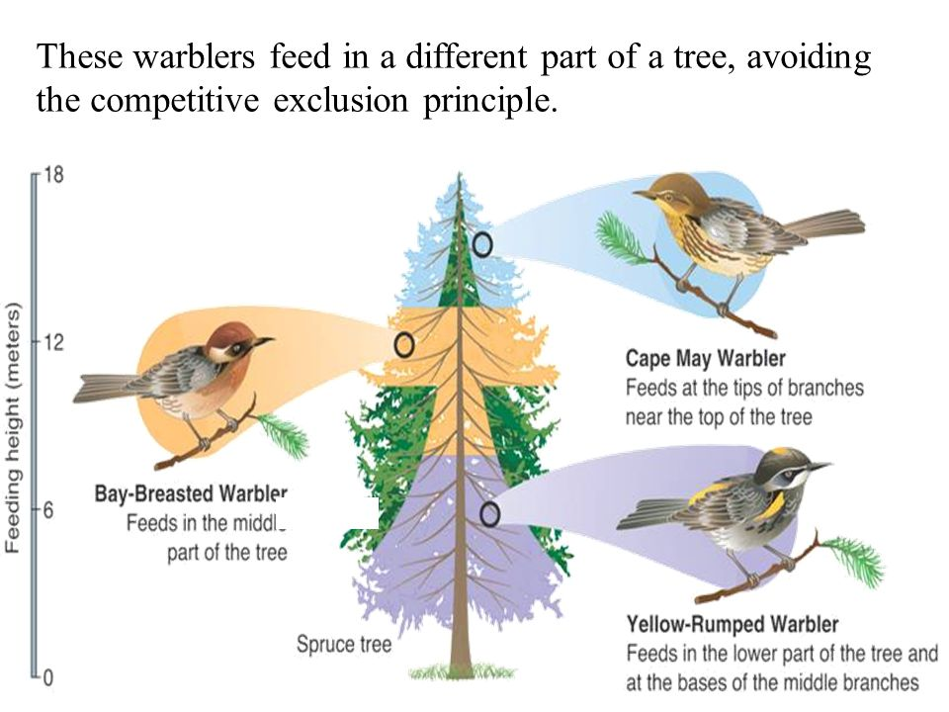
**This is an important factor that determines the potential biodiversity of an ecosystem.
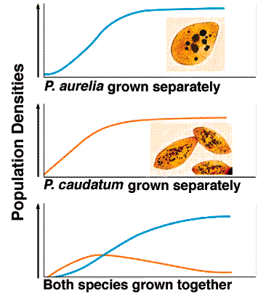

Figure 2: Spatial Niche Partitioning of a Tree between different bird species Figure 3: Two Species occupying same niche

