ATP (ADENOSINE TRIPHOSPHATE) 11/12/18

STORES POTENTIAL ENERGY FOR CELLULAR ACTIVITY
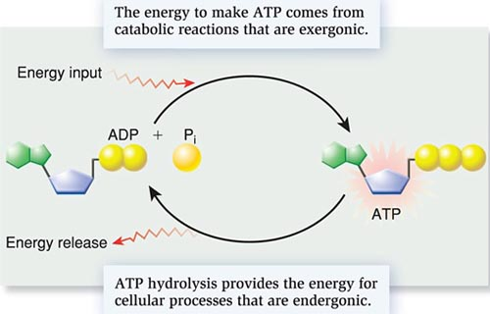
ATP SYNTHASE – ENZYME THAT CREATES ATP
MOVES H+ ions ACROSS A CONCENTRATION GRADIENT IN THE MITOCHONDRIA.
PLANTS – USE LIGHT ENERGY TO FORM ATP IN CHLOROPLASTS
ANIMALS – USE ENERGY FROM RESPIRATION IN THE MITOCHONDRIA
3 USES FOR ATP
- ACTIVE TRANSPORT (EXAMPLE: SODIUM/POTASIUM PUMP)
- MUSCLE CONTRACTIONS
- POLYMER SYNTHESIS (MAKING LARGE MACROMOLECULES LIKE PROTEINS)

PHOTOSYNTHESIS 11/13/18
AUTOTROPHS – “SELF FEEDERS”, PRODUCERS
PHOTOAUTOTROPHS – USE LIGHT (PLANTS, ALGAE)
CHEMOAUTOTROPHS – USE SULPHER OR AMONIA (BACTERIA)
HETEROTROPHS – “OTHER FEEDERS”, CONSUMERS

CHLOROPLASTS – SITE OF PHOTOSYNTHESIS
CONTAINS CHLOROPHYL WHICH ABSORBS MOST LIGHT – NOT GREEN
${CO}_{2}$ – IN FROM THE STOMATA $H_{2}O$ – FROM ROOTS
THYLAKOID – SITE OF LIGHT RxN
STROMA – SITE OF CALVIN CYCLE

OVERALL RxN OF PHOTOSYNTHESIS
$$6H_{2}O+6{CO}_{2} = C_{6}H_{12}O_{6}+6O_{2}$$
FROM PRODUCTS OF PHOTOSYNTHSIS PLANTS MAKE:
FOOD: GLUCOSE STRUCTURE: CELULOSE
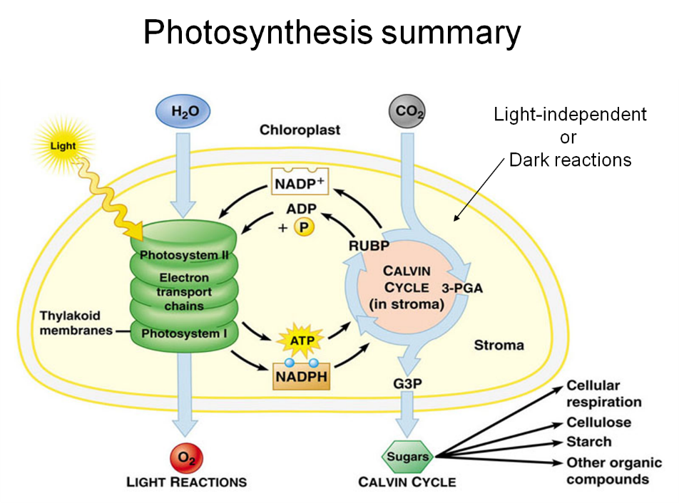

RESPIRATION 11/15/18
CATABOLIC PROCESS; BREAKDOWN OF SUGARS
MITOCHONDRIA – SITE OF RESPIRATION
$O_{2}$ – FROM LUNGS $C_{6}H_{12}O_{6}$ – FROM FOOD CONSUMED
OVERALL RxN OF RESPIRATION
$$C_{6}H_{12}O_{6}+6O_{2} → 6H_{2}O+6{CO}_{2}+38ATP$$
3 STAGES OF AEROBIC RESPIRATION
- GLYCOLYSIS (CYTOPLASM)
SPLITTING OF SUGAR (1) 6-C SUGAR (glucose) $→$ (2) 3-C SUGARS (pyruvic acid)
NO OXYGEN PRESENT OR REQUIRED
- NET GAIN OF 2 ATP’s

- KREBS CYCLE (MITOCHONDRIAL MATRIX)
PYRUVIC ACID IS FORMED INTO CITRIC ACID AND SLOWY BROKEN DOWN
- NET GAIN OF 2 ATP’s
- CO2 RELEASED

- ELECTRON TRANSPORT CHAIN (MITOCHONDRIAL MEMBRANE)
- 34 ATP’s
- H2O RELEASED
ANAEROBIC RESPIRATION “FERMENTATION”
NO OXYGEN GLYCOLYSIS SHUTS DOWN
- NET GAIN OF 2 ATP’s
TWO KINDS OF FERMENTATION
- LACTIC ACID FERMENATION
PYRUVATE GETS CONVERTED INTO LACTATE
REQUIRES OXYGEN TO BREAK DOWN LACTATE
- ALCOHOLIC FERMENTATION
ETHYL ALCOHOL IS PRODUCED
CO2 RELEASED
