11/12/18
ATP (ADENOSINE TRIPHOSPHATE)
STORES POTENTIAL ENERGY FOR CELLULAR ACTIVITY
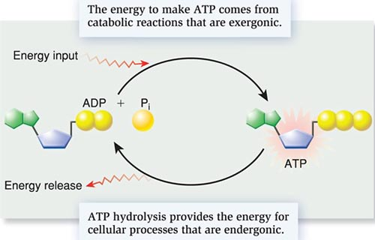
ATP SYNTHASE – ENZYME THAT CREATES ATP
MOVES H+ ions ACROSS A CONCENTRATION GRADIENT IN THE MITOCHONDRIA.
PLANTS – USE LIGHT ENERGY TO FORM ATP IN CHLOROPLASTS
ANIMALS – USE ENERGY FROM RESPIRATION IN THE MITOCHONDRIA
3 USES FOR ATP
- ACTIVE TRANSPORT (EXAMPLE: SODIUM/POTASIUM PUMP)
- MUSCLE CONTRACTIONS
- POLYMER SYNTHESIS (MAKING LARGE MACROMOLECULES LIKE PROTEINS)

PHOTOSYNTHESIS 11/13/18
AUTOTROPHS – “SELF FEEDERS”, PRODUCERS
PHOTOAUTOTROPHS – USE LIGHT (PLANTS, ALGAE)
CHEMOAUTOTROPHS – USE SULPHER OR AMONIA (BACTERIA)
HETEROTROPHS – “OTHER FEEDERS”, CONSUMERS

CHLOROPLASTS – SITE OF PHOTOSYNTHESIS
CONTAINS CHLOROPHYL WHICH ABSORBS MOST LIGHT – NOT GREEN
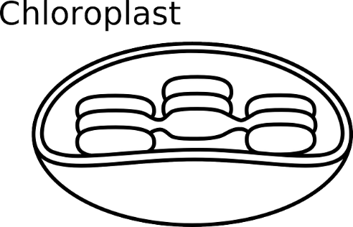
${CO}_{2}$ – FROM STOMATA $H_{2}O$ – FROM ROOTS
THYLAKOID – SITE OF LIGHT RxN
STROMA – SITE OF CALVIN CYCLE

OVERALL RxN OF PHOTOSYNTHESIS
$$6H_{2}O+6{CO}_{2} = C_{6}H_{12}O_{6}+6O_{2}$$
FROM PRODUCTS OF PHOTOSYNTHSIS PLANTS MAKE:
FOOD: GLUCOSE STRUCTURE: CELULOSE
