Population Ecology Notes
Describing Populations
Three Main Factors
1. Geographic Range​: Area inhabited by the population
2. Growth Rate​ / Density of Population
Is the population increasing, decreasing or staying constant?
How many individuals in an area?
3. Age Structure​
- How many males / females
- Age distribution
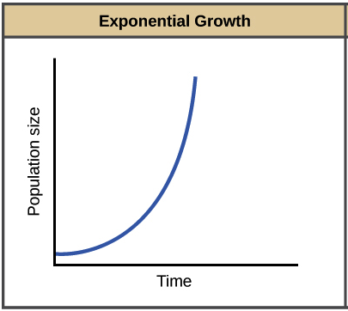
Population Growth
Factors Effecting Growth
- Birth / Death rates​
- Immigration: Individuals moving into a habitat​
- Emigration: Individuals moving out of a habitat
Exponential Growth
Almost any organism provided with ideal conditions for growth and reproduction will experience a rapid increase in its population (Example - Humans!)
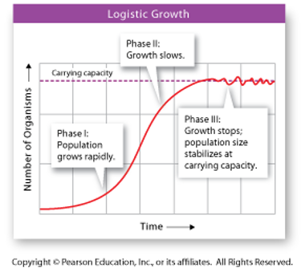
Logistic Growth
Most organisms go through 3 growth phases
Phase 1 – population grows rapidly
Phase 2 – growth slows
Phase 3 – population size stabilizes
Carrying ​capacity – the steady state of ​population size.
Limited by factors such as:
- Food availability
- Competition

- Density Dependent Limiting Factors (Occur when populations are large) ​
Examples: Competition​, Predation​, Herbivory​, Parasitism and Disease​, Crowding and Stress

- Density Independent Limiting Factors (Can limit large or small populations) ​
Examples: Weather​, Natural disasters​, Human activities, Seasonal cycles

