Products from the Rainforests: What products have you used?
Step1: Circle, underline or highlight any of the products that you may use, have used or can be found in your everyday life.
Step 2: Number from 1 to 5 the products that are most important to you.
Step 3: Choose one of the five and research the product.
Researched Product: Here is what must be covered for your researched product.
- Explain the product
- Explain the different uses of the product
- Other places in the product where it can be found.
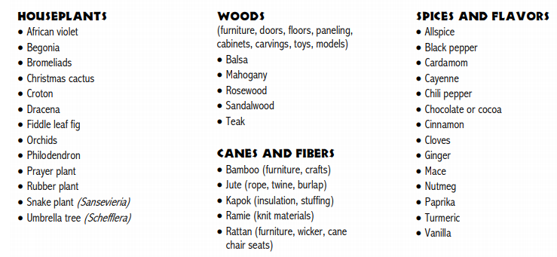
- Alternative products natural or artificial that are replacements for the product.
