Student Learning Expectations
for Ms. Vedovatti’s 6th Grade English Class

This is going to be a wonderful- and unique- school year here at HMS. Please know that I will show up for you each and every day to give you my best. It is your job to do the same, and this is how you can do it...

Be Engaged

- Participate in class chats/discussions (whether in person or on Teams)
- Reach out to Ms. Vedovatti or your classmates if you need help.
- Remember that your success is directly linked to your willingness to engage and participate!
- Every day, I expect you to come prepared to class with your necessary materials, completed schoolwork, your brains, but most importantly, your willingness to learn.

Be a Learner
- School is 5 days a week and you will have a lesson and every school day.
- Check Teams each school day for your lesson and/or assignment.
- Carefully follow the instructions for each lesson and read the directions for each assignment posted on Teams. That is your responsibility!
- Challenge yourself to do your best! Remember that you get out of this class what you put into it.
- It is okay to fail, we learn best this way. Just make sure you make an effort to correct your mistakes. We all make mistakes.

Be Responsible
- Turn in your assignments on time and make sure you seek help before work is due.
- Check PowerSchool at least once a week to monitor your own progress.
- Use your assignment book to help organize your week. Cross off your work as you complete it. Check our weekly agenda in Teams every Monday to help you do this.
- If you have a Teams meeting, arrive a few minutes early and if you cannot attend, let Ms. Vedovatti know ahead of time.
- You are responsible/accountable for yourself. Your grade is a direct reflection of that. If you want to do well, there is nothing holding you back from that but yourself!

CAPE (Citizenship, Attitude, Participation, Effort)
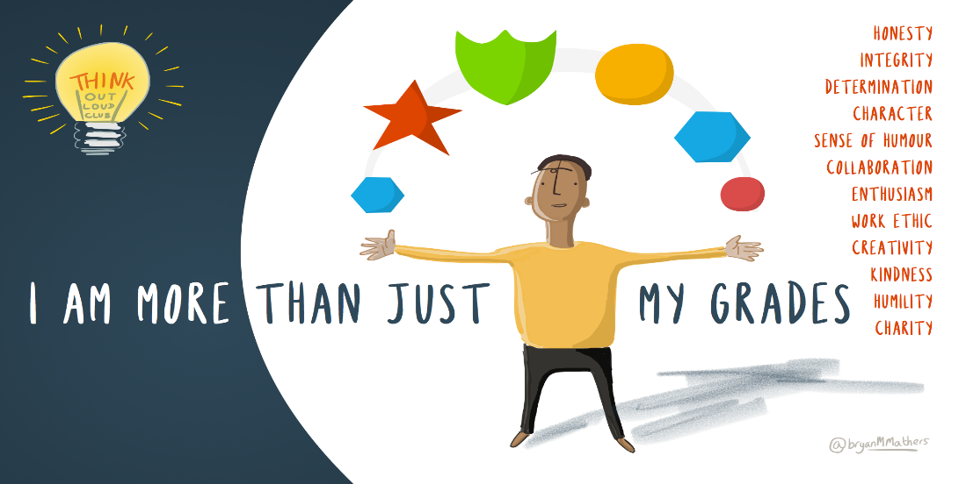
In this class, the person that you are is just as important as the work that you do, so CAPE will be an essential part of your grade as well. You will receive CAPE grades regularly.
  - Citizenship:
    - Are you supporting other students by offering help and positive feedback?
    - Are you caring, helpful and respectful to your peers, yourself, and your teacher?

  - Attitude
    - Do you work through frustration and remain persistent when you fail?
    - Do you understand that perfection is not the goal, but rather putting forth your best effort and realizing that you (and everyone) are capable of learning and doing amazing work?

  - Participation
    - Do you join in discussions/chats by sharing your thoughts, questions, and ideas with others?
    - Do you ask for help when you need it?
    - Do you do come to class/meetings prepared so that you can contribute to the class?

  - Effort
    - Are you trying your hardest every day?
    - Do you challenge yourself to do your very best?

ASSESSMENT AND GRADING:
Students will be assessed by formative and summative methods through participation, classwork, writing assignments/projects, and quizzes/tests. Parents and students can access grades at any time through PowerSchool, which will be updated at least once a week. Grades will reflect a total points system. The grading scale (set by the District) is as follows:
    - A = 90-100%
    - B = 80-89%
    - C = 70-79%
    - D = 60-69%
    - F = 0-59%

CLASSWORK
- Each student, whether remote or hybrid, will have learning in English every day, Monday-Friday. You may not have an assignment each day, but you will be engaged in learning each day.

- Most assignments are graded on a 5-4-3-2-1 scale.
  - 5/5 = you understand the material completely and make few, if any, mistakes
  - 4/5 = you have some areas to fine tune but for the most part understand the material
  - 3/5 = you are struggling with some of the material
  - 2/5 = you are struggling with most of the material or little effort was given on the work
  - 1/5 you really don’t grasp much of what was assigned and little effort was give on the work

- If the assignment was not turned in or was turned in INCOMPLETE, you will receive a zero. I DO NOT ACCEPT INCOMPLETE WORK! Late work will be accepted but may receive only partial credit and must be done within one week of the original due date.

- If you turn in an assignment LATE or re-do an assignment, you must send me a message in Teams chat so that I know you’ve done it and can assess your work.

Please remember...

- I expect everyone to RESPECT yourself, RESPECT your peers, RESPECT our school and classroom, and RESPECT the teacher (whether it is myself or a guest teacher).
●It is important to use your manners.
●I care. If I’m hard on you or push you, it’s because I have faith in your capabilities and expect more out of you. This is a good thing
●You can be anything you want to be- you are your only roadblock.
●You are a great person if you want to be and you control your outcomes and attitudes every day!

