Welcome to Mr. Salisbury’s English IV: Sports and Satire Literature
Ph #: 324-2259 Email: csalisbury@helenaschools.org
HHS Staff Webpage: https://staff.helenaschools.org/staff_page/csalisbury/
Students – access TEAMS and Staff Webpage for: Weekly Agendas, Assignments, and Communication
Welcome to English IV. I’m excited for us to share this year!
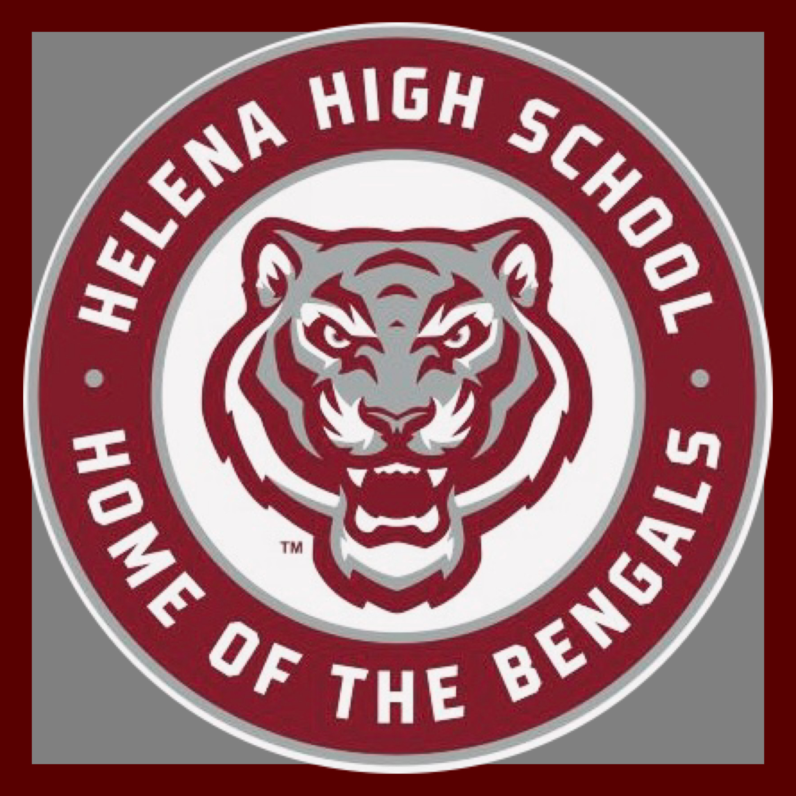
Our year-long essential question: How do stories reflect societal perspectives?

Expectations
- Be Responsible – be an active learner; challenge yourself
- Be Respectful – embrace diversity; use positive language
- Be Involved – create authentic work; encourage your peers
- Be a Graduate – plan for the future; take ownership of your education
Materials needed
- Chromebook (be sure it’s charged)
- Notebook or section of subject notebook is fine too.
- Pens and pencils
- Highlighters
- Kleenex
Our Class Procedures
Late Assignment Policy
- After the initial due date passes, you may not turn in the work for full credit. If an assignment is turned in within three days of the due date, you will receive up to 70% credit for that work. No assignment will be accepted any time after, NO EXCEPTIONS. For this reason, I recommend you keep an assignment notebook to keep track of due dates and deadlines.

Makeup Assignment Policy
- If you miss class for an EXCUSED absence, you will be granted three days to makeup missed work from the time you receive the makeup work. YOU will be expected to make the initial contact for any makeup work.
- Assignments missed for an UNEXCUSED absence will not be accepted.

Appointments for makeup work
- When a time is mutually agreed upon to make-up an assignment outside of our class time, you MUST keep that appointment or be proactive about any change.
- If you miss a mutually agreed upon appointment, you should expect to receive a zero for that makeup work. Do not expect to schedule another appointment.

Electronic device policy
- Cell phones will remain silent and in backpacks during class unless permission to use them is granted by me. *We will frequently use Chromebooks/Laptops to access learning platforms: TEAMS, Clever, NoRedink, Common Lit, iReady and more.
Food/Drinks
- Please make sure drinks have a secure lid. If you need a small snack, I’m ok with that. No buffets! All spills and messes are your responsibility. You risk losing food and drink privileges if you cannot take care of your work area.

Hall Passes
- You will be allowed to leave the room only at the discretion of the teacher. Do not ask to leave the room during discussions, lectures, or presentations unless it is an emergency.

Grades
- Grades will be posted in PowerSchool. You may access your grades online any time through this portal. There is no excuse for last minute panic at the end of the quarter or semester, you are young adults and are expected to take responsibility for your grades. Make it a priority to check your grades often.
- Grades will be based on total points possible in (3) categories:
  - Practice = 10pts - Formative = 30pts – Summative = 60pts

Writing
- We will write often exploring different modes of composition.
- We will write both informal and formal pieces.
- We will follow the writing process for specific pieces:
  - Prewrite/Outline, Draft, Revise, Edit and Publish.
Learning Platforms
- TEAMS, Clever, Noredink (grammar), Common Lit.

