**World Cultures: 2017**

**Instructor: Mr. Scott F. Evans**

**Room 23**

**Course Email &** **School Email:** [sevans@helenaschools.org](mailto:sevans@helenaschools.org)

Textbooks: *World Geography* textbook, TCI online

**SCHEDULE:**

**Period 0: AP Huma Geography 7:25 - 8:15  
Period 1: AP Huma Geography 8:20 - 9:10  
Period 2: Prep 9:15 - 10:05**

**Nutrition Break: 10:05 - 10:10  
Period 3: Team Prep 10:15 – 11:05  
Period 4: World Cultures 11:10 – 12:00  
Lunch: 12:00 – 12:35  
Period 5: AP Government 12:35 – 1:25  
Period 6: World Cultures 1:30 – 2:20**

**GRADING SCALE**

100% - 94% - A

93% - 90% - A-

89% - 87% - B+

86% - 83% - B

82% - 80% - B-

79% - 77% - C+

76% - 73% - C

72% - 70% - C-

69% - 67% - D+

66% - 63% - D

62% - 60% - D-

59% - 0% - F

**Description**

*“The World Cultures program examines major cultures of the world from several viewpoints: history, geography, government, economy, religion, customs, and current trends.” -HHS Website*

**Topics to be covered:**

* 1. First Semester: Introduction/Culture, Europe, Africa and the Middle East and
  2. Second Semester: Russia/Yugoslavia, Asia, Latin and Native American

**Methodology**

Challenging assignments involving student reading, analysis, synthesis, writing and presenting will give the students the opportunity to develop along the lines of the course objectives. Lectures will be given in order to develop the course curriculum and make clear any themes or objectives not understood by the students. Groups discussions and presentations as well Socratic discussions based on primary and secondary readings will be used in class. Class simulations, debates and videos will be used in order to enrich and expand the student’s knowledge of World Cultures.

**Materials**

Material for this class comes from a variety of sources including, but not limited to, the *World Geography* textbook, PBS, the BBC, Al Jazeera news, Time Magazine, Upfront Magazine, China Daily, El Nacional, CNN and other information researched. This year we will also be using the supplemental book *Contemporary Human Geography* and an online subscription to the textbook company *TCI.*

**Films**

The following videos may, or may not, be watched in class throughout the year accompanied by new documentary films I find essential for the class.

1. Wadjda **i**. Which Way Home
2. Anthony Bourdain – CNN **j**. War Dance
3. Once Brothers **k**. Death in Gaza
4. The Two Escobars **l**. 5 Broken Cameras
5. Call + Response (PG13) **m**. ESPN 30 for 30 episodes
6. Tibet: Cry the Snow Lion **n.** A State of Mind
7. 3 Points **o.** Inside North Korea
8. Half the Sky

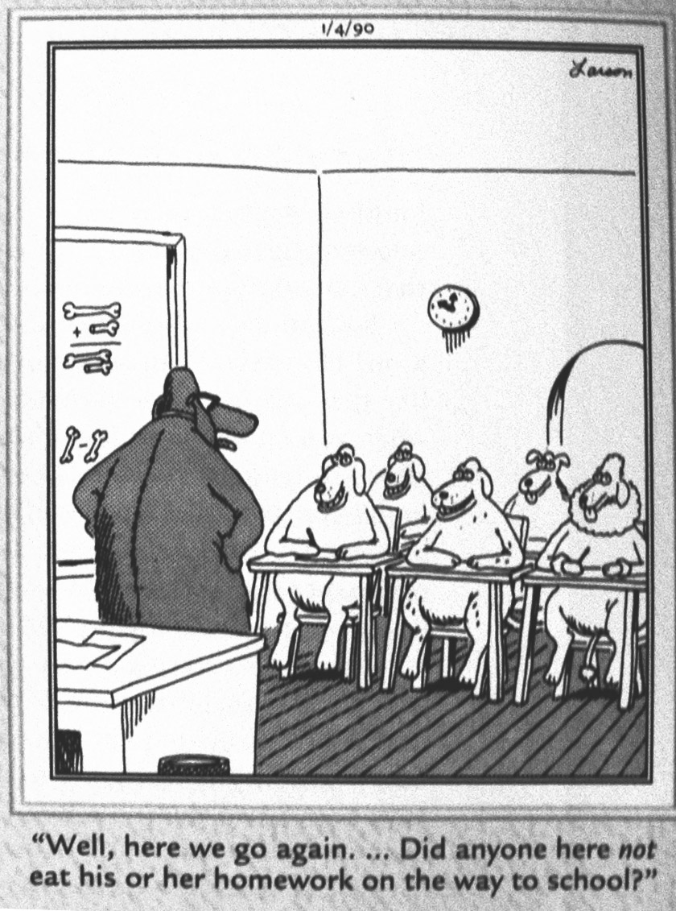**Late Work**

1. ***If a student is absent for a class it is their responsibility to get the notes and assignments from my website, a friend, or in the “extra copies” folder on the front counter.*** They have 3 days to make up the work they missed for full credit if they were physically absent from the class on the day it was assigned.
2. In Freshman Team #1 late work will be accepted up to 3 days from the due date. Late work results in an immediate deduction of 30% from the assignment grade. Tests must be made up within one week of the student’s return to class.

**Extra Help**

If you are in need of extra help, please set up a time that is contusive and agreed upon by the two of us. Mornings from 6:45 – 7:15 am, and I have prep period 2 with a Team Prep 3rd. My after school time is busy with football in the fall and track in the spring, so please try to arrange a meeting time that is suited for the two of us, and I will be sure to keep my time open for any questions or concerns you may have.

*All **discipline**, **expectations** and **procedures** mirror that of the HHS handbook and Freshmen Team #1.