

Me llamo

_____

_____________________________

La fecha es

_

__ / ___ / ___

La hora es

___



EL TRAJE DE LUCES

(

)

The Suit of Lights

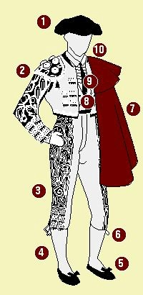

1.

_________________________________________________

2.

___________________

______________________________

3.

_________________________________________________

4.

_________________________________________________

5.

_________________________________________________

6.

_________________________________________________

7.

_________________________

________________________

8.

_________________________________________________

9.

_________________________________________________

10.

_________________________________________________



Directions:

In order to complete this activity, you need a computer and Internet

. Type in this

website

http://goo.gl/2jCRDh

. Begin by labeling all 10 parts of the “toreros” outfit. Then match

each clothing item to its description below.



A.

___________________

___

son partes pequeños de los pantalones. También son decorados.

B.

______________________

es el sombrero especial del torero

.

C.

______________________

Superman tiene uno

.

Lo usa para antagonizar al toro.

D.

______________________

es la chaqueta decor

ado del torero

.

E.

______________________

los hombres importantes con trabajos importantes

necesitan uno.

F.

______________________

los toreros los necesitan para caminar

durante la corrida.

G.

______________________

son los pantalones del torero, pero no son lar

gos.

H.

______________________

parece que es parte del sombrero, pero no es.

Está debajo del sombrero.

I.

______________________

no son pantalones, pero los toreros las llevan en las piernas.

Usualmente son de color rosa.



Directions:

Below, match eac

h clothing term from above to its description

by writing in the

Spanish word for the clothing item

. Use the information from the same website above and

your

answers from above.