Unit 2 Hydrology Review

Use your

- What percentage of Earth’s water is freshwater? Of this percentage 68.7% of all fresh water is locked up in glaciers and polar ice caps. Explain some limitations to using this frozen water as a source of drinking water on Earth.
____________________________________________________________________________________ ____________________________________________________________________________________
___________________________________________________________________________________________________________________________________________________________________________________________________________________________________________________________

- Match the following terminology to the water cycle diagram below.
(Transpiration, Groundwater, Evaporation, Runoff, Condensation, Precipitation, Infiltration)

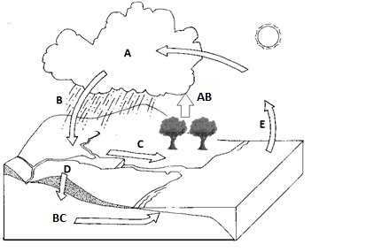

- Use the terms from the diagram above to explain why Earth is considered a “closed system”.
____________________________________________________________________________________ ____________________________________________________________________________________
___________________________________________________________________________________________________________________________________________________________________________________________________________________________________________________________

- Define:
  - Porosity _______________________________________________________________

  - Permeability _______________________________________________________________

  - Water table _______________________________________________________________

  - Artesian well _______________________________________________________________

  - Spring _______________________________________________________________

- What is the difference between a spring and an artesian well?
__________________________________________________________________________________

Running Water
- What stream variable is most important for eroding a channel and causing a stream to meander?

- What is the discharge of a stream that is 5 meters wide, 3 meters deep, and flowing at 12 m/s?

- Explain the differences between clay, silt, sand, and base load.

Study the two diagrams and be able to label each.
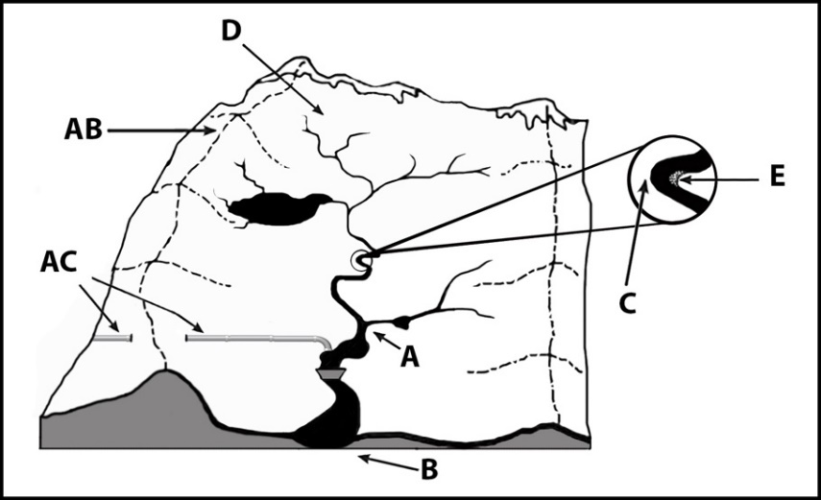
____ Confluence (tributary meets main river)
____ Mouth (where an estuary can form)
____ Cut bank (water erodes riverbank)
____ Headwaters
____ Point bar (slower water deposits sand and gravel)
____ Trans-mountain diversion (water movement)
____ Divide (Geographic area dividing two watersheds)
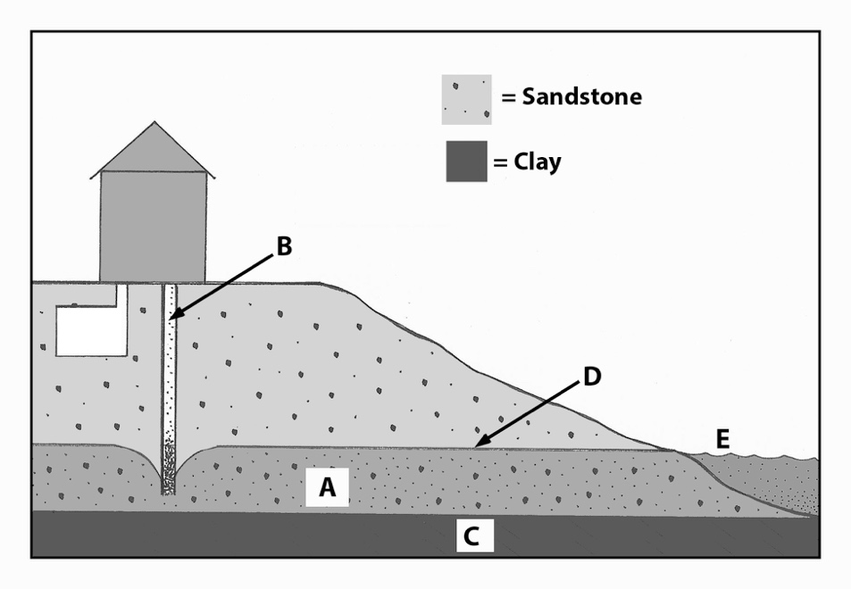

__ Aquifer
__ Bore well
__ Impermeable rock or clay
__ Water table
__ Spring

